**Information Security-LAB**



**Submitted By:**

Raja Umer Saleem 2023-CS-609

**Submitted To:**

**Ms. Shanfa**

**Dated:** **20th Jan 2025**

**Department of Computer Science**

**University of Engineering and Technology Lahore, New Campus**

1. Crack the following plaintext TRVJRI TZGYVIJ RIV HLZKV VRJP KF TIRTB

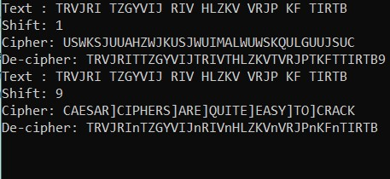

Crack text:

CAESAR CIPHERS ARE QUITE EASY TO CRACK

2. What encryption key was used?

The Key was 9.

3. Make you own cipher text using the Caesar cipher.

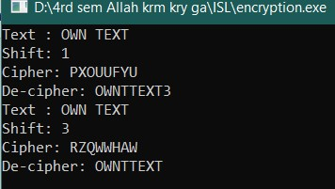

4. Can you crack other people’s ciphertexts?

Yes, I guess the the key.

5. What key do we need to make “CAESAR” become “MKOCKB”?

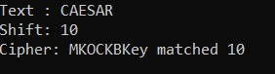

Key =10

6. What key do we need to make “CIPHER” become “SYFXUH”?

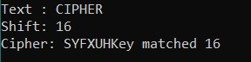

Key=16

7. Use the Caesar cipher to encrypt your first name

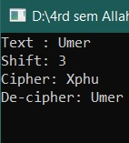

8. How can we find the decryption key from the encryption key?

The key used in encryption just simple “subtract” it.

**2nd Manual**

