UI Automation Report on RetailMart Web Application
Application: RetailMart Web Application
Browser: Chrome
Web Link: https://www.retailmart.linkpc.net
Automation Tool: Playwright
CI/CD tool: GitHub Actions
Author: Justin Philip

This is a preliminary report on the Webapp for two given scenarios:
- Product Remove Validation
- Successful Payment Validation

Scenario 1:
Objective: Remove Product Validation
Scenario: Remove products from the cart and verify updates.

Steps: 1. Add three products to the cart.
2. Remove one product.
3. Remove remaining products one by one.
Validations
- Removed products no longer appear in the cart.
- Cart badge count decreases accordingly.
- Subtotal, tax, and total are recalculated correctly.
- Empty cart message is displayed when all products are removed.
- Proceed to Checkout button is disabled or restricted for an empty cart.
Expected Result:
- Product is removed successfully
Actual Result:
- Product is removed successfully and the cart message is correct
Status: Pass

Framework:
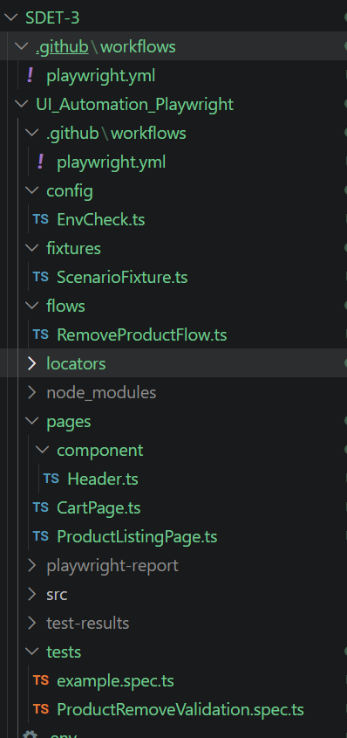
Structure:
Locators: Contains Locators
Pages: followed Page Object Model (POM)
Flows: Assertions done here
Fixtures: Calling the combined Flows here
Tests: contains Test files

Proof:
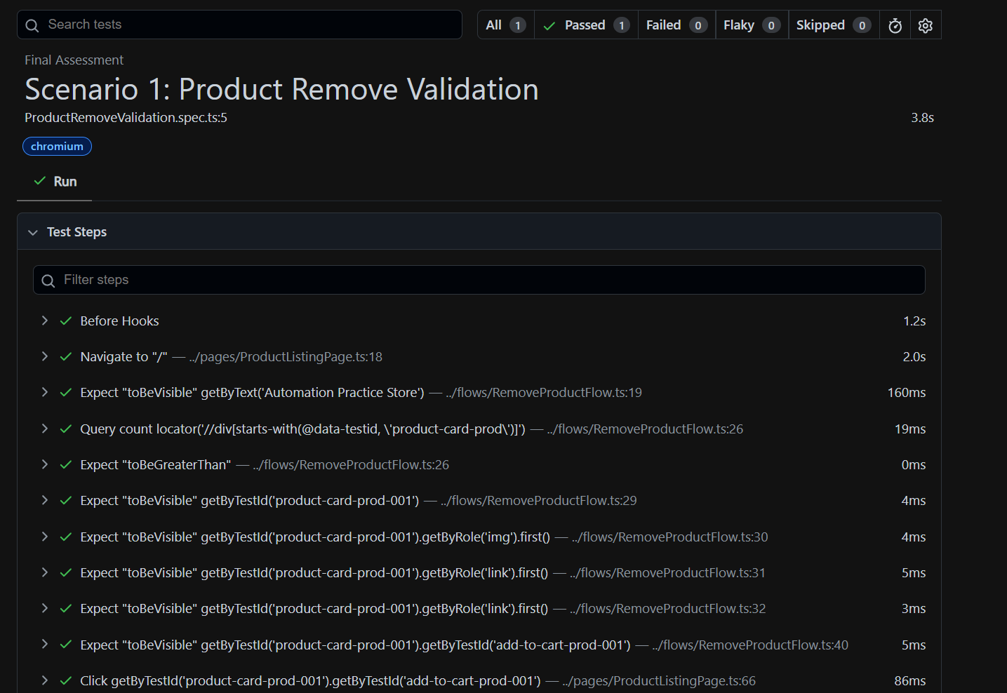
Scenario 2:
Objective: Payment Success Validation
Scenario: Complete payment using valid card details.

Steps: 1. Proceed to the Payment page.
2. Enter valid Cardholder Name.
3. Enter a valid card number.
4. Enter valid Expiry Date and CVV.
5. Select Payment Success.
6. Click Place Order.
Validations
- Payment is processed successfully.
- User is redirected to the Confirmation page.
- Order number is generated.
- Order summary matches the purchased items.
- No error messages are displayed.
Expected Result:
- Payment is done successfully and redirected to Order Page
Actual Result:
- Payment is completed
Status: Pass

Structure:
Locators: Contains Locators
Pages: followed Page Object Model (POM)
Flows: Assertions done here
Fixtures: Calling the combined Flows here
Tests: contains Test files

Proof:
