REST Assured API Automation Test Report
Prepared by: Justin Philip
Date: 25 June 2026
GitHub Repository:
- API Automation Project:

1. Objective
The objective of this automation is:
Create a user, generate an authentication token and retrieve the list of books using token.

2. Application / API Under Test
- API Type: RESTful APIs
- Base URL: https://demoqa.com
- Environment: Local/ CICD
APIs Covered:
- Creating User: https://demoqa.com/Account/v1/User
- Generating Token: https://demoqa.com/Account/v1/GenerateToken
- Getting all Books: https://demoqa.com/BookStore/v1/Books

3. Environment & Setup
Technology Stack:
- Language: Java
- Framework: Rest Assured
- Assertion Library: JUnit 5
- Build Tool: Maven
- Test Runner: Maven Surefire Plugin
- Environmental Variables: stored in .env file(local)/ secrets(CI/CD)

4. Framework Design
4.1 Architecture Overview
The framework is designed using a structured approach separating test logic and API interaction layers.

4.2 Project Structure
- src/test/java/tests → Test classes
- client/ → Clients for the different api response
- contracts/ → contracts for the json schema validation
- data/ → stores testData and requestBodies for client Requests
- model/ → stores various response models of apis
- specFactory/ → Standard Specification for Requests and Responses
- support/ → set up to call env variables
- resources/ → Test data and config
- pom.xml → Dependency management

5. Test Approach / Strategy
- API testing is conducted using functional validation
- Focus on:
  - Status code validation
  - Response body verification
  - Schema validation
Test Category:
- Smoke → Basic API availability

7. Scenarios Covered
- POST for creating User
- POST for generating Token after Authentication
- GET method for retrieving all books

8. Test Scenario

Scenario
- Scenario Name: Creating User, generating Token and retrieving Books
Steps:
- Send api POST request to “/Account/v1/User”
- Validate json schema and response body
- Send POST request to generate token to “/Account/v1/GenerateToken”.
- Validate json schema and response body
- Send GET request to “/BookStore/v1/Books”
- Validate json schema and response body

Expected Result:
- API should return status code 201 at first instance of POST
- API should return status code 200 at second instance of POST
- API should return status code 200 for GET alongwith response

Actual Result:
- API returned status code 201at first instance of POST
- API returned status code 200 at second instance of POST
- API returned status code 200 for GET

Status: Pass

Code:
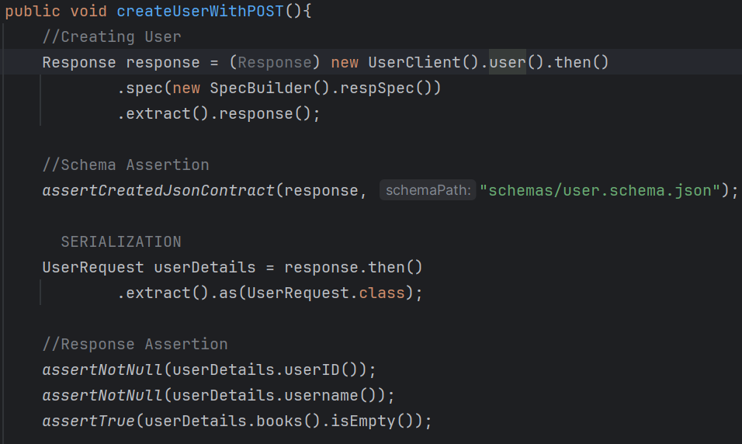
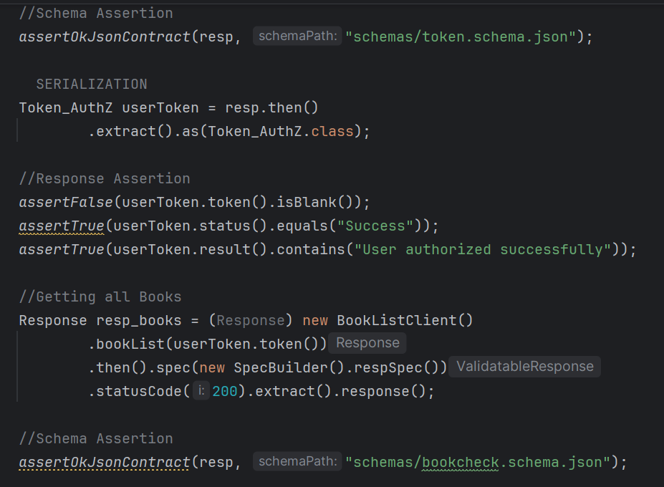
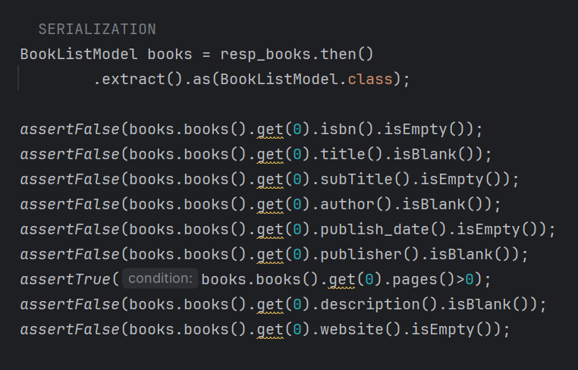

Conclusion:
The API responses of the three given endpoints are validated and found correct.

