Final Assessment Playwright Report

GitHub Link : RajaVUst/SDET-4 at capstone/304579-lahari

Folder Structure:
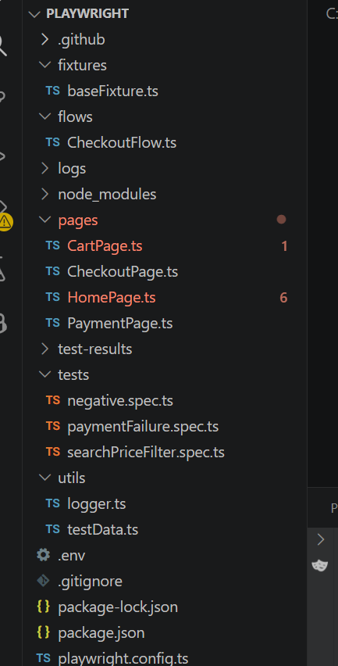

- Scenario 1: Search + Price Filter Validation
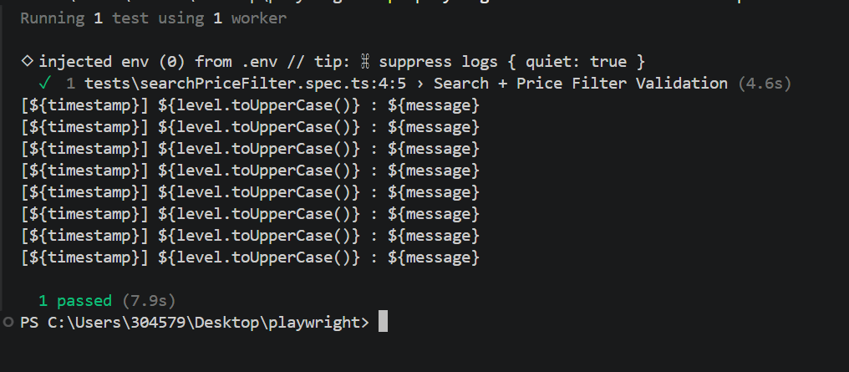
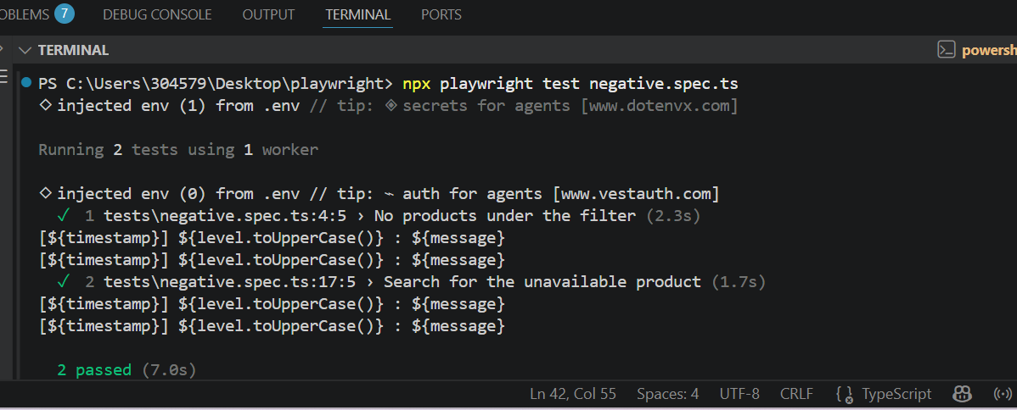

- Scenario 2: Payment Failure Validation
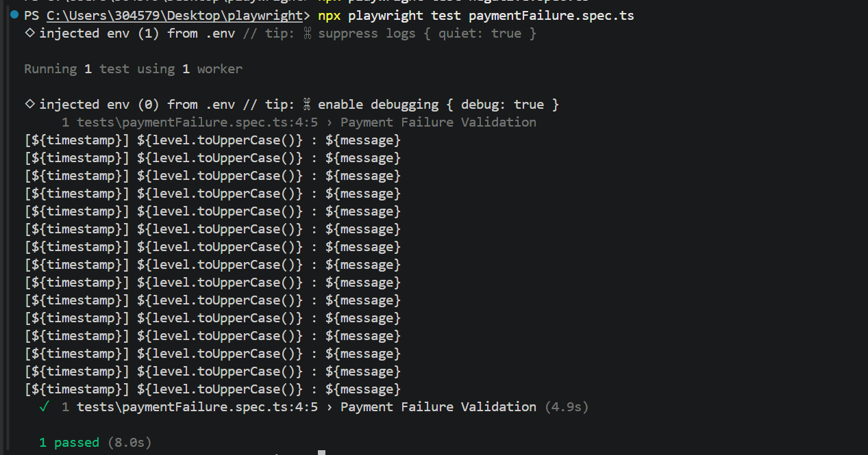

CI pipeline
