Distributed Systems and Cloud Computing
00016577
Rajabboev Anvarmirzo

Table Of Contents

1 Application Overview
2 Database
3 Containerization
4. Docker compose -service configuration
5. Deployment configuration
6. CI/CD pipeline
7. SECRETS Management
8. Challenges
9. Future Improvements
10. Links

1380 words.

Application Overview
Team Flow by its name this project is built with Django for automating and managing collaborative tasks and teams. In this app users can register, log in and manage teams and tasks, there are two types of users ‘team leads’ and ‘members. Core technologies used in this project: Django as a web framework, Bootstrap for frontend, PostgreSQL as a database and Nginx as a reverse proxy, Gunicorn as the WSGI serving the application in production. The application runs inside Docker containers orchestrated with Docker Compose on a Google Cloud Compute Engine VM. In terms of the system, there are 3 primary database models Users, Teams, and Tasks which have both many-to-one and many-to-many relationships. Key features include user auth and CRUD operations for task management, different panels for admins (team lead) and members(user) and five functional views like dashboard, team management, admin panel, task create and feedback with task tracking. 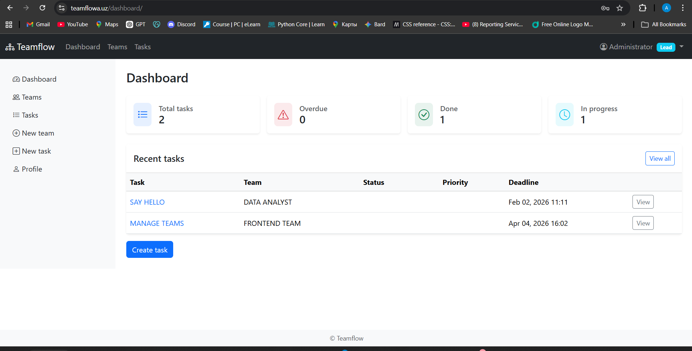
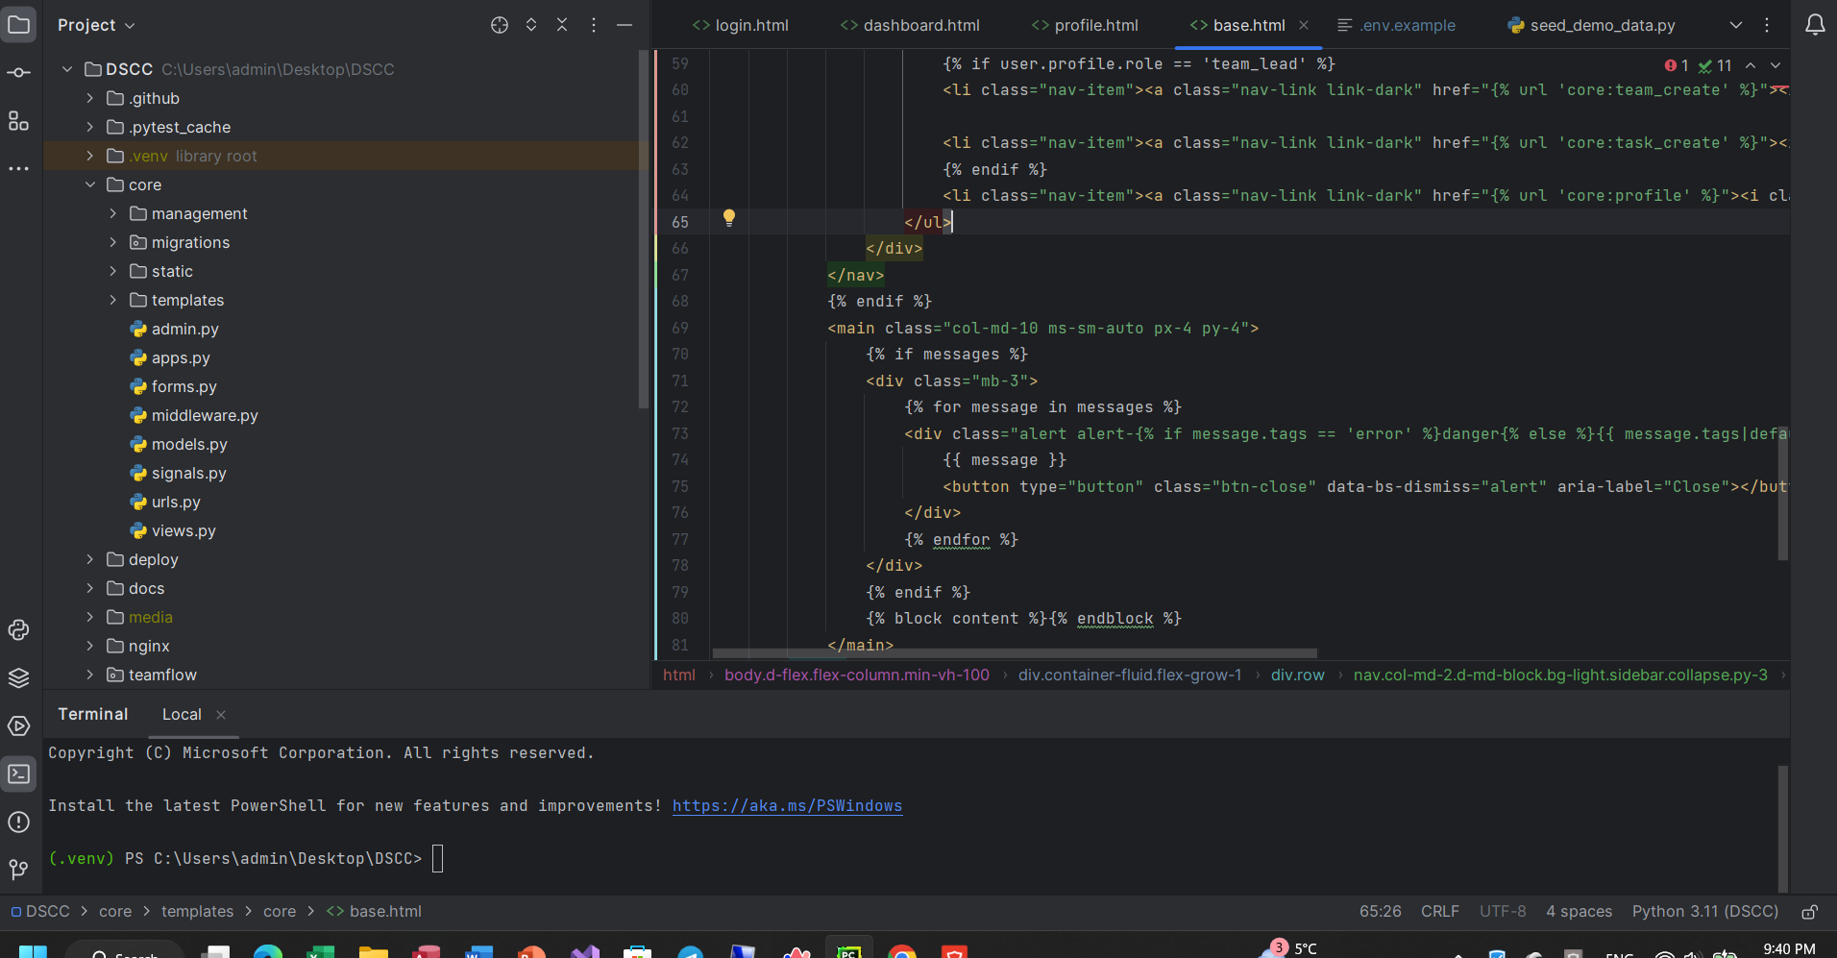
Database Schema
The application has six core models with the following relationships:
- User ↔ Profile — one-to-one (auto-created via Django signals)
- Team → User — many-to-many for members, foreign key for creator
- Task → Team — many-to-one (FK); Task → User — FK for assignee/creator
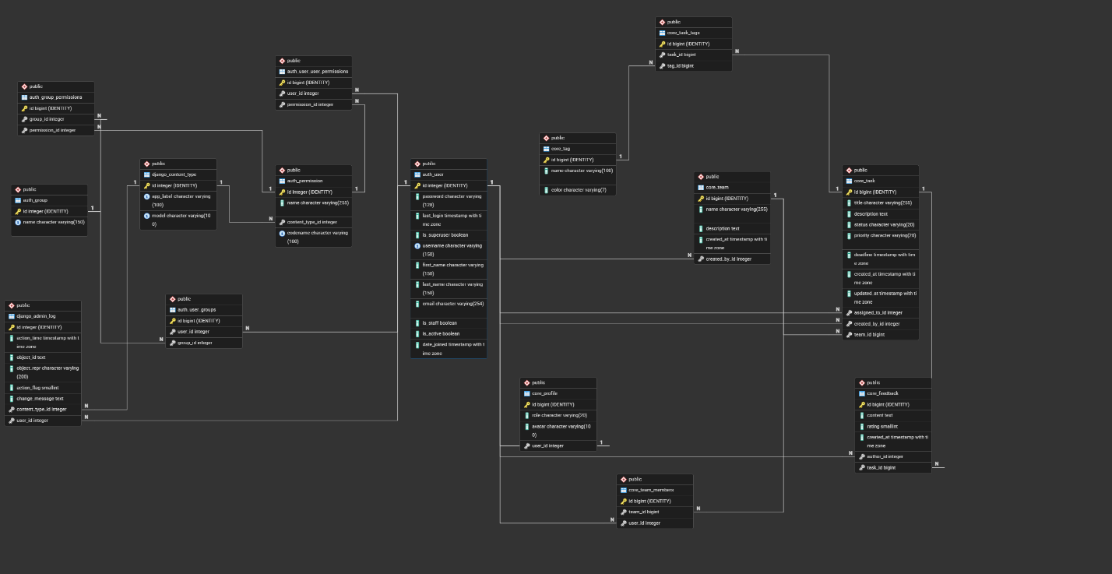
- Task ↔ Tag — many-to-manyFeedback → Task and User — foreign keys
Containerization
In order to provide a consistent and reproducible deployments, the application was fully containerized in Docker. The Dockerfile employs a multi-stage build approach:
In the first stage there are installing of dependencies, requirements and compiling of assets and the final stage copies only necessary codebase or artifacts into slim Python base image, keeping the final image size about 83 MB. Additionally, non-root user is configured inside container to follow security practices and for minimizing privilege escalation risks.
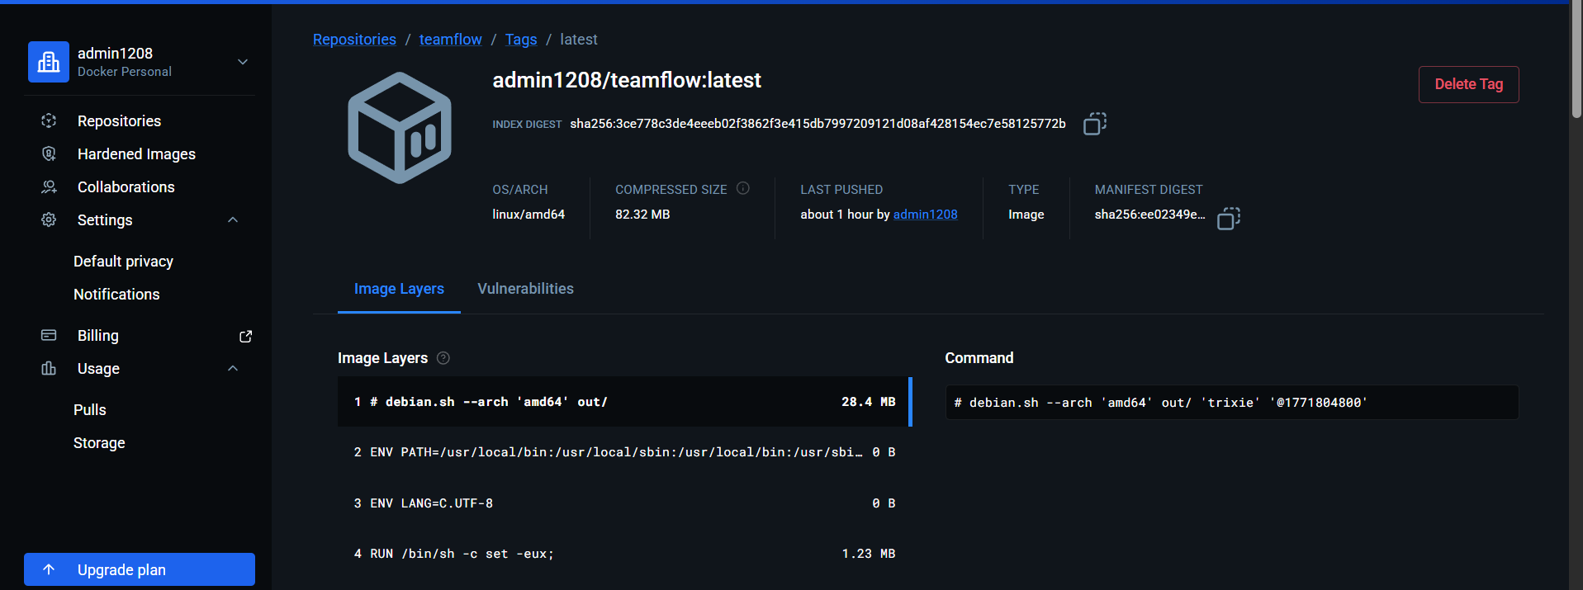

The first stage (builder) installs all Python dependencies and compiles them into wheel files. The second stage (final) copies only the pre-built wheels and application code, without any build tools. The final image runs as a non-root user called appuser, which is a basic security measure to prevent privilege escalation inside the container. The entry point script waits for PostgreSQL to be ready, runs migrations, and then starts Gunicorn with 3 workers.
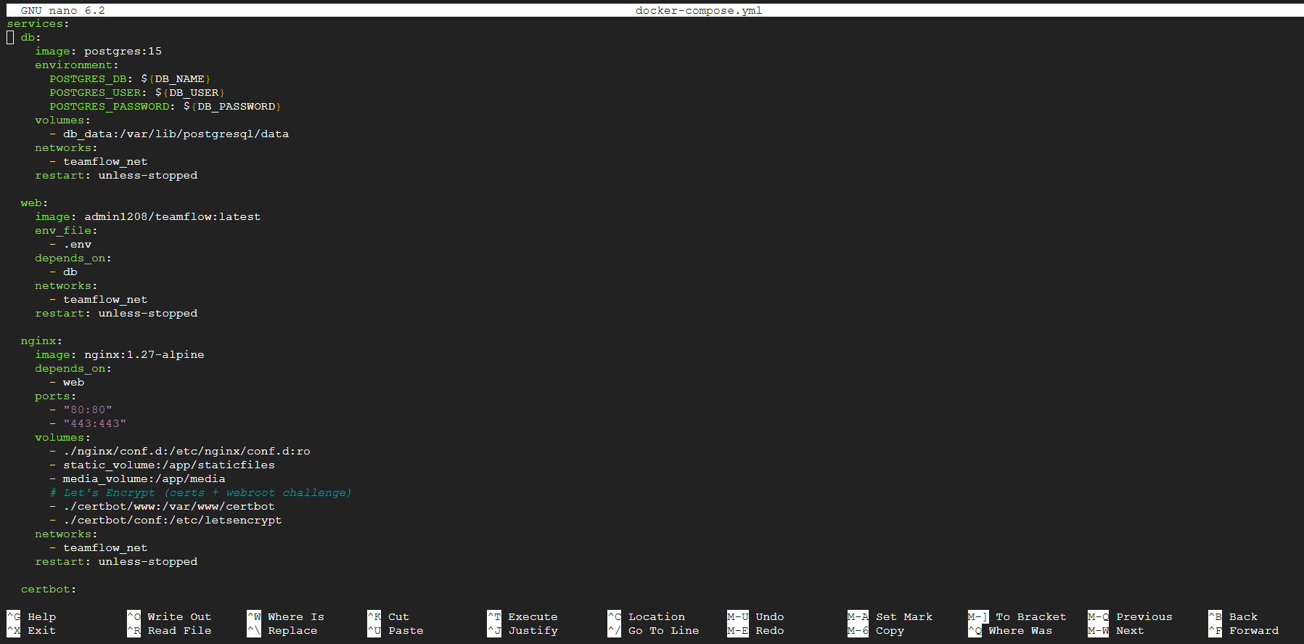
DOCKER COMPOSE -Service Configuration
The Docker-compose.yml defines four different services : first is db(PostgreSQL) and second is Django/Gunicorn, nginx and certbot . Web server don’t expose ports directly to the host but it communicates with Nginx through the international network in Docker teamflow_net.
Volumes are also configured for 3 different purposes , such as db_data, static files and media uploads so there are these 3 volumes db_data, static_volume, media_volume. Additionally Nginx server and certbot have two additional volumes for Lets encrypt certificate files and ACME webroot directory
Environment Variable Management
In the .env file all secrets and config values are stored for example Database credentials, Django secret key, allowed hosts and debug flag , also the file is listed in .gitignore and is not committed to the repo.The web server directly read that .env in docker-compose.yml
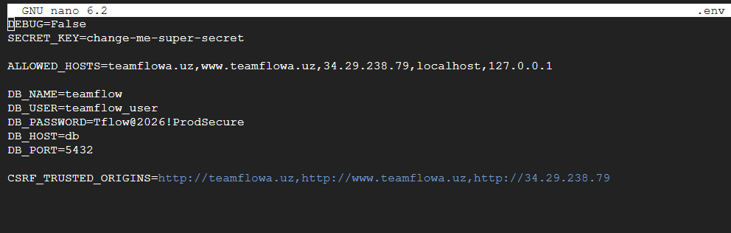

Deployment configuration
1. Google Cloud VM setup
I deployed the application on Google Cloud Compute Engine VM which is running Ubuntu 22.04 LTS . First of all I installed Docker and Docker Compose plugins and created /opt/teamflow on the server and the .env file with again the secrets but directly on server.

After created project root , configured GCP firewall rules in order to allow inbound traffic on ports (22 SSH) , 80 HTTP , and 443 HTTPS. The VM’s static IP address (34.29.238.79) is pointed to by domain DNS records. 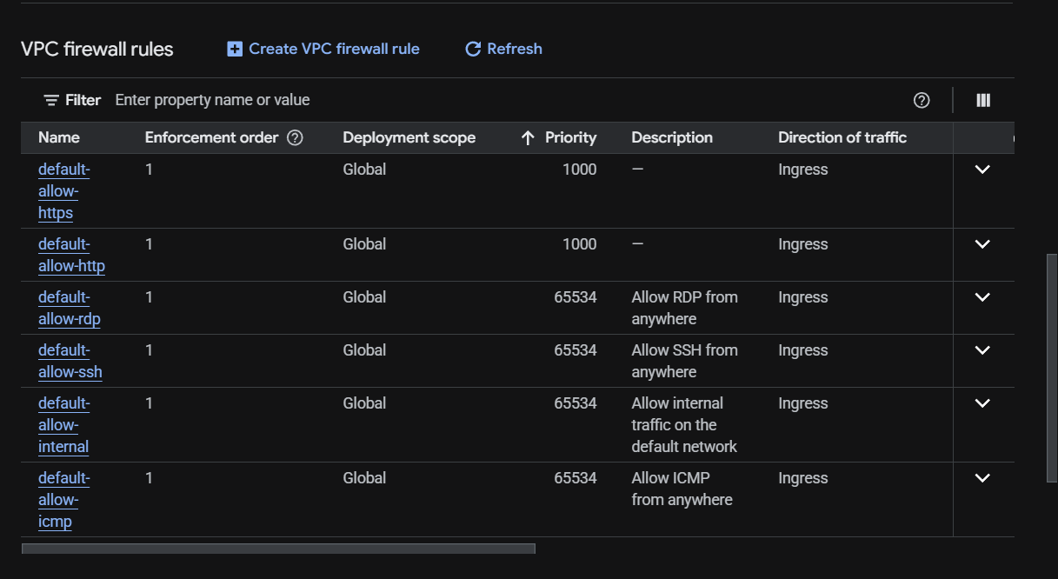

NGINX and GUNICORN configuration
I make the NGINX run as a docker container and act as a reverse proxy in front of GUnicorn which handles two main tasks: serving static and media files from shared volumes and forwarding other types of requests to Gunicorn server inside the web container on port 8000. Also Nginx configuration consist of two server blocks : listens on port 80 and handles ACME challenge for renewing the certificate after that redirects all traffic to HTTPS, the second listens on port 443 with SSL certificate and proxies for Django upstream.
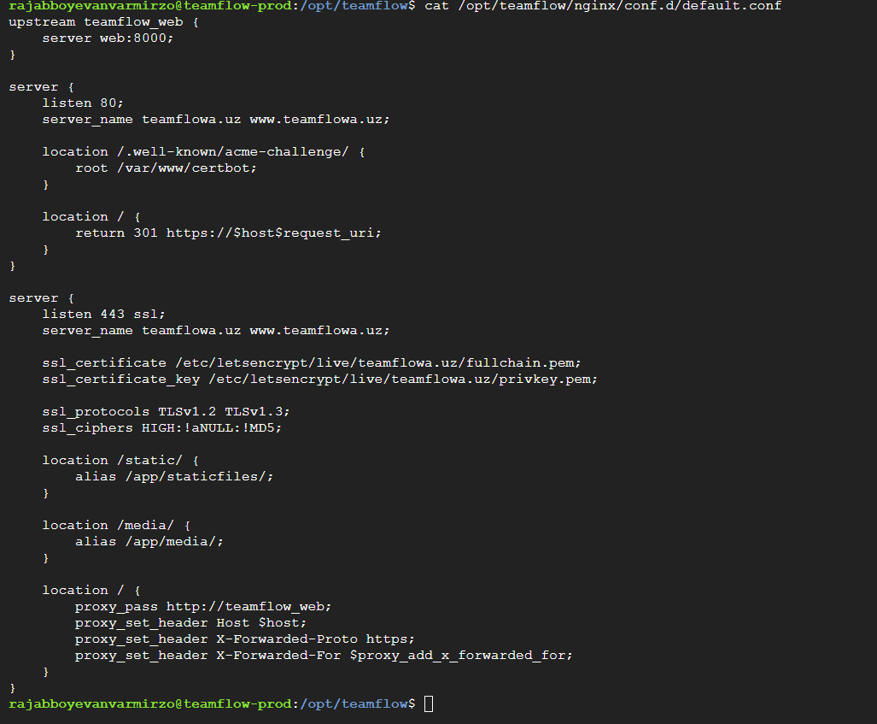
SSL/HTTP Implementation
I obtain SSL certificates using Certbot with webroot method so Certboot service writes a challenge file to the shared volume and Nginx serves it at /.well-known/acme-challenge/. Once validated Lets Encrypt issued the certificate and the certificate files are mounted into Nginx container. A cron job automatically renew the certificate every day at 3 am and reload Nginx after renewal.
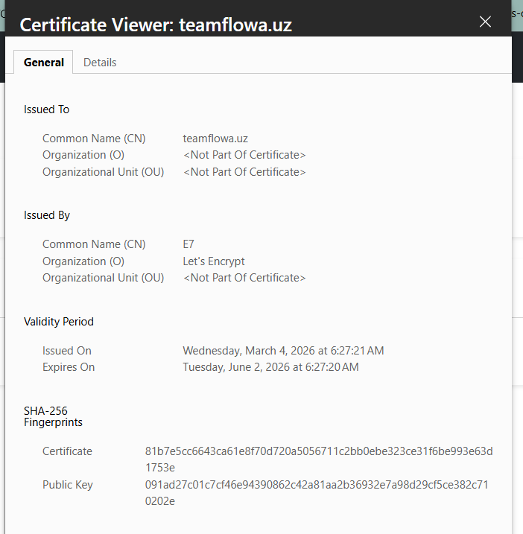
Domain Configuration
The domain teamflowa.uz was configured at the DNS provider with two A records pointing to the GCP VM's external IP (34.29.238.79): one for the root domain (@) and one for www. Initially there was a second A record pointing to the old server (185.196.212.52), which caused Let's Encrypt validation to fail because some validation requests hit the wrong server. Removing the old record resolved the issue.
CI/CD pipeline
I implemented a CI/CD pipeline with Github Actions in .github/workflows/deploy.yml where the YAML file triggers automatically on every push to the main branch and runs test-only checks on pull requests. The pipeline has three jobs that run in sequence : test>>build>>deploy
JOB 1
This job spins up a PostgreSQL service container and runs test suite against it :
steps are:
checkout code
setup Python 3.11
Install dependencies
run flake8 for style checking
Run black for format checking
Run Pytest with coverage
This job runs on all pushes and pull requests, which means if something wrong format or style or bad code is caught before it reaches the server.
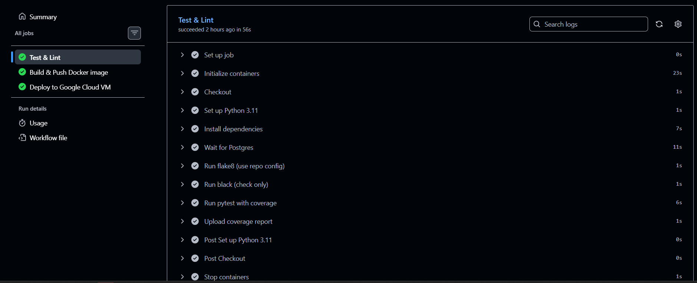
JOB 2
This job only runs on pushes to main, after the test job passes. It builds the Docker image using the production Dockerfile and pushes it to Docker Hub under admin1208/teamflow with two tags: latest and the full commit SHA. Using the commit SHA tag makes it possible to roll back to any specific version if needed. 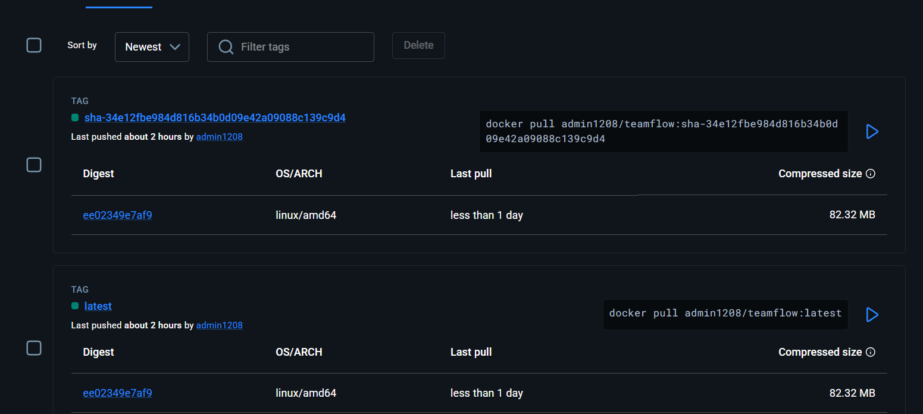
JOB 3
The deploy job connects to the server via SSH using the appleboy/ssh-action. It pulls the new image, restarts the web service, runs database migrations, collects static files, and prunes old Docker images. After deployment, a health check polls https://teamflowa.uz/health/ up to 30 times with 2-second intervals. If the endpoint returns 200 OK, the deployment is marked successful.
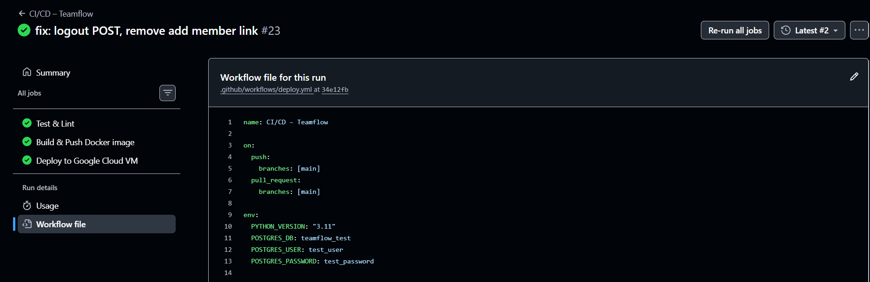
SECRETS Management
Five GitHub Secrets are configured in the repository: DOCKERHUB_USERNAME, DOCKERHUB_TOKEN, SSH_HOST, SSH_USERNAME, and SSH_PRIVATE_KEY. The SSH key pair was generated on the server with ed25519 algorithm. The public key is in ~/.ssh/authorized_keys on the server, and the private key is stored only in GitHub Secrets — it never touches the repository.
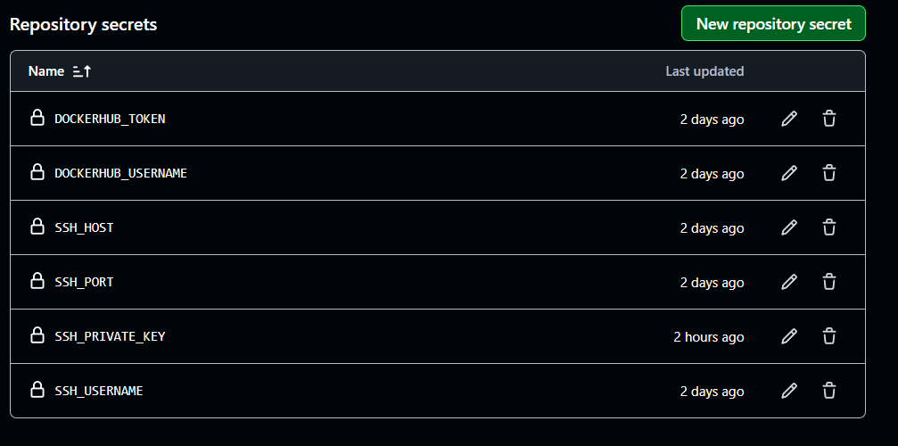
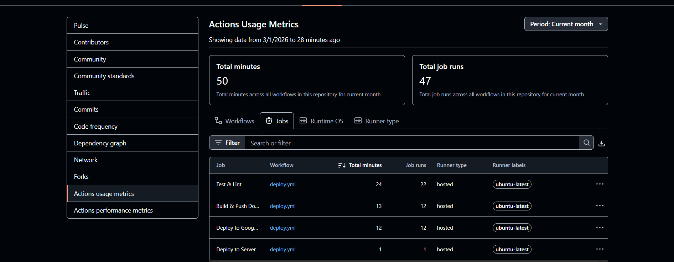
Challenges
During Development and Deployment I face several challenges : Challenge 1 – Duplicate DNS A record , after I bought a domain from ahost.com it was registered to DNS automatically with the companys info web page ip address during a creation I oversee and created an A rcord with my VM’s ip and fail with a 404 error. The solution was a deleting the old record and recreate mine and wait 12 hours to re-registration.
Challenge 2 – SSH auth in CI/CD
The GitHub Actions deploy job was failing with 'ssh: unable to authenticate'. The problem was that the server had no authorized_keys file at all, so no SSH key was trusted. The fix was to generate a new ed25519 key pair on the server, add the public key to ~/.ssh/authorized_keys with correct permissions (600), and save the private key in GitHub Secrets. After this, the pipeline connected successfully.
FUTURE Improvements
If I were to continue developing this project, I would add Redis for session caching and Celery for asynchronous tasks such as sending email notifications when tasks are assigned. I would also set up a staging environment that deploys from a dev branch before anything reaches production. Additionally, I would configure HSTS headers and Content Security Policy in Nginx to improve security.
LINKS:
1) Live Application HTTPS : https://www.teamflowa.uz/dashboard/
2) GitHub Repository : https://github.com/Rajabboev/Teamflow_Django_app.git
3) Docker Hub Repository : https://hub.docker.com/repository/docker/admin1208/teamflow/general
TEST USER CREDENTIALS
USERNAME: Administrator
Password: PasswordAdmin
Role: Team Lead Frontend – full access
VIDEO:
https://drive.google.com/file/d/17FfNVb6OErvEW5maj_8g1tC7rdvRiPKB/view?usp=drive_link
GIT HUB COMMIT SCREENSHOTS:
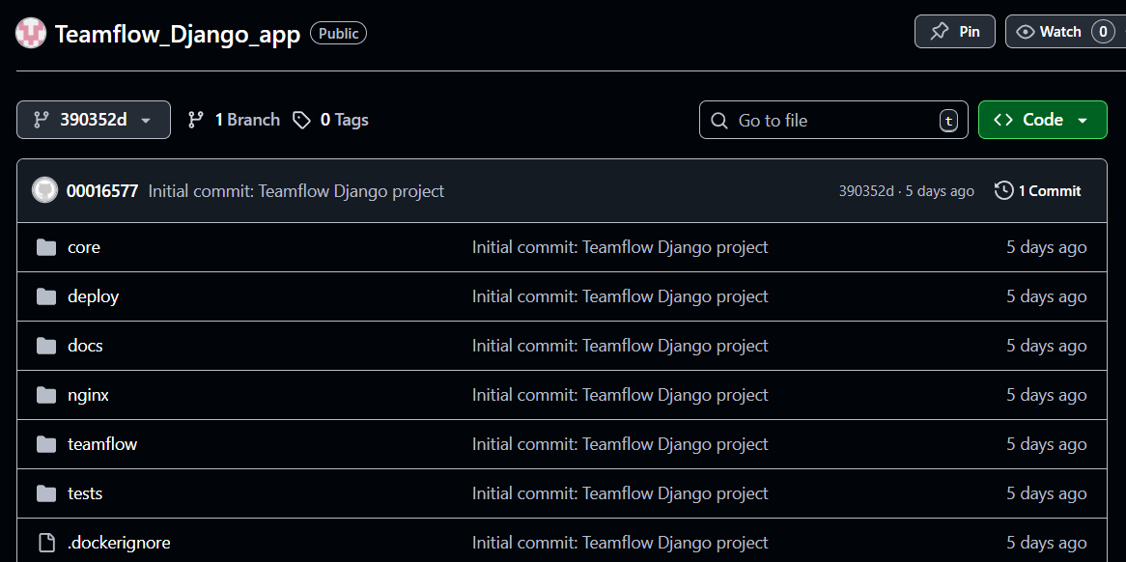
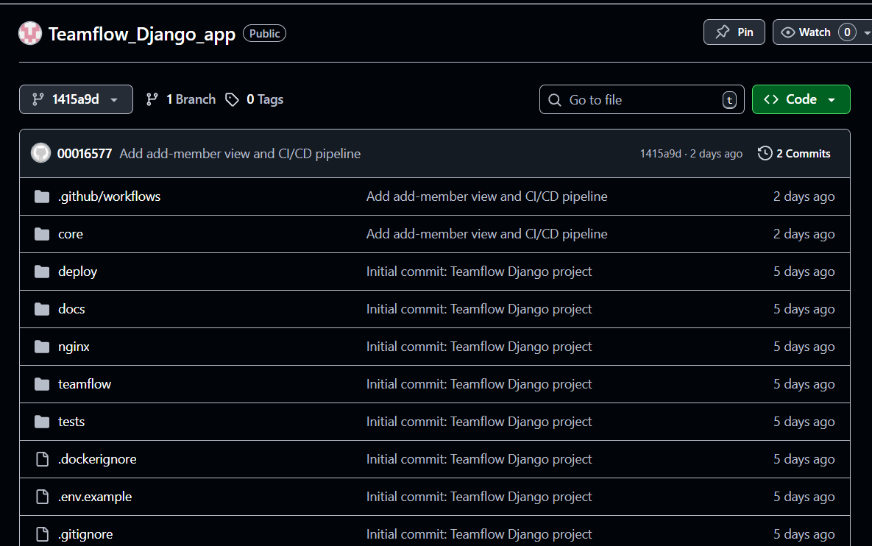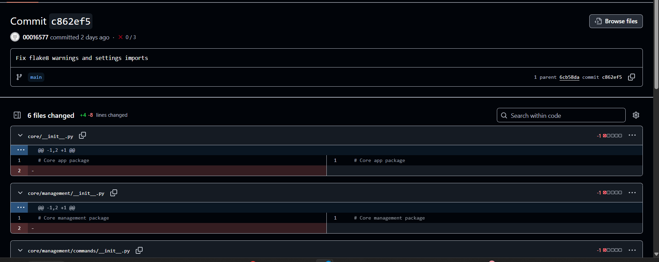
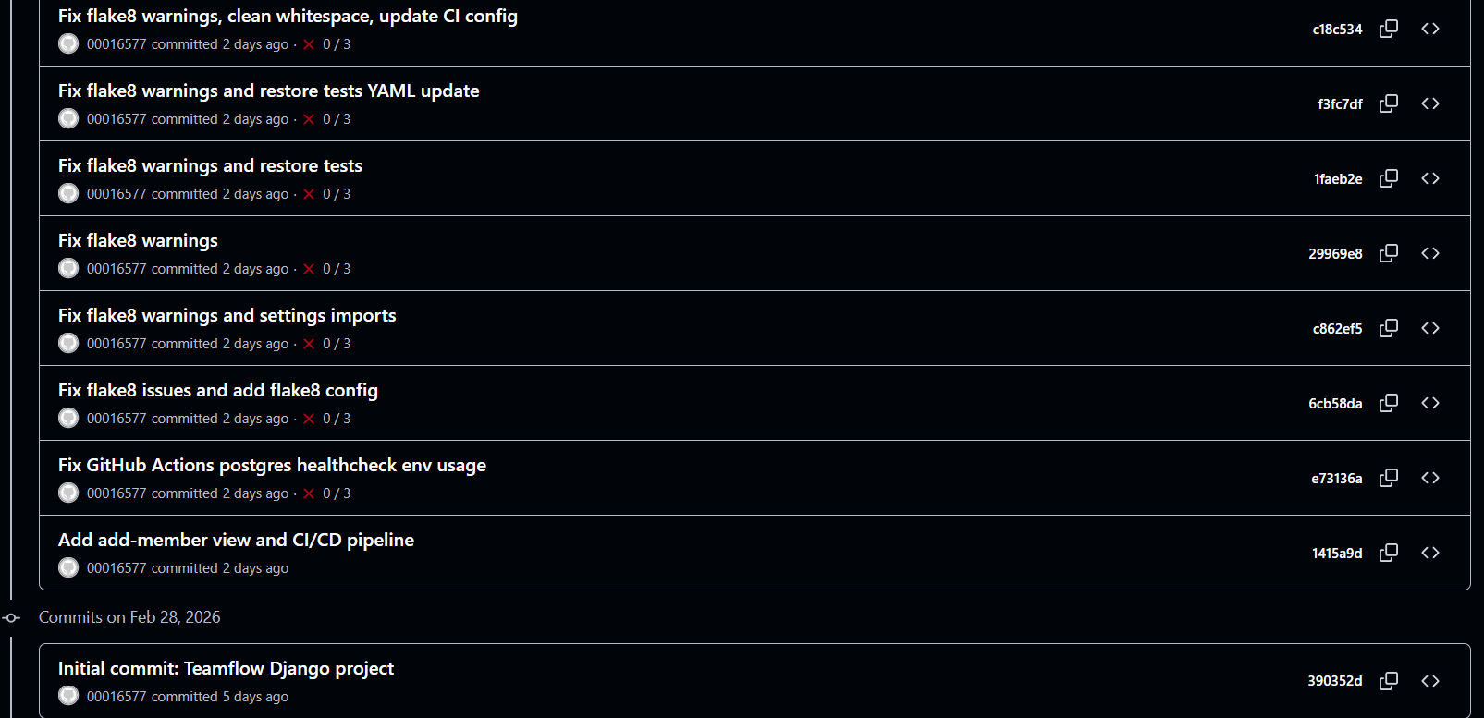
For many commits are to fix flake so one of them is provided
