Hunter Case File
Forensic Investigator: Joe Wasilewski



Cover Sheet
Confidential Material Enclosed
Only Authorized Individuals Should View Beyond This Cover Sheet

I. Summation

This case involves the examination of a Maxell DVD + R 4.7 GB disk containing an image of Steve Hunter’s, an Accounting employee at American Pacific University (APU, corporate hard drive. The hard drive image resulted from an accusation by Gloria Andrews, also an Accounting employee at APU, that Mr. Hunter had sent her several threatening emails from two yahoo and one msn email accounts, some of which were attached with graphic pornographic files. Mr. Hunter, claiming that he does not have an email account on either yahoo or msn, denies this accusation and argues that Ms. Andrews may have forged the emails by creating an email account on yahoo or msn with his name. The primary objective in this case was to gather evidence from Mr. Hunter’s hard drive which would either prove or disprove the truthfulness of his contentions.

Examination of the hard drive image revealed several critical files that seem to invalidate Mr. Hunter’s argument that Ms. Andrews may have forged the threatening emails by creating email accounts with his name. Several files, including the three emails authored by “Chest Brockwell” and the six JPG files containing graphic pornography that were attached to these emails, which were provided by APU’s IT department were encountered on Steve Hunter’s hard drive.

The first file, file 008 (see pp. 10-15), contains a string of five emails (emails 5-7 provided by APU’s IT department) between “Chest Brockwell” (email - theChest67888@yahoo.com) and Gloria Andrews (email – Gloria761@yahoo.com). This file appears to be indistinguishable from email 7, provided by APU’s IT department, and contains several threats, sexual suggestions, and pornographic attachments sent from “Chest Brockwell” to Gloria Andrews on April 9, 2007 between 11:23 AM and 11:36 AM. While it may have been possible for Ms. Andrews to forge email accounts by registering them with Mr. Hunter’s name, it is virtually impossible, without Ms. Andrews physically logging on to Mr. Hunter’s machine and creating these emails, for this file to have been present on Steve Hunter’s hard drive. Additionally, the six JPG files containing graphic pornography provided by APU’s IT department, the same files that were sent as attachments in the email string outlined in file 008 (see pp. 10-15), were present on Mr. Hunter’s hard drive and are outlined in this report in files 001-006 (see pp. 4-9). The MD5 hashes (see Appendix D, p. 30) of the six JPG files found on Mr. Hunter’s hard drive were identical to the six JPG files which were obtained by the IT department at APU from Ms. Andrews’ machine before the company recycled the computer. Therefore, it is forensically sound to conclude that the images of graphic sexual pornography sent to Ms. Andrews were identical to those found on Mr. Hunter’s hard drive.

File 007 (see pp. 9-10) entitled secrets.txt contains one hotmail and two yahoo email addresses: theMan10900@hotmail.com, theMan10900@yahoo.com, and theChest67888@yahoo.com. Gloria Andrews listed as having received threatening emails from each of these accounts, some of which were attached with graphic pornography (see files 001-006, pp. 4-9). While it could not be determined who produced this file (i.e. through metadata), the location of the document on Steve Hunter’s hard drive, the title of the document (secrets.txt), and the fact that Mr. Hunter denied having any email accounts on yahoo or msn under any name indicate a fair amount of suspicion revolving around Mr. Hunter’s relationship to these accounts and to the threatening emails, sent by “Chest Brockwell”, outlined in file 008 (see pp. 10-15).

In relation, file 011 (pp. 17-18) contains a webpage from yahoo.com that congratulates the user for selecting an available email address, thechest67888@yahoo.com, and allows the user to proceed to register this email account with yahoo. It is quite apparent at this point, in light of all of the evidence on this disk, that “Chest Brockwell” seems to be Steve Hunter. Although nothing in this file’s metadata relates it to Mr. Hunter, it is highly probable that Steve Hunter created the yahoo email account, theChest67888@yahoo.com, in order to harass and threaten Gloria Andrews via email because she rebuffed his advance at an earlier occasion. This assumption is further evidenced by file 010 (see pp. 16-17). File 010 contains a returned email authored by “Chest Brockwell” (email – theChest67888@yahoo.com), addressed to Kelly (last name unspecified) (email – kelly@buhaoren.com), and entitled “Hi Kelly”. The email was returned to the sender, “Chest Brockwell”, on April 9, 3:27 PM because the email address Kelly@buhaoren.com was not a valid address. However, the interesting thing about this email message is that “Chest Brockwell” (email – theChest67888@yahoo.com) noted that his name is Steve. Because this file was located on Steve Hunter’s hard drive and in conjunction with the various other suspicious files located on this hard drive (see files 001-011, pp. 4-18), it is quite likely that “Chest Brockwell” is in fact Steve Hunter and the emails containing threats and graphic pornography that were sent to Gloria Andrews from the email account theChest67888@yahoo.com were from Mr. Hunter.

File 009 (see p. 16) contains an address, 1167 E. Hyland Park Rd. Fayetteville, AR 72701, and a phone number, (479) 443-0998. The address contained in this file is consistent with the address noted by “Chest Brockwell” in his email threat to Gloria Andrews outlined in file 008 (pp. 10-15). With this information in mind, it is likely that the phone number listed in this file is likely to be that of Gloria Andrews. Also consistent with the address noted in the email threats which are outlined in files 008 and 009 (see pp. 10-16) are files 013-018 (see pp. 19-25). These six files contain various Map Quest searches for Gloria Andrews’ address, listed in files 008-009 (see pp. 10-16), as well as the area surrounding this address and also include maps of these locations. The presence of the six map quest searches (see files 013-018, pp. 19-25) of the area surrounding Gloria Andrews’ address, 1767 E. Hyland Park Rd. Fayetteville, AZ, in conjunction with the threatening email found on this hard drive that was sent to Ms. Andrews from “Chest Brockwell” (see file 008, pp. 10-15) clearly indicate that Mr. Hunter is or maybe attempting to appear at Gloria Andrews’ residence. Serious attention should be paid to this issue.

Finally, this hard drive contains numerous other files including documents, graphics, and other materials. Of particular note, this disk contained 282 files that were pornographic in nature. 231 of these files contained pornographic photographs depicting adult models. Although these files are not illegal in and of themselves (see Miller v. California, 413 U.S. 15 (1973)), they are likely to be against company policy in the corporate setting of APU. These files are documented on evidence DVD 1 and are numerically labeled as exhibits 1-231. 22 of these files contained apparent illegal child pornography (see New York v. Ferber, 458 U.S. 747 (1982)). The files are documented on evidence DVD 2 and are numbered as exhibits 232-253. 18 of the 282 files contained pornographic material that were graphic in nature. These files are documented on evidence DVD 3 and are numbered as exhibits 254-271. Lastly, 11 of the 282 files contained pornography that were surrealistic in nature. These files are documented on evidence DVD 4 and are numerically labeled as exhibits 272-282.

In addition, 45 files were encountered that contained internet files and web searches of legal pornographic material and/or graphic pornographic material (i.e. adult models). Of particular interest, were websites containing paintings by Millet and Salvador Dali. Websites/graphics containing works by Millet and Dali, for the purposes of this report, are to be considered pieces of graphic/surrealistic pornography. Moreover, 7 files encountered on this hard drive contained internet files and web searches for apparent illegal child pornography. The remaining files encountered on this drive are unrelated to evidence development that would assist in the investigation. A comprehensive list of all the files contained on the hard drive (evidence # 0001-2008) can be found in Appendix A (see p. 27).

Table of Contents
I. Summation ii
Table of Contents 1
II. Analysis 3
A. Media 3
Figure 001: Maxell DVD + R 4.7 GB disk 3
B. Files 4
Photographic Images 4
File 001: Dc5.jpg 4
Figure 002: Dc5.jpg 5
File 002: Dc3.jpg 5
Figure 003: Dc3.jpg 6
File 003: Dc4.jpg 6
Figure 004: Dc4.jpg 6
File 004: Dc7.jpg 7
Figure 005: Dc7.jpg 7
File 005: Dc2.jpg 8
Figure 006: Dc2.jpg 8
File 006: 2396220398.jpg 9
Figure 007: 2396220398.jpg 9
Documents 9
File 007: secrets.txt 9
Figure 008: secrets.txt 10
File 008: Compose[6] 10
Figure 009: Compose[6] 12
Figure 010: Compose[6] 13
Figure 011: Compose[6] 14
Figure 012: Compose[6] 15
File 009: address.rtf 16
Figure 013: Address.rtf 16
File 010: ShowLetter[2] 16
Figure 014: ShowLetter[2] 17
File 011: HTML_18649465[34].htm 17
Figure 015: HTML_18649465[34].htm 18
File 012: Untitled0 (a) 18
Figure 016: Untitled0 (a) 19
File 013: Untitled0 (b) 19
Figure 017: Untitled0 (b) 20
File 014: Untitled0 (c) 20
Figure 018: Untitled0 (c) 21
File 015: Untitled0 (d) 21
Figure 019: Untitled0 (d) 22
File 016: Untitled0 (e) 22
Figure 020: Untitled0 (e) 23
File 017: Map[1].htm 23
Figure 021: Map[1].htm 24
File 018: Untitled0 (f) 24
Figure 022: Untitled0 (f) 25
Remaining Files 25
Appendix A: Full File Report 27
Appendix B: Policy on Evidence Collection 28
Appendix C: Policy on Forensically Sterile Media 29
Appendix D: Glossary 30
Appendix E: Logs 31
Appendix F: Credentials 32

II. Analysis

Forensic Examiner: Joe Wasilewski

Media

The IT department at American Pacific University (APU) imaged Steve Hunter’s, an Accounting employee at APU, corporate hard drive to a sterile (see Appendix C, p. 29) Maxell DVD + R 4.7 GB disk. The hard drive image resulted from an accusation by Gloria Andrews, also an Accounting employee at APU, that Mr. Hunter had sent her several threatening emails from three email accounts, some of which were attached with pornographic files.

In their initial attempt to image the hard drive, the IT department was met with resistance from Mr. Hunter. In this initial attempt, the IT department asked Mr. Hunter to voluntarily submit to having his corporate drive imaged to which Mr. Hunter responded, “No, not without a warrant. I don’t want any planted evidence turning up on my machine that she [Gloria Andrews] put there”. The IT department investigated the situation with APU’s legal department to ascertain whether or not a warrant was necessary. The IT department’s investigation concluded that a search warrant was not necessary in a corporate setting. The IT department returned to Mr. Hunter’s office, seized his machine, and imaged the hard drive. A photograph of the DVD + R disk is provided and documented in Figure 001. The image of the disk was hashed by way of the MD5 hashing algorithm using FTK’s standard imager (image MD5 hash – ea3c18e9df61c0cd6e24905d9b2b7183). All hashes, including the MD5 hash for this disk, are reported in their entirety and are located in Appendix A (see p. 27) of this report.



Figure 001: Maxell DVD + R 4.7 GB disk

Files

The image of the hard drive (evidence #: 0001-2008) contained a total of 17,402 files. 16,293 of the files on the key were identified directly using Access Data’s Forensic Toolkit (FTK) v. 1.71 build 07.06.22. The remaining 1109 files were also identified using FTK but were found through a process known as data carving (see Appendix D, p. 30).

Photographic Images

File 001: Dc5.jpg

File 001 is a standard photographic image, stored under the file name Dc5.jpg, and found in the folder “Recycler” on partition one of the drive (evidence # 0001-2008). File 001 contained the hexadecimal string FFD8FFE000104A46 as a header and file extension .jpg which is consistent with the commonly used method of photographic image compression known as JPEG (see Appendix D, p. 30).

The continents of file 001 are located below in figure 002. File 001 was created, modified, and last accessed on 2/22/07. This file contains a photographic image of Jean Francois Millet’s painting entitled “Man With A Hoe”, a bucolic scene considered, for the purposes of this report, to be a piece of graphic sexual pornography. This file is identical to the fourth of five attachments in the third of three emails (email 7) authored by Chest Brockwell (email – thechest67888@yahoo.com) entitled “Re: Maybe this is to your liking” which was sent to Gloria Andrews (email – Gloria761@yahoo.com) on April 9, 2007 at 11:36 AM. The identification of this file as being identical to Chest Brockwell’s email attachment is evidenced by its MD5 (3EE8B34AF23AA54249ED8F7DA0CA991F) hash which is consistent with the MD5 hash of the photographic image obtained by APU’s IT department from Gloria Andrews’ corporate machine. Although this photographic image was found on Steve Hunter’s corporate hard drive, this cannot be considered overwhelming proof that the email authored by “Chest Brockwell” was related to Mr. Hunter.

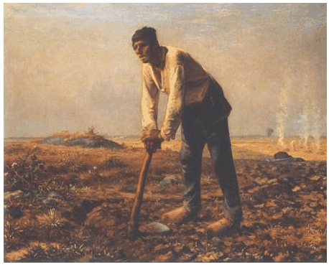

Figure 002: Dc5.jpg

File 002: Dc3.jpg

File 002 is a standard photographic image, stored under the file name Dc3.jpg, and found in the folder “Recycler” on partition one of the drive (evidence # 0001-2008). File 002 contained the hexadecimal string FFD8FFE000104A46 as a header and file extension .jpg which is consistent with the commonly used method of photographic image compression known as JPEG (see Appendix D, p. 30).

The continents of file 002 are located below in figure 003. File 002 was created, modified, and last accessed on 2/22/07. This file contains a photographic image of Jean Francois Millet’s painting entitled “Harvesters Resting”, a bucolic scene considered, for the purposes of this report, to be a piece of graphic sexual pornography. This file is identical to the fifth of five attachments in the third of three emails (email 7) authored by Chest Brockwell (email – thechest67888@yahoo.com) entitled “Re: Maybe this is to your liking” which was sent to Gloria Andrews (email – Gloria761@yahoo.com) on April 9, 2007 at 11:36 AM. The identification of this file as being identical to Chest Brockwell’s email attachment is evidenced by its MD5 (A25594728FB945DFF77E7972C7CBD865) hash which is consistent with the MD5 hash of the photographic image obtained by APU’s IT department from Gloria Andrews’ corporate machine. Although this photographic image was found on Steve Hunter’s corporate hard drive, this cannot be considered overwhelming proof that the email authored by “Chest Brockwell” was related to Mr. Hunter.

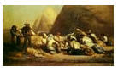

Figure 003: Dc3.jpg

File 003: Dc4.jpg

File 003 is a standard photographic image, stored under the file name Dc4.jpg, and found in the folder “Recycler” on partition one of the drive (evidence # 0001-2008). File 003 contained the hexadecimal string FFD8FFE000104A46 as a header and file extension .jpg which is consistent with the commonly used method of photographic image compression known as JPEG (see Appendix D, p. 30).

The continents of file 003 are located below in figure 004. File 003 was created, modified, and last accessed on 2/22/07. This file contains a photographic image of Jean Francois Millet’s painting entitled “Gleeners”, a bucolic scene considered, for the purposes of this report, to be a piece of graphic sexual pornography. This file is identical to the third of five attachments in the third of three emails (email 7) authored by Chest Brockwell (email – thechest67888@yahoo.com) entitled “Re: Maybe this is to your liking” which was sent to Gloria Andrews (email – Gloria761@yahoo.com) on April 9, 2007 at 11:36 AM. The identification of this file as being identical to Chest Brockwell’s email attachment is evidenced by its MD5 (222EB45C01AC82B87E13882FDBA1448B) hash which is consistent with the MD5 hash of the photographic image obtained by APU’s IT department from Gloria Andrews’ corporate machine. Although this photographic image was found on Steve Hunter’s corporate hard drive, this cannot be considered overwhelming proof that the email authored by “Chest Brockwell” was related to Mr. Hunter.



Figure 004: Dc4.jpg

File 004: Dc7.jpg

File 004 is a standard photographic image, stored under the file name Dc7.jpg, and found in the folder “Recycler” on partition one of the drive (evidence # 0001-2008). File 004 contained the hexadecimal string FFD8FFE000104A46 as a header and file extension .jpg which is consistent with the commonly used method of photographic image compression known as JPEG (see Appendix D, p. 30).

The continents of file 004 are located below in figure 005. File 004 was created, modified, and last accessed on 2/22/07. This file contains a photographic image of Jean Francois Millet’s painting entitled “Archietectonic-Angelus-Posters”, a surrealistic vision of a bucolic scene considered, for the purposes of this report, to be a piece of surrealistic sexual pornography. This file is identical to the second of five attachments in the third of three emails (email 7) authored by Chest Brockwell (email – thechest67888@yahoo.com) entitled “Re: Maybe this is to your liking” which was sent to Gloria Andrews (email – Gloria761@yahoo.com) on April 9, 2007 at 11:36 AM. The identification of this file as being identical to Chest Brockwell’s email attachment is evidenced by its MD5 (6070DFB5109DA32C1A2943601E822BDA) hash which is consistent with the MD5 hash of the photographic image obtained by APU’s IT department from Gloria Andrews’ corporate machine. Although this photographic image was found on Steve Hunter’s corporate hard drive, this cannot be considered overwhelming proof that the email authored by “Chest Brockwell” was related to Mr. Hunter.

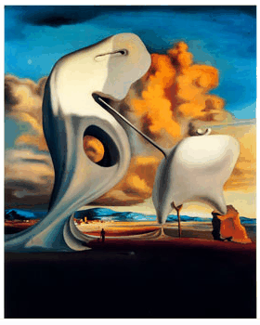

Figure 005: Dc7.jpg

File 005: Dc2.jpg

File 005 is a standard photographic image, stored under the file name Dc2.jpg, and found in the folder “Recycler” on partition one of the drive (evidence # 0001-2008). File 005 contained the hexadecimal string FFD8FFE000104A46 as a header and file extension .jpg which is consistent with the commonly used method of photographic image compression known as JPEG (see Appendix D, p. 30).

The continents of file 005 are located below in figure 006. File 005 was created, modified, and last accessed on 2/22/07. This file contains a photographic image of Jean Francois Millet’s painting entitled “Evening Prayer Angelus”, a bucolic scene considered, for the purposes of this report, to be a piece of graphic sexual pornography. This file is identical to the first of five attachments in the third of three emails (email 7) authored by Chest Brockwell (email – thechest67888@yahoo.com) entitled “Re: Maybe this is to your liking” which was sent to Gloria Andrews (email – Gloria761@yahoo.com) on April 9, 2007 at 11:36 AM. The identification of this file as being identical to Chest Brockwell’s email attachment is evidenced by its MD5 (8592D2B6AFA9FA48DECA0206A6BC55FA) hash which is consistent with the MD5 hash of the photographic image obtained by APU’s IT department from Gloria Andrews’ corporate machine. Although this photographic image was found on Steve Hunter’s corporate hard drive, this cannot be considered overwhelming proof that the email authored by “Chest Brockwell” was related to Mr. Hunter.

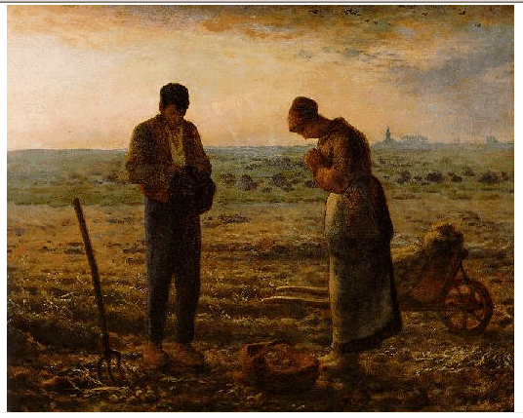

Figure 006: Dc2.jpg

File 006: 2396220398.jpg

File 006 is a standard photographic image, stored under the file name 2396220398.jpg, and found in the folder “Documents and Settings” on partition one of the drive (evidence # 0001-2008). File 006 contained the hexadecimal string FFD8FFE000104A46 as a header and file extension .jpg which is consistent with the commonly used method of photographic image compression known as JPEG (see Appendix D, p. 30).

The continents of file 006 are located below in figure 007. File 006 was created and modified on 2/9/07 and last accessed on 2/22/07. This file contains a photographic image of four puppies, a scene considered, for the purposes of this project, to be pornography featuring adult models. This file is identical to the attachment in the first of three emails (email 5) authored by Chest Brockwell (email – thechest67888@yahoo.com). The email was entitled “Maybe this is to your liking” and was sent to Gloria Andrews (email – Gloria761@yahoo.com) on April 9, 2007 at 11:23 AM. The identification of this file as being identical to Chest Brockwell’s email attachment is evidenced by its MD5 (B7B04CA891A073FC19782313319A641F) hash which is consistent with the MD5 hash of the photographic image obtained by APU’s IT department from Gloria Andrews’ corporate machine. Although this photographic image was found on Steve Hunter’s corporate hard drive, this cannot be considered overwhelming proof that the email authored by “Chest Brockwell” was related to Mr. Hunter.



Figure 007: 2396220398.jpg

Documents

File 007: secrets.txt

File 007 is a plain text document, stored under the file name secrets.txt, and found in the folder “Documents and Settings/Robert/MyDocuments” on partition one of the drive (evidence # 0001-2008). File 007 contained the hexadecimal string 7468654D616E3130 as a header and file extension .txt which is consistent with plain text documents.
The continents of file 007 are located below in figure 008. File 007 was created, modified, and last accessed on 2/22/07. This file contains one hotmail and two yahoo email addresses: theMan10900@hotmail.com, theMan10900@yahoo.com, and theChest67888@yahoo.com. Gloria Andrews has received threatening emails and pornographic attachments from each of these three email addresses. While it could not be determined who produced this document, the location of the document on Steve Hunter’s hard drive, the title of the document (secrets.txt), and the fact that Mr. Hunter denied having any email accounts on yahoo or msn under any name indicate a fair amount of suspicion revolving around Mr. Hunter’s relationship to these accounts. Additionally, Steve Hunter’s name appeared next to each email sent to Gloria Andrews from the addresses theMan10900@hotmail.com and theMan10900@yahoo.com. Although this does not prove that these emails were produced by Mr. Hunter, the appearance of his name next to the addresses, in conjunction with factors listed above, increase the likelihood that these email addresses (including theChest67888@yahoo.com) belonged to Steve Hunter.

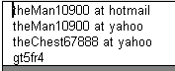

Figure 008: secrets.txt

File 008: Compose[6]
File 008 is a standard web file hypertext document, saved under the file name Compose[6], and retrieved from the “Documents and Settings” folder on partition one of the drive (evidence # 0001-2008). File 008 contained the hexadecimal string 3C212D2D77656236 as a header which is consistent with hypertext documents.

The continents of file 008 are located below in figures 009-012. File 008 was created, modified, and last accessed on 2/22/07. This file contains a string of five emails (emails 5-7) between Chest Brockwell (email - theChest67888@yahoo.com) and Gloria Andrews (email – Gloria761@yahoo.com). The original email was sent from Chest Brockwell to Gloria Andrews on April 9, 2007 at 11:23 AM and was entitled “Maybe this is to you liking”. In this message, Chest Brockwell issues a threat to Gloria Andrews, “I think this is more you speed. Something bad may happen to you. Oh Yeah. Don’t pick lemons”, and an attachment of a pornographic photographic image containing adult models. The pornographic attachment in this initial message is identical (by way of MD5 hash) to the pornographic image also found on Steve Hunter’s hard drive outlined in file 006 (see file 006: 2396220398.jpg, p. 9). Gloria Andrews responds to this threat by forwarding the email to the abuse center at yahoo.com and to APU’s IT department, this is the second message of the email string.

The third message of the email string is a response to message two. The message was authored by Chest Brockwell, addressed to Gloria Andrews, and entitled “Re: Maybe this is to your liking”. In this message, Chest Brockwell argues that he is not afraid of Gloria Andrews’ “threats” to scare him and that he will be going to her residence. In addition, Chest Brockwell states that he wants to do some gardening when he arrives at Gloria’s residence. Accordingly, any references pertaining to gardening, for the purposes of this report, are to be considered sexual suggestions. This message reads: “The chest man is not afraid of you pathetic attempts to scare him. In fact, the chest man may be dropping by your house at 1167 Hyland park, Fayetteville, AR 72701 sometime real soon. I was thinking we could do some gardening, lots of gardening. Maybe even grow some onions or my favourite bougainvillea. Oh yes, that would be fun”. Gloria responds to this email by noting that she has contacted the police and that they are investigating the situation, this is the fourth message of the email string. The message reads: “This has been sent to the police. They are going to be investigating you, you sick bastard”.

The last message in this file is a response from Chest Brockwell to Gloria Andrews’ notion in the fourth message of the email string that the police are investigating the Chest and his threats. This message is entitled “Re: Maybe this is to your liking”. In this message, Chest Brockwell states that he believes that Gloria Andrews has mistaking him for someone else and that the police cannot track him down because he lives in Spain. In addition, Chest makes various sexual suggestions and attaches five files to the message which contain graphic sexual pornography. Each of these files where also found on Steve Hunter’s hard disk and are outlined in files 001-005 (see files 001-005, pp. 4-8). This message reads: “Ha ha, what are they going to do, trace me down here in Spain? You are mistaking me for someone else my little gardening friend. Here are some gardening fantasies for you…Soon my pretty with some fava beans and a nice chianti”.

Although nothing in this file (i.e. metadata) indicates that Steve Hunter was involved with this email string, the mere existence of this file on Mr. Hunter’s hard drive in conjunction with the continents of the email photographic attachments as well as their presence on his hard drive (see files 001-006, pp. 4-9) indicate that he may be behind these messages. However, at this point this remains mere speculation.

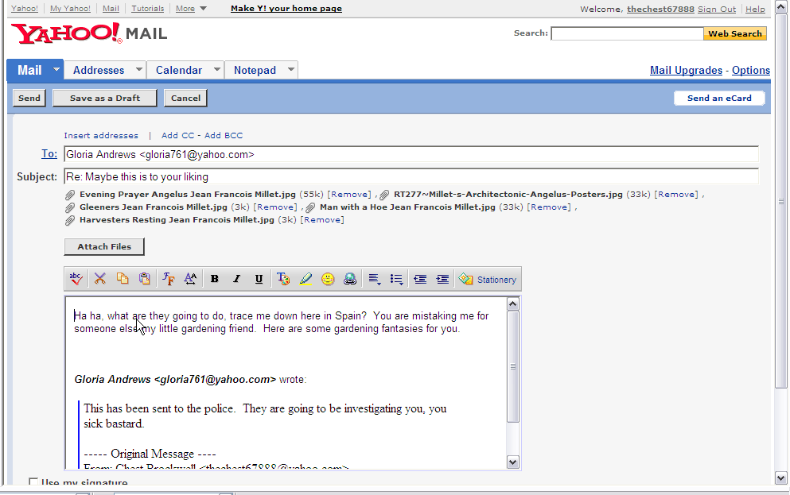

Figure 009: Compose[6]

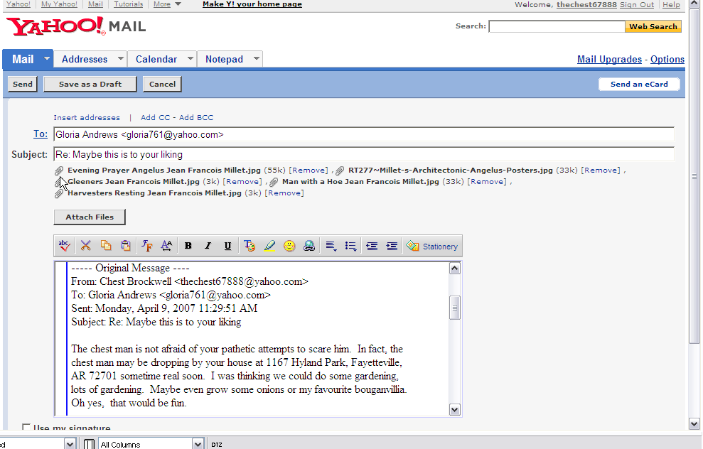

Figure 010: Compose[6]

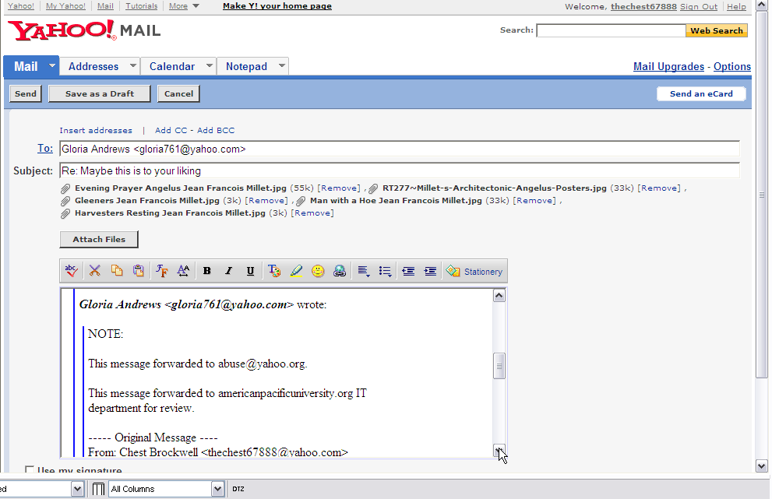

Figure 011: Compose[6]

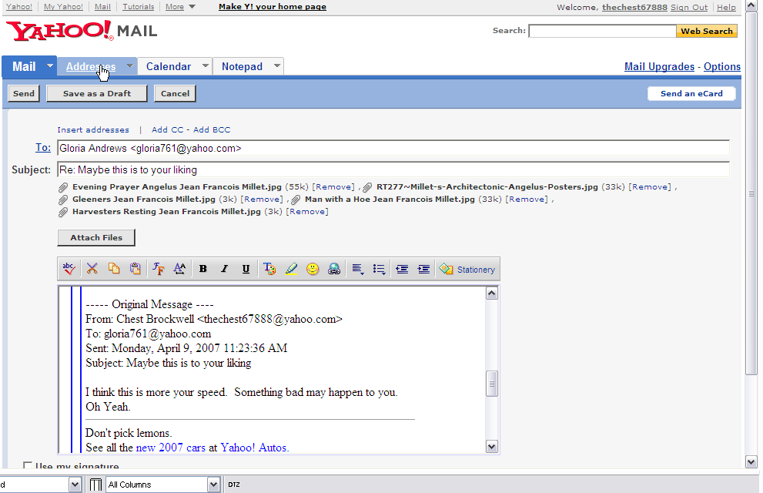

Figure 012: Compose[6]

File 009: address.rtf

File 009 is a standard rich text formatted file, stored under the name address.rtf, and retrieved from the partition one of the drive (evidence # 0001-2008). File 009 contained the hexadecimal string 7B5C727466315C61 as a header and file extension .rtf which is consistent with rich text formatted files.

The continents of file 009 are located below in figure 013. File 009 was created, modified, and last accessed on 2/22/07. This file contains an address, 1167 E. Hyland Park Rd. Fayetteville, AR 72701, and a phone number, (479) 443-0998. The address contained in this file is consistent with the address noted by Chest Brockwell in his email threat to Gloria Andrews outlined in file 008 (see file 008; Compose[6], pp. 10-15). With this information in mind, it is likely that the phone number listed in this file is likely to be that of Gloria Andrews. Yet, no information (i.e. metadata) could be retrieved from this file which would illustrate who created this document or whom this file belonged to. However, this files consistency with other files (see files 001-008, p. 4-15) on Mr. Hunter’s hard drive seem to indicate that he is, at the very minimum, involved with the email threats and graphic pornography sent to Gloria Andrews from “Chest Brockwell”.

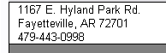

Figure 013: Address.rtf

File 010: ShowLetter[2]

File 010 is a standard web file hypertext document, stored under the file name ShowLetter[2], and retrieved from the “Documents and Settings” folder on partition one of the drive (evidence # 0001-2008). File 010 contained the hexadecimal string 3C212D2D77656236 as a header which is consistent with hypertext documents.

The continents of file 010 are located below in figure 014. File 010 was created, modified, and last accessed on 2/22/07. This file contains a returned email authored by “Chest Brockwell” (email – theChest67888@yahoo.com), addressed to Kelly (last name unspecified) (email – kelly@buhaoren.com), and entitled “Hi Kelly”. The email was returned to the sender, “Chest Brockwell”, on April 9, 3:27 PM because the email address Kelly@buhaoren.com was not a valid address. In this email, “Chest Brockwell” informs Kelly (last name unspecified) that he would like to sign up for a “hot chat session” and that he had called and registered his phone and credit card numbers. However, the interesting thing about this email message is that “Chest Brockwell” (email – theChest67888@yahoo.com) noted that his name is Steve. Because this file was located on Steve Hunter’s hard drive and in conjunction with the various other suspicious files located on this hard drive (see files 001-009, pp. 4-16), it is quite likely that “Chest Brockwell” is in fact Steve Hunter and the emails containing threats and graphic pornography that were sent to Gloria Andrews from the email account theChest67888@yahoo.com were from Mr. Hunter.

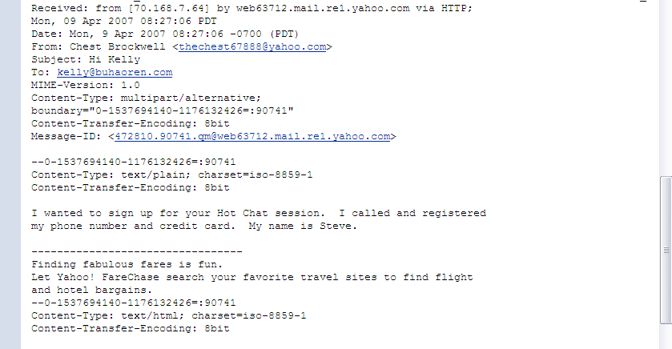

Figure 014: ShowLetter[2]

File 011: HTML_18649465[34].htm

File 011 is a standard web file hypertext document, stored under the file name HTML_18649465[34].htm, and retrieved from partition one of the drive (evidence # 0001-2008). File 011 contained the hexadecimal string 3C68746D6C3E0A3C as a header and the file extension .htm which is consistent with hypertext documents. This file was retrieved from the drive (evidence # 0001-2008) using FTK’s data carving utility.

The continents of file 011 are located below in figure 015. File 011 was created on 4/5/07, modified on 2/8/07, and last accessed on 2/22/07. This file contains a webpage from yahoo.com that congratulates the user for selecting an available email address, thechest67888@yahoo.com. In addition, there are two “buttons” on this webpage. The first “button” allows the user to cancel the apparent account registration. The second “button” allows the user to continue with the registration of the user ID. It is quite apparent at this point in light of all of the evidence on this disk that “Chest Brockwell” seems to be Steve Hunter. Although nothing in this file’s metadata relates it to Mr. Hunter, it is highly probable that Steve Hunter created the yahoo email account, theChest67888@yahoo.com, in order to harass and threaten Gloria Andrews via email because she rebuffed his advance at an earlier occasion.

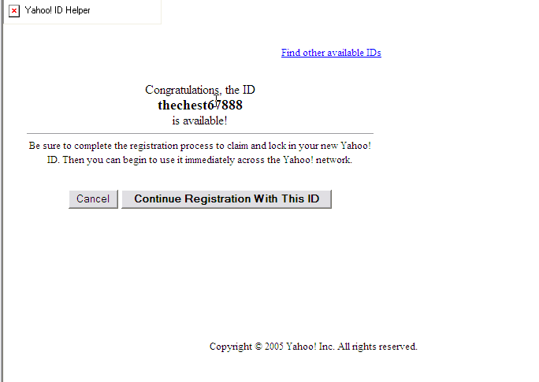

Figure 015: HTML_18649465[34].htm

File 012: Untitled0 (a)

File 012 is a standard web file hypertext document, stored under the file name Untitled0, and retrieved from the “Documents and Settings” folder on partition one of the drive (evidence # 0001-2008). File 012 contained the hexadecimal string 3C212D2D20436F70 as a header which is consistent with hypertext documents.

The continents of file 012 are located below in figure 016. The creation, modification, and last access dates of file 012 could not be determined by FTK. This file contains a Yahoo Mail Beta screen for the email address theMan10900@yahoo.com. This file is interesting to note because its metadata shows both the email address theMan10900@yahoo.com along with Steve Hunter’s name. While this depiction does not prove that Steve Hunter opened and uses this email account, it does cast some doubt upon Steve Hunter’s truthfulness as he clamed to not have any email accounts with either yahoo or msn.

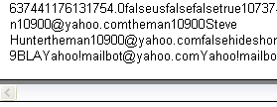

Figure 016: Untitled0 (a)

File 013: Untitled0 (b)

File 013 is a standard web file hypertext document, stored under the file name Untitled0, and retrieved from the “Documents and Settings” folder on partition one of the drive (evidence # 0001-2008). File 013 contained the hexadecimal string 0A3C21444F4354459 as a header which is consistent with hypertext documents.

The continents of file 013 are located below in figure 017. The creation, modification, and last access dates of file 013 could not be determined by FTK. This file contains a Map Quest search for the address 1167 Hyland Park, Fayetteville, AZ. This address is that of Gloria Andrews and is also consistent with other files located on this hard drive, specifically when mentioned in threats made to Gloria Andrews by “Chest Brockwell” (see files 008 and 009, pp. 10-16).

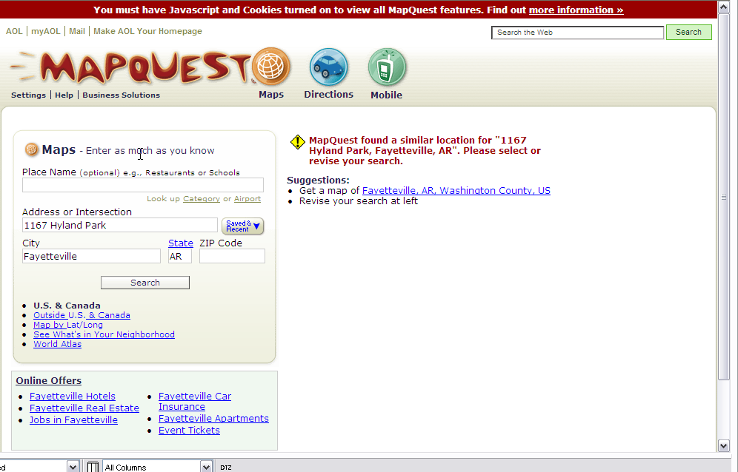

Figure 017: Untitled0 (b)

File 014: Untitled0 (c)

File 014 is a standard web file hypertext document, stored under the file name Untitled0, and retrieved from the “Documents and Settings” folder on partition one of the drive (evidence # 0001-2008). File 014 contained the hexadecimal string 0A3C21444F4354459 as a header which is consistent with hypertext documents.

The continents of file 014 are located below in figure 018. The creation, modification, and last access dates of file 014 could not be determined by FTK. This file contains Map Quest map for the area surrounding the address [2600-2622] E. Hyland Park, Fayetteville, AZ 72701, this was the second Map Quest search identified on the hard drive. This address is a nearby to Gloria Andrews’ address, 1767 E. Hyland Park Rd., Fayetteville, AZ, and is also consistent with other files located on this hard drive (see file 013, pp. 19-20).

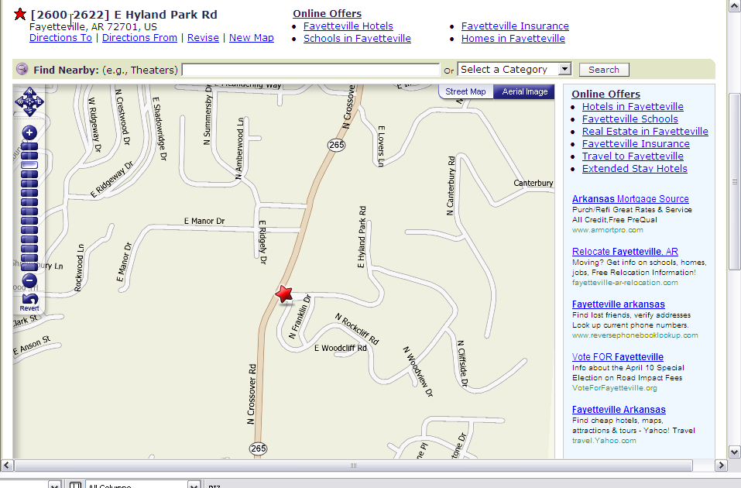

Figure 018: Untitled0 (c)

File 015: Untitled0 (d)

File 015 is a standard web file hypertext document, stored under the file name Untitled0, and retrieved from the “Documents and Settings” folder on partition one of the drive (evidence # 0001-2008). File 015 contained the hexadecimal string 0A3C21444F4354459 as a header which is consistent with hypertext documents.

The continents of file 015 are located below in figure 019. The creation, modification, and last access dates of file 015 could not be determined by FTK. This file contains a Map Quest search for the address Hyland Park, Fayetteville, AZ, this was the third Map Quest search identified on the hard drive. This address is a nearby to Gloria Andrews’ address, 1767 E. Hyland Park Rd., Fayetteville, AZ, and is also consistent with other files located on this hard drive (see files 013 and 014, pp. 19-21).

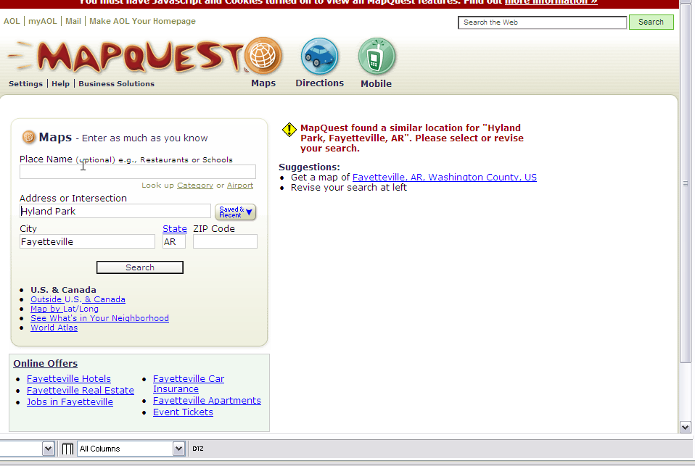

Figure 019: Untitled0 (d)

File 016: Untitled0 (e)

File 016 is a standard web file hypertext document, stored under the file name Untitled0, and retrieved from the “Documents and Settings” folder on partition one of the drive (evidence # 0001-2008). File 016 contained the hexadecimal string 0A3C21444F4354459 as a header which is consistent with hypertext documents.

The continents of file 016 are located below in figure 020. The creation, modification, and last access dates of file 016 could not be determined by FTK. This file contains a Map Quest search for the address 2863 Hyland Park, Fayetteville, AZ, this was the fourth Map Quest search identified on this hard drive. This address is a nearby to Gloria Andrews’ address, 1767 E. Hyland Park Rd., Fayetteville, AZ, and is also consistent with other files located on this hard drive (see files 013 - 015, pp. 19-22).

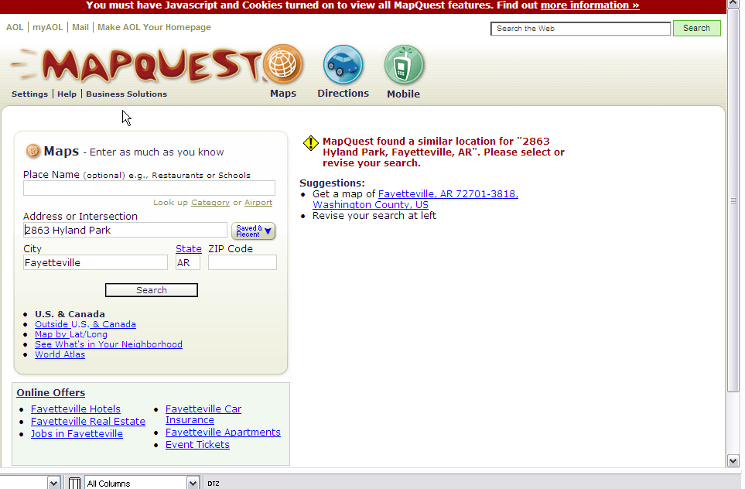

Figure 020: Untitled0 (e)

File 017: Map[1].htm

File 017 is a standard web file hypertext document, stored under the file name Map[1].htm, and retrieved from the “Documents and Settings” folder on partition one of the drive (evidence # 0001-2008). File 017 contained the hexadecimal string 0A3C21444F4354459 as a header and the file extension .htm which is consistent with hypertext documents.

The continents of file 017 are located below in figure 021. File 017 was created, modified, and last accessed on 2/22/07. This file contains a Map Quest search for the address E. Hyland Park Rd., Fayetteville, AZ as well as a map for this area, this was the fifth Map Quest search identified on this hard drive. This address is a nearby to Gloria Andrews’ address, 1767 E. Hyland Park Rd., Fayetteville, AZ, and is also consistent with other files located on this hard drive (see files 013 - 016, pp. 19-23).

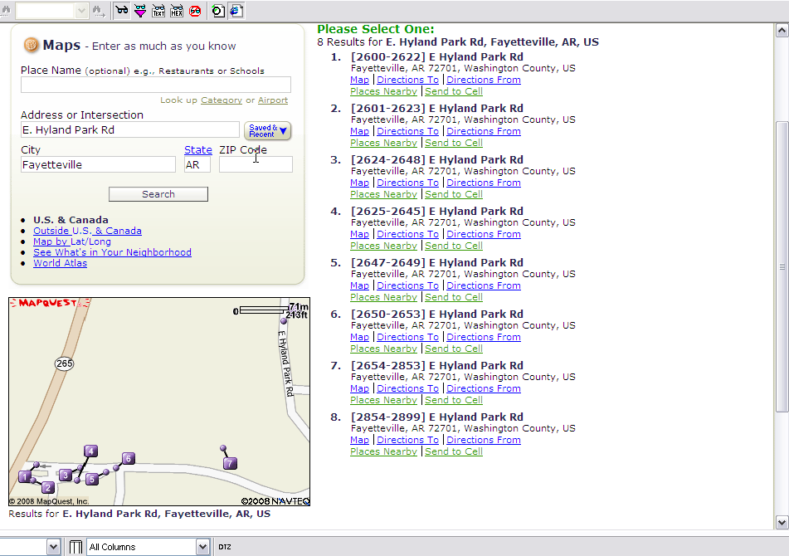

Figure 021: Map[1].htm

File 018: Untitled0 (f)

File 018 is a standard web file hypertext document, stored under the file name Untitled0, and retrieved from the “Documents and Settings” folder on partition one of the drive (evidence # 0001-2008). File 018 contained the hexadecimal string 0A3C21444F4354459 as a header which is consistent with hypertext documents.

The continents of file 018 are located below in figure 022. The creation, modification, and last access dates of file 018 could not be determined by FTK. This file contains Map Quest map for the area of Fayetteville, AZ, this was the sixth Map Quest search identified on the hard drive. The area of Fayetteville, AZ is a nearby to Gloria Andrews’ address, 1767 E. Hyland Park Rd., Fayetteville, AZ, and is also consistent with other files located on this hard drive (see file 013, pp. 19-20).

The presence of the six map quest searches (see files 013-018, pp. 19-24) of the area surrounding Gloria Andrews’ address, 1767 E. Hyland Park Rd. Fayetteville, AZ, in conjunction with the threatening email found on this hard drive that was sent to Mr. Andrews from “Chest Brockwell” (see file 008, pp. 10-15) clearly indicate that Mr. Hunter is or maybe attempting to appear at Gloria Andrews’ residence. Serious attention should be paid to this issue.

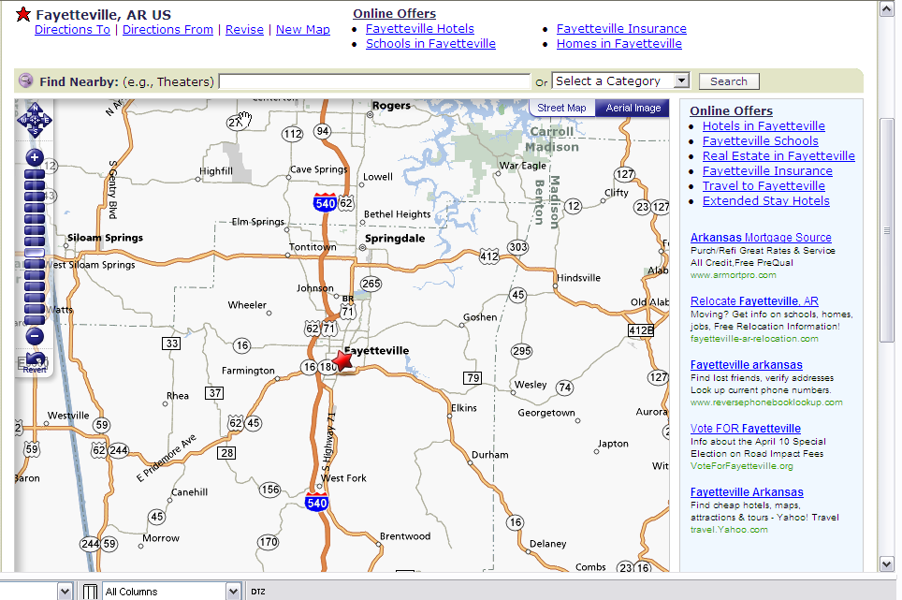

Figure 022: Untitled0 (f)

Remaining Files

This hard drive (evidence # 0001-2008) contains numerous other files including documents, graphics, and other materials. Of particular note, this hard drive contained 282 files that were pornographic in nature. 231 of these files contained pornographic photographs depicting adult models. Although these files are not illegal in and of themselves (see Miller v. California, 413 U.S. 15 (1973)), they are likely to be against company policy in the corporate setting of APU. These files are documented on evidence DVD 1 and are numerically labeled as exhibits 1-231. 22 of these files contained apparent illegal child pornography (see New York v. Ferber, 458 U.S. 747 (1982)). The files are documented on evidence DVD 2 and are numbered as exhibits 232-253. 18 of the 282 files contained pornographic material that were graphic in nature. These files are documented on evidence DVD 3 and are numbered as exhibits 254-271. Lastly, 11 of the 282 files contained pornography that were surrealistic in nature. These files are documented on evidence DVD 4 and are numerically labeled as exhibits 272-282.

In addition, 45 files were encountered that contained internet files and web searches of legal pornographic material and/or graphic pornographic material (i.e. adult models). Of particular interest, were websites containing paintings by Millet and Salvador Dali. Websites/graphics containing works by Millet and Dali, for the purposes of this report, are to be considered pieces of graphic/surrealistic pornography. Moreover, 7 files encountered on this hard drive contained internet files and web searches for apparent illegal child pornography. The remaining files encountered on this drive are unrelated to evidence development that would assist the in the investigation. A comprehensive list of all the files contained on the hard drive (evidence # 0001-2008) (including the files of interest listed above) can be found in Appendix A (see p. 27).

Appendix A: Full File Report

See enclosed CD-ROM entitled Hunter Evidence – Full File Report.

Appendix B: Policy on Evidence Collection

Obtained evidence is tagged upon acquisition with a case number. Once a case number has been assigned to a piece of evidence, a log of that evidence is started and maintained throughout the investigation. All evidence related to the case is logged and maintained including physical evidence and images. All evidence is stored in a fire safe and key secured evidence lockup. Keys are issued when, and only when, evidence is signed out of the evidence lockup. All sign outs are maintained on a chain of custody log which is also stored in a fire safe lockup.

Appendix C: Policy on Forensically Sterile Media

All media used for case investigations is forensically sterile. All media, prior to its use in a case (i.e. imaging and storage), is sterilized in compliance with the Department of Defense’s disk scrubbing utility. Media considered “new” or “never been used” is not immune from this process. In addition, all used media is sterilized again when it becomes dissociated with a case.

Appendix D: Glossary

Data Carving: A process involving the examination of media for content relating to
multiple types of empty space (i.e. slack space, unused space, unallocated space).

Deleted Files: Files which are removed from the storage space of a piece of media. In
most cases and depending on the type of deletion, deleted files can be recovered using computer forensic tools.

DVD + R: Digital versatile disk-recordable. DVD + R is a disk that can be written to but
not erased. DVD + R disks are similar in appearance to a compact disk, but
have a higher storage capacity.

Free Space: Unused, but not empty, space on a piece of storage media.

Hash: any well-defined procedure or mathematical function for turning some kind of data
into a relatively small integer, that may serve as an index.

JPEG: Joint Photographic Experts Group. A commonly used method of compression for
photographic images.

Metadata: Metadata is data about data. Metadata may describe an individual piece of
data, content, or a collection of data including multiple content item.

Appendix E: Logs

.LOG
7:00 PM 3/24/2008
A DVD+R disk containing an image of Steve Hunter’s corporate hard drive was obtained from American Pacific University’s (APU) IT Department.

The drive was imaged using FTK imager by the IT Department at APU after they seized MR. Hunter’s corporate machine. The image was tagged with the evidence label 0001-2008 and was loaded onto a secure personal computer from D:Hunter.E.01.

5:30 PM 3/31/2008
Evidence 0001-2008 was loaded to a secure personal computer for analysis through FTK v. 1.71 from D:Hunter.E.01.

FTK identified 16,293 files on the image. The image was then data carved in an attempt to access the drive’s empty space (i.e. slack space, unused space, unallocated space, and multi-sessions). 1,109 files were identified.

5:30 PM 4/1/2008
Evidence 0001-2008 was loaded on the secure personal computer and files were analyzed.

4:30 PM 4/2/2008
Evidence 0001-2008 was loaded on the secure personal computer and files were analyzed.

6 JPEG files were loaded as evidence to obtain file hashes.

9:00 PM 4/2/2008
Evidence 0001-2008 was loaded on the secure personal computer and files were analyzed.

5:30 PM 4/3/2008
Evidence 0001-2008 was loaded on the secure personal computer and files were analyzed.

Appendix F: Credentials

