**The Design and Analysis of an**

**Internet of Things Prototype Product**

Coursework for EE 4IOT: Internet of Things

Prof. Richard Nock, PhD

By: Akhmadjon Rajabov

MSc SmartNet 190200705

Date: April 30, 2020

Version: 1.0

Word count: 3141

# Summary

The report provides information on the development of a prototype of the Internet of Things (loT) device whose purpose is the collection, analysis, and transmission of data over the network. The device was developed using the HUZZA FEATHER ESP8266 board, the code was written in Arduino using the HTTP and MQTTS protocols to count the number of footfalls, and transfer the collected data.

The report describes the design and development of a prototype with supporting block-diagrams and pseudo-codes, presents an analysis of the impact on society, privacy and commerce, the benefits that a product can provide, various aspects of a product, and deployment aspects such as the deployment of operating costs.

**Table of Contents**

Summary i

1.0 Introduction 1

2.0 Design and implementation 1

3.0 Societal, privacy and commercial impact analysis 1

4.0 EE4IOT ONLY – Deployment considerations 1

5.0 Conclusion 1

6.0 References 2

7.0 Appendices 3

7.1 Tables of results (with table heading and captions) 3

7.2 Code listing (if necessary, code will be submitted separately) 3

# 1.0 Introduction

Internet of Things is taking over the world. Every day, more and more objects have some sort of network connection, for example, from coffee makers to security cameras, from air quality sensors to connected cars, there is not a single area of our life that will not be touched by IoT devices in the next decades.

In this report, the development of the IoT prototype was performed, which performs the function of a footfall for installing at the exit and entrance in public places such as shopping centers, concert halls, in racetracks to calculate the average number of visits, to avoid stowaways in concerts, for example. All this together makes it possible to analyze the effectiveness of trade, monitoring the effectiveness of staff, scheduling for staff, planning official events, analyzing the use of resources, of course, an important role in security.

The prototype reads the average number of people per minute and sends the received data to the website using the protocol of HTTP[1] and MQTTS[2] for further analysis. The report provides information on the design and implementation of the prototype, on the analysis of public, private, and commercial influence when using the IoT device and discussed the deployment of the device.

# 2.0 Design and implementation

To complete the task, an algorithm and code for Arduino IDE[3] were developed. To accomplish this task, an algorithm and code for Arduino were developed. In the development of code and algorithm, a very important role was played by the time constraints established by the task, so some functions were divided by time and not by the tasks they performed. In the beginning, a block diagram of the algorithm was compiled. As can be seen from Figure 1, the algorithm of actions consists in the fact that when the button is pressed, the device calculates the average press per minute and sends this data to the website using the HTTP protocol and to the io.adafrut.com website using the MQTTS protocol.

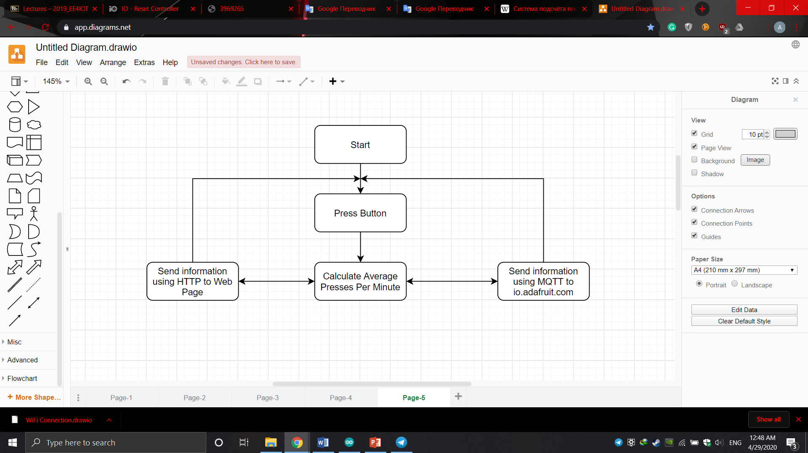

Figure 1 Block Diagram of Main Algorithm

Not only data on average presses per minute are sent, but also total presses, there is a data reset function on the website that will reset the total number of presses. The reset function exists when using both the HTTP and MQTTS protocols. Pressing the button illustrates us pressing a person with the foot of a sensor that will be installed at the entrance or exit.

Figure 2 shows a block diagram of the code that describes the pre-algorithm on which the code is based. The first initial action is to establish a connection with Wi-Fi, then the HTTP server is deployed. After connecting to the site io.adafruit.com using the MQTTS protocol and subscribing to a variable that was created on the same site in advance to store data to reset the total number of presses.

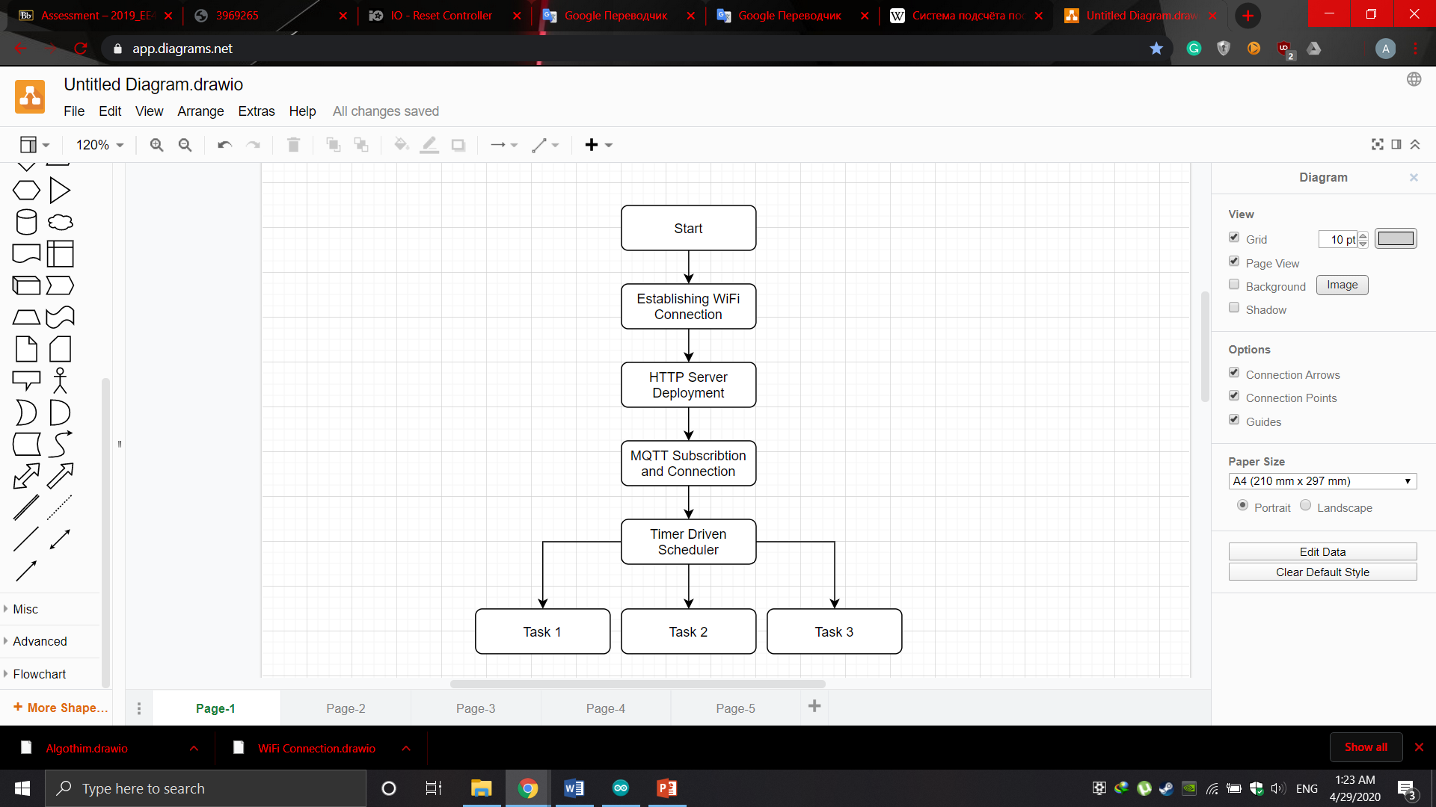

Figure 2 Pre-Algorithm for creating Arduino code.

A scheduler with a timer is one of the important parts that will control the execution time of the task in the code, which will set a timer for the work of the separate tasks that were indicated.

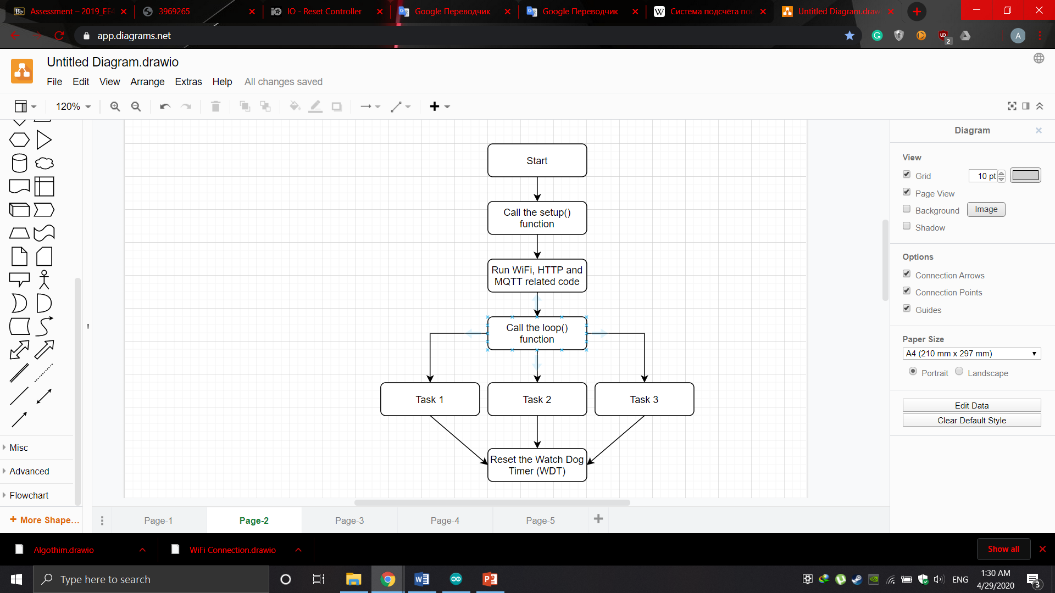

Figure 3 Code Implementation Algorithm

As a result, the code algorithm code turned out as in Figure 3. At the beginning, the setup() function is called, which in turn calls other functions such as Wi-Fi_Connection(), HTTP_Server(), MQTTS_Connection() and the inclusion of the LCD display. After that, the loop() function is executed in which the timer drove the scheduler that restarts watchdog timer (WDT).

Timer driven scheduler - A delayed software cyclic scheduler suffers from the actual task code, which affects the time between calls since the task code execution time significantly increases the cycle delay. Using the time elapsed since execution (provided by the Arduino libraries), we can significantly improve this situation, since the time between interruptions does not depend on the code of our task.

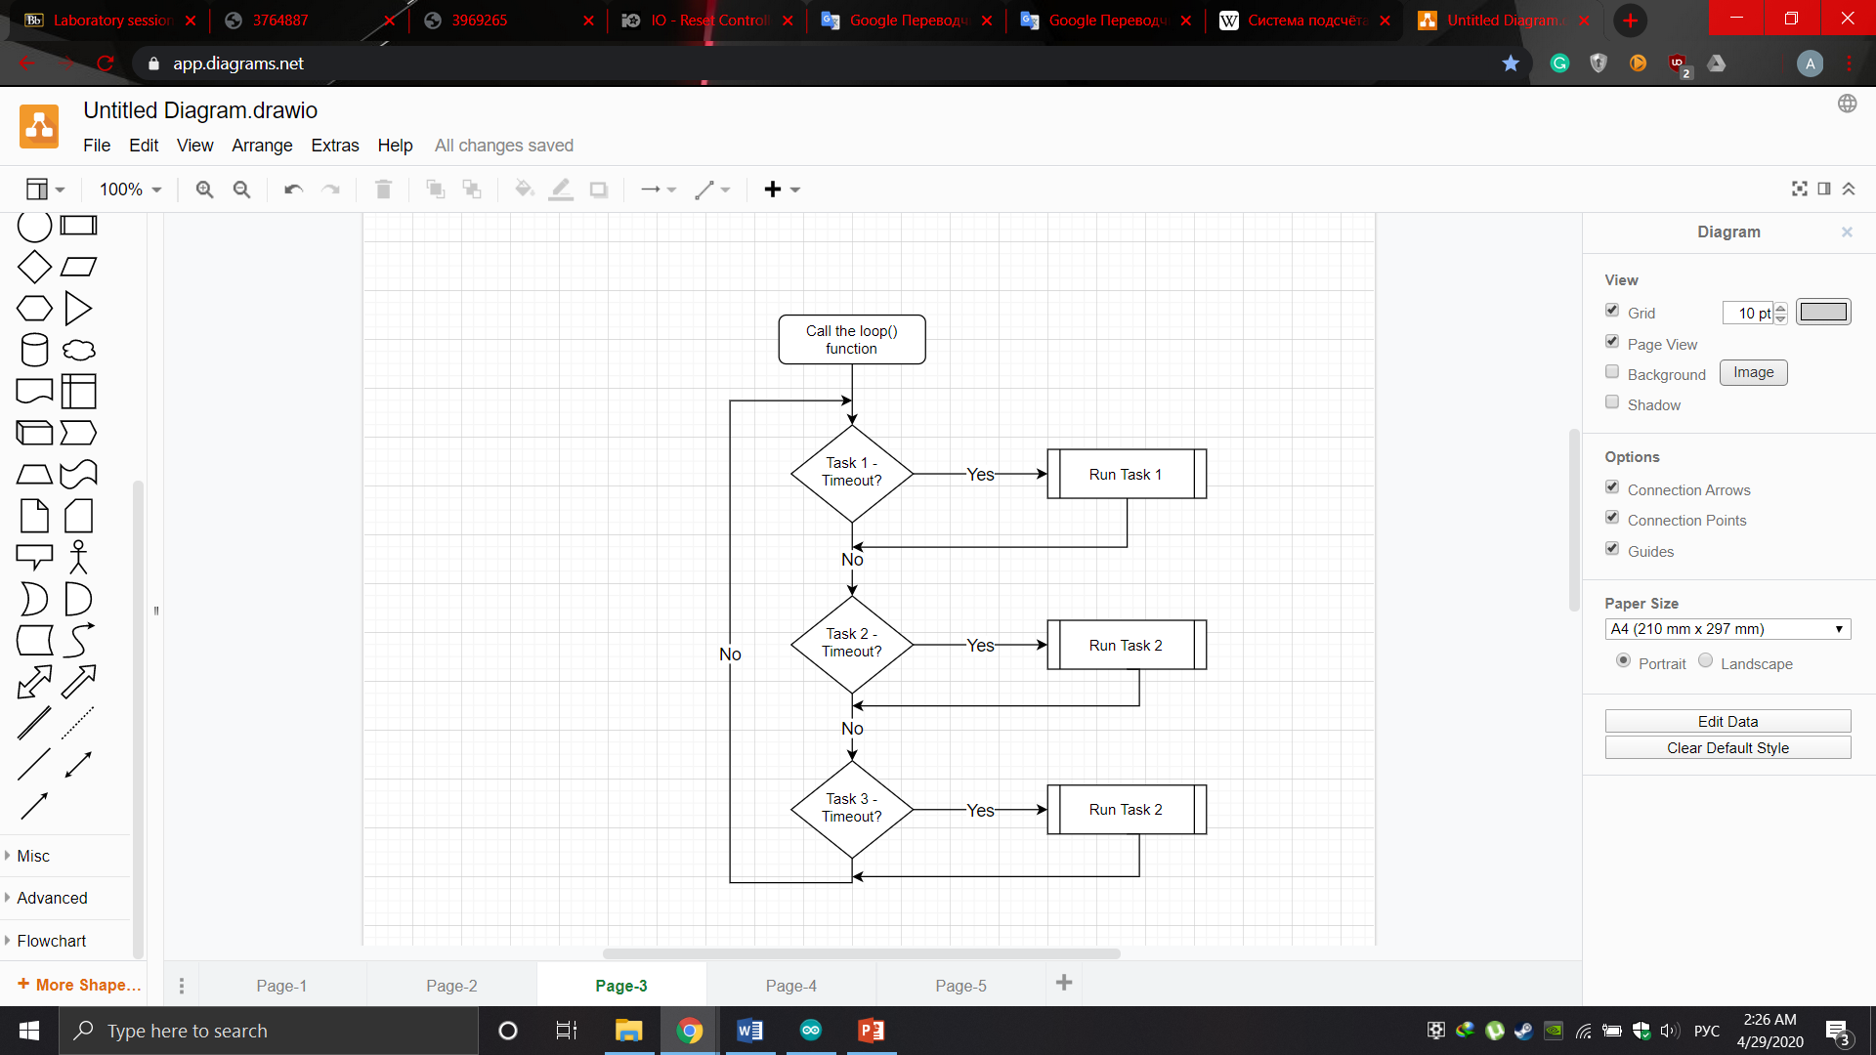

Figure 4 Interrupt driven scheduler process

Figure 4 Interrupt driven scheduler process - to generate the exact time, there is used a variable with a constant speed in the timer which increases every 1 ms. This is a feature in Arduino for development. Therefore, to complete the task, the time in milliseconds was read, which is compared with the time of the last call with the current time of the call. If the value exceeds the time between the desired calls (timeout), the task is executed.

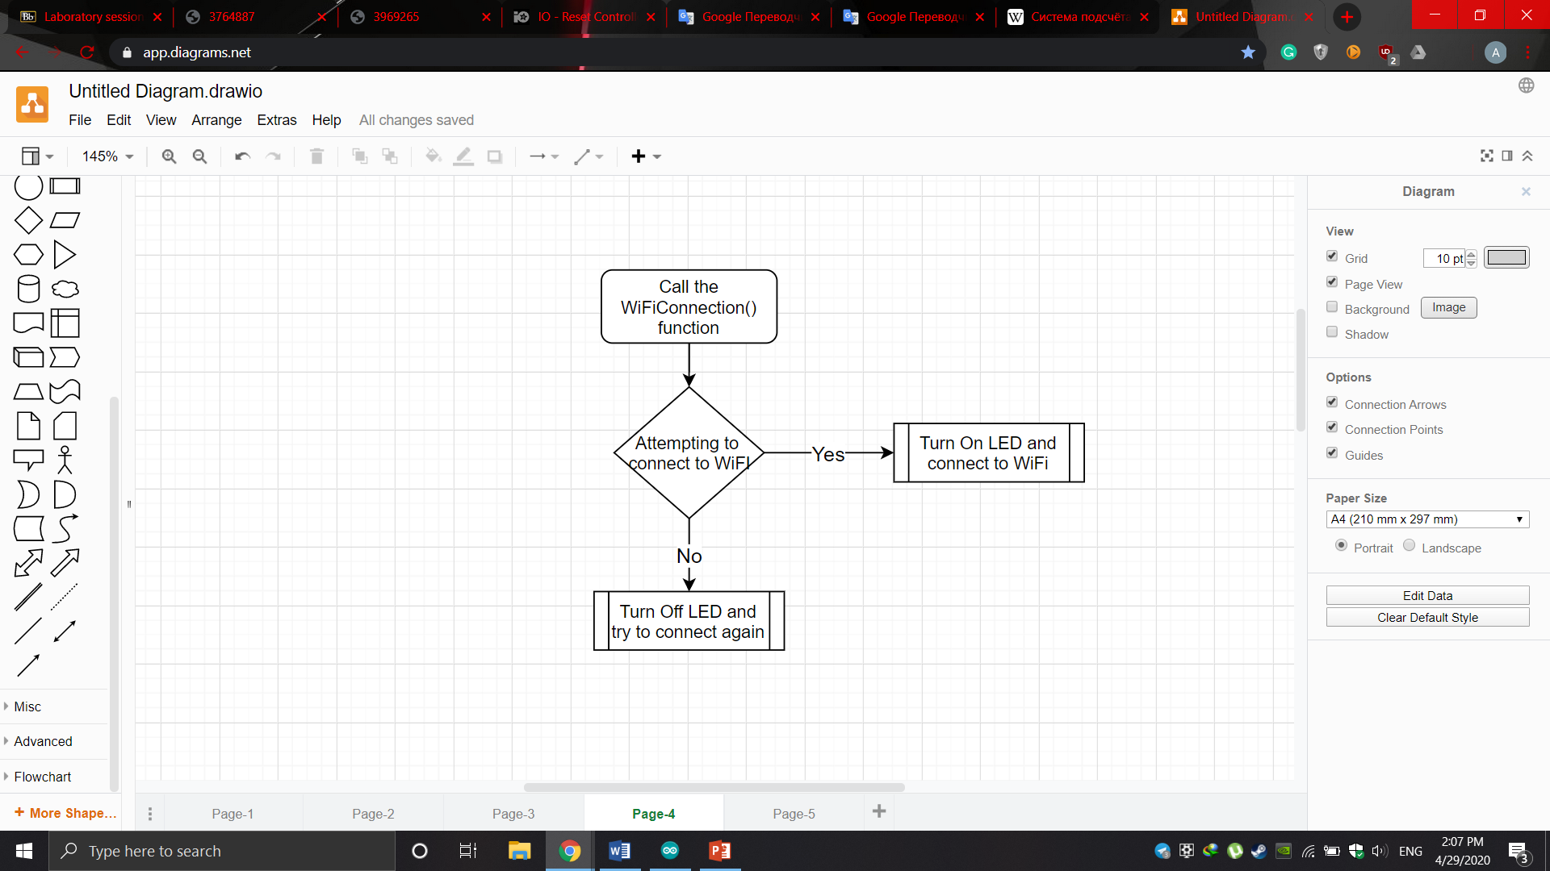

Figure 5 Algorithm of Wi-Fi connection function

On-demand, the task when connecting to Wi-Fi if there is no connection, then the LED should be ON, on the board, if there is a connection OFF. Figure 5 illustrates this algorithm. To connect to Wi-Fi, the ready-made library of our board *<ESP8266WiFi.h>*[4] was used. The library provides ready-made functions that help you easily connect to a specific network by specifying the *SSID* and *Password* of the desired network.

HTTP Server Development.

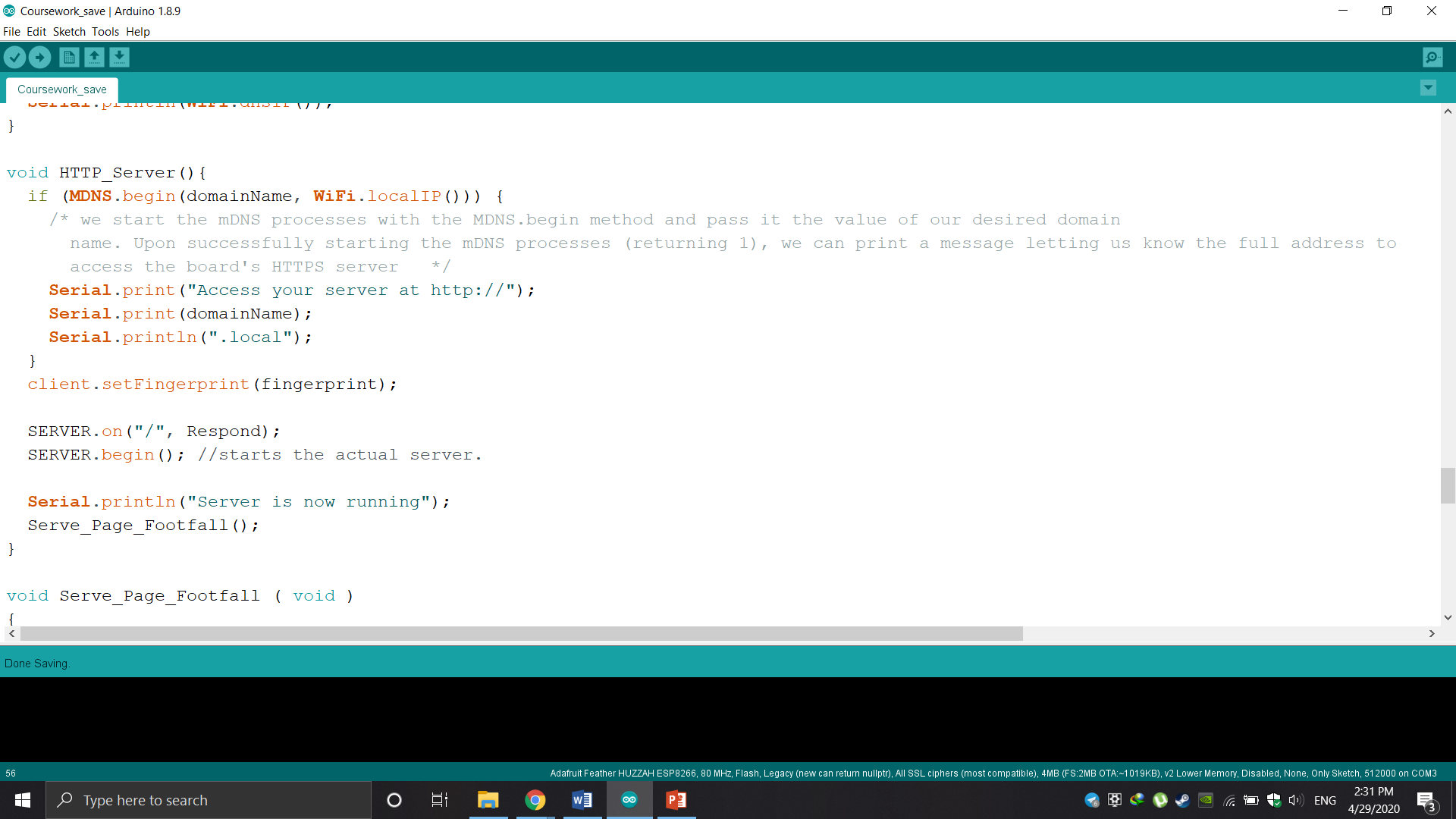

Figure 6 HTTP Server function

Figure 6 is a piece of code for deploying an HTTP server. As you can see, the mDNS technology was used to establish the domain name for the server which gives access to the website where information is stored for the user. After starting the server, the function is called *Serve_Page_Footfall()* which loads the HTML site for viewing and managing with footfalls. Also, for deployed servers in Arduino, the ready-made class *ESP8266WebServer*[5] *SERVER (80)* is built-in; which when used in the constructor of port 80 is used for HTTP which does not offer encryption or authentication. It is also possible to use the HTTPS protocol, for this, you need to specify the 443rd port.

MQTT.

The Message Queuing Telemetry Transport (MQTT) protocol has been used for many years, but now it is especially relevant due to the explosive growth of IoT: both consumer and industrial devices implement distributed networks and edge computing, and devices with continuous data transmission are becoming part of every day of life. MQTT is a publisher-subscriber-based messaging protocol. Thus, MQTT has become a protocol for streaming data between devices with limited CPU power and/or battery life, as well as for networks with expensive or low bandwidth, unpredictable stability, or high latency. In the work, the MQTTS protocol was used, this task was required according to the established specification. In the work, the MQTTS protocol was used, this task was required according to the established specification. To achieve the goal, port 8883 was used, which performs authentication encryption in MQTT. To use non-secure mode, we need to use port 1883.

Main Tasks Function.

In the *Task1()* function, each button press is calculated for 5 ms and written to a variable. In the second function *Task2()*, using MQTTS subscribes to the reset function from the io.adafruit.com website, which, when receiving a command from the website, resets the *TOTAL* variable. Also in this function, commands to output to the LCD display the local IP address, and average press per minute are executed. In the last *Task3()* function, the average press per minute is considered and the data, the total number of presses, and the average press per minute are sent to the io.adafruit.com website using the MQTTS protocol.

# 3.0 Societal, privacy, and commercial impact analysis

Social and Commercial Impact

There are a lot of business ideas and solutions on the market for calculating the number of people entering and leaving stores, shopping centers, and other buildings. The implementation of this idea is very different from simple cameras to 3D cameras that are installed in places with complex architecture. There are also a lot of counting solutions, not only indoor solutions but outdoor solutions too, for example, pedestrian counting for deciding where to open a coffee shop or restaurant. All of these decisions add up to Smart City's huge idea. Already existing solutions include the Thermal People Counter, a small thermal imaging camera that is installed in the ceiling, and uses thermal imaging technology to detect changes in people's temperature compared to the environment. The body heat of the consumer is detected by thermal imaging cameras that provide reliable data even with a large amount of traffic[6]. Multiple cameras can be connected to create wider zones, as well as to adapt to complex entrances, offering continuous counting of retail traffic in difficult conditions. Retail Sensing UK Company provides a solution, for example, counting not only people but also cyclists, cars. Counting bicycles helps control and support healthy travel promotion and provides insight into how green or green areas are in the city center. Vehicle counting can effectively control the traffic flow along the busiest routes in the city and track the days and times of the most intense traffic[7].

Powering the IoT Product

To solve the problem with power consumption, it was chosen to use lithium batteries that have 3.6 V, the same as the ESP8622 board. The choice of the battery is due to the fact that our sensor is mainly in sleep mode and turns on only for a certain time when the people counting sensor is activated thereby saving energy. The battery is made of primary lithium cell LS and LSH, based on the chemistry of lithium thionyl chloride (Li-SOCl2), ideal for high energies and high voltage over a wide temperature range. The design of the LS series provides maximum loading of active materials and, therefore, maximum energy. With its surprisingly low self-discharge, it is ideally suited for long-term (from five to 20 years or more) applications with several base μA currents and periodic pulses, usually in the range of 5-150 mA[8].

Privacy and Security

Different physical and network devices embedded with sensors and connectivity, also known as the Internet of Things, are one of the emerging cyber threats. Smartphones, smartwatches, smart homes, smart refrigerators, even running shoes are examples of IoT devices. IoT spreads in all areas of human life and the number of devices raises rapidly. By 2020, it is expected that over 50 billion connected devices will exist[9].

With increasing, IoT products security challenges are increasing respectively. Smart devices that collect and store personal, biometric or health information can cause information leakage and dangerously affect people's life. An example can be used in different cases of hacking car-tracking systems or smart houses[10].

It is necessary to test and analyze every IoT device, consider different ways and test-cases not to cause security problems or harm people and their reputation. Developed prototype with a given specification monitors the amount of entering visitors. Sensors placed in entrance in public places do not have recognition feature, hence this product collects and uses only impersonal information, which cannot be used against visitors. Therefore no potential security or ethical issues can be raised. However, data leakage may cause problems for the shopping center management. Consequently, all collected information required to use the encryption algorithm and safe transferring.

Considering facts and details above the Internet of things device that senses footfalls offers accurately count incoming visitors in a store and with the gathered data, it can help businesses make smart decisions to increase profitability and operational efficiency. It is particularly helpful in establishments like gaming/casinos, libraries, offices[11].

Comparison

In comparing the prototype and existing systems, we can primarily single out the fact that the prototype is cheaper and the operation of the prototype is cheaper. Since existing solutions are mainly based on cameras that are more expensive than other sensors and they can also take people's faces, which leads to total control. It will be either a hacker or a state that will be able to monitor ordinary citizens and use the data obtained for carnal purposes. Implementing people counting with the help of a developed prototype can help avoid this. But despite these advantages, the prototype needs to be worked out more accurately using other components and tested in real conditions, since it can be tricked, for example, by jumping elementarily, but this will not happen with the camera thereby proving that the system developed is not entirely reliable.

# 4.0 EE4IOT ONLY – Deployment considerations

The deployment issue can be attributed primarily to the distances between the IoT products and the Wi-Fi access point. In the work, the ESP8266 board was used in which there are components such as LED, button, LCD display, RFID, potentiometer, LDR, humidity and temperature sensors, and a Wi-Fi module. In order to calculate the distance between the access point and the IoT device, we need to use the formula Free Space Path Loss (FSPL)[17]:

Distance for ESP8622 will be calculated using parameters and using as access point Cisco Aironet 3800 Series Access Point[14].

The result was a very large distance because the free space model does not take into account scattering diffraction reflection.

Cost of Components

The cost of an IoT device will depend on the components. There is a lot of equipment on the market from different suppliers and the price of components is different. For example, HUZZA FEATHER esp8266, the cost of this board differs in different sources, in Amazon the cost of a component is $30, which is about the most expensive package and for $10 – $15 the cheapest version. But we also need an LCD display that costs about $10, a button cost $1 per set but in real industry solutions, for example, can be used IR Depth sensor cost $25, a set of LEDs about $12.

Energy Consumption

As described in Chapter 3, using batteries is one way of providing energy to a prototype. When using a lithium-thionyl chloride battery with a voltage of 3.6V. For example, a battery from the manufacturer of Saft LS33600[8] with a capacity of 17 Ah turns out 212 hours of operation life of the motherboard ESP8622 as its power consumption is 0.288 watts.

Based on the price of electricity in the UK, 1 kWh costs 14.40p. If you roughly calculate the working hours of a supermarket or a shopping center that works from 7 am to 11 pm, the device must work 16 hours a day[16]. With a power consumption of 0.288 W per year, 1.68192 kWh is spent[15].

As a result, for the implementation of the project, it will be necessary at the beginning of about 50 pounds for only one device. And the number of devices will depend on the area of the room and how many inputs and outputs will exist. Also, this price is not accurate since there is a very extensive range of assortments for components.

# 5.0 Conclusion

As a result of the work done, information about the IoT system was studied, what concept and business solution exist on the market. The approximate cost of the project and the initial costs for real implementation were calculated. What components are needed for their valuable categories and energy costs. Also, technical calculations related to power and hardware were performed.

Moreover, the market was analyzed at the moment which systems have their advantages and disadvantages in commercial use, there was a comparison with the prototype and solutions that already exist.

The approach that was used in this report is not perfect since the implementation of the code needs to be reviewed and optimized, and new features added that can expand the prototype's potential. In the future, the project recommends improving the algorithm and implementing an adaptive approach to various environmental changes and emergencies.

# 6.0 References

1. MDN Web Docs. 2020. *An Overview Of HTTP*. [online] Available at: <https://developer.mozilla.org/en-US/docs/Web/HTTP/Overview> [Accessed 30 April 2020].
2. Mqtt.org. 2020. *Documentation | MQTT*. [online] Available at: <http://mqtt.org/documentation> [Accessed 30 April 2020].
3. Arduino.cc. 2020. *Arduino - Docs*. [online] Available at: <https://www.arduino.cc/en/main/docs> [Accessed 30 April 2020].
4. Arduino-esp8266.readthedocs.io. 2020. *Esp8266wifi Library — ESP8266 Arduino Core Documentation*. [online] Available at: <https://arduino-esp8266.readthedocs.io/en/latest/esp8266wifi/readme.html> [Accessed 30 April 2020].
5. Arduino-esp8266.readthedocs.io. 2020. *Server — ESP8266 Arduino Core Documentation*. [online] Available at: <https://arduino-esp8266.readthedocs.io/en/latest/esp8266wifi/server-examples.html> [Accessed 30 April 2020].
6. Ipsos. 2020. *7 TYPES OF PEOPLE COUNTER SYSTEMS YOU SHOULD BE AWARE OF » Ipsos » Market Leader In People Counting, Management And Behaviour Insights*. [online] Available at: <https://www.ipsos-retailperformance.com/en/insights/people-counter-systems-aware/> [Accessed 30 April 2020].
7. Sensing, R., Sensing, R., Solutions, S., and Ltd, R., 2020. *Smart City Solutions - Counting Pedestrians, Vehicles & Bicycles With The IoT*. [online] Retail Sensing. Available at: <https://www.retailsensing.com/smart-city-iot.html#count-pedestrians> [Accessed 30 April 2020].
8. Directory.ifsecglobal.com. 2020. [online] Available at: <https://directory.ifsecglobal.com/Selector-guide_54083-2-0219-LD-file093890.pdf> [Accessed 30 April 2020].
9. MyTechMag. 2020. *The Societal Impacts Of Internet Of Things (IoT) | IoT*. [online] Available at: <https://iot.mytechmag.com/the-societal-impacts-of-iot-1177.html> [Accessed 30 April 2020].
10. The Guardian. 2020. *There Are Real And Present Dangers Around The Internet Of Things*. [online] Available at: <https://www.theguardian.com/technology/2014/mar/20/internet-of-things-security-dangers> [Accessed 30 April 2020].
11. Tech Times. 2020. *Top 5 Best People Counting Software In 2019*. [online] Available at: <https://www.techtimes.com/brandspin/237845/20190129/top-5-best-people-counting-software-2019.htm> [Accessed 30 April 2020].
12. Mouser.com. 2020. [online] Available at: <https://www.mouser.com/datasheet/2/336/W3320-1082542.pdf> [Accessed 30 April 2020].
13. Espressif.com. 2020. [online] Available at: <https://www.espressif.com/sites/default/files/documentation/0a-esp8266ex_datasheet_en.pdf> [Accessed 30 April 2020].
14. Cisco.com. 2020. [online] Available at: <https://www.cisco.com/c/en/us/products/collateral/wireless/aironet-3800-series-access-points/datasheet-c78-741682.pdf> [Accessed 30 April 2020].
15. Electricity, B., Gas, B., Comparison, E., and Suppliers, E., 2020. *Compare 2020 Electricity Prices: Average UK Rates & Tariffs Per Kwh*. [online] Power Compare. Available at: <https://powercompare.co.uk/electricity-prices/> [Accessed 30 April 2020].
16. Rapidtables.com. 2020. *Energy Consumption Calculator | Kwh Calculator*. [online] Available at: <https://www.rapidtables.com/calc/electric/energy-consumption-calculator.html> [Accessed 30 April 2020].
17. 2020. [online] Available at: <https://www.quora.com/Whats-the-maximum-distance-a-Wi-Fi-signal-can-be-reached> [Accessed 30 April 2020].

# 7.0 Appendices

## 7.1 Tables of results (with table heading and captions)

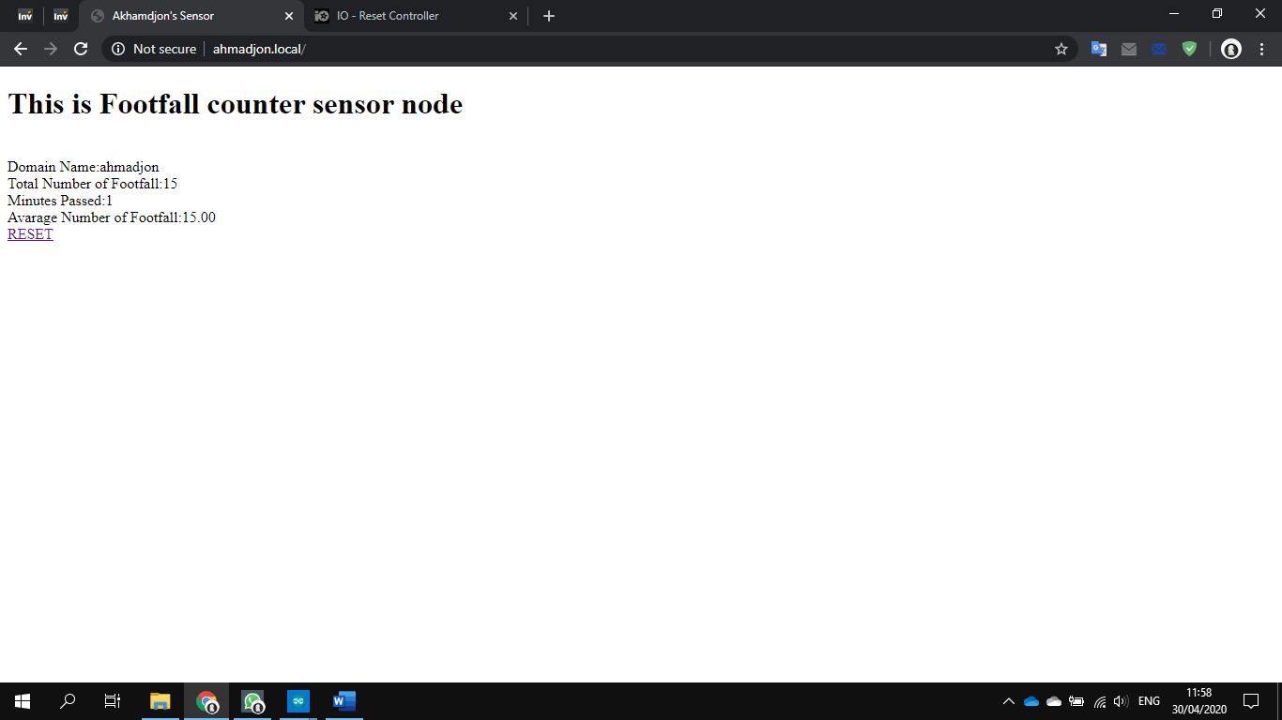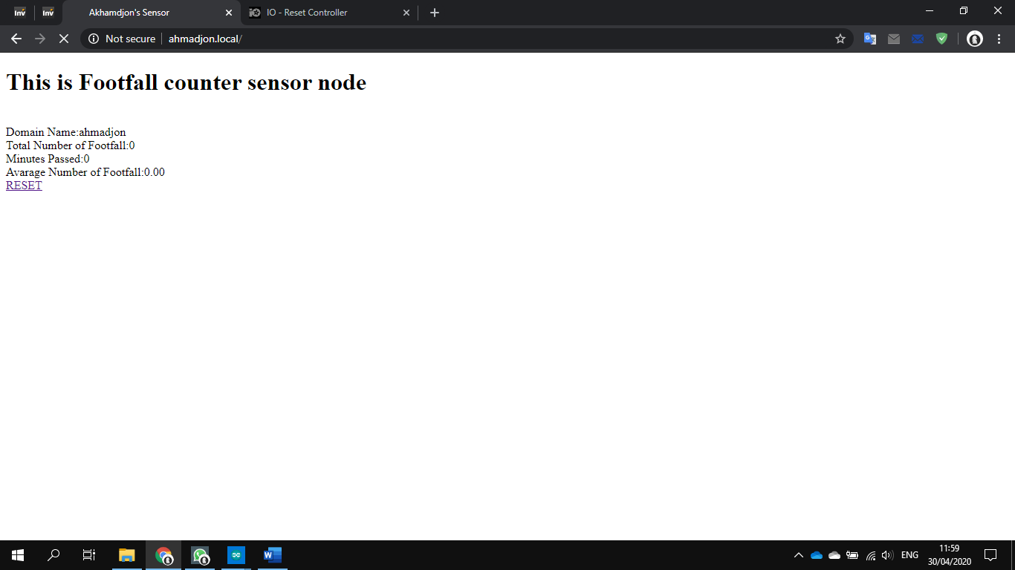

Figure 7 Implementation of the website using the HTTP protocol and the use of the Reset function

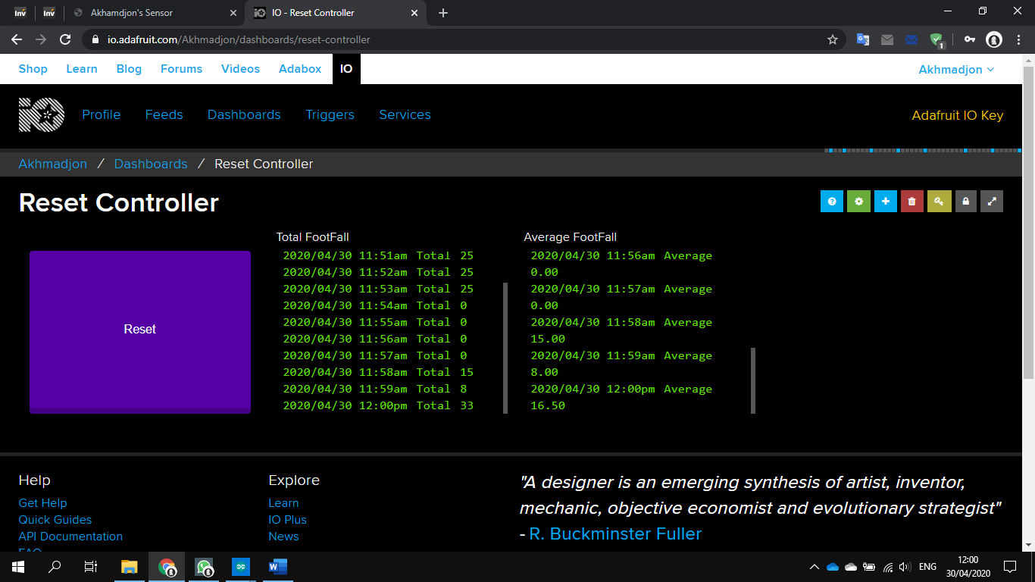

Figure 8 Data from the website io.adafruit.com and Reset function using MQTTS

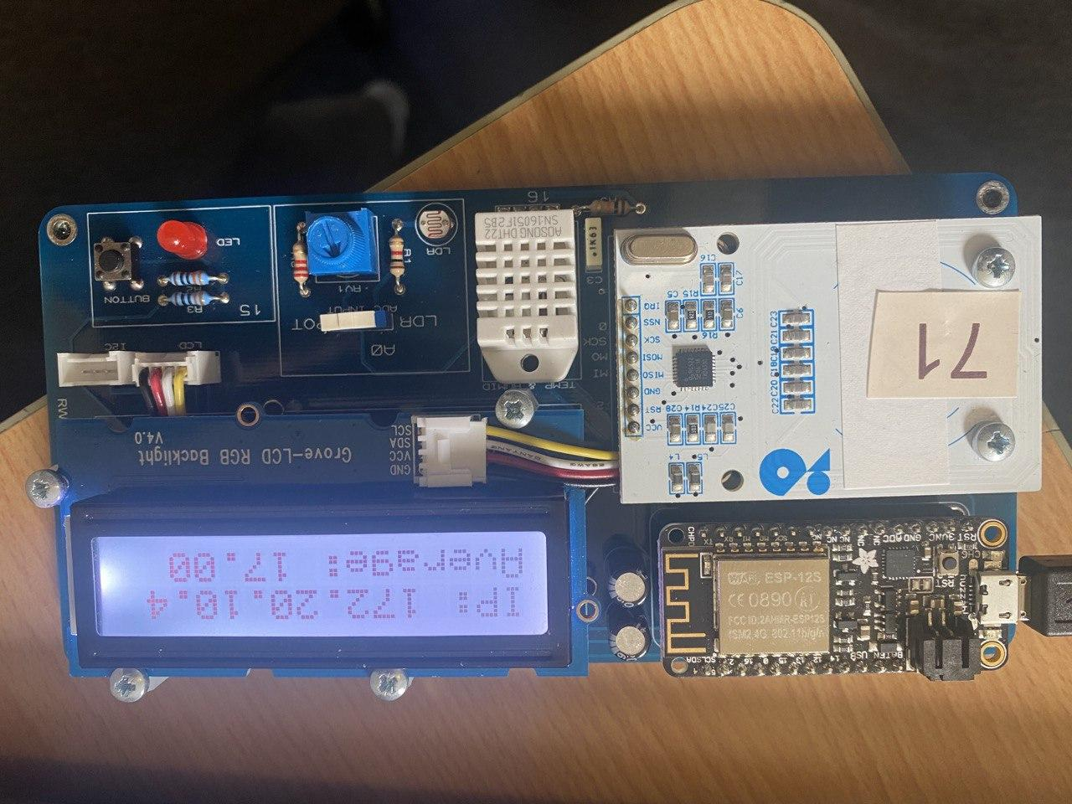

Figure 9 Hardware implementation of the code, display of IP address and average press per minute

## 7.2 Code listing (if necessary, code will be submitted separately)

Submitted separately