# 1.8. Task

You need to write an application that has 4 TextViews  
3 text views will work as a buttons with text of different color. When the specific color button is clicked, the 4th TextView text must be updated to notify that the specific button has been clicked

Github Link:

https://github.com/Rajadurai02/Day_1_Task_AndroidApp

Sample Output:

Initial View:

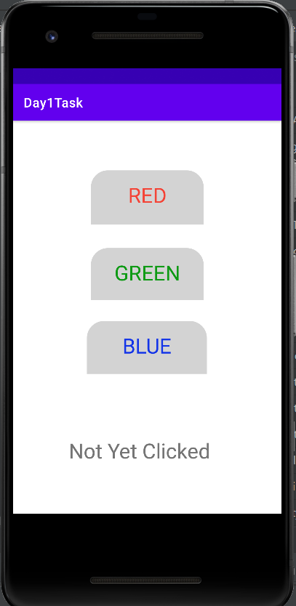

Red Button Clicked:

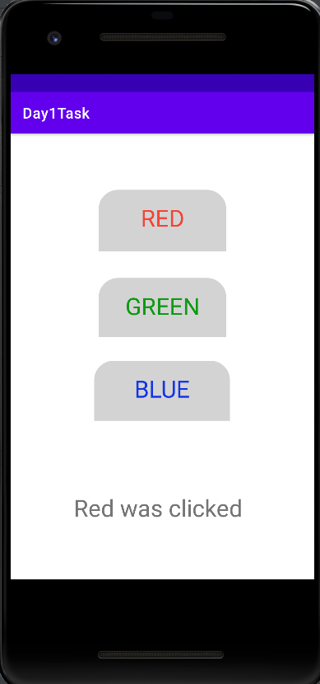

Green Button Clicked:

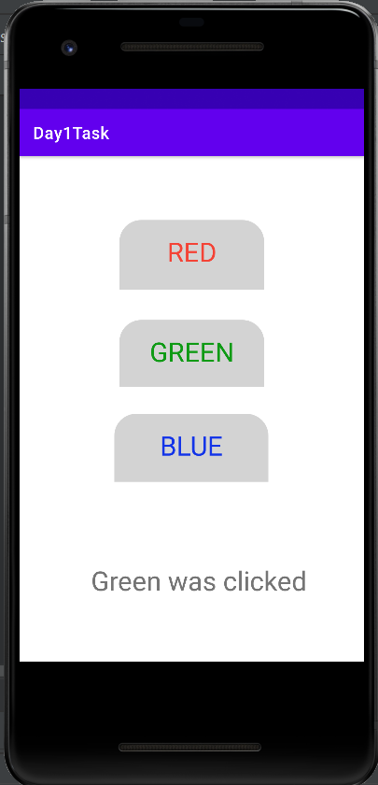

Blue Button Clicked:

