# 2.2. Task1

modify the application, so each new user would have their separate click counter. In the above scenario, it must be:  
- user clicks button 3 times -> user sees 'Nishanth clicked 3 times' message  // 3 times, not 8 times in total

**Github Link:**

<https://github.com/Rajadurai02/Day_2_Task_1_AndroidApp>

Sample Output:

Initial View: Clicking Without Entering Name 5 Times

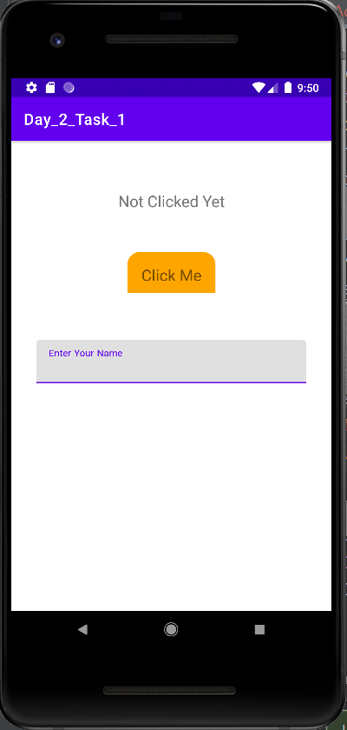 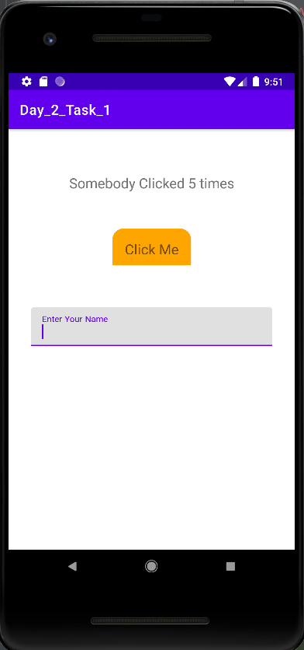

Entering Name and Clicked 1 Time Clicking Without Entering Name 1 Time

(The clickcount reseted) (Corresponding clickcount increased)

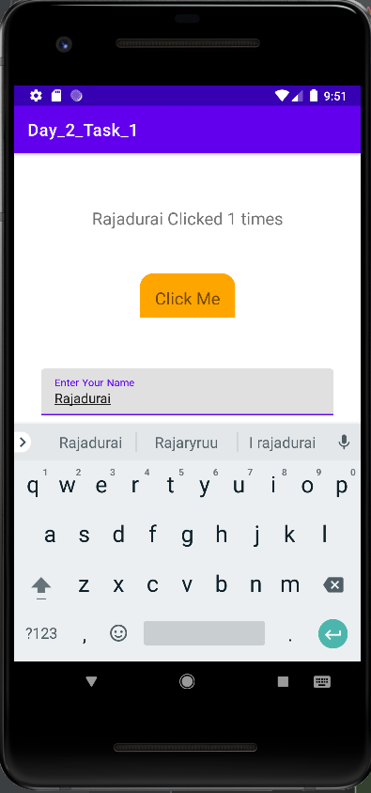 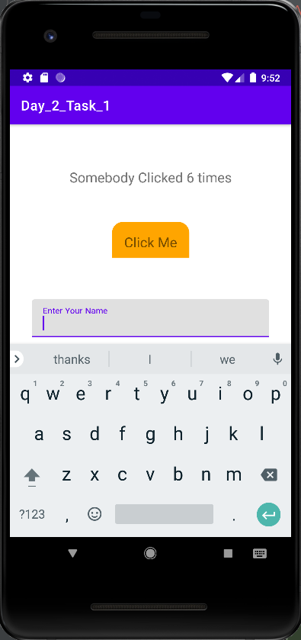

Try with Another name:(clicked four times)

