# 3.3. Task1. Create an application that plays a guessing game with you

There's a classical guessing game: Person1 picks secret a number between 0 and 1000. Person2 tries to guess the number. If the guess fails, Person1 tells if the guessed number was bigger or smaller than the secret number.

**Github Link:**

https://github.com/Rajadurai02/Day_3_Task_1_AndroidApp

Sample Output:

Initial View: Number is smaller

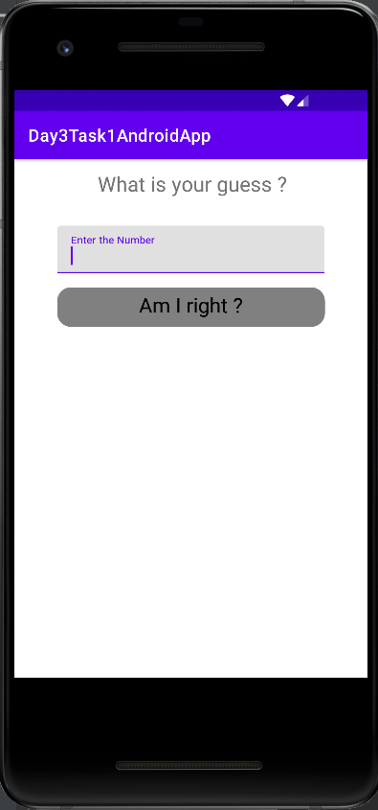 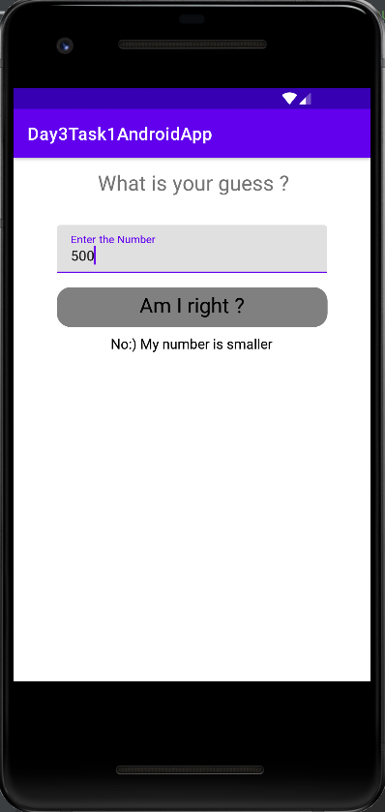

Number is smaller Number is bigger

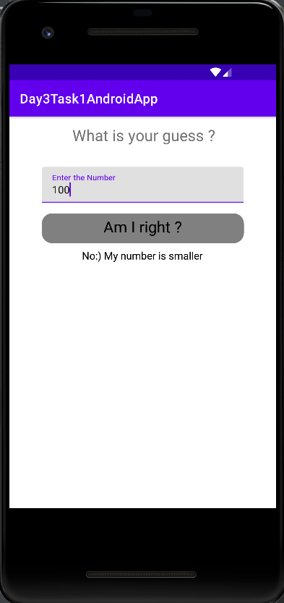 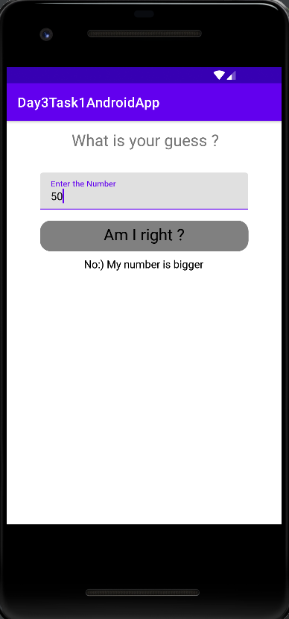

Number is bigger Number is correct

