# 3.6. Task2. Add a new screen to an application that plays a guessing game with you

Change the previous application that played a game with you.  
1. Now, after you win, the application should start a new activity, EndGameActivity, telling that you won the game, writing the correct number with large green digits.  
2. If you haven't won during 12 attempts, after the 12th attempt, the application should start a new activity, telling you've lost the game, writing the correct number with large red digits

**Github Link:**

https://github.com/Rajadurai02/Day_3_Task_2_AndroidApp

Sample Output:

Initial View: Correct Number Found

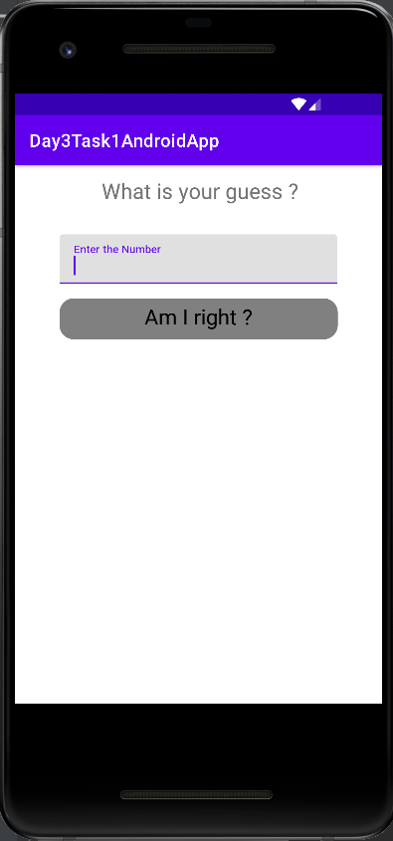 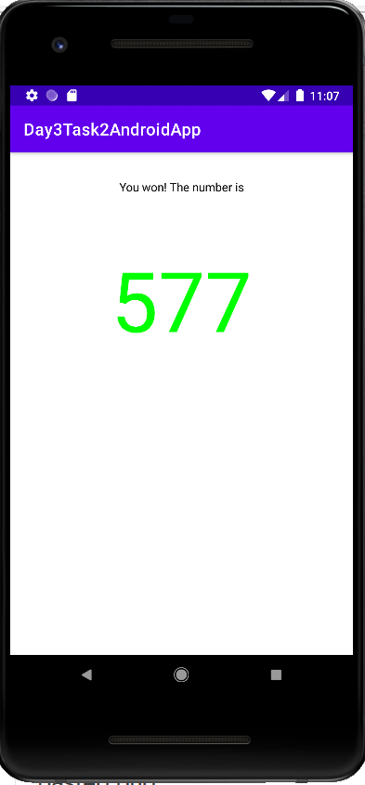

After 12 attempts (cannot find the correct number)

