# 4.4. Implement books filter application

1. The application that downloads these data (from the http endpoint)  
2. GUI of the application must contain two filtering criteria (any you like, up to your choice). For example, 'by author' and 'by country' (or any other you like). User must be able to edit specific values, which are filtering data.  
3. GUI must have the button, clicking on which new filtering criteria is applied.  
4. When filtering criteria is applied, top 3 results must be displayed using the TextView. Total count of results must also be displayed using TextView (for a reference, check attached draft image).  
5. Criteria must be combined using 'OR' or 'AND' condition - up to you.

**Github Link:**

https://github.com/Rajadurai02/Day_4_Task_1_BookFilterApplication

Sample Output:

Initial View: Author = “Jane Austen” OR operator used Language = “English”

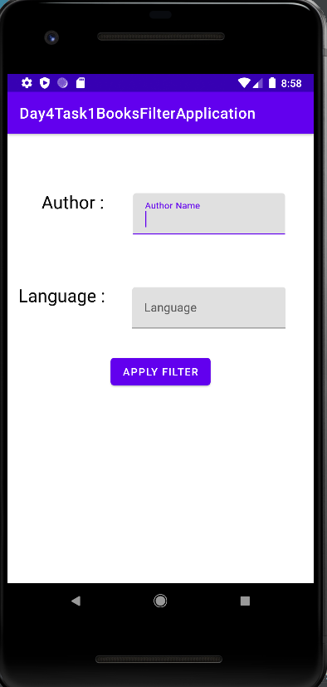 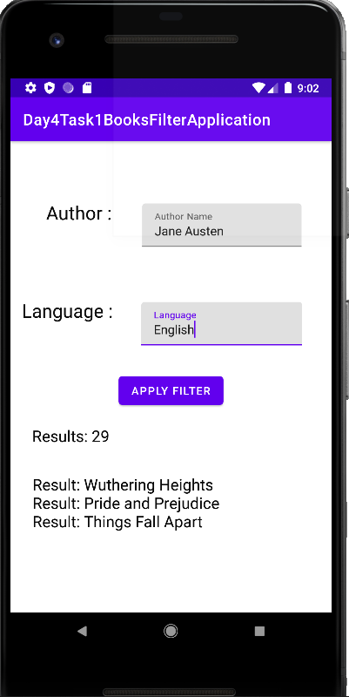

Author = “Jane Austen” OR operator Author = “Chinua Achebe” OR

used Language = “French” 0perator used Language = “Old Norse”

