# 5.2. Task. Change the book filter application to work with device onboard SQL

Change the book filter application from day 4 to work with device onboard SQL.  
The application must do GET query once, write all book data to local Room/SQL storage, and then operate with the local SQL storage only.

**Github Link:**

<https://github.com/Rajadurai02/Day_5_BookFilterAppUsingRoom>

Sample Output:

Initial View: Author = Jane Austen

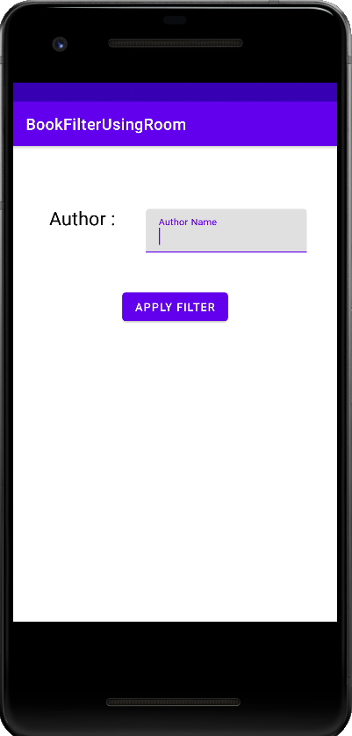 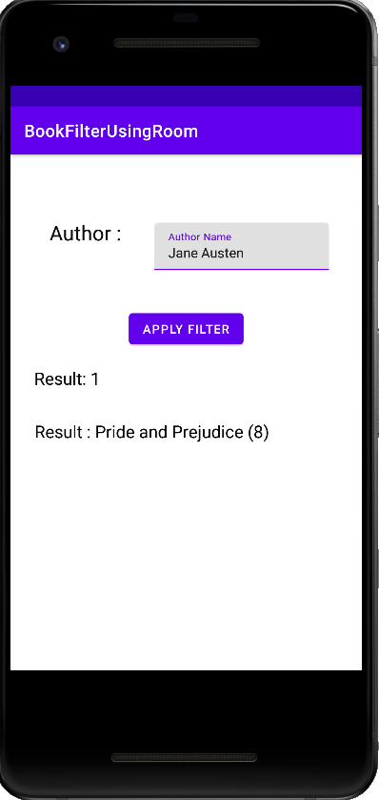

Author = Fyodor Dostoevsky Author = Gustave Flaubert

