MEASURE ENERGY CONSUMPTION :

AI TECHNOLOGY :

AI technology can help measure energy consumption by analyzing data from various sources.Here’s how it can be done:

1.DATA COLLECTION:

AI systems can gather data from smart meters,sensors,and other devices that monitor energy consumption in homes,buildings or industrial facilities.

2.DATA PROCESSING:

AI algorithms processing the data,identifying patterns and anomalies in energy usage.

3.PREDICTIVE ANALYTICS:

AI can predict future energy consumption based on historical data and factors like weather conditions,occupancy,and equipment usage.

4.ENERGY EFFICIENCY RECOMMENDATIONS:

AI can suggest energy-saving measure,such as optimizing heating/cooling systems or scheduling equipment faults or wastage.

5.ANOMALY DETECTION:

AI can flag unusual energy consumption,indicating potentisl faults or wastage.

6.REAL-TIME MONITORING:

AI can provide real-time updates on energy consumption,allowing for immediate action when needed.

7.REPORTING AND VISUALIZATION:

AI-generated reports and visualizations make it easier for users to understand their energy consumption patterns.

BY intergrating AI into energy management systems,individuals and organizations can make informed

Decisions to reduce energy consumption and lower costs.

To measure energy consumption in a program,you typically need access to hardware-level power consumption data,which is not always straightforward to obtain in all programming environment.However,here’s a high- level overview of how you can approach measuring energy consumption in a program:

Here’s a simple example in python to monitor executon time,which can be an indirect indicator of energy consumption using the TIME module:

## import time

## start_time=time.time()

## #your program’s code here

## end_time=time.time()

## execution_time=end_time-

## start_time

## print(f”Execution time

## {execution_time}seconds”)

Remember,measuring energy consumption accurately may require specialized tools,and results can vary significantly depending on the hardware and operating conditions.It’s also important to consider ethical and privacy concerns when measuring energy consumption as it may involve monitoring.

1.USE A PROFILLING TOOL:

Some programming environment and developments and development tools come with built-in profiling tools that can provide information about energy consumption.

Example:Android studio provides the “battery historian”tool for profiling energy usage in andriofd apps.

2.ENERGY PROFILING LIBRARIES:

Some platforms and programming languages have libraries or APIs for monitoring energy consumption.

3.EXTERNAL HARDWARE TOOLS:

There are external hardware tools and meters that can measure b power consumption.

4. ESTIMATION:

If you can’t measure power consumption directly,you can estimate energy consumption by analyzing the code and making educated guesses about how power-hungry certain operations.

5.BENCHMARKING:

Run your program on different devices and scenarios to gather data about energy consumption variations.

6.USE PROFILING SOFTWARE:

For desktop applications, tools like Intel power gadget or windows performance monitors can help monitor energy consumption.

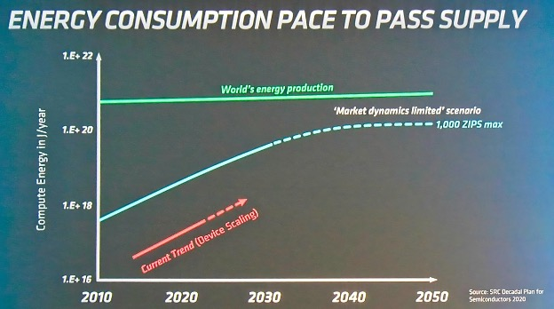

Smart meters are used to measure energy consumption and the data collected can be enhanced using artificial intelligence (AI). Using machine learning (ML) creates accurate results much earlier in the product development process for problems suited to AI.

De Vries estimates that based on the available data regarding power consumption and AI, if Google were to use AI for its around 9 billion daily searches, it would need 29.2 terrawatt hours (TWh) of power each year - the equivalent to the annual electricity consumption of Ireland.

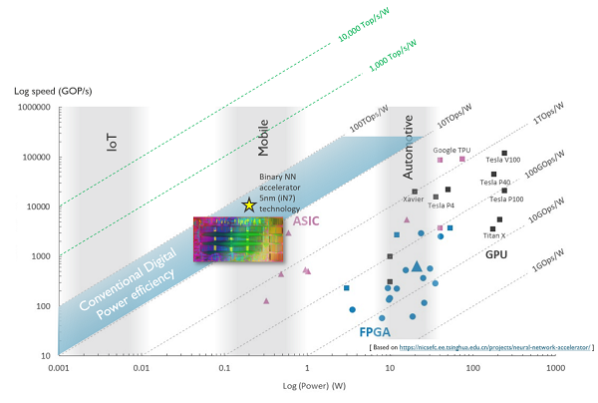

IBM's The Weather Company [processes around 400 terabytes](https://www.ibm.com/case-studies/the-weather-company-ibm-cloud/) of data per day to enable its models to predict the weather days in advance around the globe. Facebook generates about 4 petabytes (4,000 terabytes) of data per day.

People generated 64.2 zettabytes of data in 2020. That's about 58,389,559,853 terabytes, market research company IDC estimated.

Data centers store that data around the world.