**House Price Prediction Project Design and Innovation**

|  |  |
| --- | --- |
| **Date** | **11-10-2023** |
| **Team ID** | **935** |
| **Project Name** | **House Price Prediction using ML** |

**Table of Contents**

|  |  |
| --- | --- |
| 1 | Introduction |
| 2 | Problem Statement |
| 3 | Design and Innovation Strategies |
| 3.1 | Data Collection and Feature Engineering |
| 3.2 | Data Pre-processing |
| 3.3 | Model Selection and Training |
| 3.4 | Geographic Analysis |
| 3.5 | Market Sentiment Analysis |
| 3.6 | Explainable AI (XAI) |
| 3.7 | Continuous Learning |
| 4 | Conclusion |

**1. Introduction**

House price prediction using machine learning involves several steps, including data collection, feature engineering, data pre processing, model selection and training, geographic analysis, market sentiment analysis, explainable AI, and continuous learning.

**2. Problem Statement**

House price prediction involves using machine learning to train a model that can recognize patterns and make predictions based on data. The data used for this task includes various features of a house, such as its location, size, and amenities, along with corresponding sale prices. Linear regression is a common algorithm used for predicting house prices, but other algorithms like k-Nearest-Neighbours regression (k-NN) and Random Forest (RF) regression can also be used. By following the steps of data preprocessing, model selection, model training, model testing, model evaluation, and model deployment, you can create a model that accurately predicts the sale prices of houses based on their features.

**3. Design and Innovation Strategies**

**3.1. Data Collection and Feature Engineering**

Innovation: Comprehensive Data Gathering

Collecting a comprehensive dataset containing diverse features crucial for price prediction is the first step. Feature engineering involves creating new features and transformations to enhance the model's accuracy. Advanced attributes such as purchase history can be leveraged for enhanced accuracy

**3.2. Data Pre-processing**

Innovation: Natural Language Processing (NLP) for Unstructured Data

Data quality assurance, handling missing values, outlier detection, and normalization are essential steps. A clean and well-prepared dataset significantly influences the model's performance. Pre processing steps may include cleaning, encoding, and imputing data.

**3.3. Model Selection and Training**

Innovation: Ensemble Learning and Deep Learning Integration

Choosing an appropriate machine learning algorithm is critical. Models like Linear Regression, Decision Trees, or Gradient Boosting might be considered based on the dataset's complexity. Training involves using historical data to enable the model to predict house prices accurately. Hyper parameter exploration and model optimization can enhance the model's performance.

**3.4. Geographic Analysis**

Innovation: Location-Based Predictions

Geographic factors such as neighbourhood amenities, proximity to schools, safety, and accessibility to public transport profoundly impact house prices. Geospatial analysis aids in understanding these dynamics. This analysis can be done using tools like ArcGIS or QGIS.

**3.5. Market Sentiment Analysis**

Innovation: Sentiment Analysis for Real Estate Market

Analysing market sentiment through social media data, news articles, or expert opinions provides valuable insights. Positive or negative sentiments can influence buyer behaviour and, consequently, house prices. This analysis can be done using tools like sentiment analysis libraries in Python.

**3.6. Explainable AI (XAI)**

Innovation: Model Interpretability

Utilizing Explainable AI techniques like SHAP (SHapley Additive exPlanations) or LIME (Local Interpretable Model-agnostic Explanations) helps in understanding how the model arrives at specific predictions. This transparency enhances user trust. These techniques can be implemented using libraries like SHAP or LIME in Python.

**3.7. Continuous Learning**

Innovation: Model Maintenance and Improvement

.Implementing continuous learning mechanisms allows the model to adapt to changing market trends and user preferences. Regular updates based on new data ensure the predictions remain accurate over time. This can be done using techniques like online learning or incremental learning.

Note: In the diagram below, we've depicted the key components and interactions described in sections 3.1 to 3.7, offering a clear and concise overview of our solution architecture. This visualization simplifies the complex concepts and relationships discussed in those sections, making it easier for the reader to grasp the overall design and innovation strategies at a glance.

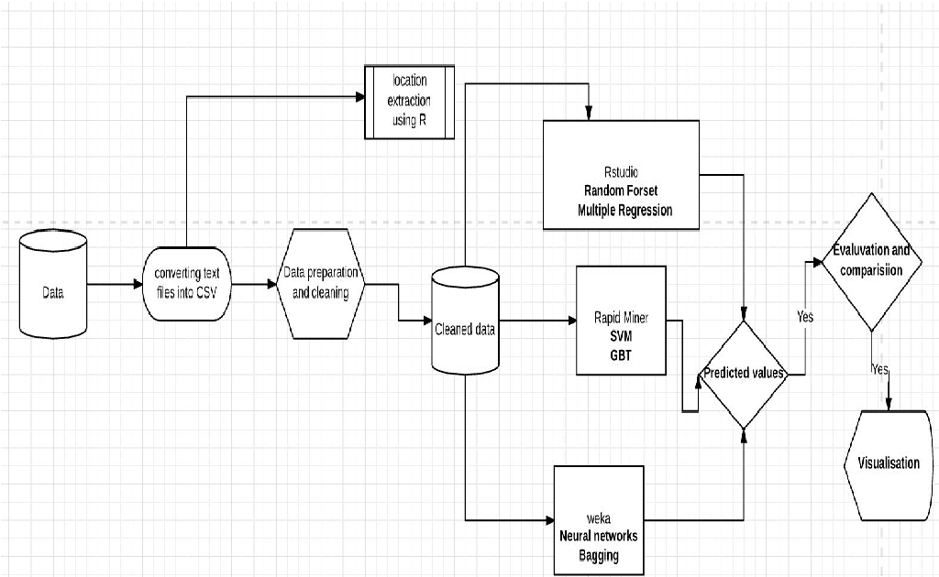

**4. Conclusion**

By addressing data quality, utilizing advanced machine learning algorithms, considering geographic and market sentiment factors, and incorporating Explainable AI and continuous learning, a robust solution for house price prediction can be developed. Through careful analysis and model refinement, the tool developed will not only be accurate but also adaptable, catering to the dynamic nature of the real estate market. The implementation of these techniques ensures the model's reliability and user satisfaction, making it an invaluable asset in the real estate industry.