
School of Electrical Engineering
COURSE PROJECT REPORT

Course Code & Title: BEEE416L – Electric Vehicles
Semester : Fall Semester 2025–2026
Title of the Project:
Bidirectional Ev Charging Station For Grid-To-Vehicle (G2V) And Vehicle-To-Grid (V2G) Power Exchange
Team Members:
Sl.No | Reg. No | Name
1 | 22BEE0063 | Rajagopal. B
2 | 22BEE0133 | Rakshith. S
3 | 22BEE0088 | Venmuhil Bharathi G

Course Faculty: Dr. D ELANGOVAN
Date of Submission: 08/11/2025
Bidirectional Ev Charging Station For Grid-To-Vehicle (G2V) And Vehicle-To-Grid (V2G) Power Exchange
ABSTRACT:
Electric cars are also energy producers in addition to energy users which is what this project reports on. We present our work on the design and simulation of what is in fact a bi-directional EV charger that goes between Vehicle to Grid (V2G) and Grid to Vehicle (G2V) modes. We have put together a system which ties many electric cars into a common DC bus via bi directional converters which in turn control the energy flow based on state of charge of each battery. Also we have a three phase grid interface which includes an LCL filter and a voltage source inverter which in large part take care of smooth power exchange and also see to it that we get minimal harmonics.
Control strategy employs dq-axis transformation with PLL synchronization, where PI controllers manage active and reactive power through Id and Iq. High SOC selected EVs provide grid support (V2G), and low SOC EVs are energy consumers for charging (G2V). Simulation results show stable DC bus voltage, balanced power sharing, and effective interaction with the grid. This model illustrates the potential for coordinated bidirectional control at EV charging stations to bolster grid stability, integrated with advanced smart energy management systems.
INTRODUCTION :
The rise of electric vehicles (EVs) poses new challenges and opportunities for modern power systems. Aside from functioning as modes of transportation, EVs are portable energy storages that are actively involved with the grid [1]. The relationship EVs have with the grid manifests in two primary ways—Grid-to-Vehicle (G2V) and Vehicle-to-Grid (V2G). In G2V, EVs access power for charging, while in V2G, EVs discharge power they have stored back to the grid. The three functions these systems offer in unison are demand balancing, renewable energy integration [2].
Traditional charging stations only permit unidirectional power flow. This situation, particularly, during peak charging cycles, generates the situation of low power supply and high demand imbalance. This has led to the focus of research on bidirectional charging systems that offer the ability to stabilize grid voltage. A properly controlled inverter and LCL filter allow smooth power transfer with low harmonic distortion.
The motivation for this project is to construct a bidirectional EV charging station model that manages charging and discharging according to each battery’s state of charge (SOC). Consistent switching between charging and discharging is attained using dq-axis control, phase-locked loop (PLL) synchronization, and PI regulators. This coordinated operation aids the grid and contributes to a smart and sustainable power system for the more intelligent power networks of the smart cities of the future [3].
PROBLEM STATEMENT :
As we see an increase in the number of electric vehicles on the road today uncoordinated charging of these vehicles is causing issues with grid voltage stability, power quality and we are seeing inefficient energy use. This project we are working on is that of the development of a bidirectional EV charging station which will smartly manage power flow between the grid and many EVs at the same time, we aim for balanced load management, stable DC bus voltage and smooth V2G G2V transition.
LITERATURE REVIEW:
As electric vehicle (EV) proliferation increases and the grids require flexible storage resources, research on Vehicle-to-Grid (V2G) and bidirectional charging has intensified. Recent literature reviews point out that the potential of V2G is heavily conditioned by accurate power-electronic interfaces and system-level coordination. Modern surveys indicate a shift towards modular, scalable converter topologies and integrated erMAC layers coordinating large amount of vehicles while ensuring in power quality and battery wear [4]. These reviews are system-oriented: hardware design, control algorithms and market/business models should be well coordinated for V2G to deployment in practice.
At the converter level, several studies compare two-stage (DC-DC + inverter) and single-stage bi-directional solutions. Research on three-phase bidirectional inverters emphasizes the requirement of a robust synchronization and current control for serving charging demand and grid support services. Control structures often employ an abc→dq transformation using a phase-locked loop (PLL) as a reference and cascaded PI controllers in the d- and q-axis for active/reactive power control for similar predictable performance that is also relatively simple to implement in Simulink/real-time environments [5]. Advanced controllers (eg, resonant, sliding-mode, predictive) have also been studied to enhance dynamic response and minimize harmonic injection in face of fast switching and mode transition.
Another field of active research is filter design, LCL filters remain popular for grid-connected bidirectional charges since the achieve effective damping of the switching harmonics without overly increasing the dimensions of passive elements. In recent works, systematic design procedures of the LCL filters for bidirectional operation are presented with stability considerations when using a digital current controller and proposing several damping strategies to avoid resonance and the controller interactions [6]. Good damping design is important when the new type of converter switches in both directions and when there are paralleled chargers at a point of common coupling.
Deployment perspectives and practical studies are also considered in the context of modularity, fault tolerance, and power-quality services. New topologies and modular multilevel have also enhanced scalability and reliability for residential or commercial charging hubs [7]. These designs frequently involve local energy management in order to enforce SOC targets, whilst also providing ancillary services such as frequency regulation and fast response during disturbances.
Adoption depends on economy and lifecycle. Technoeconomic assessments estimate revenue streams for ancillary services as opposed to battery degradation and infrastructure costs, showing promising business cases in some cases profitability depends on local market price energy cycling patterns and on policies rewarding grid services [8]. Field trials and pilots bring practical insight: demonstration projects have demonstrated the turnover of EV fleets for fast backup and frequency support, validating control concepts as well as identifying operational challenges - customer participation, interoperability, standards alignment [9].

OBJECTIVES OF THE PROJECT :
An Electric Vehicle (EV) bidirectional charging station will be developed in this project with integrated Rich Interaction Devices that enables such station to have the ability to charge and discharge. It is aimed at grid stability in which the lowest harmonic distortion and minimal energy loss efficiency of the power flow between grid to multiple EVs are considered. Advanced controlling modes including dq-axis control, PLL synchronization and PI regulation help to achieve real time power regulation. SOC is also used to dynamically evaluate operation mode by the system.
“To design and simulate a bidirectional EV charging station enabling stable and efficient V2G–G2V power transfer using intelligent control.”

BLOCK DIAGRAM:
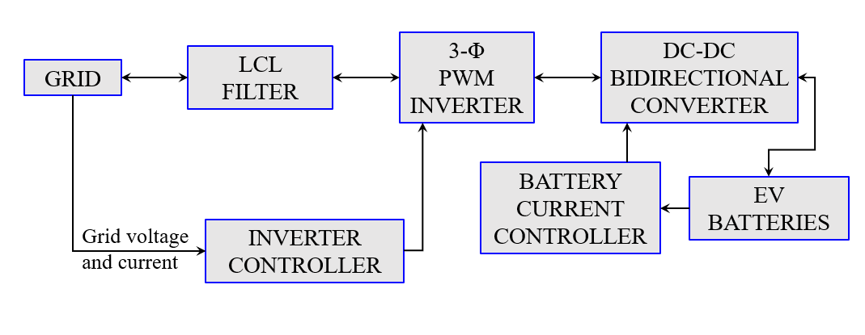
Fig.1 : Block Diagram of EV Charging Station (V2G and G2V).
METHODOLOGY :
The system is described in terms of the energy and control structure from the grid to electric vehicle battery. Each stage is dedicated to ensuring stable, efficient and bidirectional power exchange between the grid and EVs. The procedure is described in the following, structured as the block diagram above.
1. Grid
During charging (G2V), the 3-phase AC grid is a power source and during discharging it is a power load (V2G). It offers the voltage and (or) current reference, which is required for control loops. The inverter control unit constantly checks the grid voltage to detect synchronization. This ensures that power is smoothly and in-phase with the grid waveform, and so prevents instability.
2. LCL Filter
An LCL filter is applied right after the grid connection to eliminate unnecessary high frequency harmonics generated by the inverter switching. It is composed of two inductors and a capacitor connected as an LCL-type network. Filter smoothes the output current offering the grid with clean sinusoidal waveforms. This leads to reduced total harmonic distortion (THD), in line with the Grid codes and quality of power is provided.
3. Three-Phase PWM Inverter
The three-phase voltage source inverter (VSI) works as the main link between AC and DC - functioning like a rectifier when charging from grid to vehicle, turning incoming AC from the power line into stable DC, usually around 800 volts. On the flip side, during vehicle-to-grid operation, it flips roles and behaves like an inverter, changing the car’s stored DC energy back into matched three-phase AC so it can feed into the electrical network. To manage this shift, pulse width modulation (PWM) steps in, directing how fast the IGBT switches turn on and off to shape the right voltage plus frequency mix. While that happens, a control setup keeps tabs on things, tweaking the inverter's result whenever needed.
4. Inverter Closed-Loop Control
To add precise control of both the active and/or reactive power, we need to use dq-axis (synchronous reference frame) which is also implemented in the inverter. First, the three-phase measured currents are transformed from abc → dq using Park transform.
- The d-axis current (Id) controls the active power or DC bus voltage.
- The q-axis current (Iq) controls the reactive power and maintains unity power factor.
Inverter phase angle is synchronized with the grid voltage through a Phase Locked Loop (PLL). The PLL monitors grid frequency and phase to keep the inverter output synchronized with the grid. Within the control loop, reference and actual dq currents are compared by PI-controllers to drive voltage references for PWM generation. This feedback mechanism is looped so that to maintain the voltage regulation stable and a smooth bidirectional G2V/V2G transition.
5. Electric Vehicle Section :
The EV part includes two key pieces: one’s a bidirectional DC-DC converter, while the other's the battery.
(a) DC-DC Bidirectional Converter
The converter connects the 800 V DC line to the EV's lower battery voltage. When charging from grid to vehicle, it runs in buck mode - when sending power back, it switches to boost mode. Besides managing these flows, it handles multiple essential tasks:
- Manages which way electricity moves depending on signals received along with how much charge the battery holds.
- Keeps battery flow steady using a PI-driven system to stick within safe charge and release levels.
- Makes sure power stays steady on the line no matter how many electric cars plug in.
- Balances power on-the-fly between car batteries and the electrical network when demand shifts. Uses real-time adjustments instead of fixed settings as usage changes. Keeps flow stable even when supply or draw fluctuates unexpectedly.
(b) Battery
The battery works as a power supply along with a storage spot. It gives live readings of charge level, voltage, plus current - these get sent straight to the converter’s control system. Depending on Vehicle owner’s wish , the V2G and G2V operation will occur. Smart movement like this keeps things effective while also backing up the grid.
DESIGN & CALCULATIONS:
- LCL Filter design :
- Line-to-line voltage (V_LL) = 415 V (rms)
- Grid frequency (f_g) = 50 Hz
- DC link voltage (V_dc) = 800 V
- Switching frequency (f_sw) = 10,000 Hz
- Target grid current THD ≤ 5%
- Inverter apparent power = 30 kVA
To achieve optimal performance and reduced harmonic distortion, the following targets are set:
- Peak-to-peak inverter current ripple (ΔI) ≈ 5% of rated phase current.
- Capacitor reactive power (Q_C) ≈ 5% of inverter rated apparent power.
Phase voltage:
$$V_{p}h=V_{L}L/\sqrt{3}=415/\sqrt{3}=239.6V$$
Rated phase current (assuming unity power factor):
$$I_{ph}=P_{rated}/\left(3×V_{p}h\right)=30,000/\left(3×239.6\right)=41.75A$$
Allowable ripple current:
$$ΔI=0.05×I_{p}h=0.05×41.75=2.09A$$
INDUCTOR(L) :
Using SPWM ripple relation:
$$ΔI=V_{dc}/\left(8×f_{s}w×L1\right)$$
$$L1=V_{dc}/\left(8×f_{s}w×ΔI\right)$$
$$L1 = 800 / (8 × 10,000 × 2.0877) = 0.00479 H ≈ 4.79 mH$$
Hence, L1 = 5 mH (practical value). Similarly, L2 = L1 = 5 mH.

CAPACITOR (C) :
$$Q_{C}\left(3φ\right)=0.05×P_{rated}=0.05×30,000=1,500VAR$$
$$Perphase:Q_{C}\left(phase\right)=Q_{C}\left(3φ\right)/3=500VAR$$
$$UsingQ_{C}\left(phase\right)={V_{ph}}^{2}×ω×C$$
$$C=Q_{C}\left(phase\right)/\left({V_{ph}}^{2}×ω\right)$$
$$ω=2π×f_{g}=314.16rad/s$$
$$C=500/\left({239.6}^{2}×314.16\right)=27.72×{10}^{-6}F≈30µF$$

RESONANCE FREQUENCY :
$$f_{r}=\left(1/\left(2π\right)\right)×\sqrt{\left(\left(L1+L2\right)/\left(L1×L2×C\right)\right)}$$
$$f_{r}=\left(1/\left(2π\right)\right)×\sqrt{\left(\left(10×{10}^{-3}\right)/\left({\left(5×{10}^{-3}\right)}^{2}×30×{10}^{-6}\right)\right)}=581Hz$$
The resonance frequency lies between grid frequency (50 Hz) and switching frequency (10 kHz), ensuring stable operation.
- Bidirectional Converter Design of EVs :
- CONVERTER 1:
Vin = 800 V (DC bus)
Vout = 440 V (battery nominal)
f_sw = 10000 Hz
Iout = 30 A
Inductor ripple target: $ΔI = 10\% of Iout = 3.00 A (peak-to-peak)$Output voltage ripple target: ΔVout = $1\% of Vout = 4.40 V (peak-to-peak)$
Duty ratio (steady-state buck): $D = Vout / Vin = 0.55$
$$ΔI = ((Vin - Vout) * D) / (L * f_sw) \\ ⇒ L = ((Vin - Vout) * D) / (ΔI * f_sw) \\ Substitute values: \\ L = ((800 - 440) * 0.55) / (3.00 * 10000) = 0.0066 H = 6.60 mH \\ So, L = 6.60 mH \\ ΔVout ≈ ΔI / (8 * f_sw * C) \\ ⇒ C ≈ ΔI / (8 * f_sw * ΔVout) \\ Substitute: \\ C = 3.00 / (8 * 10000 * 4.40) = 0.000009 F = 8.52 µF \\ So, C ≈ 8.52 µF$$
- CONVERTER 2:
Vin = 800 V (DC bus)
Vout = 240 V (battery nominal)
f_sw = 10000 Hz
Iout = 15 A
Inductor ripple target: $ΔI = 10\% of Iout = 1.50 A (peak-to-peak)$Output voltage ripple target: ΔVout = $1\% of Vout = 2.40 V (peak-to-peak)$
Duty ratio (steady-state buck): $D = Vout / Vin = 0.3$
$$ΔI = ((Vin - Vout) * D) / (L * f_sw) \\ ⇒ L = ((Vin - Vout) * D) / (ΔI * f_sw) \\ Substitute values: \\ L = ((800 - 240) * 0.3) / (1.50 * 10000) = 0.0112 H = 11.20 mH \\ So, L = 11.20 mH \\ ΔVout ≈ ΔI / (8 * f_sw * C) \\ ⇒ C ≈ ΔI / (8 * f_sw * ΔVout) \\ Substitute: \\ C = 1.50 / (8 * 10000 * 2.40) = 0.0000078 F = 7.81 µF \\ So, C ≈ 7.81 µF$$
- CONVERTER 3:
Vin = 800 V (DC bus)
Vout = 420 V (battery nominal)
f_sw = 10000 Hz
Iout = 30 A
Inductor ripple target: $ΔI = 10\% of Iout = 3.00 A (peak-to-peak)$Output voltage ripple target: ΔVout = $1\% of Vout = 4.20 V (peak-to-peak)$
Duty ratio (steady-state buck): $D = Vout / Vin = 0.53$
$$ΔI = ((Vin - Vout) * D) / (L * f_sw) \\ ⇒ L = ((Vin - Vout) * D) / (ΔI * f_sw) \\ Substitute values: \\ L = ((800 - 420) * 0.53) / (3.00 * 10000) = 0.0066 H = 6.65 mH \\ So, L = 6.65 mH \\ ΔVout ≈ ΔI / (8 * f_sw * C) \\ ⇒ C ≈ ΔI / (8 * f_sw * ΔVout) \\ Substitute: \\ C = 3.00 / (8 * 10000 * 4.20) = 0.000009 F = 8.93 µF \\ So, C ≈ 8.93 µF$$
- CONVERTER 4:
Vin = 800 V (DC bus)
Vout = 620 V (battery nominal)
f_sw = 10000 Hz
Iout = 30 A
Inductor ripple target: $ΔI = 10\% of Iout = 3.00 A (peak-to-peak)$Output voltage ripple target: ΔVout = $1\% of Vout = 6.20 V (peak-to-peak)$
Duty ratio (steady-state buck): $D = Vout / Vin = 0.78$
$$ΔI = ((Vin - Vout) * D) / (L * f_sw) \\ ⇒ L = ((Vin - Vout) * D) / (ΔI * f_sw) \\ Substitute values: \\ L = ((800 - 620) * 0.78) / (3.00 * 10000) = 0.0046 H = 4.65 mH \\ So, L = 4.65 mH \\ ΔVout ≈ ΔI / (8 * f_sw * C) \\ ⇒ C ≈ ΔI / (8 * f_sw * ΔVout) \\ Substitute: \\ C = 3.00 / (8 * 10000 * 6.20) = 0.000006 F = 6.05 µF \\ So, C ≈ 6.05 µF$$
EXPERIMENTAL SETUP :
The test layout runs through three phases to check how well the two-way EV charging works. First up, one electric vehicle charges from the grid using G2V mode, with the converter acting like a buck circuit pulling energy into the battery. Next comes V2G action - here, that same unit flips to boost mode, sending stored power from the car’s battery back into the network. Last part brings in four cars together: two soaking up charge while two feed electricity out at once, all linked on the shared DC line to keep things balanced. Each scenario got its own Simulink build so we could track voltage shifts, current flow, and state-of-charge changes.
- Case 1 : (single EV operates in G2V mode)
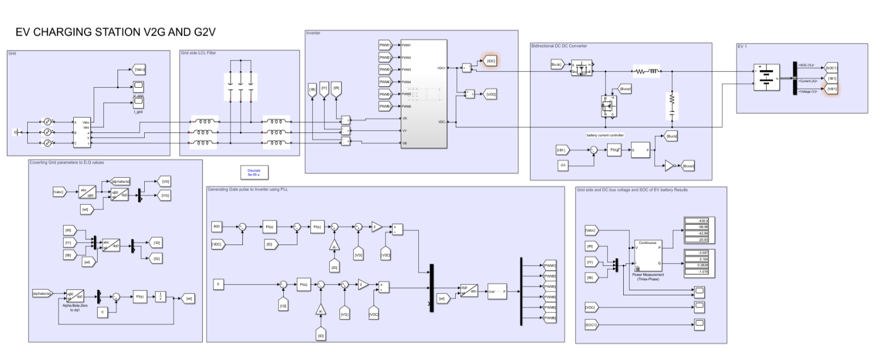
Fig.2 : Simulink Model of G2V Charging Station
- Case 2: (single EV operates in V2G mode)
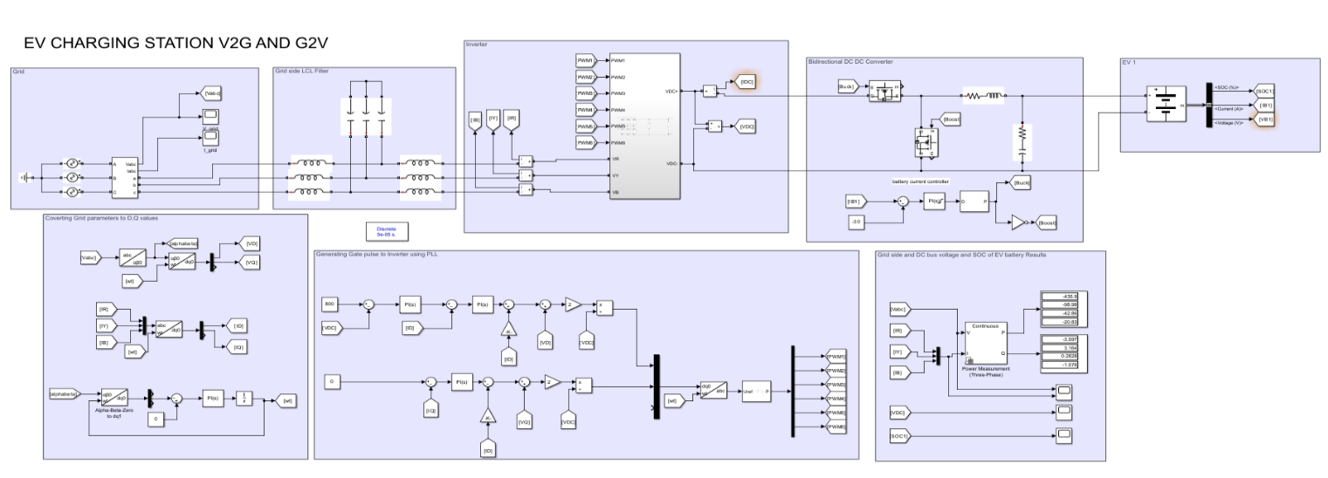
Fig.3 : Simulink Model of V2G Charging Station
- Case 3 : (Multiple EV operates in both G2V and V2G)
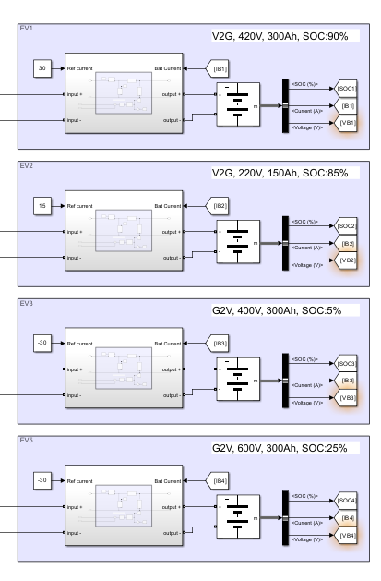
Fig.4 : EV Battery Informations in Simulink Model
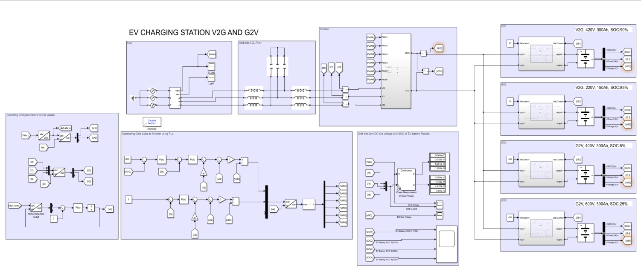
Fig.5 : Simulink Model of Charging Station for both G2V and V2G
RESULTS & DISCUSSION :
- Case 1 : (single EV operates in G2V mode)
In the first scenario, the two-way converter runs in Grid-to-Vehicle mode - power moves from the grid into the electric vehicle's battery. Voltage and current from the grid form smooth sine waves, which means it stays well-aligned thanks to PLL-driven regulation. Current trails voltage by a quarter cycle, revealing that the inverter pulls reactive power during charge mode, helping keep the grid steady. The DC link holds firm at 800 volts, proving the feedback system on the inverter works right. Meanwhile, the EV battery’s charge level climbs slowly, reflecting solid power delivery and accurate response from the charging regulator.
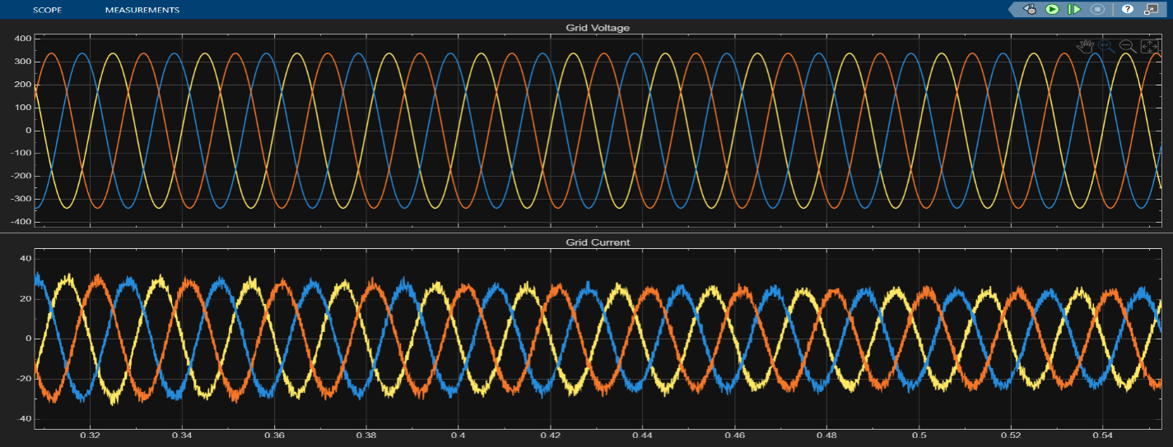
Fig.6 : Grid Voltage and Current.
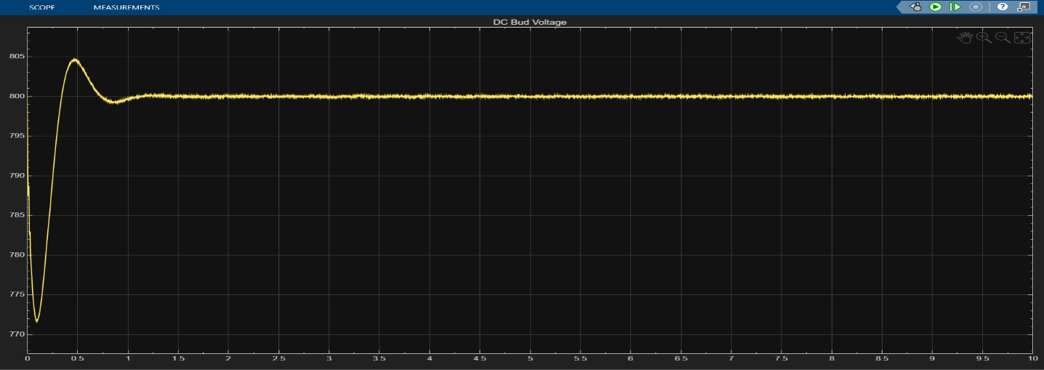
Fig.7 : DC Bus voltage
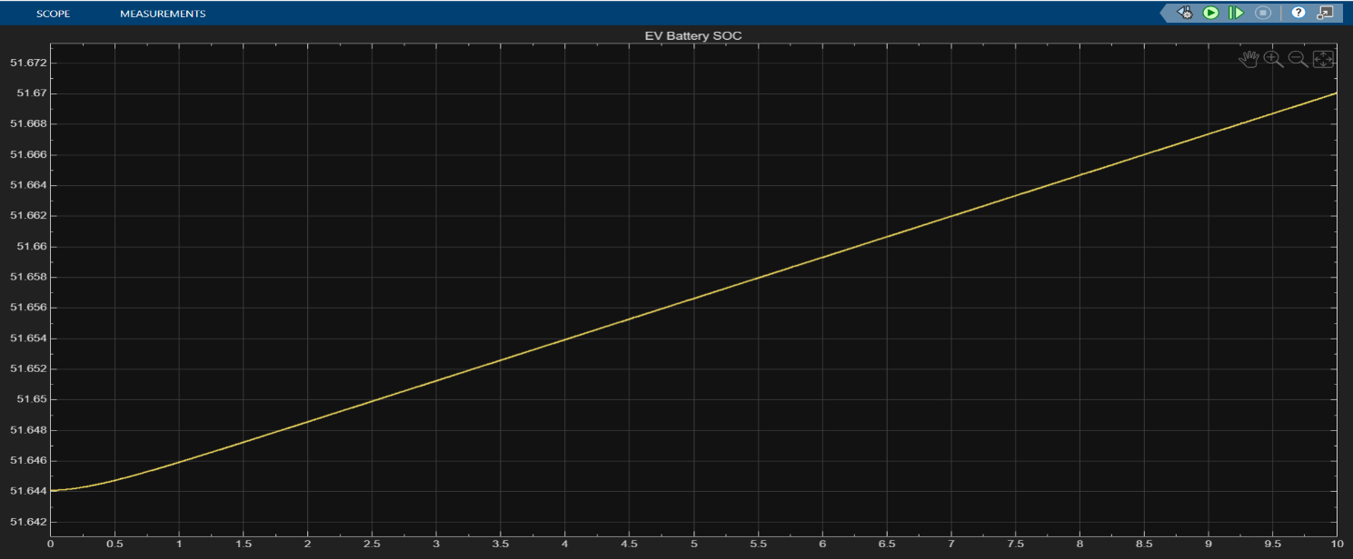
Fig.8 : SOC of the EV Battery
- Case 2 : (single EV operates in V2G mode)
In the second case, the bidirectional converter operates in Vehicle-to-Grid (V2G) mode, meaning that the EV battery delivers power to the grid. Since the grid voltage and current remain clean sine waves, this indicates that the inverter is suitably synchronized to the utility power grid under dq-PLL synchronization permitting solid control. As current lines up exactly with voltage, this means actual power gets fed into the network. While the DC link voltage holds firm at 800 V, it proves the inverter's feedback loop manages voltage reliably. Over time, the battery’s State of Charge drops slowly, reflecting a steady release of stored energy to meet grid demand.
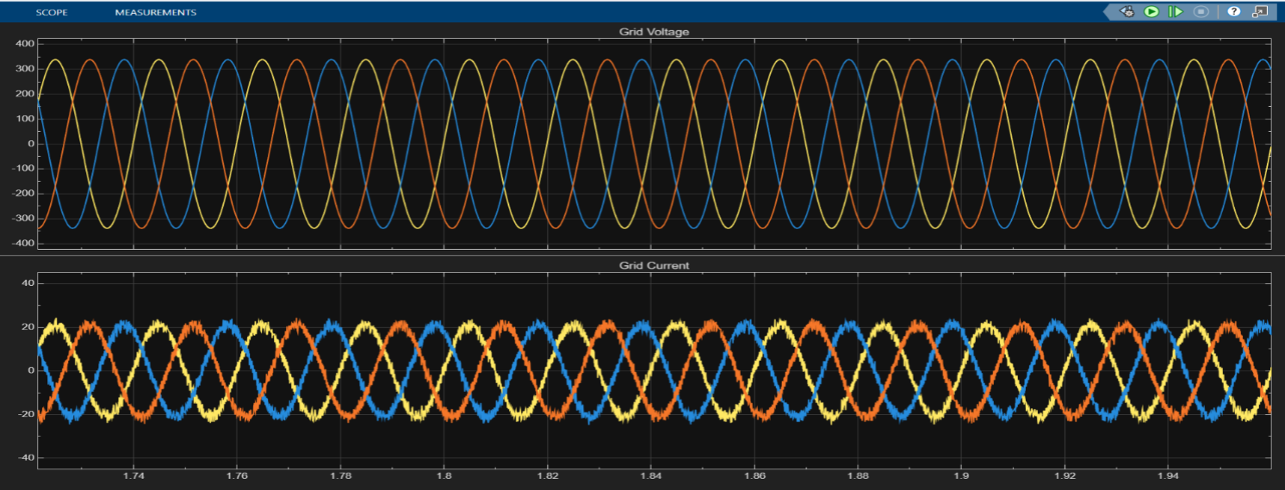
Fig.9 : Grid Voltage and Current.
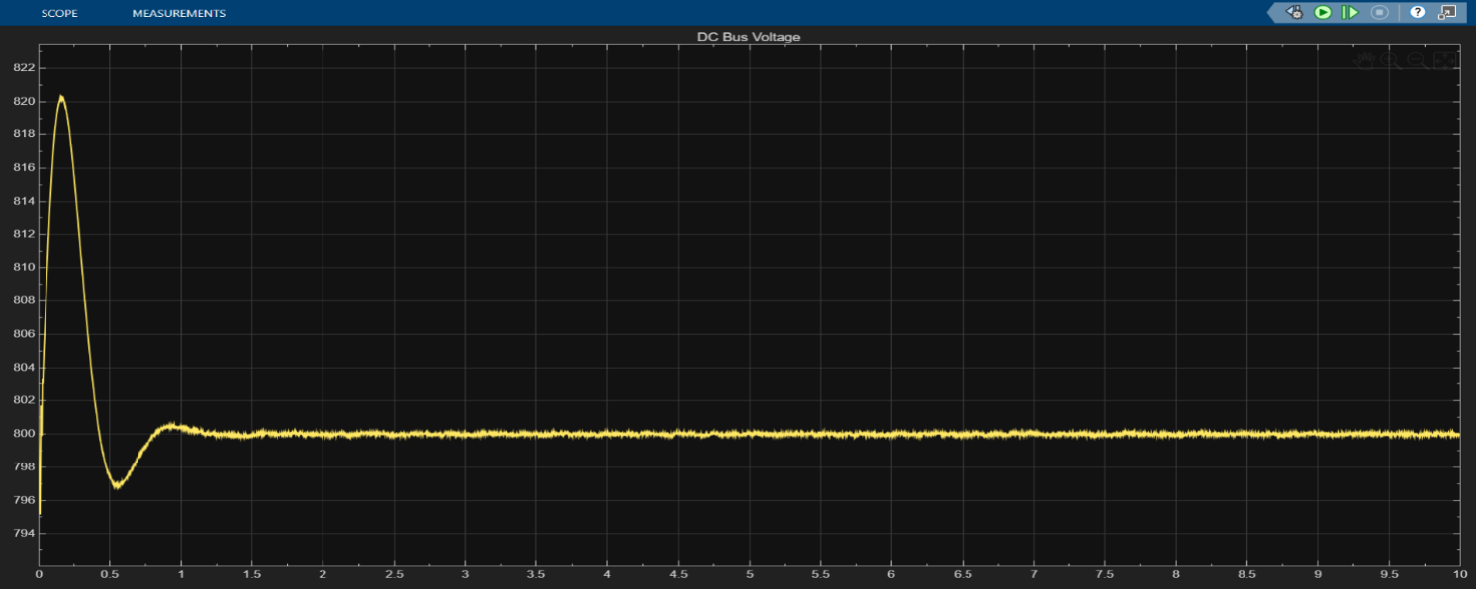
Fig.10 : DC Bus voltage
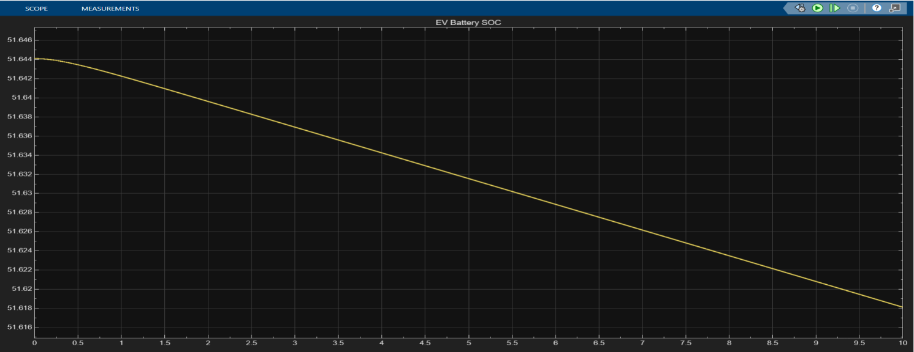
Fig.11 : SOC of the EV Battery
- Case 3 : (Multiple EV operates in both G2V and V2G)
In the last scenario, four electric cars link up through a shared DC line - two pulling power from the grid, two feeding it back. Voltage and current from the grid form smooth sine waves, which means the LCL filter handles harmonics well and balance holds steady. Current trails behind voltage here because some energy gets soaked up by the charging vehicles. Despite shifting loads, the DC line sticks close to 800 volts, proving solid control over inverter performance. Battery levels drop in V2G units as they send out electricity, whereas G2V pack levels climb, revealing synchronized flow both ways and reliable handling across multiple EVs.
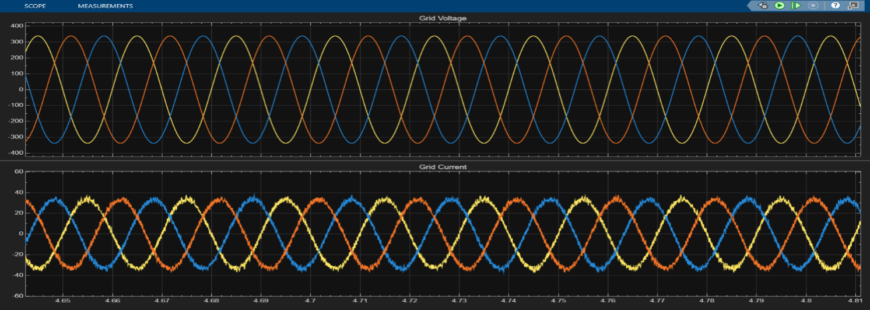
Fig.12 : Grid Voltage and Current.
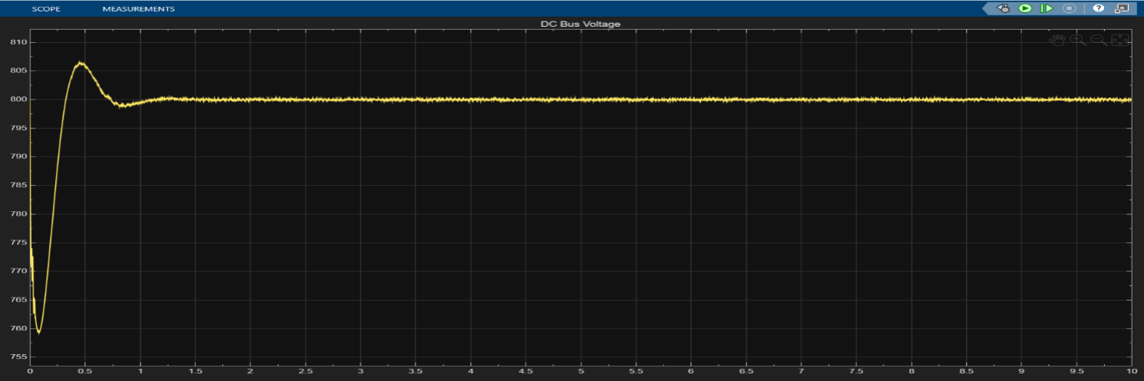
Fig.13 : DC Bus voltage
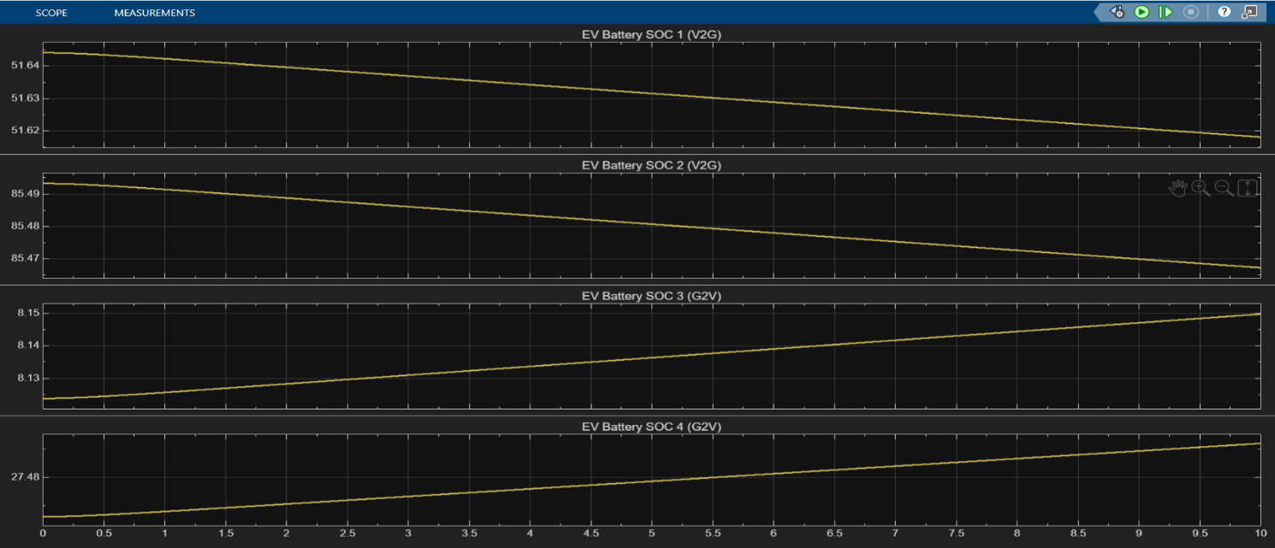
Fig.14 : SOC of the EV Battery
CONCLUSION :
This project shows how a two-way EV charger works, switching between drawing power from the grid and sending it back through one shared DC line. Instead of relying on complex setups, it uses a three-phase inverter managed by dq-PLL control, paired with an LCL filter that cuts down electrical noise, alongside separate DC–DC converters for every car to keep energy moving smoothly. Simulations confirm voltage and current stay clean and sine-shaped, proving the feedback loop and filtering do their job right. No matter the load or mode, the DC link holds steady at 800 volts, making sure transfers between cars and grid don’t falter. When charging, the vehicle’s battery level climbs since electricity flows in from the network; during reverse delivery, that charge drops because energy moves out into the grid. In a setup with four electric vehicles working together, some charge while others release power at the same time, keeping everything in check. The model shows it’s doable to link several EVs so they send energy both ways, helping the grid stay steady, making better use of green power, and handling electricity smarter.
REFERENCES :
- Tan, K. T., Ramachandaramurthy, V. K., Yong, J. Y., Mithulananthan, N., & Bansal, R. C. (2016). Integration of electric vehicles in smart grid: A review on vehicle to grid technologies and optimization techniques. Renewable and Sustainable Energy Reviews, 53, 720–732.
- Kempton, W., & Tomić, J. (2005). Vehicle-to-grid power fundamentals: Calculating capacity and net revenue. Journal of Power Sources, 144(1), 268–279.
- Gough, R., Dickerson, C., Rowley, P., & Walsh, C. (2017). Vehicle-to-grid feasibility: A techno-economic analysis of EV-based energy storage. Applied Energy, 192, 12–23.
- Tasnim, M. N. (2024). A critical review on contemporary power-electronics interfaces for vehicle-to-grid applications. IET Power Electronics.
- Aneke, J., & [coauthor]. (2024). Design and simulation considerations for three-phase bidirectional EV chargers. International Journal of Electric and Electronic Engineering (IJEEI).
- Sonnati, V., [coauthors]. (2024). Soft-switching three-phase bidirectional charger design and control. E3S Conferences (ICREGCSD Proceedings).
- Buberger, J., [coauthors]. (2023). Bidirectional charging for battery electric vehicles with reconfigurable modular architectures. MDPI Electronics.
- Gough, R., Dickerson, C., Rowley, P., & Walsh, C. (2017). Vehicle-to-grid feasibility: A techno-economic analysis of EV-based energy storage. Applied Energy, 192, 12–23.
- The Guardian. (2024, July 9). Canberra trial shows EVs can provide backup power to grid in blackouts and emergencies. The Guardian.

