**RAJAGOPAL FSD55WD2**

The Product documents are store in a JASzha Collection.

>use JASzha

**1.Find all the information about each product:**

> db.products.find()

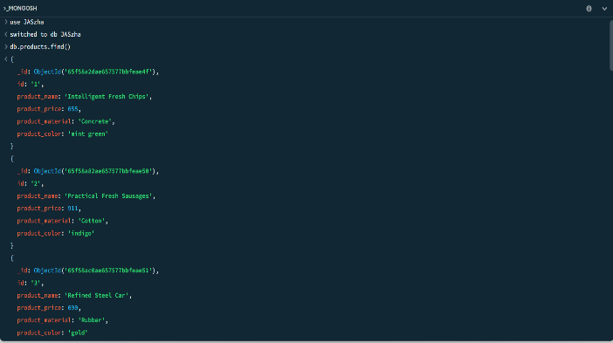 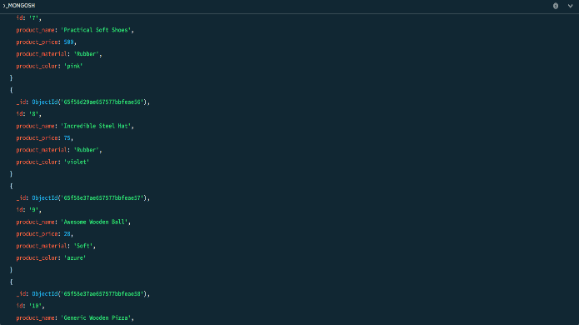 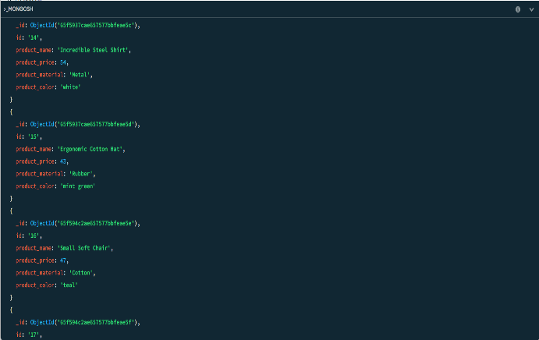 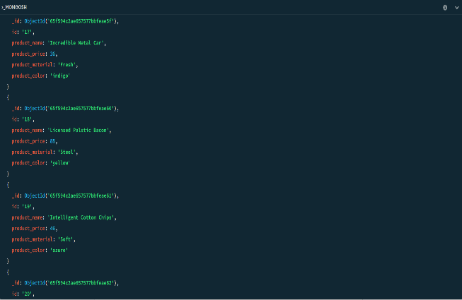 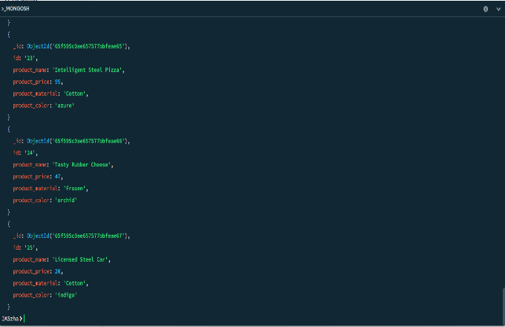

**2. Find the product price which are between 400 to 800**

> db.products.find( { product_price:{ $gt: 400, $lt:800 } } )

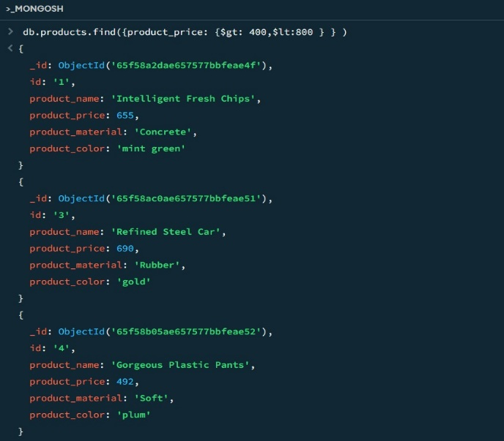 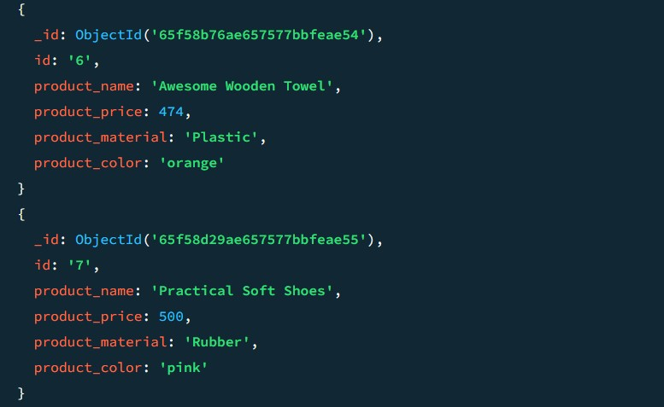

**3. Find the product price which are not between 400 to 600**

> db.products.find({ $or : [ { product_price:{$lt:400} } , { product_price : {$gt:600} } ] }) .sort( {product_price:-1} )

> it

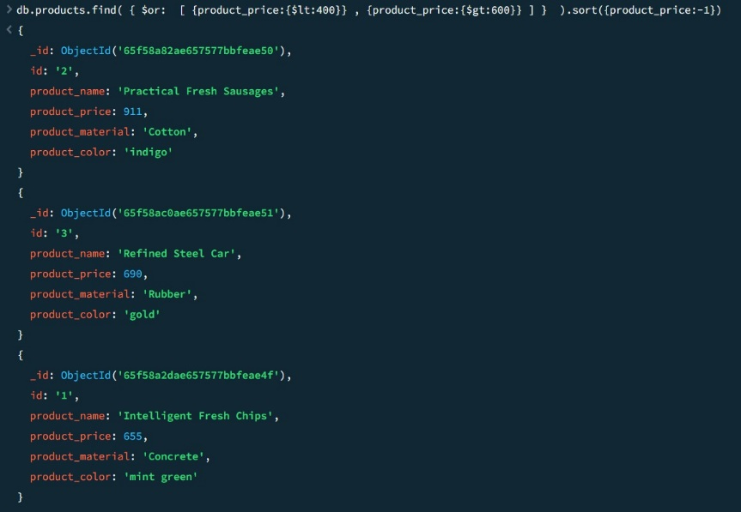 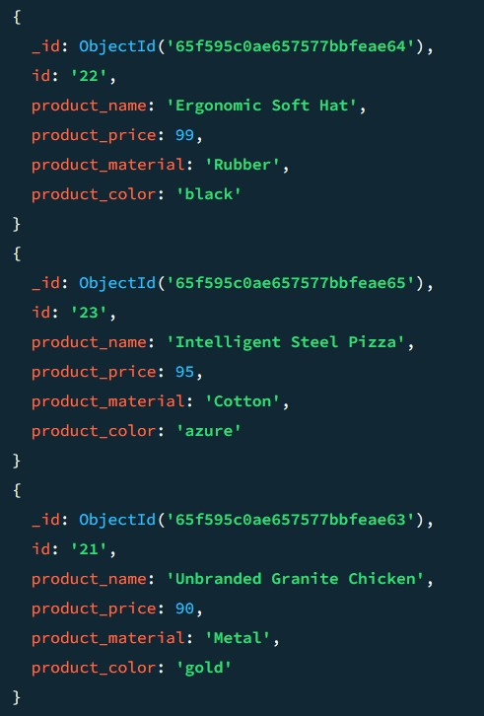

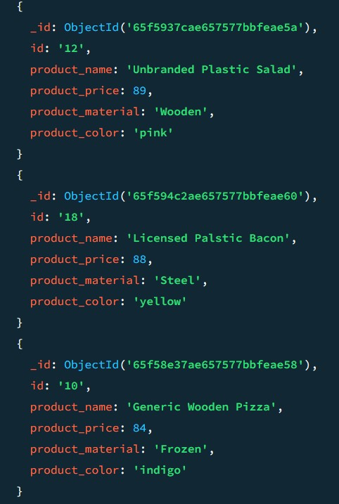 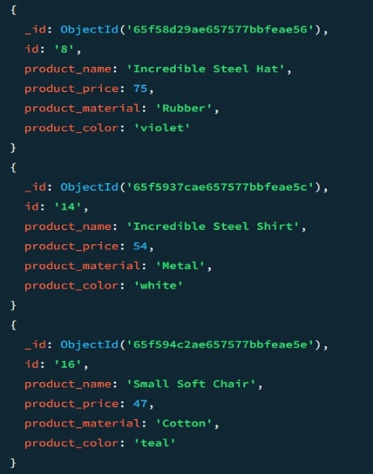 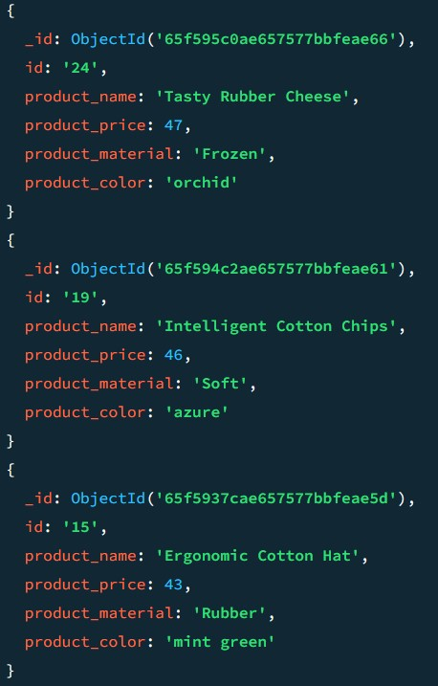

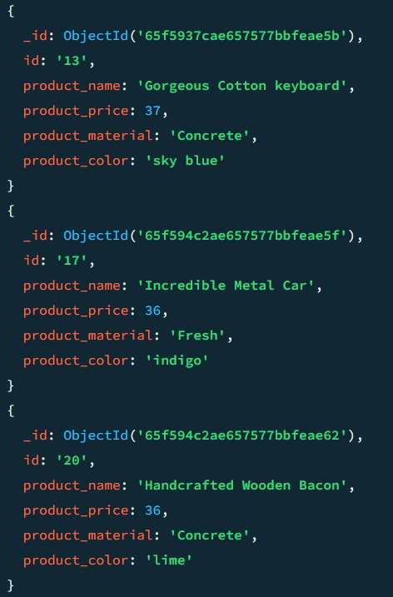 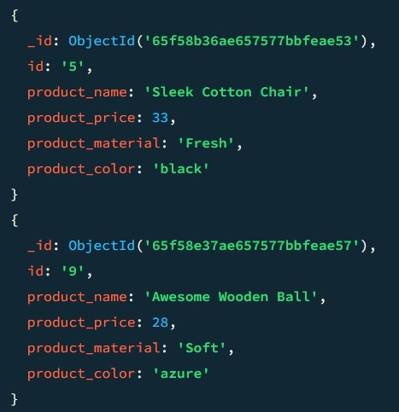 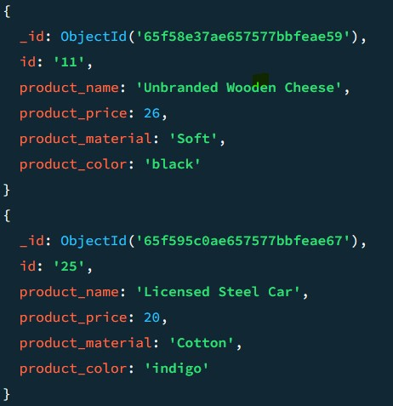

**4. List the four product which are greater than 500 in price**

> db.products.find( { product_price:{$gt: 500} } )

.sort({product_price:1).limit(4)

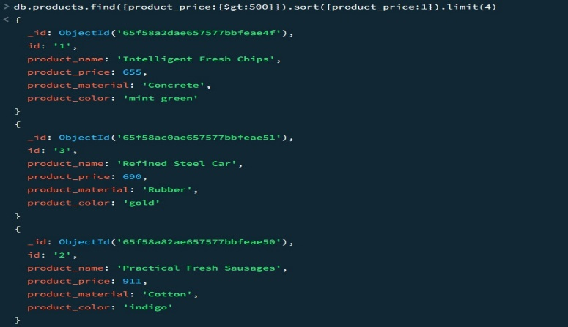

**5. Find the product name and product material of each products**

> db.products.find({“id”:{$exists:1}},{product_name:1, product_material:1}).sort({product_name:1})

> it

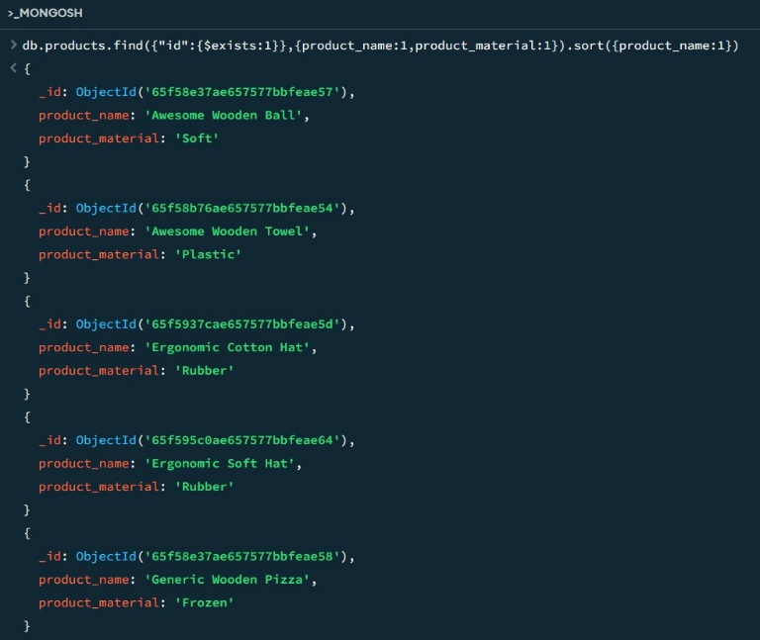 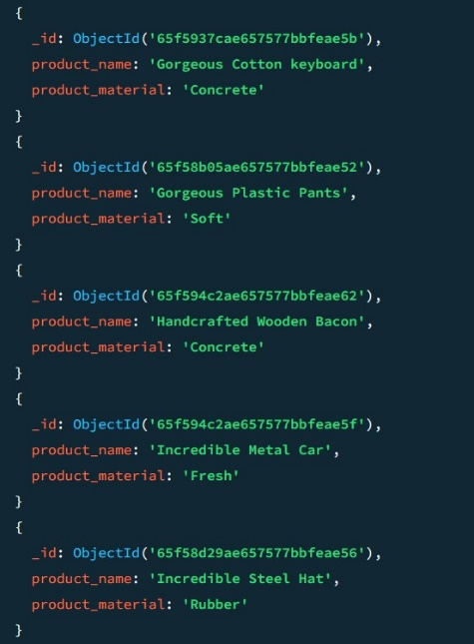

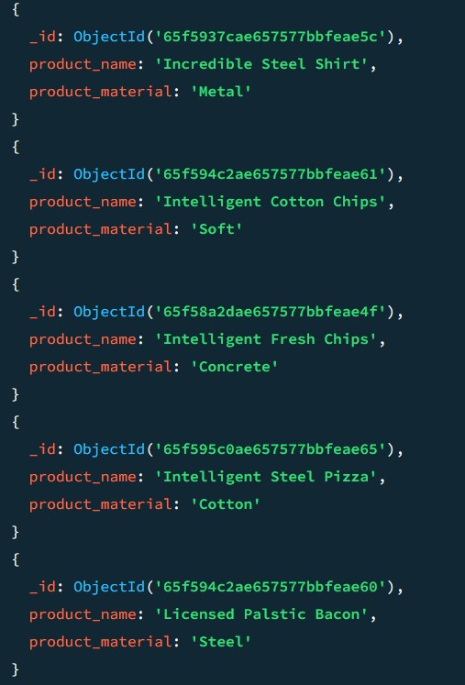 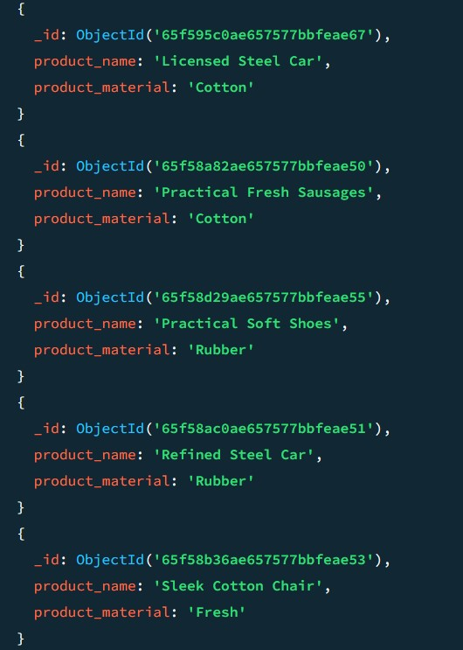 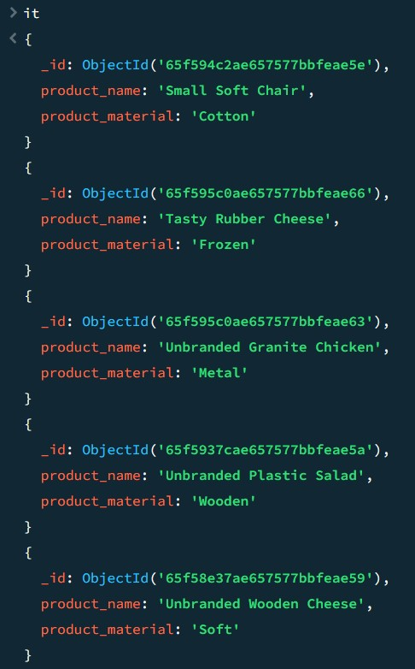

**6. Find the product with a row id of 10**

> db.products.find( { id : “10” } )

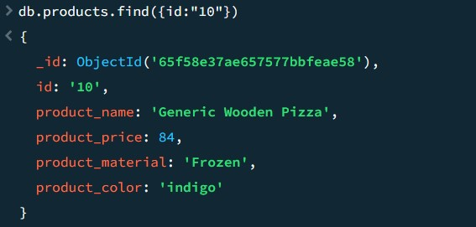

**7. Find only the product name and product material**

> db.products.find({},{product_name:1,product_material:1,_id:0})

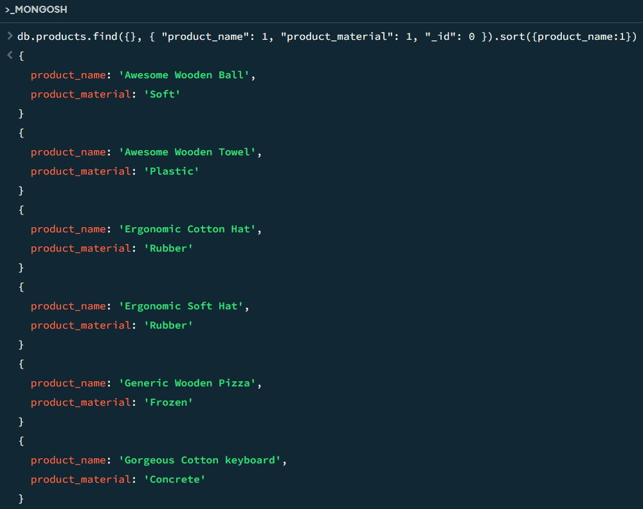 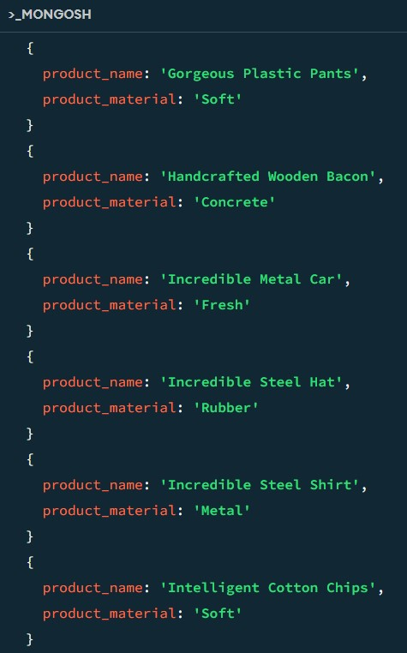

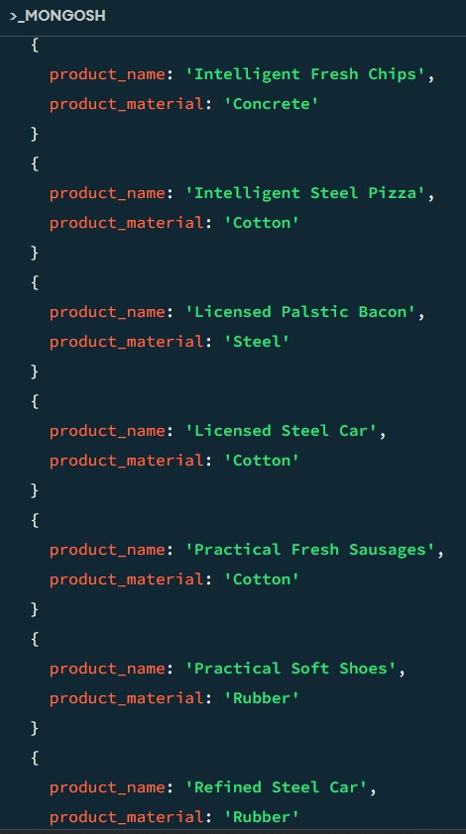 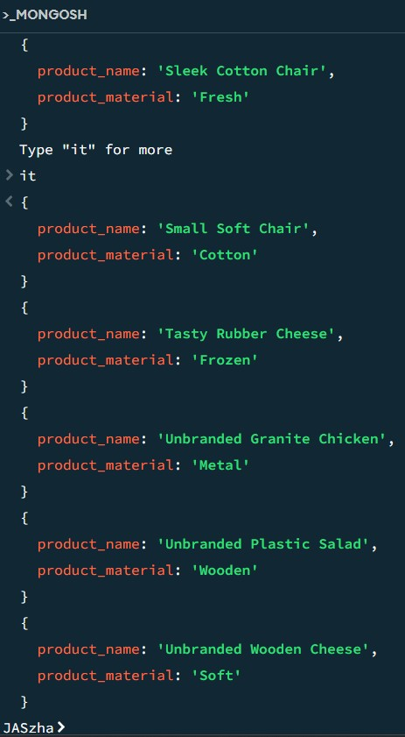

**8. Find all products which contain the value of soft in product material**

> db.products.find( { product_material : “Soft” } )

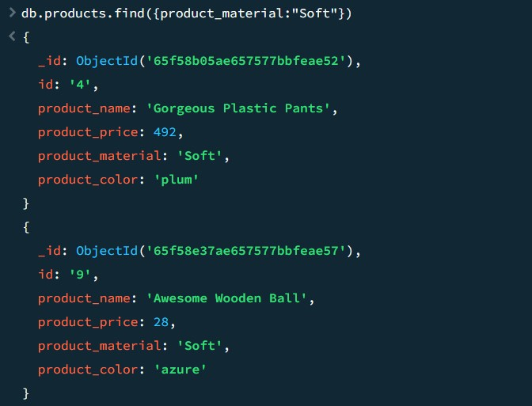 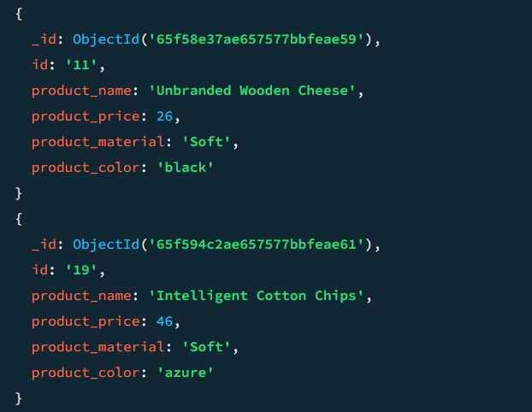

**9. Find products which contain product color indigo and product price 492.00**

> db.products.find ( { product_color: “indigo”, product_price:492 } )

No one product not available color in indigo and price 492

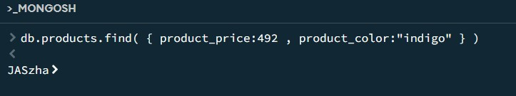

**10. Delete the products which product price value are same**