**FIIT-(FUTURA INNOVATIVE INFORMATION TECHNOLOGY FORMATION PRIVATE LIMITED-TIRUVANNAMALAI-606604)**

**A Project Report Submitted To Tiruvannamalai Branch in Partial Fulfilment Of The Requirement For The Award Of The Course Of…,**

****HTML,CSS,JAVASCRIPT PROJECT****

**FOOD ZONE WEBSITE**

****Under the Guidance Of****

****AKSHAYA.S****

*****Software Trainer*****

****A Project Submitted By****

****ABINESH.R****

********

**FIIT-(FUTURA INNOVATION INFORMATION TECHNOLOGY FORMATION PRIVATE LIMITED)**

**#1545,1st FLOOR,VELLORE MAIN ROAD,VENGIKKAL,TIRUVANNAMALAI-606604**

**JUNE-2024**

***FOODZONE WEBSITE***

**1. Introduction:**

The FoodZone website is a responsive web application designed to showcase various food items and related services. It provides users with information about different food offerings, pricing plans, client reviews, blogs, and contact details. The website is built using HTML, CSS, and JavaScript, with the addition of various external libraries for enhanced functionality and design.

## **2. Project Structure**

* **HTML Files**: The primary structure of the website.
* **CSS Files**: Styling of the website, including layout, fonts, and responsiveness.
* **JavaScript Files**: Adding interactivity to the website.
* **Images**: Used for displaying food items, client reviews, and blog posts.

## **3. HTML Structure**

### **3.1 Head Section**

* **Meta Tags**: Define the character set, viewport settings, and compatibility settings for Internet Explorer.
* **External CSS Links**:
  + **Swiper CSS**: For the slider functionality.
  + **Font Awesome**: For using icons throughout the website.
  + **Custom CSS**: Link to the main stylesheet, style.css.

### **3.2 Body Section**

#### **3.2.1 Header Section**

* **Logo**: Includes a logo icon and the website name "Food Zone."
* **Search Form**: An input field for users to search for food items.
* **Icons**: Interactive icons for search, theme change, user login, and menu.
* **Navigation Bar**: Links to different sections of the website (Home, Packages, Services, Pricing, Review, Contact, Blogs).

#### **3.2.2 Home Section**

* **Image and Content**: Displays an eye-catching image of a burger and text promoting the website.
* **Explore Button**: A call-to-action button that encourages users to explore the website.

#### **3.2.3 Filter Form Section**

* **Form Fields**: Input fields for users to search places, select a date, and choose a time for booking.

#### **3.2.4 Packages Section**

* **Heading**: Highlights the food items available.
* **Food Items**: Displays various food items, including images, prices, and order buttons.

#### **3.2.5 Pricing Section**

* **Plans**: Displays different pricing plans (Basic, Standard, Premium) with their respective benefits and costs.

#### **3.2.6 Review Section**

* **Client Reviews**: Features testimonials from clients, with images, names, reviews, and star ratings.
* **Swiper Slider**: Implements a slider to showcase multiple reviews.

#### **3.2.7 Contact Section**

* **Form**: Allows users to send a message by providing their name, email, phone number, subject, and message.

#### **3.2.8 Blogs Section**

* **Blog Posts**: Displays blog articles with images, titles, read more buttons, and meta information like date and author.

#### **3.2.9 Footer Section**

* **Branches**: Lists the different locations where the FoodZone branches are located.
* **Quick Links**: Provides navigation shortcuts to various sections of the website.
* **Contact Info**: Displays email, phone number, and address for contact.
* **Social Media Links**: Includes icons and links to social media profiles.

## **4. CSS Styling**

### **4.1 Root Variables**

Defines the primary color scheme and default styles for text, background, and box shadows.

### **4.2 Global Styles**

* **Font Family**: Poppins, imported from Google Fonts.
* **Base Styles**: Resetting margins, padding, and box-sizing for consistency.

### **4.3 Specific Section Styles**

* **Header**: Fixed positioning with a background color and box shadow for a floating effect.
* **Buttons**: Custom styling for the buttons with hover effects.
* **Sections**: Padding and layout settings for each section.

### **4.4 Responsive Design**

* **Media Queries**: Ensures the website is fully responsive across different screen sizes.

## **5. JavaScript Functionality**

### **5.1 AOS (Animate On Scroll)**

* **Initialization**: The AOS library is used for smooth animations as the user scrolls through the website.
* **Custom Settings**: Duration and delay for animations.

### **5.2 Swiper.js**

* **Initialization**: Handles the slider functionality for the review section.
* **Custom Settings**: Configurations for the Swiper slider, such as autoplay, navigation, and pagination.

## **6. External Resources**

* **Font Awesome**: Used for icons.
* **Google Fonts**: Poppins font.
* **Swiper.js**: For the review slider.
* **AOS.js**: For scroll animations.

## **7. Conclusion**

The FoodZone website effectively showcases the food offerings and services in a user-friendly and visually appealing manner. The combination of HTML, CSS, and JavaScript, along with external libraries, provides a seamless and interactive experience for users.

***Html code:***

<!DOCTYPE html>

<html lang="en">

<head>

<meta charset="UTF-8">

<meta http-equiv="X-UA-Compatible" content="IE=edge">

<meta name="viewport" content="width=device-width, initial-scale=1.0">

<link rel="stylesheet" href="https://unpkg.com/swiper/swiper-bundle.min.css" />

<!-- font awesome cdn link -->

<link rel="stylesheet" href="https://cdnjs.cloudflare.com/ajax/libs/font-awesome/6.1.1/css/all.min.css">

<!-- custom css file cdn link -->

<link rel="stylesheet" href="style.css">

</head>

<body>

<!-- header section start -->

<header class="header">

<a href="#" class="logo"> <i class="fas fa-utensils"></i> Food Zone </a>

<form action="" class="search-form">

<input type="search" name="" placeholder="search here..." id="searchBox">

<label for="searchBox" class="fas fa-search"></label>

</form>

<div class="icons">

<div class="fas fa-search" id="search-btn"></div>

<div class="fas fa-share" id="theme-btn"></div>

<div class="fas fa-user" id="login-btn"></div>

<div class="fas fa-bars" id="menu-btn"></div>

</div>

<nav class="navbar">

<a href="#home">home</a>

<a href="#packages">packages</a>

<a href="#services">services</a>

<a href="#pricing">pricing</a>

<a href="#review">review</a>

<a href="#contact">contact</a>

<a href="#blogs">blogs</a>

</nav>

</header>

<!-- header section ends -->

<!-- home section start -->

<section class="home" id="home">

<div class="image" data-aos="fade-down">

<img src="https://cdn.vox-cdn.com/thumbor/8hZcUxUOBb4GV1JiDsz1USpT29w=/385x352:1561x1061/1200x800/filters:focal(831x620:1137x926)/cdn.vox-cdn.com/uploads/chorus_image/image/70609268/Burger_King_Plant_based_Double_Cheeezeburger.0.jpg" alt="">

</div>

<div class="content" data-aos="fade-up">

<h3>Most Tasty Burger For You</h3>

<p>At FoodZone, we take pride in serving burgers that are both tasty and unforgettable. Whether you’re in the mood for a classic cheeseburger or something more adventurous, we’ve got you covered</p>

<a href="#" class="btn">explore now</a>

</div>

</section>

<!-- home section ends -->

<!-- filter form section starts -->

<section class="form-container" data-aos="zoom-in">

<form action="">

<div class="inputBox">

<span>where</span>

<input type="text" placeholder="search places">

</div>

<div class="inputBox">

<span>When</span>

<input type="date">

</div>

<div class="inputBox">

<span>Time</span>

<input type="time">

</div>

<input type="submit" value="book now" class="btn">

</form>

</section>

<!-- filter form section ends -->

<!-- packages section starts -->

<section class="packages" id="packages">

<h1 class="heading"> our <span>Foods</span> </h1>

<div class="box-container">

<div class="box" data-aos="fade-up">

<div class="image">

<img src="blog-1.jpg" alt="">

<h3> <i class="fas fa-utensils"></i> Burger </h3>

</div>

<div class="content">

<div class="price"> 290.99 <span>350.99</span> </div>

<p>"Bursting with flavor and grilled to perfection! 🔥🍔"</p>

<a href="#" class="btn"> Order now</a>

</div>

</div>

<div class="box" data-aos="fade-up">

<div class="image">

<img src="blog-2.jpg" alt="">

<h3> <i class="fas fa-utensils"></i> Burger </h3>

</div>

<div class="content">

<div class="price"> 290.99 <span>350.99</span> </div>

<p>"A sandwich that's as satisfying as it is delicious! 🤤🍞"</p>

<a href="#" class="btn"> Order now</a>

</div>

</div>

<div class="box" data-aos="fade-up">

<div class="image">

<img src="blog-3.jpg" alt="">

<h3> <i class="fas fa-utensils"></i> Burger </h3>

</div>

<div class="content">

<div class="price"> 290.99 <span>350.99</span> </div>

<p>"A plate of biryani is pure happiness! 🍛❤️"</p>

<a href="#" class="btn"> Order now</a>

</div>

</div>

<div class="box" data-aos="fade-up">

<div class="image">

<img src="blog-4.jpg" alt="">

<h3> <i class="fas fa-utensils"></i> Burger </h3>

</div>

<div class="content">

<div class="price"> 290.99 <span>350.99</span> </div>

<p>Happiness is a bowl full of perfectly spiced biryani. 😊🍚"</p>

<a href="#" class="btn"> Order now</a>

</div>

</div>

<div class="box" data-aos="fade-up">

<div class="image">

<img src="blog-5.jpg" alt="">

<h3> <i class="fas fa-utensils"></i> Burger </h3>

</div>

<div class="content">

<div class="price"> 290.99 <span>350.99</span> </div>

<p>"A delicious chicken recipe that never fails to impress! 🌟👩‍🍳"</p>

<a href="#" class="btn"> Order now</a>

</div>

</div>

<div class="box" data-aos="fade-up">

<div class="image">

<img src="blog-6.jpg" alt="">

<h3> <i class="fas fa-utensils"></i> Burger </h3>

</div>

<div class="content">

<div class="price"> 290.99 <span>350.99</span> </div>

<p>"This chicken recipe is finger-licking good! 🍗🤤"</p>

<a href="#" class="btn"> Order now</a>

</div>

</div>

</div>

</section>

<!-- packages section ends -->

<!-- pricing section starts -->

<section class="pricing" id="pricing">

<h1 class="heading"> our <span>pricing</span> </h1>

<div class="box-container">

<div class="box" data-aos="zoom-in-up">

<h3> basic plan </h3>

<div class="price">

<span>$</span>

<span class="amount">30</span>

<span>/mo</span>

</div>

<ul>

<li>10 days</li>

<li>food and drinks</li>

<li>safty guide</li>

<li>insurance</li>

<li>luxury hotel</li>

</ul>

<a href="#" class="btn">choose plan</a>

</div>

<div class="box" data-aos="zoom-in-up">

<h3> standard plan </h3>

<div class="price">

<span>$</span>

<span class="amount">50</span>

<span>/mo</span>

</div>

<ul>

<li>20 days</li>

<li>food and drinks</li>

<li>safty guide</li>

<li>insurance</li>

<li>luxury hotel</li>

</ul>

<a href="#" class="btn">choose plan</a>

</div>

<div class="box" data-aos="zoom-in-up">

<h3> premium plan </h3>

<div class="price">

<span>$</span>

<span class="amount">90</span>

<span>/mo</span>

</div>

<ul>

<li>30 days</li>

<li>food and drinks</li>

<li>safty guide</li>

<li>insurance</li>

<li>luxury hotel</li>

</ul>

<a href="#" class="btn">choose plan</a>

</div>

</div>

</section>

<!-- pricing section ends -->

<!-- review section starts -->

<section class="review" id="review">

<h1 class="heading"> client's <span>review</span> </h1>

<div class="swiper-container review-slider" data-aos="zoom-in">

<div class="swiper-wrapper">

<div class="swiper-slide slide">

<img src="p-1.jpg" alt="">

<h3>Ravi</h3>

<p>FoodZone Biriyani provides a satisfying dining experience with its delicious biryani offerings and pleasant environment. It's a great spot for biryani enthusiasts looking to enjoy traditional flavors in a relaxed setting. </p>

<div class="stars">

<i class="fas fa-star"></i>

<i class="fas fa-star"></i>

<i class="fas fa-star"></i>

<i class="fas fa-star"></i>

<i class="fas fa-star-half-alt"></i>

</div>

</div>

<div class="swiper-slide slide">

<img src="p-2.jpg" alt="">

<h3>Chandru</h3>

<p> A FoodZone Prices are reasonable for the quality and portion sizes. The value for money is commendable, especially considering the generous servings and fresh ingredients.</p>

<div class="stars">

<i class="fas fa-star"></i>

<i class="fas fa-star"></i>

<i class="fas fa-star"></i>

<i class="fas fa-star"></i>

<i class="fas fa-star-half-alt"></i>

</div>

</div>

<div class="swiper-slide slide">

<img src="p-3.jpg" alt="">

<h3>Dinesh</h3>

<p>FoodZone Biriyani offers excellent value for money. The pricing reflects the high quality of ingredients and the care taken in preparation. Generous portions ensure you leave fully satisfied, making it a worthwhile dining experience.</p>

<div class="stars">

<i class="fas fa-star"></i>

<i class="fas fa-star"></i>

<i class="fas fa-star"></i>

<i class="fas fa-star"></i>

<i class="fas fa-star-half-alt"></i>

</div>

</div>

<div class="swiper-slide slide">

<img src="p-4.jpg" alt="">

<h3>Manoj</h3>

<p>The service at FoodZone Biriyani is impeccable. From the moment you walk in, you’re greeted with a genuine smile and attentive care.</p>

<div class="stars">

<i class="fas fa-star"></i>

<i class="fas fa-star"></i>

<i class="fas fa-star"></i>

<i class="fas fa-star"></i>

<i class="fas fa-star-half-alt"></i>

</div>

</div>

</div>

</div>

</section>

<!-- review section ends -->

<!-- contact section starts -->

<section class="contact" id="contact">

<h1 class="heading"> <span>contact</span> us </h1>

<form action="" data-aos="zoom">

<div class="inputBox">

<input type="text" placeholder="name" data-aos="fade-up">

<input type="email" placeholder="email" data-aos="fade-up">

</div>

<div class="inputBox">

<input type="number" placeholder="number" data-aos="fade-up">

<input type="text" placeholder="subject" data-aos="fade-up">

</div>

<textarea name="" placeholder="your message" id="" cols="30" rows="10" data-aos="fade-up"></textarea>

<input type="submit" value="send message" class="btn">

</form>

</section>

<!-- contact section ends -->

<!-- blog section starts -->

<section class="blogs" id="blogs">

<h1 class="heading"> our <span>blogs</span> </h1>

<div class="box-container">

<div class="box" data-aos="fade-up">

<div class="image">

<img src="img1.jpg" alt="">

</div>

<div class="content">

<h3>What is bombay and hyderabadi biryani?</h3>

<a href="#" class="btn">read more</a>

<div class="icons">

<a href="#"> <i class="fas fa-calendar"></i> 1st jan, 2021 </a>

<a href="#"> <i class="fas fa-user"></i> by admin </a>

</div>

</div>

</div>

<div class="box" data-aos="fade-up">

<div class="image">

<img src="img2.jpg" alt="">

</div>

<div class="content">

<h3>How many types of burger are there?</h3>

<a href="#" class="btn">read more</a>

<div class="icons">

<a href="#"> <i class="fas fa-calendar"></i> 1st jan, 2021 </a>

<a href="#"> <i class="fas fa-user"></i> by admin </a>

</div>

</div>

</div>

<div class="box" data-aos="fade-up">

<div class="image">

<img src="img3.jpg" alt="">

</div>

<div class="content">

<h3>Did you know some facts about pizza?</h3>

<a href="#" class="btn">read more</a>

<div class="icons">

<a href="#"> <i class="fas fa-calendar"></i> 1st jan, 2021 </a>

<a href="#"> <i class="fas fa-user"></i> by admin </a>

</div>

</div>

</div>

</div>

</section>

<!-- blog section ends -->

<!-- footer section starts -->

<section class="footer">

<div class="box-container">

<div class="box" data-aos="fade-up">

<h3>our branches</h3>

<a href="#"> <i class="fas fa-map-marker-alt"></i> india </a>

<a href="#"> <i class="fas fa-map-marker-alt"></i> russia </a>

<a href="#"> <i class="fas fa-map-marker-alt"></i> japan </a>

<a href="#"> <i class="fas fa-map-marker-alt"></i> france </a>

<a href="#"> <i class="fas fa-map-marker-alt"></i> canada </a>

</div>

<div class="box" data-aos="fade-up">

<h3>quick links</h3>

<a href="#"> <i class="fas fa-chevron-right"></i> home </a>

<a href="#"> <i class="fas fa-chevron-right"></i> packages </a>

<a href="#"> <i class="fas fa-chevron-right"></i> services </a>

<a href="#"> <i class="fas fa-chevron-right"></i> pricing </a>

<a href="#"> <i class="fas fa-chevron-right"></i> review </a>

<a href="#"> <i class="fas fa-chevron-right"></i> contact </a>

<a href="#"> <i class="fas fa-chevron-right"></i> blogs </a>

</div>

<div class="box" data-aos="fade-up">

<h3>contact info</h3>

<a href="#"> <i class="fas fa-envelop"></i> Abineshraja12@gmail.com </a>

<a href="#"> <i class="fas fa-phone"></i> +6379201156 </a>

<a href="#"> <i class="fas fa-map-marker-alt"></i> chennai, india - 606602 </a>

</div>

<div class="box" data-aos="fade-up">

<h3>follow us</h3>

<a href="#"> <i class="fab fa-facebook-f"></i> facebook </a>

<a href="#"> <i class="fab fa-twitter"></i> twitter </a>

<a href="#"> <i class="fab fa-instagram"></i> instagram </a>

<a href="https://www.linkedin.com/in/abineshraja12/"> <i class="fab fa-linkedin"></i> linkedin </a>

<a href="#"> <i class="fab fa-pinterest"></i> pinterest </a>

</div>

</div>

<div class="credit"> creadet by <span>My Rowdy</span> | all rights reserved </div>

</section>

<!-- footer section ends -->

<script src="https://cdnjs.cloudflare.com/ajax/libs/aos/2.3.4/aos.js"></script>

<script src="https://unpkg.com/swiper/swiper-bundle.min.js"></script>

<!-- custom js file link -->

<script src="script.js"></script>

<script>

AOS.init({

duration:800,

delay:400

});

</script>

</body>

</html>

***Css code:***

@import url('https://fonts.googleapis.com/css2?family=Poppins:wght@300;600;700&display=swap');

:root{

--orange:#F79F1F;

--text-color-1:#444;

--text-color-2:#666;

--bg-color-1:#fff;

--bg-color-2:#eee;

--box-shadow:0 .5rem 1.5rem rgba(0,0,0,.1);

}

*{

font-family: 'Poppins', sans-serif;

margin:0; padding:0;

box-sizing: border-box;

outline: none; border:none;

text-decoration: none;

text-transform: capitalize;

transition:all .2s linear;

}

html{

font-size: 62.5%;

overflow-x: hidden;

scroll-padding-top: 7rem;

scroll-behavior: smooth;

}

html::-webkit-scrollbar{

width:.8rem;

}

html::-webkit-scrollbar-track{

background:transparent;

}

html::-webkit-scrollbar-thumb{

background:var(--orange);

border-radius: 5rem;

}

body{

background:var(--bg-color-2);

}

body.active{

--text-color-1:#fff;

--text-color-2:#eee;

--bg-color-1:#333;

--bg-color-2:#222;

--box-shadow:0 .5rem 1.5rem rgba(0,0,0,.4);

}

section{

padding:2rem 7%;

}

.heading{

text-align: center;

padding-bottom: 2rem;

color:var(--text-color-1);

font-size: 4rem;

}

.heading span{

position: relative;

z-index: 0;

}

.heading span::before{

content: '';

position: absolute;

left: 0;

z-index: -1;

background: var(--orange);

height: 100%;

width: 100%;

clip-path: polygon(0 90%, 100% 83%, 100% 100%, 0% 100%);

}

.btn{

margin-top: 1rem;

display: inline-block;

padding:.8rem 3rem;

font-size: 1.7rem;

color:#fff;

background:#ab6806;

border-radius: .5rem;

cursor: pointer;

}

.btn:hover{

letter-spacing: .2rem;

}

.header{

position: fixed;

top:0; left:0; right:0;

background:var(--bg-color-1);

box-shadow: var(--box-shadow);

padding: 1.5rem 7%;

z-index: 1000;

display: flex;

align-items: center;

justify-content: space-between;

}

.header .logo{

font-weight: bolder;

font-size: 2.5rem;

color:var(--text-color-1);

}

.header .logo i{

color:var(--orange);

}

.header .search-form{

background:var(--bg-color-2);

border-radius: .5rem;

display: flex;

align-items: center;

height: 4.5rem;

width:50rem;

}

.header .search-form input{

height:100%;

width:100%;

background:none;

text-transform: none;

font-size: 1.5rem;

color:var(--text-color-1);

padding:1rem;

}

.header .search-form label{

font-size: 2rem;

margin-right: 1.5rem;

color:var(--text-color-1);

cursor: pointer;

}

.header .search-form label:hover{

color:var(--orange);

}

.header .icons div{

height:4.5rem;

width:4.5rem;

line-height:4.5rem;

font-size: 2rem;

border-radius: .5rem;

margin-left: .5rem;

background:var(--bg-color-2);

color:var(--text-color-1);

cursor: pointer;

text-align: center;

}

.header .icons div:hover{

color:#fff;

background:var(--orange);

}

#search-btn{

display:none;

}

.header .navbar{

position:absolute;

top:115%; right:7%;

background:var(--bg-color-1);

border-radius: .5rem;

box-shadow: var(--box-shadow);

width:25rem;

transform:scale(0);

transform-origin: top right;

}

.header .navbar.active{

transform:scale(1);

}

.header .navbar a{

display:block;

margin:1rem;

padding:1rem;

font-size: 1.5rem;

color:var(--text-color-1);

border-radius: .5rem;

}

.header .navbar a:hover{

color:var(--orange);

background:var(--bg-color-2);

padding-left: 2rem;

}

.home{

display: flex;

align-items: center;

flex-wrap: wrap;

gap:1.5rem;

padding-top: 7rem;

background: #fff;

}

.home .image{

flex:1 1 45rem;

}

.home .image img{

width: 100%;

}

.home .content{

flex:1 1 45rem;

}

.home .content h3{

color:var(--text-color-1);

font-size: 4rem;

}

.home .content p{

color:var(--text-color-2);

font-size: 1.7rem;

line-height: 1.7;

padding:1rem 0;

}

.form-container form{

background: var(--bg-color-1);

box-shadow: var(--box-shadow);

border-radius: .5rem;

padding:2rem;

display: flex;

flex-wrap: wrap;

gap:1rem;

align-items: center;

}

.form-container form .inputBox{

flex:1 1 23rem;

}

.form-container form .inputBox span{

font-size: 1.7rem;

color:var(--text-color-2);

}

.form-container form .inputBox input{

font-size: 1.5rem;

color:var(--text-color-1);

background:var(--bg-color-2);

border-radius: .5rem;

margin:.5rem 0;

text-transform: none;

width: 100%;

padding:1rem;

}

.form-container form .btn{

flex:1 1 23rem;

}

.packages .box-container{

display: grid;

grid-template-columns: repeat(auto-fit, minmax(30rem, 1fr));

gap:1.5rem;

}

.packages .box-container .box{

background:var(--bg-color-1);

border-radius: .5rem;

box-shadow: var(--box-shadow);

}

.packages .box-container .box .image{

height:25rem;

width: 100%;

padding:1.5rem;

position: relative;

}

.packages .box-container .box .image img{

height:100%;

width: 100%;

object-fit: cover;

border-radius: .5rem;

}

.packages .box-container .box .image h3{

position: absolute;

top:2.5rem; left:2.5rem;

font-size: 2rem;

color:#fff;

background: rgba(0,0,0,.5);

border-radius: .5rem;

font-weight: lighter;

padding:.5rem 1.5rem;

}

.packages .box-container .box .image h3 i{

color:var(--orange);

}

.packages .box-container .box .content{

padding:1.5rem;

padding-top: 0;

}

.packages .box-container .box .content .price{

font-weight: 600;

color:var(--text-color-1);

font-size: 2.5rem;

}

.packages .box-container .box .content .price span{

font-weight: lighter;

color:var(--text-color-2);

font-size: 1.5rem;

text-decoration: line-through;

}

.packages .box-container .box .content p{

font-size: 1.5rem;

padding:.5rem 0;

color:var(--text-color-2);

line-height: 1.7;

}

.pricing .box-container{

display: grid;

grid-template-columns: repeat(auto-fit, minmax(30rem, 1fr));

gap:1.5rem;

}

.pricing .box-container .box{

background:var(--bg-color-1);

border-radius: .5rem;

box-shadow: var(--box-shadow);

padding:2rem;

text-align: center;

}

.pricing .box-container .box h3{

padding:1rem;

background: var(--bg-color-2);

border-radius: .5rem;

font-size: 2rem;

color:var(--text-color-1);

}

.pricing .box-container .box .price{

padding-top: 2rem;

}

.pricing .box-container .box .price span{

font-size: 2rem;

color:var(--text-color-2);

}

.pricing .box-container .box .price .amount{

font-size: 5rem;

color:var(--text-color-1);

font-weight: bolder;

}

.pricing .box-container .box ul{

padding: .5rem 0;

list-style: none;

}

.pricing .box-container .box ul li{

padding: 1rem 0;

font-size: 1.7rem;

color:var(--text-color-2);

}

.review .review-slider{

box-shadow: var(--box-shadow);

}

.review .review-slider .slide{

background: var(--bg-color-1);

border-radius: .5rem;

text-align: center;

padding: 3rem;

}

.review .review-slider .slide img{

height: 10rem;

width: 10rem;

border-radius: 50%;

object-fit: cover;

margin-bottom: .5rem;

}

.review .review-slider .slide h3{

font-size: 2.5rem;

color:var(--text-color-1);

}

.review .review-slider .slide p{

font-size: 1.6rem;

color:var(--text-color-2);

line-height: 1.7;

padding: 1rem 0;

}

.review .review-slider .slide .stars{

padding: 1rem 0;

padding-bottom: 1.5rem;

}

.review .review-slider .slide .stars i{

font-size: 2rem;

color:var(--orange);

}

.swiper-pagination-bullet-active{

background: var(--orange);

}

.contact form{

max-width: 70rem;

margin: 0 auto;

text-align: center;

}

.contact form .inputBox{

display: flex;

flex-wrap: wrap;

justify-content: space-between;

}

.contact form textarea,

.contact form .inputBox input{

width: 100%;

padding:1rem;

font-size: 1.6rem;

color:var(--text-color-1);

margin:.7rem 0;

background: var(--bg-color-1);

box-shadow: var(--box-shadow);

text-transform: none;

border-radius: .5rem;

}

.contact form textarea{

height: 20rem;

resize: none;

}

.contact form .inputBox input{

width: 49%;

}

.blogs .box-container{

display: grid;

grid-template-columns: repeat(auto-fit, minmax(30rem, 1fr));

gap:1.5rem;

}

.blogs .box-container .box{

background:var(--bg-color-1);

border-radius: .5rem;

box-shadow: var(--box-shadow);

padding:2rem;

}

.blogs .box-container .box .image{

height: 20rem;

width: 100%;

overflow:hidden;

border-radius: .5rem;

background: var(--bg-color-2);

}

.blogs .box-container .box .image img{

height: 100%;

width: 100%;

}

.blogs .box-container .box:hover .image img{

transform:scale(1.2);

}

.blogs .box-container .box .content{

padding-top: 1rem;

}

.blogs .box-container .box .content h3{

font-size: 2rem;

color:var(--text-color-1);

line-height: 1.5;

}

.blogs .box-container .box .content .icons{

display: flex;

justify-content: space-between;

border-top: .1rem solid var(--text-color-2);

margin-top: 2rem;

padding-top: 1.5rem;

}

.blogs .box-container .box .content .icons a{

font-size: 1.5rem;

color:var(--text-color-2);

}

.blogs .box-container .box .content .icons a:hover{

color:var(--orange);

}

.blogs .box-container .box .content .icons a i{

padding-right: .5rem;

color:var(--orange);

}

.footer{

background: var(--bg-color-1);

}

.footer .box-container{

display: grid;

grid-template-columns: repeat(auto-fit, minmax(22rem, 1fr));

gap:1.5rem;

}

.footer .box-container .box h3{

font-size: 2.5rem;

color:var(--text-color-1);

padding:1rem 0;

}

.footer .box-container .box a{

display: block;

font-size: 1.5rem;

color:var(--text-color-2);

padding:1rem 0;

}

.footer .box-container .box a i{

padding-right: .5rem;

color:var(--orange);

}

.footer .box-container .box a:hover i{

padding-right: 2rem;

}

.footer .credit{

background-color: var(--bg-color-1);

font-size: 2rem;

text-align: center;

border-top: .3rem solid var(--text-color-2) ;

padding:1rem;

padding-top: 2rem;

margin-top: 2rem;

color:var(--text-color-3);

}

.footer .credit span{

color:var(--orange);

}

/* media queries */

@media (max-width:991px){

html{

font-size: 55%;

}

.header{

padding:1.5rem 2rem;

}

section{

padding:2rem;

}

}

@media (max-width:768px){

.header .navbar{

right: 2rem;

}

.header .login-form{

right: 2rem;

}

#search-btn{

display:inline-block;

}

.header .search-form{

position: absolute;

top:115%; right: 2rem;

background:var(--bg-color-1);

border-radius: .5rem;

width: 90%;

box-shadow: var(--box-shadow);

transform:scale(0);

transform-origin: top right;

}

.header .search-form.active{

transform:scale(1);

}

}

@media (max-width:450px){

html{

font-size: 50%;

}

.contact form .inputBox input{

width: 100%;

}

}

***Java Script Code:***

let navbar = document.querySelector('.navbar')

document.querySelector('#menu-btn').onclick = () =>{

navbar.classList.toggle('active');

loginForm.classList.remove('active');

searchForm.classList.remove('active');

}

let searchForm = document.querySelector('.search-form')

document.querySelector('#search-btn').onclick = () =>{

searchForm.classList.toggle('active');

navbar.classList.remove('active');

loginForm.classList.remove('active');

}

window.onscroll = () =>{

navbar.classList.remove('active');

loginForm.classList.remove('active');

searchForm.classList.remove('active');

}

var swiper = new Swiper(".review-slider", {

loop:true,

spaceBetween: 30,

centeredSlides: true,

autoplay: {

delay: 5500,

disableOnInteraction: false,

},

pagination: {

el: ".swiper-pagination",

},

});

***Output ScreenShot:***

***Pic 1 home page in website:***

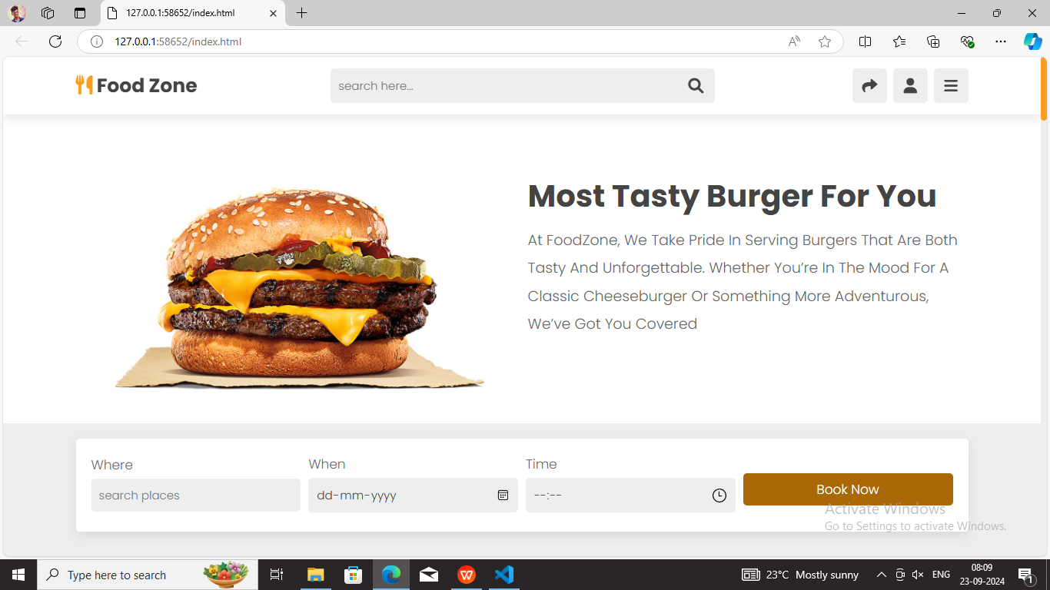

***Pic 2 menu options in website:***

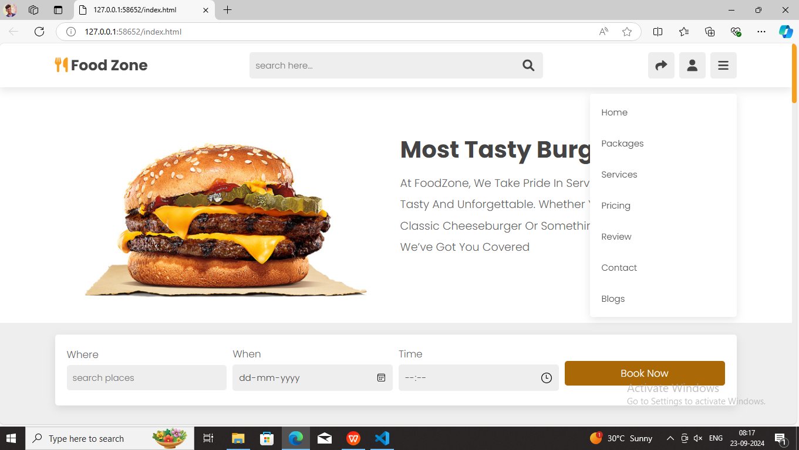

***Pic 3 sign in page :***

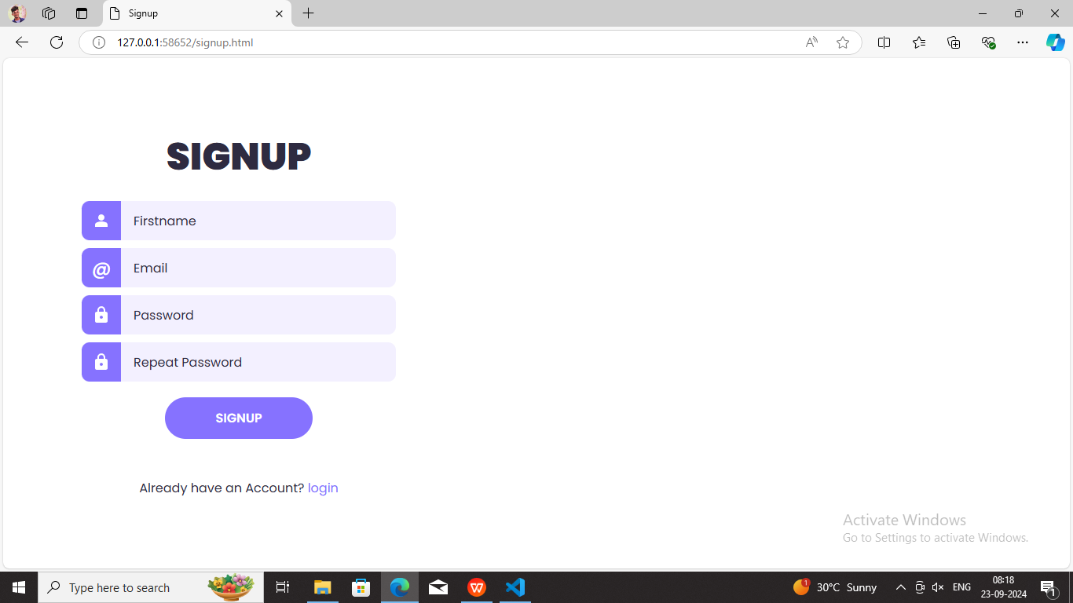

***Pic 4 Login page :***

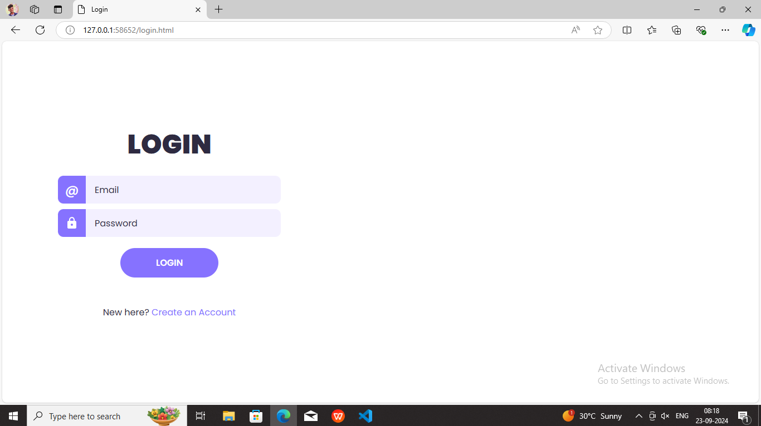

***Pic 5 our foods blog:***

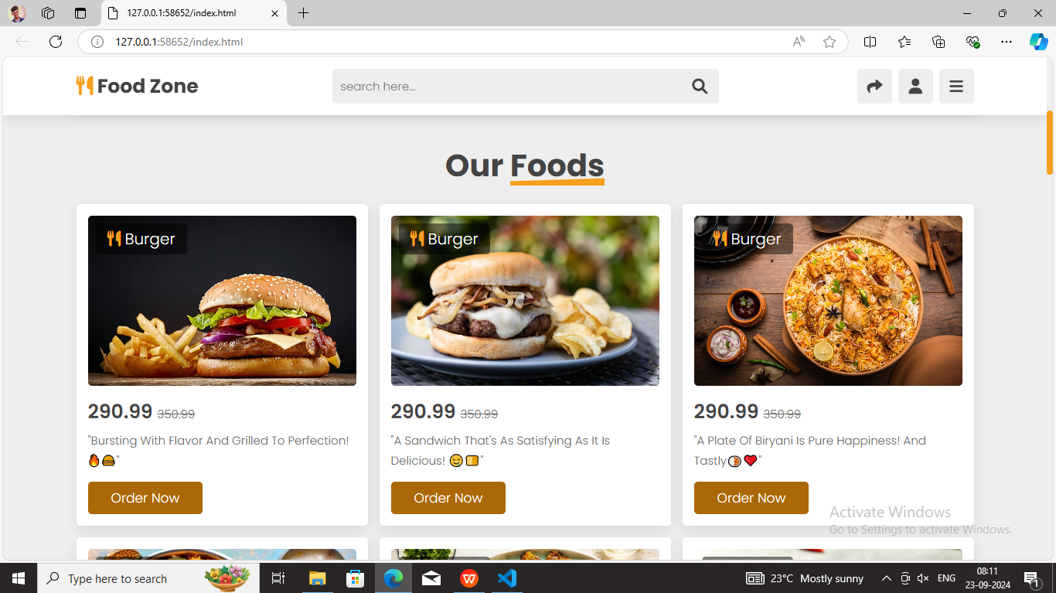

***Pic 5.1 our foods :***

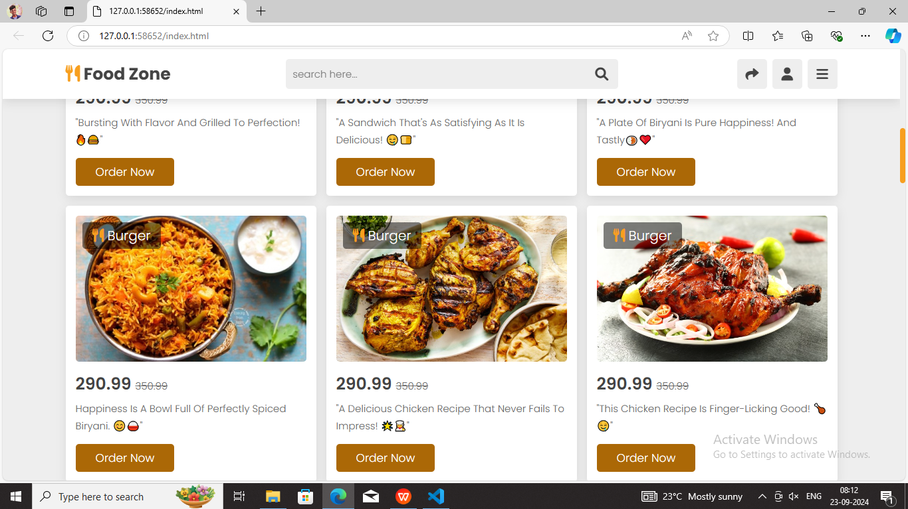

***Pic 6 Pricing plan page :***

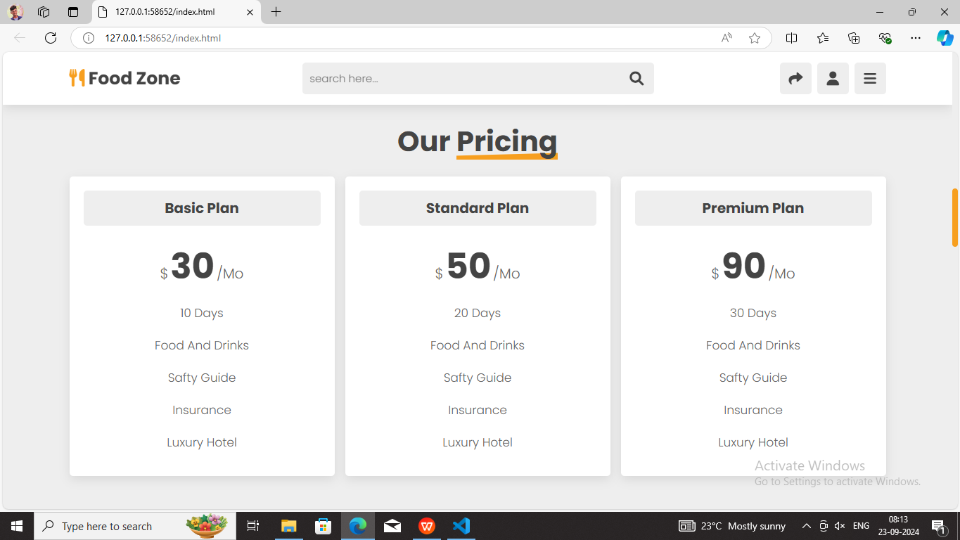

***Pic 7 Review page slide comments:***

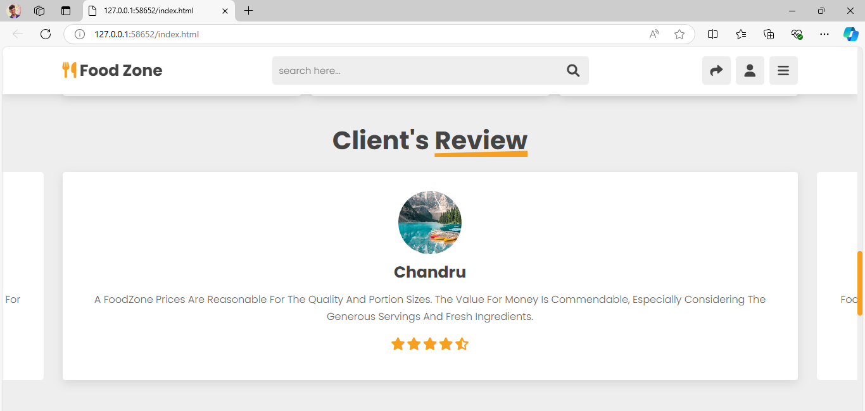

***Pic 8 Contact and message section:***

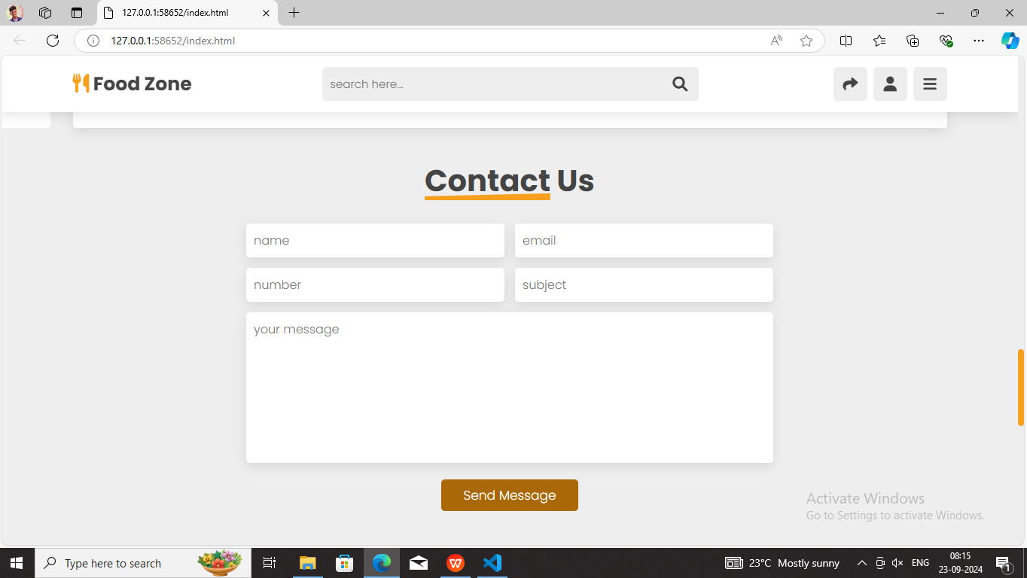

***Pic 9 Discription in blogs of foods :***

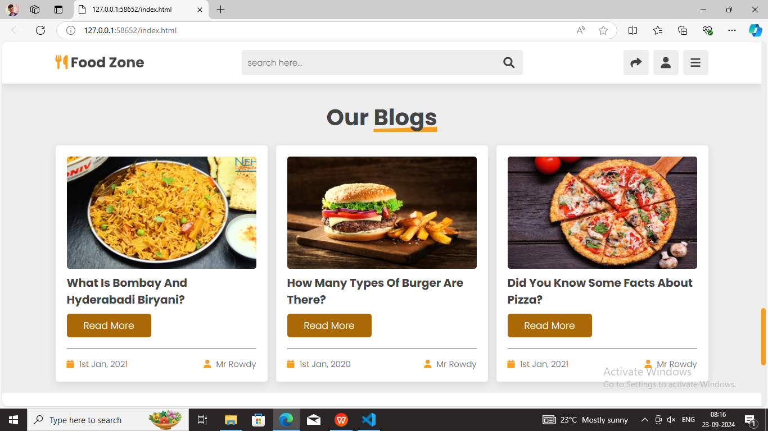

***Pic 10 Footer section and follow links :***

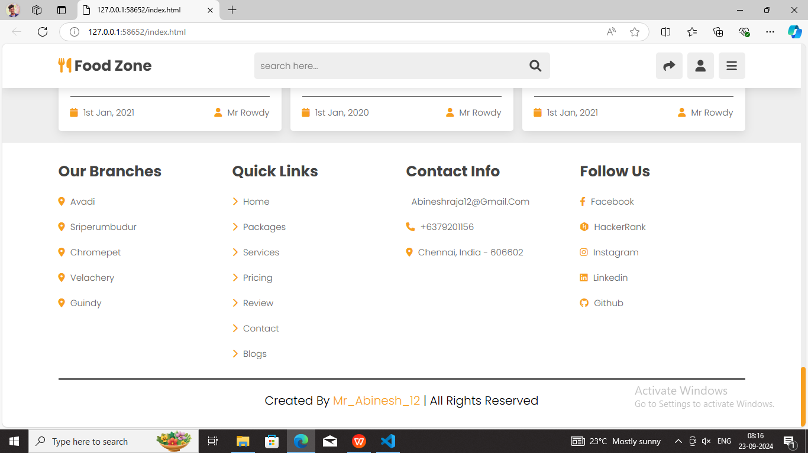

***Thank you…***