**Project Name: CARTway**

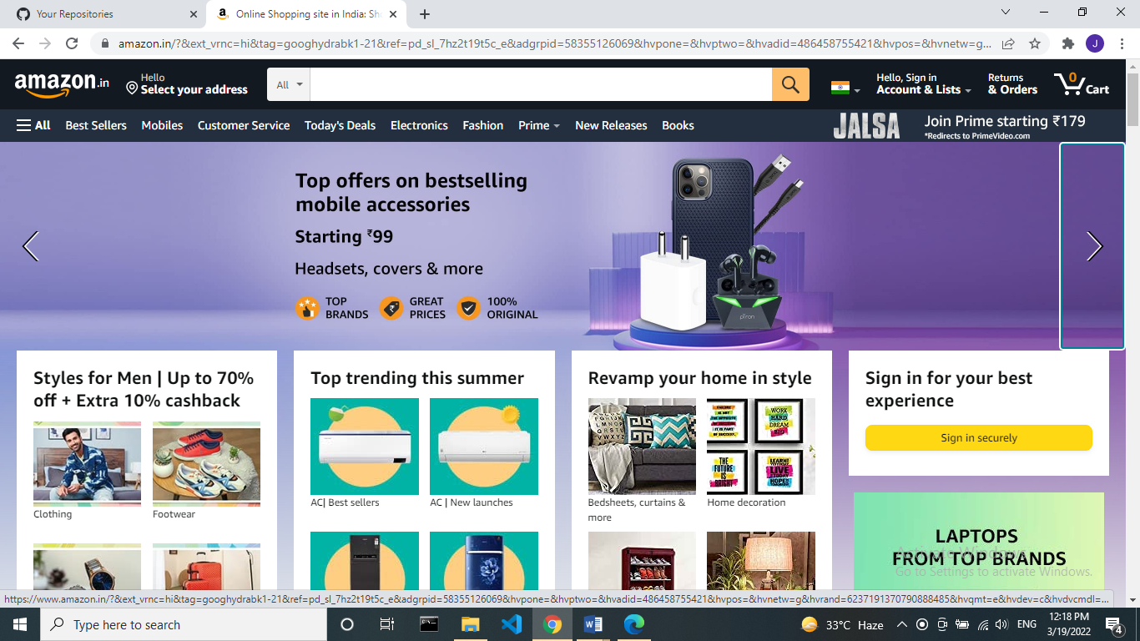

**Overview**:

CARTway is a clone of Amazon which is the world’s largest online retailer.

It is an e-commerce website.

**Goals**:

1.Login page

2.Home page

3.Listing page

4.Details page

5.Payment page

**History**:

Amazon was started as an online bookstore but when it got bigger, it started selling DVDs, Blu-rays, CDs, video downloads/streaming, MP3s, audiobooks, software, video games, electronics, apparel, furniture, food, toys, and jewelry. It also makes consumer electronics like Kindle e-readers, Fire tablets, Fire TV, and Echo. It is the world's largest provider of cloud computing services.Amazon also sells products like USB cables using the name AmazonBasics.

**Technologies used in CARTway**:

**Front-End**:

1. Html

2. Css

3. Bootstrap

4.RectJS

**Dynamic**:

Javascript

**Back-End**:

1.NodeJS

2.ExpressJS

3.MongoDB

**Database**:

Json Data Code

**Compilers**:

1. Visual studio code

2. Git bash

3. GitHub

**GitHub link**:

https://github.com/RajagopalJahnavi/JahnaviSecondProject.git