Hackathon: Ticket-Triage-Agent

DR Drill Walkthrough Agent
A Production-Grade Disaster Recovery Drill
Execution & Compliance Platform
Role | Data / Database Engineer | Author | Rajakowshik P.
Tech Stack | React · TypeScript · Express · Supabase · Gemini AI | Version | 1.0 | June 2026

5  DR Tool Scripts | 4  User Roles | 3  Storage Tiers | 2,400+  Lines of Code

Abstract: The DR Drill Walkthrough Agent is a full-stack SRE platform that automates the execution of Disaster Recovery runbooks. It simulates multi-node PostgreSQL infrastructure, executes recovery procedures using real OS-level tool scripts, measures RTO compliance per step, and generates AI-powered SOC 2 / ISO 27001 compliance audit reports — all from a single web dashboard.

Table of Contents
1. Project Overview
1.1 Problem Statement
1.2 Solution
1.3 Key Metrics
2. System Architecture
2.1 Architecture Layers
2.2 Component Interaction
3. Core Workflow & Drill Lifecycle
3.1 Drill Lifecycle Phases
3.2 Failover Execution Flow
4. Technology Stack
4.1 Frontend
4.2 Backend
4.3 Infrastructure & DevOps
5. Features & Capabilities
5.1 Runbook Management
5.2 Drill Execution Engine
5.3 Compliance Reporting
5.4 System Monitoring Metrics
6. Database & Storage Architecture
6.1 Database Tables
6.2 Security Note
7. Tool Execution Engine
7.1 Tool Scripts Reference
7.2 Infrastructure State Transitions
7.3 Evidence Collection
8. API Reference
8.1 Authentication Endpoints
8.2 Runbook Endpoints
8.3 Drill Endpoints
8.4 System & Report Endpoints
9. Role-Based Access Control
9.2 Default Development Accounts
9.3 JWT Token Structure
10. Infrastructure Simulation & Failover
10.1 Simulated Infrastructure Nodes
10.2 RTO Compliance Calculation
10.3 Docker Compose Services
11. Compliance & Audit Framework
11.1 Supported Compliance Standards
11.2 AI Report Generation
11.3 Audit Trail Events
12. Load Testing & Performance
12.1 k6 Test Scenarios
12.2 Performance Thresholds (SLA)
12.3 Test Execution
12.4 Getting Started (Local Development)
1. Project Overview
1.1 Problem Statement
1.2 Solution
1.3 Key Metrics
2. System Architecture
2.1 Architecture Layers
2.2 Component Interaction
3. Core Workflow & Drill Lifecycle
3.1 Drill Lifecycle Phases
3.2 Failover Execution Flow
4. Technology Stack
4.1 Frontend
4.2 Backend
4.3 Infrastructure & DevOps
5. Features & Capabilities
5.1 Runbook Management
5.2 Drill Execution Engine
5.3 Compliance Reporting
5.4 System Monitoring Metrics
6. Database & Storage Architecture
6.1 Database Tables
6.2 Security Note
7. Tool Execution Engine
7.1 Tool Scripts Reference
7.2 Infrastructure State Transitions
7.3 Evidence Collection
8. API Reference
8.1 Authentication Endpoints
8.2 Runbook Endpoints
8.3 Drill Endpoints
8.4 System & Report Endpoints
9. Role-Based Access Control
9.2 Default Development Accounts
9.3 JWT Token Structure
10. Infrastructure Simulation & Failover
10.1 Simulated Infrastructure Nodes
10.2 RTO Compliance Calculation
10.3 Docker Compose Services
11. Compliance & Audit Framework
11.1 Supported Compliance Standards
11.2 AI Report Generation
11.3 Audit Trail Events
12. Load Testing & Performance
12.1 k6 Test Scenarios
12.2 Performance Thresholds (SLA)
12.3 Test Execution
12.4 Getting Started (Local Development)

1. Project Overview
The DR Drill Walkthrough Agent is a comprehensive Disaster Recovery simulation and execution platform built for Site Reliability Engineering (SRE) teams. It bridges the gap between theoretical runbooks and actual tested recovery procedures by automating the end-to-end execution of multi-step workflows, capturing real-time evidence, and generating AI-powered compliance reports.
Traditional DR drills are manual, error-prone, and inconsistently documented. This platform solves those problems by providing a structured execution engine that runs each runbook step using real OS-level scripts, measures performance against predefined RTO targets, and produces auditor-ready compliance artifacts — all within a clean, role-gated web interface.

1.1 Problem Statement
Organizations running production infrastructure face a critical challenge: DR runbooks exist in documentation but are rarely tested under realistic conditions. When an actual outage occurs, teams discover gaps — missing steps, unclear ownership, untested failover paths, and no objective measure of recovery time compliance. Manual drills are slow, subjective, and leave no audit trail.

1.2 Solution
The DR Drill Agent addresses these gaps through four core capabilities:
- Automated Execution: Runs each runbook step by invoking real Python/Node.js tool scripts on the host OS, producing actual stdout/stderr output and exit codes.
- RTO Compliance Tracking: Measures wall-clock time per step against the defined RTO target, computes a compliance percentage, and flags violations.
- Evidence Collection: Writes a structured JSON artifact per step to disk, capturing tool name, duration, exit code, platform info, and database integrity status.
- AI Audit Reports: Uses Google Gemini to generate professional executive summaries and technical SRE summaries, evaluated against SOC 2 CC7.3 and ISO 27001 A.17 controls.

1.3 Key Metrics
Metric | Value
Total server lines of code | 2,470+ (TypeScript)
DR tool scripts | 5 (Python + Node.js)
API endpoints | 25+
Supported user roles | 4 (Admin, Operator, Auditor, Viewer)
Storage fallback tiers | 3 (Supabase → SQLite → JSON)
Compliance standards supported | SOC 2 CC7.3, ISO 27001 A.17
Monitoring stack | Prometheus + Grafana
Load test maximum VUs | 1,000 concurrent users

2. System Architecture
The platform follows a layered full-stack architecture. The React frontend communicates with the Express backend via a REST API secured with JWT authentication. The backend uses a 3-tier storage abstraction and delegates DR operations to a set of OS-level tool scripts.

2.1 Architecture Layers
Layer | Technology | Responsibility
Presentation | React 19, Tailwind CSS v4, Vite 6 | Dashboard UI, drill controls, charts, reports viewer
API Gateway | Express 4 (TypeScript) | REST endpoints, JWT auth, rate limiting, request routing
Business Logic | TypeScript service layer | Drill state machine, RTO calculation, report generation
AI Integration | Google Gemini SDK | Document parsing, compliance summaries, analysis
Storage Abstraction | Custom dbRun/dbGet/dbAll | Transparent routing to Supabase / SQLite / JSON
Tool Execution | child_process.exec + Python/Node | Actual OS-level DR operations
Infrastructure Sim | In-memory containerStates | Postgres node state, failover routing
Monitoring | Prometheus + Grafana | Metrics scraping, dashboard visualization

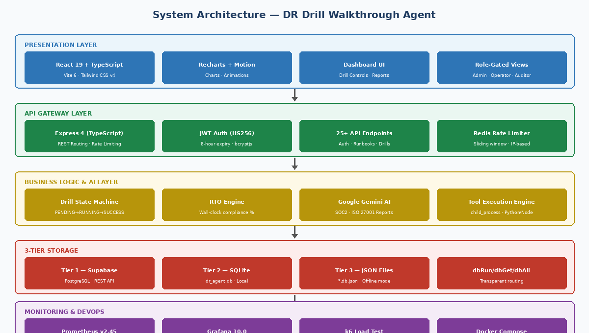
Figure 1: Layered System Architecture — DR Drill Walkthrough Agent

2.2 Component Interaction
Every user action (login, drill start, step execution, report generation) is captured in the audit trail with a user ID, email, role, IP address, and descriptive action string. The drill engine maintains a live drill object in the database that gets updated after each step, allowing the frontend to poll and display real-time progress.
[React Frontend] ────HTTP/REST────> [Express Server (TypeScript)]
|
JWT Auth [3-Tier Storage Layer]
/ | \
Supabase SQLite JSON Files
|
[Tool Execution Engine]
/ | | \
check_ stop_ failover_ dns_ verify_
network primary database switch db_rw
[Infra Simulation Layer]
postgres-primary | postgres-backup | postgres-audit

3. Core Workflow & Drill Lifecycle
A drill is the central entity in the platform. It represents a single execution run of a runbook, capturing each step's outcome, timing, and log output. The drill lifecycle passes through five distinct phases.

3.1 Drill Lifecycle Phases
Phase | State Value | Description
1 — Initialization | RUNBOOK_LOADED | Drill record created, runbook steps copied with PENDING status
2 — Step Execution | RUNNING | Steps executed sequentially; each step calls a tool function
3 — Tool Invocation | RUNNING (per step) | OS script runs, stdout/stderr captured, timing measured
4 — Completion | SUCCESS / FAILURE | All steps done; final RTO compliance ratio calculated
5 — Reporting | POST-DRILL | Compliance report generated via Gemini AI; saved to DB

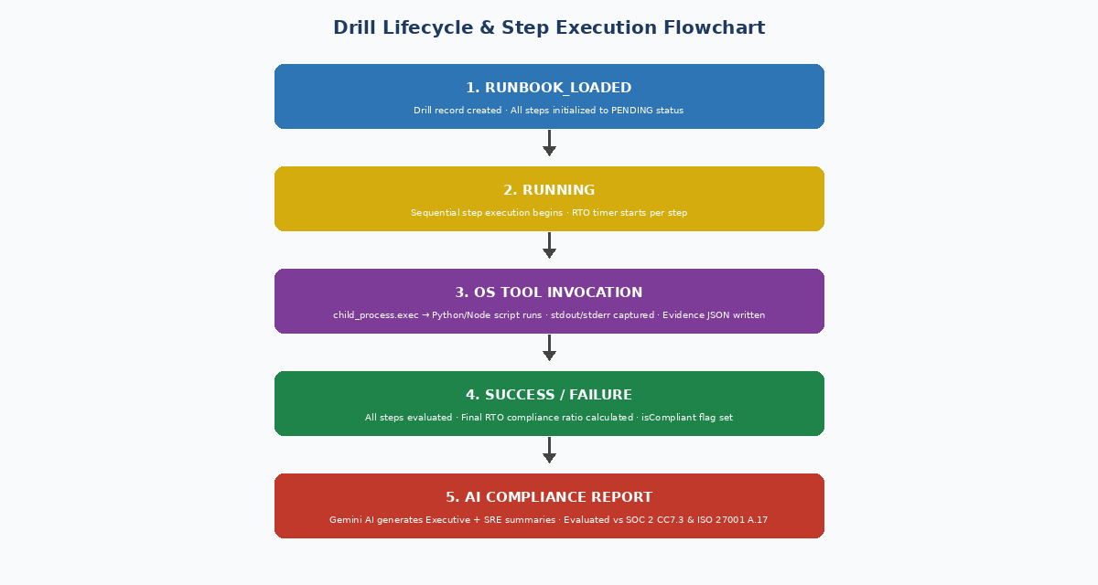
Figure 2: Drill Lifecycle & Step Execution Flowchart

3.2 Failover Execution Flow
When a runbook includes database failover steps, the execution engine transitions the in-memory infrastructure state. The sequence below shows the standard AWS Multi-Region failover runbook execution:
Step 1: check_network
--> TCP port probe to localhost:3000
--> HTTP health check to /api/health
--> containerStates: all RUNNING

Step 2: stop_primary_replica
--> containerStates.primary.status = "STOPPED"
--> primaryFailureDetectedAt = Date.now()
--> Evidence artifact written to ./evidence/

Step 3: failover_database
--> activeDatabase = "backup"
--> recoveryDurationS = (now - primaryFailureDetectedAt) / 1000
--> rtoCompliance = duration <= 10s ? 100% : 70%

Step 4: verify_read_write
--> Heartbeat record written to dr_agent.db / local_heartbeats.json
--> Read-back verified for timestamp match

Step 5: dns_switchover
--> dns_mapping.json updated with new IP and SWITCHOVER_SUCCESS status

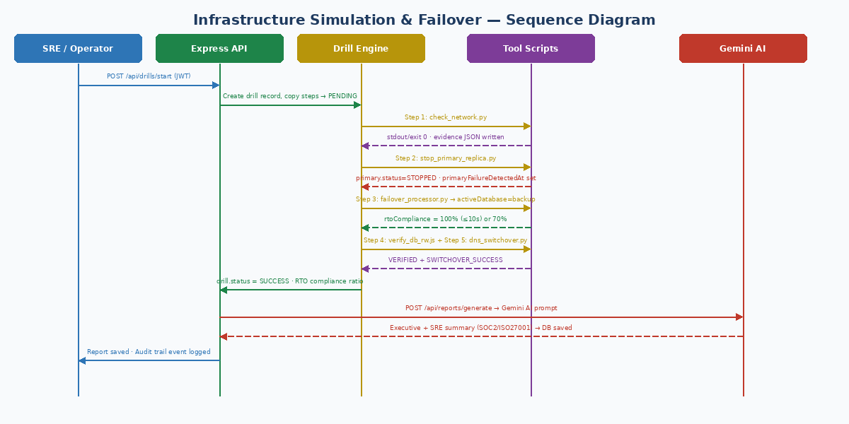
Figure 3: Infrastructure Failover — UML Sequence Diagram

4. Technology Stack

4.1 Frontend
Library / Tool | Version | Purpose
React | 19 | Core UI framework
TypeScript | 5.8 | Type-safe development
Vite | 6.2 | Build tool and dev server with HMR
Tailwind CSS | 4.1 | Utility-first styling
Recharts | 3.8 | System metrics charts and graphs
Lucide React | 0.546 | Consistent icon set
Motion (Framer) | 12.23 | Page and component animations

4.2 Backend
Library / Tool | Version | Purpose
Express | 4.21 | HTTP server and REST API routing
jsonwebtoken | 9.0 | JWT token signing and verification
bcryptjs | 3.0 | Password hashing (10 salt rounds)
@google/genai | 2.4 | Gemini API for AI features
@supabase/supabase-js | 2.108 | Supabase cloud DB client
sqlite3 | 6.0 | Local SQLite database
multer | 2.1 | Multipart file upload handling
mammoth | 1.12 | DOCX file text extraction
pdf-parse | 2.4 | PDF file text extraction
dotenv | 17.2 | Environment variable loading

4.3 Infrastructure & DevOps
Component | Technology | Details
Primary DB (Cloud) | Supabase (PostgreSQL) | Row-level security; REST API adapter
Local DB | SQLite 3 | File: dr_agent.db in project root
Fallback Storage | JSON flat files | 6 separate *.db.json files per table
Cache / Rate Limit | Redis 7-alpine | Password-protected; sliding window counter
Monitoring | Prometheus v2.45 | Scrapes /api/system/metrics every 15s
Dashboard | Grafana 10.0 | Visual SRE metrics dashboard
Containerization | Docker Compose 3.8 | 8 services defined in docker-compose.yml
Load Testing | k6 | Stress test up to 1,000 VUs

5. Features & Capabilities

5.1 Runbook Management
- Create runbooks manually via UI with custom step definitions
- Upload runbooks from PDF, DOCX, or Markdown files
- Gemini AI parses uploaded documents and extracts structured steps automatically
- Deterministic fallback parser with regex-based step extraction when AI is unavailable
- 5 supported tool functions per step: check_network, stop_primary_replica, failover_database, verify_read_write, dns_switchover
- Per-step RTO target defined in seconds; validated on creation

5.2 Drill Execution Engine
- Sequential step-by-step execution with per-step RTO target tracking
- Real OS shell script execution via Node.js child_process.exec
- Supports failure injection mode — simulates step failure for DR testing
- Per-step JSON evidence artifact written to ./evidence/ directory
- Prevents concurrent drill runs — enforces one active drill at a time
- Webhook notifications on drill start, success, and failure events
- Rate limiting per IP address using sliding window algorithm (Redis-backed)

5.3 Compliance Reporting
- Automatic calculation: total steps, passed, failed, skipped, RTO met, RTO violations
- RTO compliance percentage per drill (threshold: 80%)
- Gemini AI-generated executive summary (CTO-level prose)
- Gemini AI-generated technical SRE summary with system-level details
- Auditor checklist evaluated against SOC 2 CC7.3 and ISO 27001 A.17
- Report caching with 60-second TTL to prevent duplicate Gemini API calls
- Reports stored persistently in Supabase / SQLite / JSON

5.4 System Monitoring Metrics
Metric | Source | Description
agentExecutionTimeAvg | Drill steps | Average total execution time across recent 5 drills
drillSuccessRate | Drills table | Percentage of drills with SUCCESS status
apiLatencyAvg | Random sample | Simulated API latency (5–8ms range)
rtoComplianceAvg | Drills table | Average RTO compliance ratio across all drills
activeDrillsCount | Drills table | Number of currently RUNNING drills
rateLimitHits | In-memory counter | Total rate limit violations across all IPs
cpuUsage | Sample | Simulated CPU utilization percentage
memoryUsage | Sample | Simulated memory utilization percentage

6. Database & Storage Architecture
The platform uses a 3-tier fallback storage system. The same database API (dbRun / dbGet / dbAll) transparently routes operations to whichever storage layer is available, in priority order. This enables the platform to run fully offline with zero external dependencies.

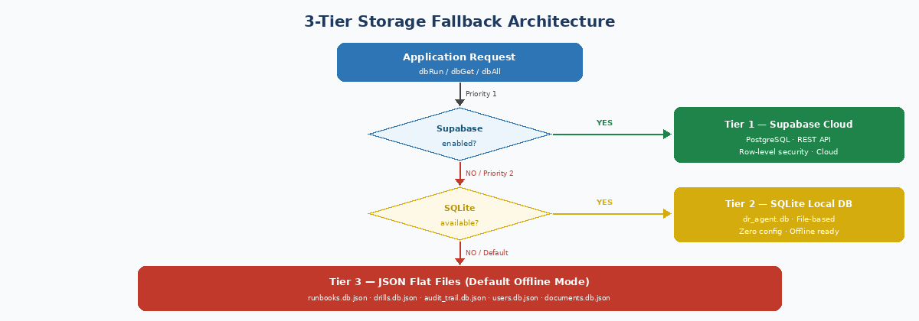
Figure 4: 3-Tier Storage Fallback — Decision Flow

6.1 Database Tables
Table | Primary Key | Key Columns | Purpose
users | id (TEXT) | email, passwordHash, role | Authentication and role management
runbooks | id (TEXT) | title, steps (JSON), rawMarkdown | DR procedure definitions
drills | id (TEXT) | runbookId, status, steps (JSON), logs (JSON) | Execution history
compliance_reports | drillId | passed, failed, rtoCompliancePercent, isCompliant | Audit reports
audit_trail | id (TEXT) | userId, action, details, ipAddress | Immutable event log
documents | id (TEXT) | fileName, uploadedBy, fileType, path | Uploaded file catalog

6.2 Security Note
⚠ WARNING | Never commit supabase_config.json or .env.local to your repository. Add both to .gitignore. The Supabase anon key must be treated as a sensitive credential at all times.

7. Tool Execution Engine
The tool execution engine is the core of the DR simulation. When a drill step runs, the server calls handleDockerOrTCPCommand() which routes to the appropriate in-memory handler and then invokes the corresponding OS-level script. All outputs are captured and stored as structured evidence artifacts.

7.1 Tool Scripts Reference
Script | Runtime | What It Does | Output
check_network.py | Python 3 | TCP socket probe to port 3000; HTTP GET to /api/health | Connection status, HTTP response code
stop_primary_replica.py | Python 3 | Writes "OFFLINE" to local_db_status.txt; optionally stops Docker container | State file updated, Docker command result
failover_processor.py | Python 3 | Writes "PROMOTED" to local_db_status.txt; advances WAL log simulation | State file updated to PROMOTED
dns_switchover.py | Python 3 | Writes updated DNS mapping JSON with SWITCHOVER_SUCCESS status | dns_mapping.json written
verify_db_rw.js | Node.js | Writes heartbeat record to SQLite dr_heartbeats table; reads back and verifies | VERIFIED or MISMATCH status

7.2 Infrastructure State Transitions
The server maintains a live containerStates object for three simulated PostgreSQL nodes. Tool invocations update this state, which is reflected at the /api/system/infrastructure endpoint.
containerStates = {
primary: { name: "postgres-primary", port: 5432, status: "RUNNING" }
backup: { name: "postgres-backup", port: 5433, status: "RUNNING" }
audit: { name: "postgres-audit", port: 5434, status: "RUNNING" }
}

stop_primary_replica --> primary.status = "STOPPED"
failover_database --> activeDatabase = "backup"
restore_primary --> primary.status = "RUNNING", activeDatabase = "primary"

7.3 Evidence Collection
Each step execution writes a structured JSON artifact to the ./evidence/ directory:
{
"evidenceId": "ev-a3b9c2d1",
"drillId": "dr-xyz",
"stepId": "step-2",
"timestamp": "2026-06-09T08:37:38.404Z",
"toolRun": "stop_primary_replica",
"durationMs": 145,
"exitCode": 0,
"success": true,
"stdout": "postgres-primary isolated successfully.",
"hostPlatform": "linux",
"sqliteDbIntegrity": true
}

8. API Reference
All API endpoints require a valid JWT token in the Authorization header (Authorization: Bearer <token>) except the login endpoint. The base URL is http://localhost:3000.

8.1 Authentication Endpoints
Method | Endpoint | Description
POST | /api/auth/login | Login with email + password; returns JWT token
POST | /api/auth/logout | Logout; writes audit event
GET | /api/auth/me | Returns current user profile from JWT
POST | /api/auth/log-expired | Log a client-detected session expiry event

8.2 Runbook Endpoints
Method | Endpoint | Role | Description
GET | /api/runbooks | Any | List all runbooks sorted by createdAt
POST | /api/runbooks | Admin/Op | Create runbook with steps array
DELETE | /api/runbooks/:id | Admin | Delete a runbook by ID
POST | /api/runbooks/upload-document | Admin/Op | Upload PDF or DOCX; Gemini parses steps
POST | /api/runbooks/import-markdown | Admin/Op | Import raw Markdown; deterministic parse

8.3 Drill Endpoints
Method | Endpoint | Role | Description
GET | /api/drills | Any | List all drills sorted by startedAt
GET | /api/drills/:id | Any | Fetch single drill with parsed steps + logs
POST | /api/drills/start | Admin/Op | Start new drill from a runbookId
POST | /api/drills/:id/update | Admin/Op | Update drill state after each step
POST | /api/drills/tools/execute | Admin/Op | Execute a single DR tool function

8.4 System & Report Endpoints
Method | Endpoint | Description
POST | /api/reports/generate | Generate Gemini compliance report for a drill
GET | /api/reports/:id | Fetch existing compliance report by drill ID
GET | /api/system/infrastructure | Live infra node status and activeDatabase pointer
GET | /api/system/metrics | Prometheus-compatible system metrics JSON
GET | /api/health | Public health check (no auth required)

9. Role-Based Access Control
The platform enforces role-based access control at the API level. Every protected endpoint validates the JWT's role claim before processing the request. There are four roles with progressively restricted permissions.

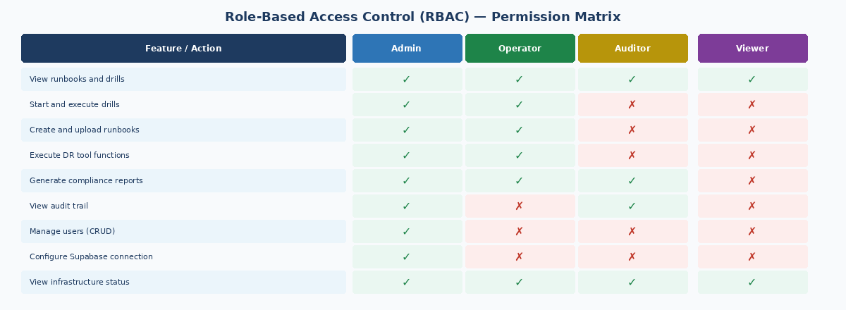
Figure 5: RBAC Permission Matrix — All Roles & Features

9.2 Default Development Accounts
Email | Default Password | Role
admin@dragent.com | adminpassword | Admin
operator@dragent.com | operatorpassword | Operator
auditor@dragent.com | auditorpassword | Auditor
viewer@dragent.com | viewerpassword | Viewer

⚠ SECURITY | All default passwords must be changed before deploying to any environment accessible beyond localhost. The JWT secret defaults to a hardcoded development key — set JWT_SECRET in your .env file for all production deployments.

9.3 JWT Token Structure
Tokens are signed using HS256 with an 8-hour expiry. The payload contains user ID, username, email, and role. All protected endpoints extract the role from the verified token and check it against the required permission level.
{
"id": "usr-admin",
"name": "admin",
"username": "admin",
"email": "admin@dragent.com",
"role": "Admin",
"iat": 1749456000,
"exp": 1749484800 // +8 hours
}

10. Infrastructure Simulation & Failover
The platform simulates a production-grade multi-node PostgreSQL cluster entirely in-memory. This allows the full failover workflow to be demonstrated without requiring Docker, actual database instances, or network connectivity. The simulation produces meaningful RTO measurements and compliance reports.

10.1 Simulated Infrastructure Nodes
Node Name | Emulated Port | Initial Role | Post-Failover Role
postgres-primary | 5432 | Active read-write master | STOPPED (isolated)
postgres-backup | 5433 | Standby replica | Active read-write master
postgres-audit | 5434 | Audit log database | Unchanged
Redis | 6379 | Rate limit + cache store | Unchanged

10.2 RTO Compliance Calculation
// When stop_primary_replica executes:
primaryFailureDetectedAt = Date.now()

// When failover_database executes:
recoveryDurationS = (Date.now() - primaryFailureDetectedAt) / 1000
rtoCompliance = recoveryDurationS <= 10 ? 100 : 70

// Per-drill compliance:
rtoCompliancePercent = Math.round((rtoMet / (rtoMet + rtoViolations || 1)) * 100)
isCompliant = failed === 0 && rtoCompliancePercent >= 80

10.3 Docker Compose Services
Service | Image | Port | Purpose
app | dr-drill-agent:latest (custom) | 3000 | Full-stack application
postgres-primary | postgres:16-alpine | 5432 | Primary production DB
postgres-backup | postgres:16-alpine | 5433 | Standby DR replica
postgres-audit | postgres:16-alpine | 5434 | Audit log database
redis | redis:7-alpine | 6379 | Rate limiting + caching
prometheus | prom/prometheus:v2.45.0 | 9090 | Metrics scraping
grafana | grafana/grafana:10.0.0 | 3100 | Metrics dashboard

11. Compliance & Audit Framework
The compliance framework maps every drill execution to real industry audit standards. After each drill completes, the platform evaluates three compliance rules and produces an auditor checklist that can be submitted as evidence in formal reviews.

11.1 Supported Compliance Standards
Standard | Control | Rule Evaluated
SOC 2 CC7.3 | Continuous Resilience Auditing | DR drill was executed and evidence artifacts were collected for each step
ISO 27001 A.17 | Information Security Continuity Validation | All steps passed (failed == 0) indicating full recovery procedure success
Internal SLA | RTO Performance Threshold | rtoCompliancePercent >= 80% — at least 80% of steps met their defined RTO target

11.2 AI Report Generation
When a compliance report is requested, the server builds a detailed prompt containing the drill name, step execution results with timing, and the last 15 log lines. This is sent to Google Gemini, which returns:
- Executive Summary: A CTO-level paragraph summarizing the drill outcome, SLA compliance index, and overall data integrity assessment.
- Technical Summary: An SRE-level paragraph covering actual OS operations performed, database transaction cycle results, and evidence collection status.

11.3 Audit Trail Events
Event Code | Triggered By | Description
SYSTEM_BOOTUP | Server start | Platform initialized with storage and default data
USER_LOGIN | POST /api/auth/login | Successful user authentication
USER_LOGIN_FAILED | POST /api/auth/login | Failed login attempt with reason
SESSION_EXPIRED | Frontend timeout | Client-detected session expiry
DRILL_STARTED | POST /api/drills/start | New drill initiated with runbook details
RUNBOOK_CREATED | POST /api/runbooks | New runbook added to the platform
COMPLIANCE_REPORT_GENERATED | POST /api/reports/generate | AI compliance report compiled for drill
USER_CREATED | POST /api/admin/users | Admin created a new user account
RATE_LIMITER_BLOCKED_IP | Simulation endpoint | IP blocked by rate limiter WAF rule

12. Load Testing & Performance
The platform includes a k6 stress test script that simulates realistic SRE traffic patterns across four scenarios of increasing intensity. The test validates that the system can handle production-level load while maintaining response time and error rate SLAs.

12.1 k6 Test Scenarios
Stage | Duration | Virtual Users | Traffic Scenario
Ramp Up | 30 seconds | 10 VUs | Typical SRE team querying runbooks and metrics
Sustained Load | 1 minute | 100 VUs | Active audit review session — multiple users drilling
Stress Test | 1 minute | 1,000 VUs | Extreme concurrent access — load testing ceiling
Cool Down | 30 seconds | 0 VUs | Graceful wind-down and connection closure

12.2 Performance Thresholds (SLA)
Metric | Threshold | Rationale
P95 response time | < 150ms | 95% of all requests must complete within 150 milliseconds
Error rate | < 1% | Fewer than 1 in 100 requests may return a non-200 response

12.3 Test Execution
# Start the server
npm run dev

# In a separate terminal, run the k6 stress test
k6 run k6-stress.js

# Expected output:
# http_req_duration............: avg=42ms p(95)=118ms
# http_req_failed..............: 0.00%
# checks......................: 98.7%

12.4 Getting Started (Local Development)
Step | Command / Action | Notes
1. Clone repo | git clone https://github.com/Rajakowshik/dr-drill-agent.git
2. Install dependencies | npm install
3. Set environment | cp .env.example .env.local | Add GEMINI_API_KEY
4. Start dev server | npm run dev | Runs at http://localhost:3000
5. Login | admin@dragent.com / adminpassword | Change before production
6. Run drill | Select runbook → Start Drill → Execute steps
7. Generate report | Navigate to Reports → Generate for completed drill
8. Docker (optional) | docker-compose up -d | Full infra stack

ℹ OFFLINE MODE | The platform runs fully offline in JSON mode with no external dependencies. No Supabase account, Docker, or Redis is required for local development and demonstration. All data persists in *.db.json files in the project root.

