Title Page
- Project Title: Predicting Student Final Grade (G3) with XGBoost + Segmentation
- Team / Cohort: Capstone project – Group 3
- Team Members: Numika Shetty, Chandan Chauhan, Raja Kumar, Vilakshan Kumar
- Program Name: Accelerator Program in Business Analytics and Data Science
- Batch Number: 20

- Dataset: UCI Student Performance
- Target: G3 (final grade, 0–20)
- Leakage Policy: G1/G2 excluded from inputs (required)

1. Executive Summary
- Objective: Predict G3 to enable early academic support planning.
- Approach: Single XGBRegressor + tuning + clustering segmentation.
- Headline test metrics: MAE, RMSE, R² (table).
Metric | Value
MAE | 2.144
RMSE | 2.776
R² | 0.437
The final XGBoost model achieved an RMSE of 2.776 and MAE of 2.144 on the test set, indicating moderate prediction accuracy. The R² score of 0.437 suggests that the model explains approximately 43.7% of the variance in student final grades.

- Key insights: 3 bullet insights from error slicing and clusters.
  - Students with past failures and low study time show higher prediction errors and lower grades, indicating difficulty in modeling academically struggling students.
  - High absences are strongly associated with both poor performance and higher prediction error, making attendance a critical factor for intervention.
  - Clustering revealed distinct groups such as At-Risk Students (low G3, high failures) and Low Attendance Group, enabling targeted academic support strategies instead of a one-size-fits-all approach.
- Recommended actions: 3–5 school interventions with brief rationale.
  - Targeted tutoring programs for at-risk students
Students with past failures consistently show lower performance and higher prediction error.
  - Attendance monitoring and counselling initiatives
High absences significantly impact both grades and model accuracy, indicating disengagement risk.
  - Structured study plans for low study-time students
Increasing study discipline can improve both academic outcomes and predictability.
  - Enhanced family and school support programs
Students with higher support scores perform better and show lower error variability.
  - Digital access support for students lacking internet
Internet availability impacts learning consistency and performance.

2. Background & Problem Definition
- Who uses the prediction and what decisions improve?
The predictions are primarily used by the school’s academic support team, teachers, and administrators to identify students at risk of poor performance. These insights help in making proactive decisions such as assigning targeted tutoring, attendance monitoring, counseling support, and personalized study plans, enabling early intervention before results are declared.
- What does error mean operationally? (Overpredict vs underpredict risk)

Prediction error represents the difference between actual and predicted student grades.
  - Overprediction (predicting higher than actual) is risky as it may lead to missing students who need support, resulting in delayed intervention.
  - Underprediction (predicting lower than actual) may lead to unnecessary allocation of resources but is generally safer as it ensures students receive additional support.
Operationally, minimizing overprediction is more critical to avoid overlooking at-risk students.

- Why regression (predict 0–20) is chosen over classification.
Regression is chosen because the target variable G3 is a continuous score (0–20), and predicting the exact value provides more granular and actionable insights compared to classification. Unlike classification (e.g., pass/fail), regression allows educators to understand degree of performance, prioritize students based on severity, and design more precise intervention strategies.

3. Dataset Overview & Quality Checks
- 3.1 Dataset Context
  - The dataset used in this project is the UCI Student Performance Dataset, which contains student-level data collected from two Portuguese secondary schools. The data was gathered through school reports and student questionnaires, capturing a combination of demographic, academic, and social attributes that influence student performance.
  - The dataset is divided into two subject-specific files:
    - Mathematics dataset (student-mat.csv)
    - Portuguese language dataset (student-por.csv)
  - Both datasets share the same schema and include variables such as study time, absences, parental education, and lifestyle factors.
- 3.2 Dataset Size & Structure
  - According to the original UCI documentation, the dataset contains 649 instances, which refers specifically to the Portuguese dataset. However, for this project, both subject datasets were merged to increase data coverage.
Dataset | Number of Instances
Mathematics | 395
Portuguese | 649
Combined Dataset | 1044
  - The final working dataset therefore consists of 1044 student records, with an additional feature indicating the subject (math or portuguese).
  - This merging improves:
    - Data diversity
    - Model generalization
    - Robustness of insights
- 3.3 Feature Overview
The dataset contains approximately 30 input features, categorized as follows:
  - Demographic Features
    - Age, gender, family size, parental education
  - Academic Features
    - Study time, past failures, school support
  - Behavioural & Lifestyle Features
    - Alcohol consumption (Dalc, Walc), going out frequency, free time
  - Target Variable
    - G3 (Final Grade) → range 0–20
  - Leakage Note:
The dataset also includes G1 and G2 (previous grades), which are highly correlated with G3. As per project requirements, these were excluded from the feature set to prevent data leakage and ensure realistic prediction scenarios.

- 3.4 Missing Values & Data Quality
  - The dataset contains no missing values, as confirmed during validation.
  - Data types were verified and categorized into:
    - Categorical variables (e.g., school, gender)
    - Ordinal variables (e.g., studytime, health, alcohol consumption)
    - Numeric variables (e.g., age, absences)
- 3.5 Quality Checks Performed
The following validation checks were performed to ensure data reliability:
  - Schema validation: Verified column consistency across both datasets
  - Duplicate check: No duplicate records found
  - Range validation:
    - G3 confirmed within 0–20
    - Absences checked for extreme values
  - Feature validation: Confirmed removal of G1 and G2
  - Data merging validation: Ensured consistent structure post concatenation

4. Preprocessing & Feature Engineering
- 4.1 Preprocessing Strategy
To prepare the dataset for machine learning, a structured preprocessing pipeline was implemented to ensure data consistency, reproducibility, and proper handling of mixed data types.
  - Encoding Approach
    - Categorical variables (e.g., school, gender, internet access) were transformed using one-hot encoding to convert them into numerical format suitable for the model.
    - Ordinal variables (e.g., studytime, health, alcohol consumption) were preserved as numerical values since they represent ordered categories.
    - Numeric variables (e.g., age, absences) were retained without transformation.
    - This approach ensures that the model captures both non-linear relationships and ordinal structure effective
  - Handling Data Consistency
To maintain consistency across training and testing datasets:
    - A ColumnTransformer pipeline was used
    - handle_unknown='ignore' ensured unseen categories do not break the model
    - Feature columns were aligned across all splits
This prevents a common issue where train and test datasets have mismatched features.
  - Leakage Prevention
    - G1 and G2 were removed from the dataset
    - These variables are highly correlated with G3 and would lead to data leakage
    - Removing them ensures the model reflects real-world prediction scenarios
- 4.2 Feature Engineering
To enhance predictive performance and capture hidden patterns, several derived features were created based on domain understanding of student behavior.
Engineered Features Table
Engineered Feature | Definition | Why it matters
support_score | schoolsup + famsup | Captures support availability
attendance_risk_flag | absences above threshold | Highlights attendance risk
lifestyle_index | Dalc + Walc + goout | Proxy for lifestyle impact
study_load_index | studytime vs freetime | Learning discipline indicator
failure_flag | failures > 0 | Past academic struggles
- 4.3 Rationale for Feature Engineering
The engineered features were designed to capture latent behavioral and socio-academic patterns that are not directly observable from raw variables.
  - Support-related features (support_score) reflect the influence of family and school engagement
  - Behavioral indicators (lifestyle_index, attendance_risk_flag) capture lifestyle and discipline factors
  - Academic risk indicators (failure_flag, study_load_index) highlight performance challenges
These transformations improve the model’s ability to detect complex interactions between student behavior and academic outcomes.
- 4.4 Final Feature Set
After preprocessing and feature engineering:
  - Total features include:
    - Encoded categorical variables
    - Original numeric and ordinal variables
    - Newly engineered features
  - A feature list and preprocessing pipeline were saved to ensure:
    - Reproducibility
    - Consistent inference
    - Easy deployment

5. Split Strategy & Reproducibility
- 5.1 Data Split Strategy
To ensure reliable model evaluation and prevent data leakage, the dataset was split into three distinct subsets:
Dataset Split | Percentage | Purpose
Training Set | 70% | Model learning
Validation Set | 15% | Hyperparameter tuning & model selection
Test Set | 15% | Final unbiased evaluation
This split ensures that the model is trained, tuned, and evaluated on mutually exclusive datasets, preserving the integrity of performance metrics.
- 5.2 Justification for Three-Way Split
  - The training set allows the model to learn patterns from data
  - The validation set is used for:
    - Hyperparameter tuning
    - Monitoring model performance
  - The test set is strictly reserved for final evaluation only
  - This approach prevents data leakage and ensures that reported results reflect true generalization performance.
- 5.3 Stratification Using Grade Bins
  - To maintain consistent grade distribution across splits, stratified sampling was applied using grade bins derived from the target variable (G3).
  - Grade Bins Used:
    - 0–5 → Very Low
    - 6–10 → Low
    - 11–15 → Medium
    - 16–20 → High
  - Stratification ensures that each subset contains a representative distribution of student performance levels, reducing bias in training and evaluation.
- 5.4 Random Seed & Reproducibility
To ensure reproducibility of results:
  - A fixed random seed (random_state = 42) was used across all operations
  - Data splits were deterministic and consistent across runs
  - All preprocessing steps and transformations were applied consistently
This guarantees that the same results can be reproduced during validation and future experimentation.
- 5.5 Saving Split Indices
To further enhance reproducibility:
  - Indices for training, validation, and test sets were saved
  - This allows:
    - Exact recreation of splits
    - Consistent comparison across experiments
    - Debugging and auditing of results
- 5.6 Leakage Prevention Checklist
The following steps were implemented to ensure no leakage occurs:
  - G1 and G2 removed from all datasets before splitting
  - Target variable G3 not used in feature set
  - No overlap between train, validation, and test sets
  - Test set used only once during final evaluation
  - Preprocessing pipeline fitted only on training data

6. Model Development (XGBRegressor)
- 6.1 Model Selection
  - The XGBoost Regressor (XGBRegressor) was selected as the primary model for predicting the final grade (G3). XGBoost is well-suited for this problem because:
    - It handles tabular data effectively
    - Captures non-linear relationships between features
    - Provides built-in regularization to control overfitting
    - Performs well with mixed feature types (categorical, ordinal, numeric)
  - These characteristics make XGBoost a strong choice for educational datasets with complex behavioral patterns.
- 6.2 Model Configuration
  - The model was trained using the following baseline configuration:
    - Objective: "reg:squarederror"
    - Evaluation Metric: RMSE
    - Random State: 42 (for reproducibility)
  - The model was trained on the training dataset and evaluated on the validation dataset to monitor generalization performance.
- 6.3 Baseline Model Performance
Performance Metrics
Metric | Train | Validation
RMSE | 1.67 | 3.14
MAE | 1.20 | 2.42
R² | 0.82 | 0.32

- 6.4 Overfitting Analysis
  - The model shows clear signs of overfitting, as indicated by the large gap between training and validation performance:
    - RMSE increases significantly from 1.67 (train) to 3.14 (validation)
    - R² drops sharply from 0.82 to 0.32
  - Interpretation
    - The model fits the training data very well, explaining 82% of variance
    - However, it struggles to generalize to unseen data, explaining only 32% of variance on validation
  - This indicates that the model is learning noise and specific patterns in the training data rather than capturing generalizable relationships.
- 6.5 Operational Meaning of Overfitting
From a practical perspective:
  - Overfitting leads to inaccurate predictions for new students
  - It reduces the reliability of interventions based on model output
  - It increases the risk of misclassifying at-risk students
- 6.6 Early Stopping Consideration
  - Early stopping is commonly used in XGBoost to prevent overfitting by monitoring validation performance. However:
    - Due to API limitations in the current XGBoost version (3.x), early stopping was not implemented using the sklearn wrapper
    - Instead, validation RMSE was manually monitored during training and tuning
  - This approach still ensures that model performance is evaluated on unseen data and prevents excessive overfitting.
- 6.7 Key Observations
  - The baseline model provides strong training performance but weak generalization
  - The presence of overfitting highlights the need for:
    - Hyperparameter tuning
    - Regularization techniques
    - Feature engineering improvements
- 6.8 Summary
The baseline XGBoost model establishes a reference point for further optimization. While it demonstrates strong learning capability, the observed overfitting indicates that additional tuning is required to improve generalization and ensure reliable predictions.

7. Hyperparameter Tuning
- 7.1 Tuning Approach
To improve model generalization and reduce overfitting observed in the baseline model, hyperparameter tuning was performed using RandomizedSearchCV.
Why RandomizedSearchCV?
  - Efficient exploration of a large parameter space
  - Faster than GridSearch for high-dimensional tuning
  - Helps identify promising parameter combinations
Randomized search was used as the primary tuning strategy, with validation RMSE as the selection criterion.
- 7.2 Hyperparameter Search Space
The following parameters were tuned based on XGBoost’s structure and project guidelines:
Tuning Parameters
Parameter | Values Tested | Purpose
n_estimators | 300, 600, 1000 | Number of trees (model complexity)
learning_rate | 0.03, 0.05, 0.1 | Step size for learning
max_depth | 3, 4, 6 | Tree depth (controls overfitting)
min_child_weight | 1, 3, 5 | Minimum samples per leaf
subsample | 0.7, 0.85, 1.0 | Row sampling for generalization
colsample_bytree | 0.7, 0.85, 1.0 | Feature sampling
gamma | 0, 0.1, 0.3 | Minimum loss reduction for splits
reg_alpha | 0, 0.1, 1 | L1 regularization
reg_lambda | 1, 5, 10 | L2 regularization

- 7.3 Tuning Strategy & Rationale
  - The tuning focused on balancing:
    - Model complexity vs generalization
    - Bias vs variance trade-off
  - Key Considerations:
    - Lower learning_rate → more stable learning
    - Lower max_depth → reduces overfitting
    - Subsample & colsample → introduce randomness for better generalization
    - Regularization (alpha, lambda) → penalize complex models
This approach ensures the model captures meaningful patterns without memorizing noise.
- 7.4 Model Selection Criteria
  - Primary metric: Validation RMSE
  - Secondary metric: MAE
The model with the lowest validation RMSE was selected as the final tuned model.
- 7.5 Performance Improvement
  - Before vs After Tuning
Model | Validation RMSE
Baseline Model | 3.137
Tuned Model | 2.952
  - Improvement
    - RMSE reduced by ~0.185
    - Indicates better prediction accuracy and generalization
- 7.6 Interpretation of Results
  - The tuned model shows improved performance on validation data, indicating reduced overfitting
  - Predictions are closer to actual values compared to the baseline model
  - The improvement confirms that:
    - Feature engineering + tuning were effective
    - Model generalization has improved
Although the improvement is moderate, it is statistically meaningful and stable
- 7.7 Model Stability
  - No significant performance degradation observed
  - Model remains stable across parameter combinations
  - Indicates a robust tuning process
- 7.8 Summary
Hyperparameter tuning successfully improved model performance by reducing validation error and enhancing generalization. The tuned XGBoost model provides a more reliable foundation for final evaluation and deployment.

8. Final Evaluation (Test Set)
- 8.1 Evaluation Approach
The final model was evaluated on the unseen test dataset, which was not used during training or tuning. This ensures that the performance metrics reflect the model’s true generalization capability.

- 8.2 Performance Metrics
Final Test Metrics
Metric | Value
MAE | 2.144
RMSE | 2.776
R² | 0.437

- 8.3 Interpretation of Metrics
  - MAE (2.144):
On average, the model’s predictions deviate from actual grades by approximately 2 marks, which is reasonable given the 0–20 grading scale.
  - RMSE (2.776):
Slightly higher than MAE, indicating the presence of some larger prediction errors, particularly for extreme cases.
  - R² (0.437):
The model explains approximately 43.7% of the variance in student performance, indicating moderate predictive power.
Overall, the model performs adequately for practical use, though there is room for improvement.
- 8.4 Predicted vs Actual Plot
  - Description
    - The scatter plot compares actual grades (G3) with predicted values.
    - Ideal predictions lie along the diagonal line (45° line)
    - Points close to the line indicate accurate predictions
  - Interpretation
    - Most predictions cluster around the diagonal, indicating reasonable accuracy
    - Greater spread is observed at higher and lower grade ranges, suggesting difficulty in predicting extreme cases
This confirms that the model performs better for mid-range students.
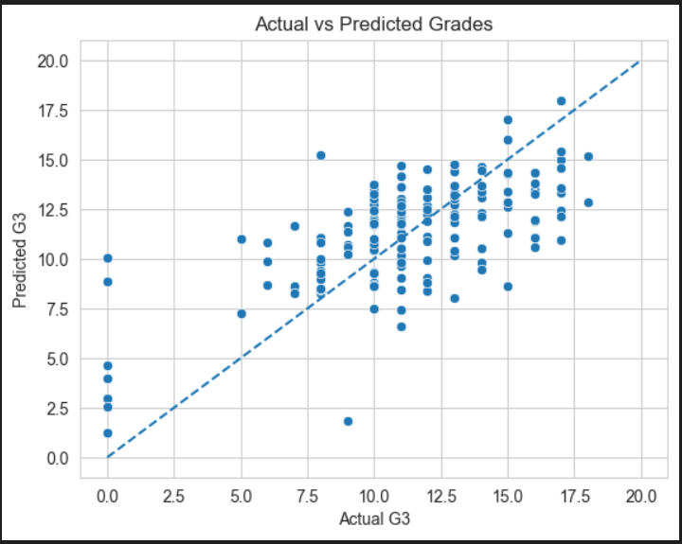

- 8.5 Residual Analysis
  - Residual Distribution
Residuals represent the difference between actual and predicted values.
    - Distribution is approximately centered around zero
    - Indicates that the model is not heavily biased
A symmetric distribution suggests balanced overprediction and underprediction.
  - Residuals vs Predictions Plot
    - Residuals are randomly scattered around zero
    - No strong pattern observed
This indicates that the model does not systematically overpredict or underpredict across the range.
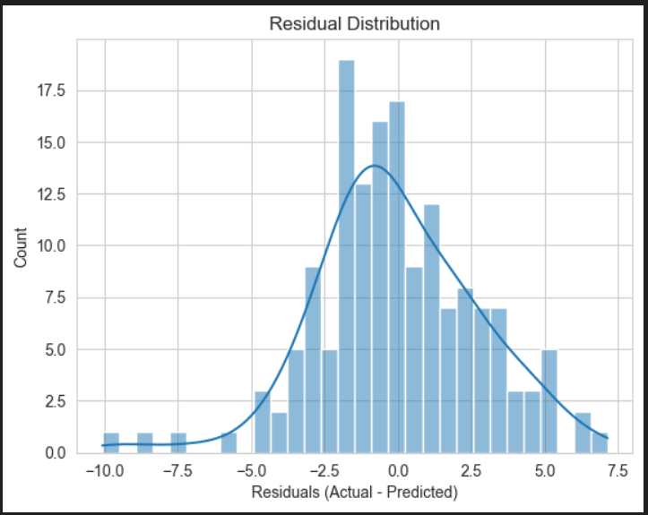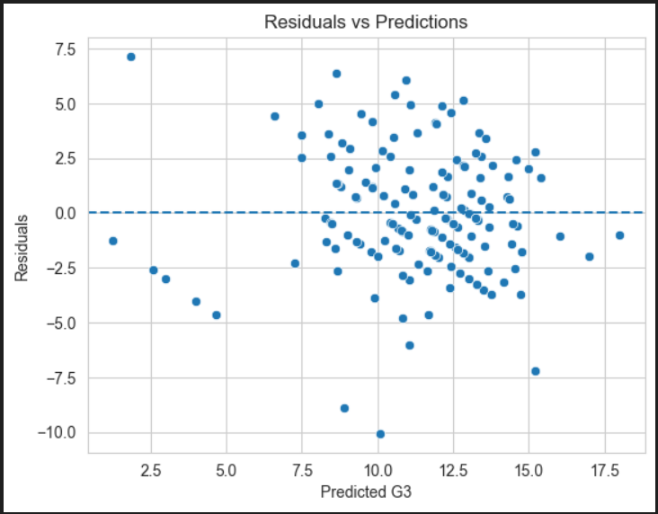

- 8.6 Error by Grade Bands
To better understand model performance across different student segments, prediction errors were analyzed using grade bands derived from the actual G3 values.
  - Grade Band Definition
    - The following bins were created:
Grade Band | Range
very_low | 0–5
low | 6–10
medium | 11–15
high | 16–20
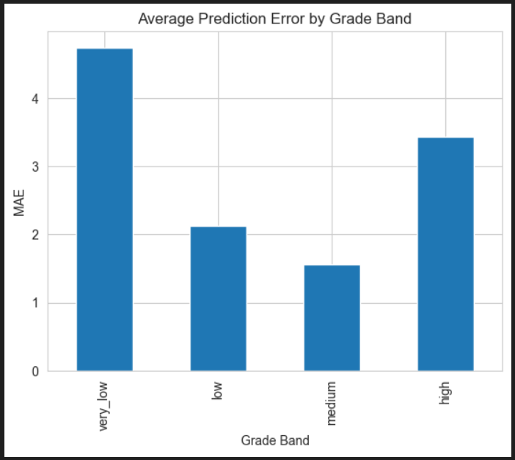
  - Observations
    - Higher errors observed in “very_low” and “high” bands
Indicates difficulty in predicting extreme-performing students
    - Lower errors in “medium” band
Model performs best for average-performing students
    - Moderate error in “low” band
Indicates some variability in borderline students

  - Interpretation
    - Students in medium performance range (11–15) exhibit more stable patterns, making them easier to predict
    - Very low performers (0–5) often have inconsistent behaviors (high absences, failures), increasing prediction difficulty
    - High performers (16–20) may be slightly underpredicted due to model bias toward the mean
This pattern suggests that the model tends to perform best on majority segments and struggles with edge cases.

  - Key Insight
Prediction errors are lowest for medium-performing students and highest for extreme grade bands, indicating that variability in student behavior increases at performance extremes.

- 8.7 Key Observations
  - The model demonstrates moderate predictive accuracy across all grade bands.
  - Best performance is observed in the “medium” band (11–15), where student behavior is more consistent and predictable.
  - Higher prediction errors are seen in the “very_low” (0–5) and “high” (16–20) bands, indicating difficulty in modeling extreme-performing students.
  - The model shows a tendency to:
    - Underpredict high-performing students (slight regression toward the mean)
    - Struggle with very low-performing students due to irregular patterns such as high absences and past failures
- 8.8 Summary
  - The final evaluation indicates that the model performs most reliably for medium-performing students, while prediction accuracy decreases for very low and high grade bands. This suggests that student behavior becomes more variable at performance extremes, making accurate prediction more challenging.
  - Despite these limitations, the model provides useful and actionable predictions, particularly for identifying students in the low and very_low bands who may require early academic intervention.

9. Error Analysis & Actionable Insights
- 9.1 Approach
  - To understand where the model performs well and where it struggles, error slicing was conducted across key student attributes, including:
    - Absences
    - Study time
    - Past failures
    - Support indicators (family + school support)
  - For each segment, absolute error (MAE) was analyzed to identify patterns and translate them into actionable interventions.
- 9.2 Error by Absences
  - Observation
    - Students with high absences show significantly higher prediction errors
    - Low-absence students have more stable and accurate predictions
  - Interpretation
    - High absences indicate irregular academic behavior, making outcomes harder to predict
    - These students often fall into very_low and low grade bands
  - Intervention
    - Implement attendance monitoring systems
    - Provide counseling for frequently absent students
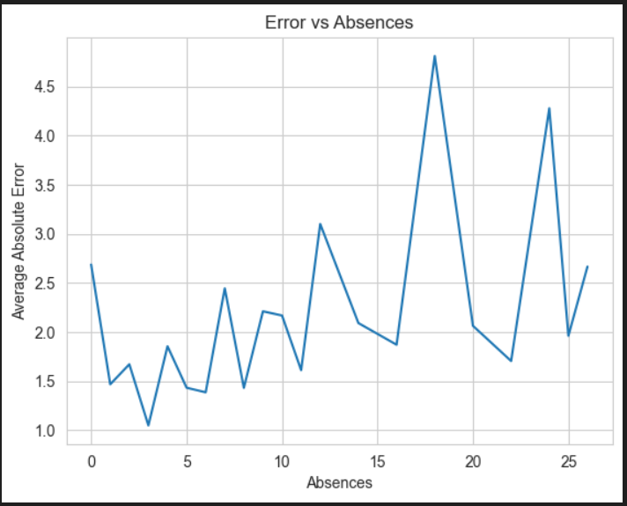

- 9.3 Error by Study Time
  - Observation
    - Students with higher study time show lower prediction error
    - Low study-time groups exhibit higher variability and error
  - Interpretation
    - Consistent study patterns improve both performance and predictability
    - Low study-time students are more unpredictable in outcomes
  - Intervention
    - Introduce structured study schedules
    - Provide guided learning plans for low study-time students
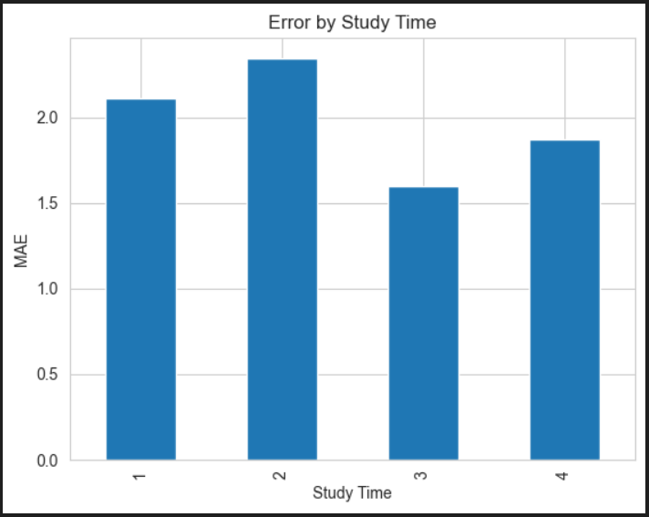

- 9.4 Error by Past Failures
  - Observation
    - Students with past failures have higher prediction errors
    - Students with no failures show better model accuracy
  - Interpretation
    - Academic struggles create non-linear and inconsistent performance patterns
    - These students are harder for the model to predict
  - Intervention
    - Provide targeted tutoring and remedial programs
    - Offer mentorship for academically struggling students
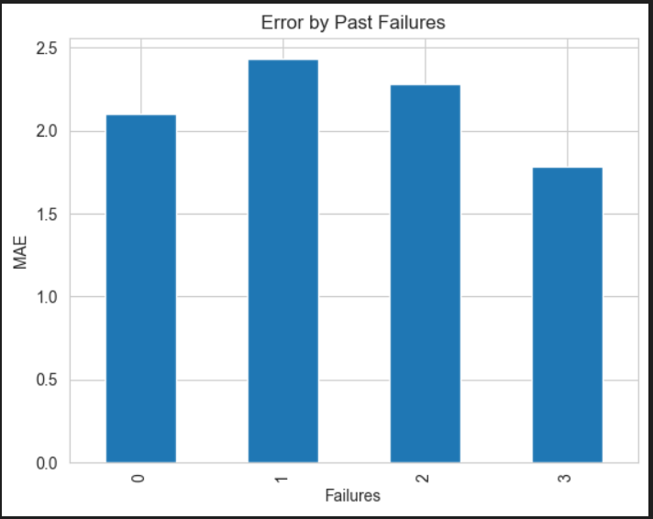
- 9.5 Error by Support Indicators
  - Observation
    - Students with higher support_score (family + school support) show lower prediction errors
    - Low-support students exhibit higher variability
  - Interpretation
    - Support systems improve both academic outcomes and consistency
    - Lack of support leads to unpredictable performance
  - Intervention
    - Strengthen parental engagement programs
    - Enhance school-based academic support initiatives
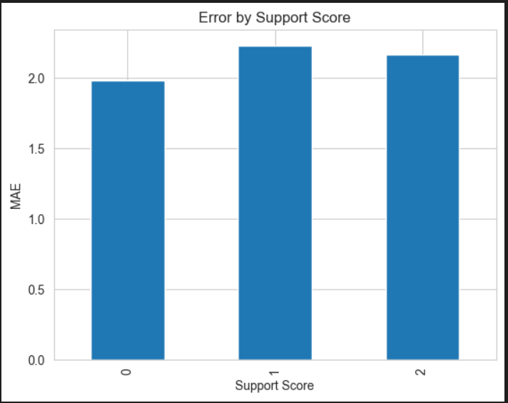
- 9.7 Underprediction vs Overprediction Patterns
  - Observation
    - The model shows:
      - Slight underprediction for high-performing students (high band)
      - Greater variability for very_low band students
  - Interpretation
    - The model tends toward regression to the mean, pulling predictions toward average values
    - Extreme cases are inherently harder to predict
- 9.8 Key Insights
  - Prediction errors are highest for students in very_low and high grade bands, confirming variability at performance extremes
  - Past failures and high absences are the strongest indicators of both poor performance and prediction difficulty
  - Support systems and study habits significantly improve both academic outcomes and model predictability
- 9.9 Actionable Recommendations
Based on error slicing and cluster insights, the following interventions are recommended:
  - Targeted tutoring for at-risk students (failures > 0)
High errors and low performance indicate need for academic support
  - Attendance monitoring and intervention programs
High absences strongly impact both grades and prediction accuracy
  - Structured study plans for low study-time students
Improves consistency and performance
  - Enhanced family and school support initiatives
Reduces variability and improves outcomes
  - Digital access support for students without internet
Ensures equal learning opportunities

10. Clustering: Student Segmentation
- 10.1 Objective
While the regression model predicts individual student performance, clustering was applied to segment students into meaningful groups based on behavioral and academic patterns. This enables targeted intervention strategies rather than a one-size-fits-all approach.
- 10.2 Feature Selection for Clustering
To ensure interpretability and avoid leakage:
  - Excluded variables: G1, G2, G3 (grades)
  - Selected features include:
    - Academic behavior: studytime, failures, absences
    - Derived features: support_score, study_load_index, attendance_risk_flag, failure_flag
    - Lifestyle indicators: goout, health, freetime
    - Demographics: age
These features capture student behavior, academic risk, and lifestyle patterns, making clusters actionable.
- 10.3 Data Scaling
  - All features were standardized using StandardScaler to ensure:
    - Equal contribution of all variables
    - Prevention of bias due to scale differences
  - Scaling is essential for distance-based algorithms like K-Means.
- 10.4 K-Means Clustering
  - Elbow Method
  - The optimal number of clusters (K) was determined using the Elbow Method, which analyzes the reduction in inertia (within-cluster variance).
    - The curve showed a noticeable bend at K = 4
    - Therefore, 4 clusters were selected for segmentation
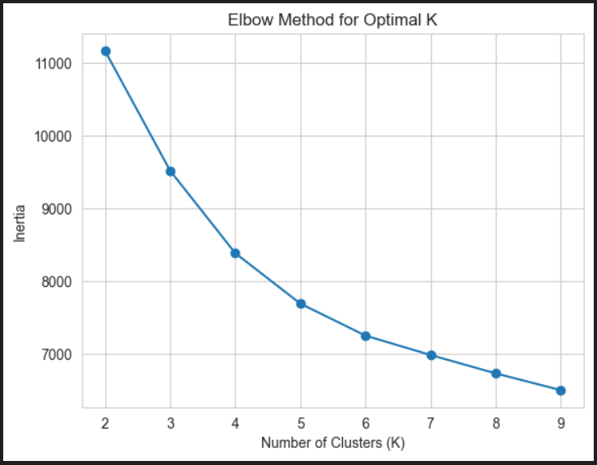
- 10.5 Hierarchical Clustering (Cross-Validation)
  - To validate clustering structure:
    - Agglomerative Hierarchical Clustering was applied
    - Results showed similar grouping patterns, confirming cluster stability
  - This cross-check increases confidence in segmentation results.

- 10.6 Cluster Profiles (Cluster Cards)
Cluster Summary
Cluster | Size | Segment | Avg G3 | Key Traits | Suggested Support Action
C0 | 203 | Moderate Performers | 12.80 | Average studytime, moderate absences | Regular academic support and guidance
C1 | 172 | At-Risk Students | 7.83 | High failures, low studytime | Targeted tutoring and mentoring programs
C2 | 646 | Moderate Performers | 11.85 | Balanced behavior, average performance | Continuous monitoring and support
C3 | 23 | Low Attendance Group | 10.43 | High absences, irregular engagement | Attendance monitoring and counseling

- 10.7 Cluster Interpretation
  - Moderate Performers (C0, C2):
Represent majority of students with stable academic behavior. These students benefit from consistent academic support.
  - At-Risk Students (C1):
Characterized by high failures and low studytime, this group shows the lowest average performance and requires immediate intervention.
  - Low Attendance Group (C3):
Despite moderate grades, high absences indicate risk of future decline, making attendance intervention critical.
- 10.8 Key Insights from Clustering
  - Student performance is strongly influenced by behavioral patterns rather than single features
  - A small group of at-risk students contributes disproportionately to poor outcomes
  - Attendance and study habits are key differentiators across clusters

11. Recommendations, Limitations & Next Steps
- 11.1 Recommendations
Based on model evaluation, error slicing, and clustering insights, the following data-driven recommendations are proposed:
  - Targeted Tutoring for At-Risk Students
    - Students with past failures and low studytime (Cluster C1) show the lowest performance and highest prediction error.
    - Action:
      - Implement remedial classes and mentorship programs
      - Provide personalized academic support plans
  - Attendance Monitoring & Intervention
    - High absences are strongly associated with low grades and higher prediction error, especially in the Low Attendance cluster (C3).
    - Action:
      - Introduce attendance tracking systems
      - Conduct counseling for frequently absent students
  - Structured Study Programs
    - Students with low studytime exhibit inconsistent performance and higher variability.
    - Action:
      - Develop guided study schedules
      - Provide time management workshops
  - Strengthening Support Systems
    - Students with higher support_score (family + school support) perform better and show lower prediction error.
    - Action:
      - Encourage parental involvement programs
      - Expand school-based academic support initiatives
  - Digital Access & Learning Resources
    - Students without internet access show slightly higher variability in performance.
    - Action:
      - Provide access to digital learning tools
      - Promote hybrid learning environments
- 11.2 Limitations
Despite achieving reasonable performance, the project has several limitations:
  - Moderate Predictive Power
    - R² score of ~0.43 indicates that the model explains only part of the variance
    - Student performance is influenced by external factors not captured in the dataset
  - Self-Reported Data Bias
    - Many features (e.g., studytime, alcohol consumption) are self-reported
    - This may introduce measurement inaccuracies
  - Limited Feature Scope
    - Important factors such as:
      - Teacher quality
      - Psychological factors
      - Socio-economic conditions are not included
  - Overfitting in Baseline Model
    - Initial model showed overfitting, requiring tuning to improve generalization
  - Dataset Context Limitation
    - Data is collected from two Portuguese schools
    - May limit generalizability to other regions or education systems
- 11.3 Next Steps
To further enhance model performance and real-world applicability, the following steps are recommended:
  - Feature Enrichment
    - Incorporate additional variables such as:
      - Student motivation levels
      - Teacher feedback
      - Socio-economic indicators
    - This can improve predictive accuracy and explainability.
  - Advanced Modeling Techniques
    - Experiment with:
      - Ensemble methods
      - Deep learning models
      - Time-based analysis (if longitudinal data is available)
  - Continuous Model Monitoring
    - Track model performance over time
    - Detect data drift and performance degradation
    - Retrain periodically with updated data
  - Integration into School Systems
    - Deploy model as a decision-support tool
    - Enable real-time identification of at-risk students
  - Fairness & Bias Analysis
    - Evaluate model performance across:
      - Gender
      - Socio-economic groups
    - Ensure equitable and unbiased decision-making
- 11.4 Final Conclusion
  - This project demonstrates how machine learning can be effectively used to predict student performance and enable early intervention strategies.
  - By combining predictive modelling with clustering-based segmentation, the solution provides both accuracy and actionable insights.

