**WEEK-7**

**REACTJS**

**9.Create a React Application named “cricketapp” with the following components**

**CODE:**

**ListofPlayers.js:**

import React from 'react';

const ListofPlayers = () => {

const players = [

{ name: 'Player1', score: 85 },

{ name: 'Player2', score: 45 },

{ name: 'Player3', score: 70 },

{ name: 'Player4', score: 90 },

{ name: 'Player5', score: 60 },

{ name: 'Player6', score: 75 },

{ name: 'Player7', score: 50 },

{ name: 'Player8', score: 95 },

{ name: 'Player9', score: 40 },

{ name: 'Player10', score: 65 },

{ name: 'Player11', score: 55 },

];

const filteredPlayers = players.filter(player => player.score < 70);

return (

<div>

<h2>All Players with scores:</h2>

<ul>

{players.map((p, index) => (

<li key={index}>{p.name} - {p.score}</li>

))}

</ul>

<h2>Players with score below 70:</h2>

<ul>

{filteredPlayers.map((p, index) => (

<li key={index}>{p.name} - {p.score}</li>

))}

</ul>

</div>

);

};

export default ListofPlayers;

**IndianPlayers.js:**

import React from 'react';

const IndianPlayers = () => {

const players = ['Sachin1', 'Dhoni2', 'Virat3', 'Rohit4', 'Yuvaraj5', 'Raina6'];

const oddPlayers = players.filter((_, i) => i % 2 === 0); // 0,2,4

const evenPlayers = players.filter((_, i) => i % 2 !== 0); // 1,3,5

const [first, , third, , fifth] = oddPlayers;

const [, second, , fourth, , sixth] = players;

const T20players = ['Mr. First Player', 'Mr. Second Player', 'Mr. Third Player'];

const RanjiTrophyPlayers = ['Mr. Fourth Player', 'Mr. Fifth Player', 'Mr. Sixth Player'];

const mergedPlayers = [...T20players, ...RanjiTrophyPlayers];

return (

<div>

<h2>Odd Players</h2>

<ul>

<li>First : {first}</li>

<li>Third : {third}</li>

<li>Fifth : {fifth}</li>

</ul>

<h2>Even Players</h2>

<ul>

<li>Second : {second}</li>

<li>Fourth : {fourth}</li>

<li>Sixth : {sixth}</li>

</ul>

<h2>List of Indian Players Merged:</h2>

<ul>

{mergedPlayers.map((p, index) => (

<li key={index}>{p}</li>

))}

</ul>

</div>

);

};

export default IndianPlayers;

**OUTPUT:**

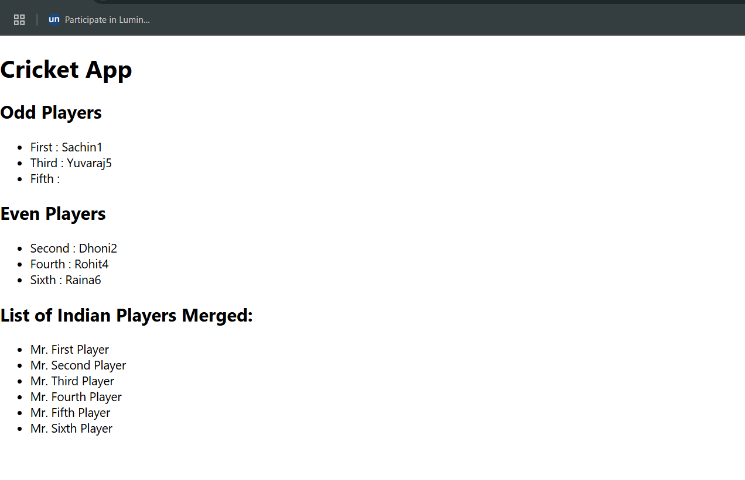

**10.Create a React Application named “officespacerentalapp” which uses React JSX to create elements, attributes and renders DOM to display the page.**

**CODE:**

import React from 'react';

import './App.css';

function App() {

const offices = [

{

name: "DBS",

rent: 50000,

address: "Chennai",

image: "https://t3.ftcdn.net/jpg/04/85/10/94/360_F_485109454_rGi42bZ3ICpVtPCEbAMVUUKR1I6OElo1.jpg"

},

{

name: "WeWork",

rent: 75000,

address: "Bangalore",

image: "https://media.istockphoto.com/id/1413721723/photo/modern-office-building.jpg?s=612x612&w=0&k=20&c=YKPCCIK29KKnF6DLMcUvDAjPAz5ut6YrjOeTyTVctTc="

},

{

name: "Innov8",

rent: 59000,

address: "Mumbai",

image: "https://images.unsplash.com/photo-1590490352756-cdb56ecf7e0f"

}

];

return (

<div className="App">

<h1>Office Space , at Affordable Range</h1>

{offices.map((office, index) => (

<div key={index} className="office">

<img src={office.image} alt={office.name} width="300" />

<h2>Name: {office.name}</h2>

<h3 style={{ color: office.rent < 60000 ? 'red' : 'green' }}>

Rent: Rs. {office.rent}

</h3>

<p><b>Address:</b> {office.address}</p>

</div>

))}

</div>

);

}

export default App;

**OUTPUT:**

**11.Create a React Application “eventexamplesapp” to handle various events of the form elements in HTML.**

**CODE:**

**App.js:**

import React, { useState } from 'react';

import CurrencyConvertor from './CurrencyConvertor';

function App() {

const [count, setCount] = useState(1);

const handleIncrement = () => {

setCount(count + 1);

sayHello();

};

const handleDecrement = () => {

setCount(count - 1);

};

const sayHello = () => {

console.log("Hello from eventexamplesapp!");

};

const sayWelcome = (message) => {

alert(message);

};

const handleClick = (event) => {

alert("I was clicked");

};

return (

<div style={{ padding: '20px' }}>

<p>{count}</p>

<button onClick={handleIncrement}>Increment</button>

<br /><br />

<button onClick={handleDecrement}>Decrement</button>

<br /><br />

<button onClick={() => sayWelcome("Welcome!")}>Say welcome</button>

<br /><br />

<button onClick={handleClick}>Click on me</button>

<hr />

<CurrencyConvertor />

</div>

);

}

export default App;

**CurrencyConvertor.js:**

import React, { useState } from 'react';

function CurrencyConvertor() {

const [amount, setAmount] = useState('');

const [currency, setCurrency] = useState('');

const handleSubmit = (e) => {

e.preventDefault();

let convertedValue = 0;

if (currency === "Euro") {

convertedValue = parseFloat(amount) * 80;

alert(`Converting to ${currency} Amount is ${convertedValue}`);

} else if (currency === "Dollar") {

convertedValue = parseFloat(amount) * 75;

alert(`Converting to ${currency} Amount is ${convertedValue}`);

} else {

alert("Unsupported currency");

}

};

return (

<div>

<h2 style={{ color: "green" }}>Currency Convertor!!!</h2>

<form onSubmit={handleSubmit}>

<div>

<label>Amount: </label>

<input

type="number"

value={amount}

onChange={(e) => setAmount(e.target.value)}

required

/>

</div>

<br />

<div>

<label>Currency: </label>

<select

value={currency}

onChange={(e) => setCurrency(e.target.value)}

required

>

<option value="">--Select--</option>

<option value="Euro">Euro</option>

<option value="Dollar">Dollar</option>

</select>

</div>

<br />

<button type="submit">Submit</button>

</form>

</div>

);

}

export default CurrencyConvertor;

**OUTPUT:**

**12.Create a React Application named “ticketbookingapp” where the guest user can browse the page where the flight details are displayed whereas the logged in user only can book tickets.**

**CODE:**

**UserPage.js:**

import React from 'react';

function UserPage() {

return (

<div>

<h1>Welcome! You can book your flight tickets.</h1>

</div>

);

}

export default UserPage;

**GuestPage.js:**

import React from 'react';

function GuestPage() {

return (

<div>

<h1>Please sign up.</h1>

</div>

);

}

export default GuestPage;

**App.js:**

import React, { useState } from 'react';

import GuestPage from './GuestPage';

import UserPage from './UserPage';

function App() {

const [isLoggedIn, setIsLoggedIn] = useState(false);

const toggleLogin = () => {

setIsLoggedIn(!isLoggedIn);

};

return (

<div style={{ textAlign: 'center', paddingTop: '50px' }}>

{isLoggedIn ? <UserPage /> : <GuestPage />}

<br />

<button onClick={toggleLogin}>

{isLoggedIn ? 'Logout' : 'Login'}

</button>

</div>

);

}

export default App;

**OUTPUT:**

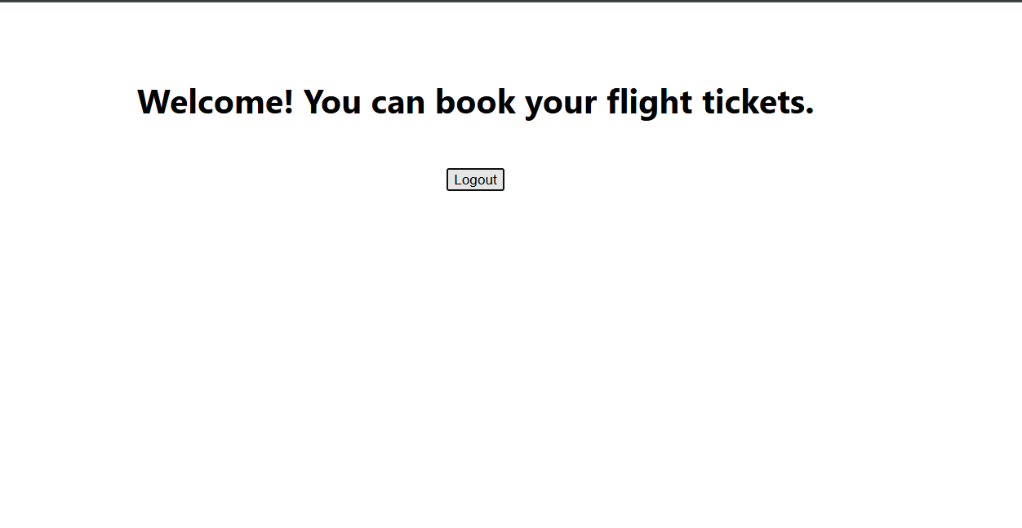

**13.Create a React App named “bloggerapp” in with 3 components.**

**CODE:**

**CourseDetails.js:**

import React from 'react';

const CourseDetails = ({ show }) => {

if (!show) return null;

const courses = [

{ name: "Angular", date: "4/5/2021" },

{ name: "React", date: "6/3/20201" },

];

return (

<div>

<h2>Course Details</h2>

{courses.map((course, i) => (

<div key={i}>

<b>{course.name}</b>

<p>{course.date}</p>

</div>

))}

</div>

);

};

export default CourseDetails;

**BookDetails.js:**

import React from 'react';

const BookDetails = ({ show }) =>

show && (

<div>

<h2>Book Details</h2>

<p><b>Master React</b><br />670</p>

<p><b>Deep Dive into Angular 11</b><br />800</p>

<p><b>Mongo Essentials</b><br />450</p>

</div>

);

export default BookDetails;

**BlogDetails.js:**

import React from 'react';

function BlogDetails({ show }) {

return (

<>

{show ? (

<div>

<h2>Blog Details</h2>

<p><b>React Learning</b><br /><i>Stephen Biz</i><br />Welcome to learning React!</p>

<p><b>Installation</b><br /><i>Schwezdenier</i><br />You can install React from npm.</p>

</div>

) : null}

</>

);

}

export default BlogDetails;

**App.js:**

import React, { useState } from 'react';

import CourseDetails from './CourseDetails';

import BookDetails from './BookDetails';

import BlogDetails from './BlogDetails';

import './App.css';

function App() {

const [showCourse, setShowCourse] = useState(true);

const [showBook, setShowBook] = useState(true);

const [showBlog, setShowBlog] = useState(true);

return (

<div className="App">

<div className="container">

{/* Conditional Rendering using "if" inside component */}

<div className="box">

<CourseDetails show={showCourse} />

</div>

{/* Conditional Rendering using logical && operator */}

<div className="box">

<BookDetails show={showBook} />

</div>

{/* Conditional Rendering using ternary operator */}

<div className="box">

<BlogDetails show={showBlog} />

</div>

</div>

</div>

);

}

export default App;

**OUTPUT:**

**14.Developers of Apps Centric Solutions have created an employee management application which supports light and dark themes for the buttons.**

**CODE:**

**EmployeeCard.js:**

import React, { useContext } from 'react';

import ThemeContext from './ThemeContext';

function EmployeeCard({ employee }) {

const theme = useContext(ThemeContext);

const buttonClass = theme === 'dark' ? 'btn-dark' : 'btn-light';

return (

<div className="card">

<h3>{employee.name}</h3>

<p>{employee.role}</p>

<button className={buttonClass}>View</button>

</div>

);

}

export default EmployeeCard;

**EmployeesList.js:**

import React from 'react';

import EmployeeCard from './EmployeeCard';

function EmployeesList() {

const employees = [

{ id: 1, name: 'Alice', role: 'Developer' },

{ id: 2, name: 'Bob', role: 'Designer' },

{ id: 3, name: 'Charlie', role: 'Manager' }

];

return (

<div>

{employees.map(emp => (

<EmployeeCard key={emp.id} employee={emp} />

))}

</div>

);

}

export default EmployeesList;

**App.js:**

import React, { useState } from 'react';

import EmployeesList from './EmployeesList';

import ThemeContext from './ThemeContext';

function App() {

const [theme, setTheme] = useState('light');

return (

<ThemeContext.Provider value={theme}>

<div className="App">

<h1>Employee Management App</h1>

<button onClick={() => setTheme(theme === 'light' ? 'dark' : 'light')}>

Toggle Theme

</button>

<EmployeesList />

</div>

</ThemeContext.Provider>

);

}

export default App;

**ThemeContext.js:**

import { createContext } from 'react';

const ThemeContext = createContext('light');

export default ThemeContext;

**OUTPUT:**

**15.Create a React App named “ticketraisingapp” which will help to raise a complaint and get it resolved.**

**CODE:**

**ComplaintRegister.js:**

import React, { useState } from 'react';

function ComplaintRegister() {

const [name, setName] = useState('');

const [complaint, setComplaint] = useState('');

const handleSubmit = (e) => {

e.preventDefault();

const transactionId = Math.floor(Math.random() * 1000) + 1;

alert(`Thanks ${name}\nYour Complaint was Submitted.\nTransaction ID is: ${transactionId}`);

setName('');

setComplaint('');

};

return (

<div style={{ textAlign: 'center', marginTop: '50px' }}>

<h2 style={{ color: 'red' }}><b>Register your complaints here!!!</b></h2>

<form onSubmit={handleSubmit}>

<div>

<label><b>Name:</b> </label>

<input

type="text"

value={name}

onChange={(e) => setName(e.target.value)}

required

/>

</div><br/>

<div>

<label><b>Complaint:</b> </label>

<textarea

value={complaint}

onChange={(e) => setComplaint(e.target.value)}

required

/>

</div><br/>

<button type="submit">Submit</button>

</form>

</div>

);

}

export default ComplaintRegister;

**App.js:**

import React from 'react';

import ComplaintRegister from './components/ComplaintRegister';

function App() {

return (

<div className="App">

<ComplaintRegister />

</div>

);

}

export default App;

**OUTPUT:**

**16.Create a React App named “mailregisterapp” which will have a component named “register.js”.**

**CODE:**

**Register.js:**

import React, { useState } from 'react';

function Register() {

const [form, setForm] = useState({ name: '', email: '', password: '' });

const [errors, setErrors] = useState({});

const handleChange = (e) => {

const { name, value } = e.target;

setForm({ ...form, [name]: value });

// Live validation

let tempErrors = { ...errors };

if (name === 'name' && value.length < 5) {

tempErrors.name = 'Name must be at least 5 characters';

} else if (name === 'email' && (!value.includes('@') || !value.includes('.'))) {

tempErrors.email = 'Email must contain "@" and "."';

} else if (name === 'password' && value.length < 8) {

tempErrors.password = 'Password must be at least 8 characters';

} else {

delete tempErrors[name];

}

setErrors(tempErrors);

};

const handleSubmit = (e) => {

e.preventDefault();

let validationErrors = {};

if (form.name.length < 5) {

validationErrors.name = 'Name must be at least 5 characters';

}

if (!form.email.includes('@') || !form.email.includes('.')) {

validationErrors.email = 'Email must contain "@" and "."';

}

if (form.password.length < 8) {

validationErrors.password = 'Password must be at least 8 characters';

}

if (Object.keys(validationErrors).length > 0) {

setErrors(validationErrors);

} else {

alert('Form Submitted Successfully');

setForm({ name: '', email: '', password: '' });

setErrors({});

}

};

return (

<div style={{ padding: '20px' }}>

<h2>Register</h2>

<form onSubmit={handleSubmit}>

<div>

<label>Name: </label><br />

<input

type="text"

name="name"

value={form.name}

onChange={handleChange}

/>

{errors.name && <div style={{ color: 'red' }}>{errors.name}</div>}

</div>

<div>

<label>Email: </label><br />

<input

type="email"

name="email"

value={form.email}

onChange={handleChange}

/>

{errors.email && <div style={{ color: 'red' }}>{errors.email}</div>}

</div>

<div>

<label>Password: </label><br />

<input

type="password"

name="password"

value={form.password}

onChange={handleChange}

/>

{errors.password && <div style={{ color: 'red' }}>{errors.password}</div>}

</div>

<br />

<button type="submit">Register</button>

</form>

</div>

);

}

export default Register;

**App.js:**

import React from 'react';

import Register from './Register';

function App() {

return (

<div>

<Register />

</div>

);

}

export default App;

**OUTPUT:**

**17.Create a React Application “fetchuserapp” which will retrieve the user details from** [**https://api.randomuser.me/**](https://api.randomuser.me/) **and display the title, firstname and image of a user.**

**CODE:**

**Getuser.js:**

import React, { Component } from 'react';

class Getuser extends Component {

constructor() {

super();

this.state = {

name: '',

image: ''

};

}

async componentDidMount() {

const response = await fetch('https://api.randomuser.me/');

const data = await response.json();

const user = data.results[0];

this.setState({

name: `Mr ${user.name.first} ${user.name.last}`,

image: user.picture.medium

});

}

render() {

return (

<div style={{ textAlign: 'center', marginTop: '50px' }}>

<h1>{this.state.name}</h1>

<img src={this.state.image} alt="User" />

</div>

);

}

}

export default Getuser;

**OUTPUT:**

