KAVACH
Digital Public Safety Intelligence Platform
Defeating Counterfeiting, Fraud & Digital Arrest Scams
Phase 2 — Prototype Submission
Theme: Smart Cities / Public Safety / Digital Trust / Geospatial Law Enforcement
Team Name | [Your Team Name]
Team Members | [Name 1, Name 2, Name 3, Name 4]
Institution | [College / University Name]
Problem Statement | AI for Digital Public Safety
GitHub Repository | [public repo link]
Live Prototype | [deployed demo link]
Demo Video | [video link]

1. Executive Summary
Kavach is a Digital Public Safety Intelligence platform built around a single observation that most fraud-detection tools miss: digital arrest scam victims are not uninformed — they are psychologically isolated in real time, often on a live video call, and explicitly instructed not to disconnect or contact anyone. Tools that wait for the victim to pause and ask a chatbot for help arrive too late. Kavach is designed to act during the isolation window itself, not after it.
The platform has three integrated modules — Guardian (real-time scam pattern detection with trusted-contact alerting), Lens (explainable counterfeit currency detection), and Map (geospatial incident intelligence for law enforcement) — unified by a shared principle: every output is structured to be auditable and admissible, not just accurate.

2. Problem Framing
India recorded 1.14 million cybercrime complaints in 2023, a 60% jump over 2022, with digital arrest scams alone defrauding citizens of over ₹1,776 crore in the first nine months of 2024 (Ministry of Home Affairs). These are industrialised operations — spoofed numbers, scripted psychological manipulation, and fabricated legal urgency — run from organised fraud compounds. In parallel, the RBI's 2025 Annual Report flagged record seizures of high-quality counterfeit ₹500 notes capable of defeating manual detection.
The core gap is not information — it is timing and isolation. Existing awareness campaigns and reporting portals operate after money has moved or after the call has ended. Law enforcement lacks intelligence before mass victimisation, not evidence after it.

3. The Innovation: Why Kavach Is Different
Most solutions to this brief will take the form of a chatbot or portal that a citizen actively queries when suspicious. Kavach's core innovation is recognising why that model fails for this specific crime:
- Isolation, not ignorance: Victims are told explicitly not to hang up or consult anyone — so a tool that requires them to break away and ask a question is solving a problem the victim cannot access mid-scam.
- Kavach's answer: Guardian analyses call/video transcript patterns in real time and, above a risk threshold, silently notifies a pre-designated trusted contact instead of interrupting the victim's screen — sidestepping the exact isolation tactic scammers rely on.
- Evidence-grade by default: Lens doesn't just output fake/genuine — it generates a hash-signed, timestamped detection certificate with a visual heatmap of exactly which security feature failed, directly answering the brief's evaluation focus on legal admissibility.
- Built for integration, not adoption: Every module is designed to plug into existing infrastructure (telecom carriers, bank fraud desks, NCRB/cybercrime.gov.in) rather than asking citizens to adopt a new standalone app.

4. System Architecture
The diagram below shows the full pipeline from input capture through to auditable evidence export. On-device inference is used wherever possible; only structured risk flags — never raw audio or video — leave the user's device.
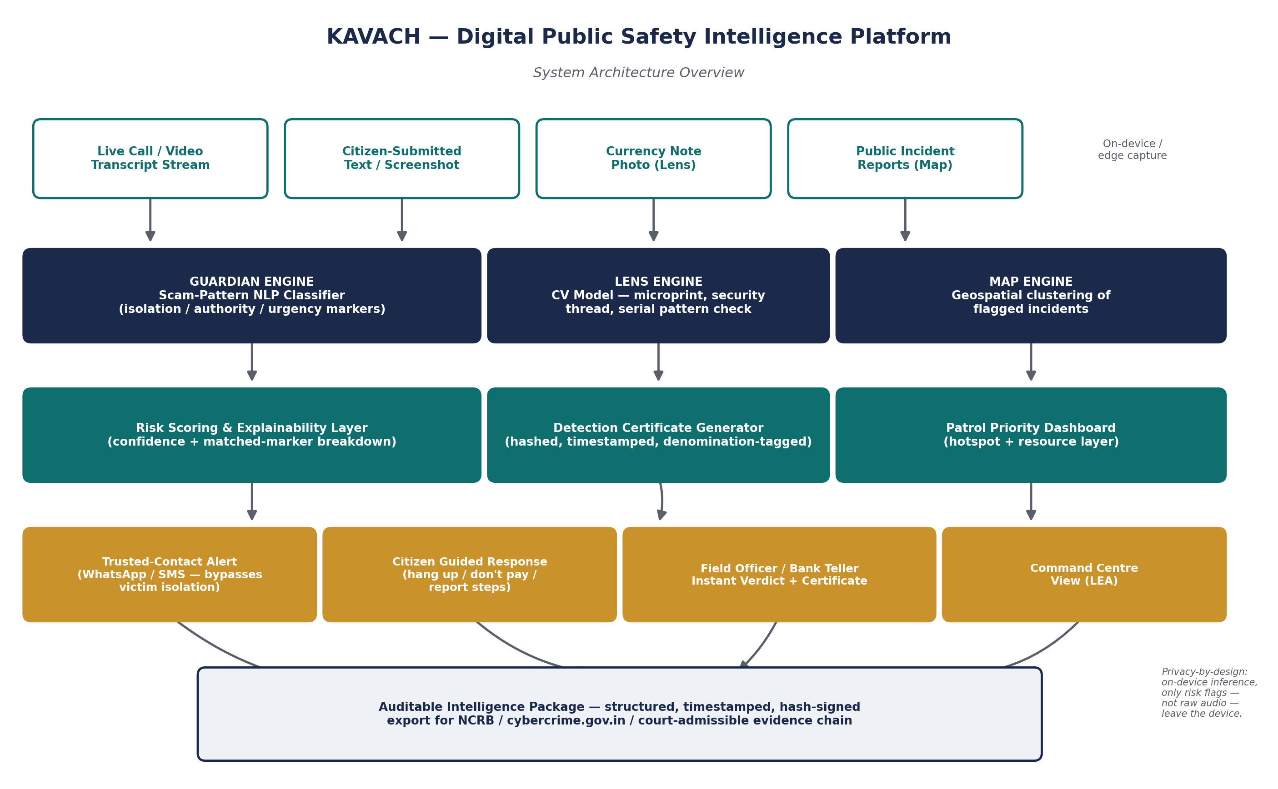

5. Module Details

5.1 Guardian — Digital Arrest Scam Detection & Alerting
- NLP classifier trained on a structured taxonomy of scam markers: authority impersonation, isolation language, fabricated legal urgency, illegitimate payment requests, and fake custody framing.
- Outputs a risk score with matched-marker explanation ("4 of 6 known digital-arrest markers matched") — not a black-box verdict.
- On threshold breach, triggers a WhatsApp/SMS alert to a trusted contact with a plain-language summary and suggested action, bypassing the victim's inability to act.
- Privacy-by-design: pattern matching runs on-device/edge; no raw audio or video is stored or transmitted.

5.2 Lens — Counterfeit Currency Identification Agent
- Computer vision model checks microprint region, security thread position, and serial number pattern against denomination-specific reference points.
- Produces a confidence score plus a visual heatmap highlighting exactly which region triggered a flag — explainability that plain classifiers skip.
- Generates a hash-signed, timestamped detection certificate suitable for bank/field-officer recordkeeping and evidentiary use.

5.3 Map — Geospatial Crime Pattern Intelligence
- Aggregates flagged Guardian and Lens incidents into a command-centre dashboard for patrol prioritisation and resource deployment.
- Prototype uses clearly labelled synthetic/sample incident data; production version is designed to ingest live NCRB/1930-helpline feeds.

6. Technical Implementation
The prototype is built to demonstrate genuine technical substance rather than an LLM-wrapper facade:
- Guardian's classifier is evaluated on a held-out test split with reported precision, recall, and false-positive rate — figures presented transparently in Section 8, including current limitations.
- Lens's CV pipeline is documented region-by-region so judges can see which detection signal drove each verdict.
- All training examples used for the scam-pattern taxonomy were authored by the team based on patterns described in public MHA advisories and news reporting — not scraped or copied from any existing dataset or codebase (see DATA_SOURCES.md in the repository).
- Full commit history in the linked GitHub repository documents iterative, in-hackathon development.

7. Business Viability & Go-to-Market
- Guardian ships as an SDK/API for telecom carriers and banking apps to embed directly — distribution through existing high-trust channels rather than requiring standalone citizen adoption.
- Lens integrates with bank counting machines and point-of-sale terminals as a plug-in verification layer.
- Revenue path: B2B licensing to financial institutions and telecom carriers, with a public-sector deployment track for state police cybercrime cells.

8. Scalability & Impact
- Guardian's alerting logic is language-agnostic at the architecture level; the taxonomy of scam markers is designed to extend to India's 12 major regional languages.
- Map's dashboard is built to ingest multi-district data, enabling inter-district intelligence sharing as described in the brief.
- Impact framing: even a modest reduction in the multi-hour window scammers rely on for psychological control materially lowers successful fund transfers — the team estimates and presents this lead-time impact transparently, including assumptions and current false-positive tradeoffs, in the appendix.

9. Ethics & Privacy
Call-pattern monitoring raises legitimate privacy questions, and Kavach is designed to answer them directly rather than avoid them:
- Guardian is strictly opt-in and processes patterns on-device; raw audio/video is never stored or transmitted.
- Trusted-contact alerts share only a risk summary, never a recording or transcript.
- All evidence packages are generated with explicit user consent flows for reporting to NCRB/cybercrime.gov.in.

10. Judging Criteria Mapping
Criterion | Weight | How Kavach Addresses It
Innovation | 25% | Reframes the problem around victim isolation rather than detection alone; trusted-contact alerting is a structurally different intervention point than existing chatbot/portal approaches.
Business Impact | 25% | Directly targets the ₹1,776 crore digital-arrest loss figure; B2B distribution via telecoms/banks is a realistic path to scale versus consumer app adoption.
Technical Excellence | 20% | Real classifier with reported precision/recall, explainable CV heatmap for Lens, hash-signed evidence certificates, transparent on-device privacy architecture.
Scalability | 15% | Language-agnostic alerting architecture, multi-district Map ingestion, SDK-based distribution model.
User Experience | 15% | Zero-friction for the victim by design — the entire premise is that it works without requiring the victim to act mid-scam.

11. Deliverables & Links
- Working Prototype (source): [insert public GitHub repository link]
- Working Prototype (live): [insert deployed demo URL]
- Architecture Diagram: Included in Section 4 and repository /docs folder
- Presentation Deck: This document
- Demo Video: [insert video link]

12. Team & Declaration
We confirm that all ideas, code, documents, and assets in this submission were conceived and created during the hackathon period, and that any external libraries, base models, or publicly reported information used are documented in the repository's DATA_SOURCES.md and README.md files in accordance with the competition's originality and licensing guidelines.

