1.

<!DOCTYPE html>

<html>

<head>

 <script>

     var name;

     let h;

     const num=14;

     console.log(name);

     console.log(h);

     console.log(num);

 </script>

</head>

<body>

</body>

</html>

Output:

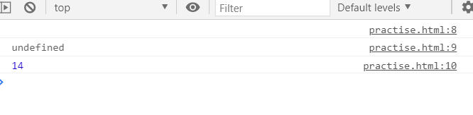

2.Challenge 1

<!DOCTYPE html>

<html>

<head>

 <script>

     const myVar=10;

     console.log(myVar);

 </script>

</head>

<body>

</body>

</html>

Output:

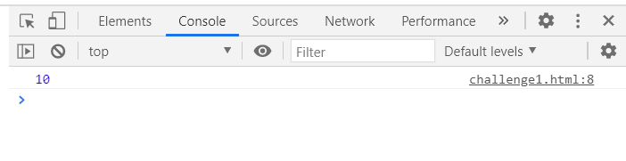

3.Console printing

<!DOCTYPE html>

<html>

<head>

 <script>

     var x=10;

    var y=5.2;

    var z=true;

    var str="Welcome"

    console.log("var x=",+x,",","var x=",+y,",","var x=",+z,",","var x=",+str);

 </script>

</head>

<body>

</body>

</html>

Output:

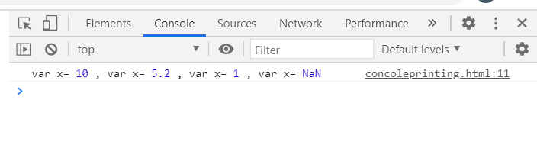

4.Array printing

<!DOCTYPE html>

<html>

<head>

</head>

<body>

    <h2>Empty array:</h2>

  <p id='cl'></p>

  <h2 >New method:</h2>

  <p id="k"></p>

  <h2 >Normal method:</h2>

  <p id="a"></p>

  <script>

    var x=new Array();

    var y=new Array(50,40,2,1,1,6);

    var z=[80,50,4,1,2,6];

    var lo="";

    var zo="";

    var i=0;

    for(i=0;i<x.length;i++){

        lo += x[i]+ "<br>";

     }

    document.getElementById('cl').innerHTML=lo;

    console.log(x);

    for(i=0;i<y.length;i++){

        lo += y[i]+ "<br>";

        }

    document.getElementById('k').innerHTML=lo;

    console.log(y);

    for(i=0;i<z.length;i++){

        zo += z[i]+ "<br>";

    }

    document.getElementById('a').innerHTML=zo;

    console.log(z);

</script>

</body>

</html>

Output:

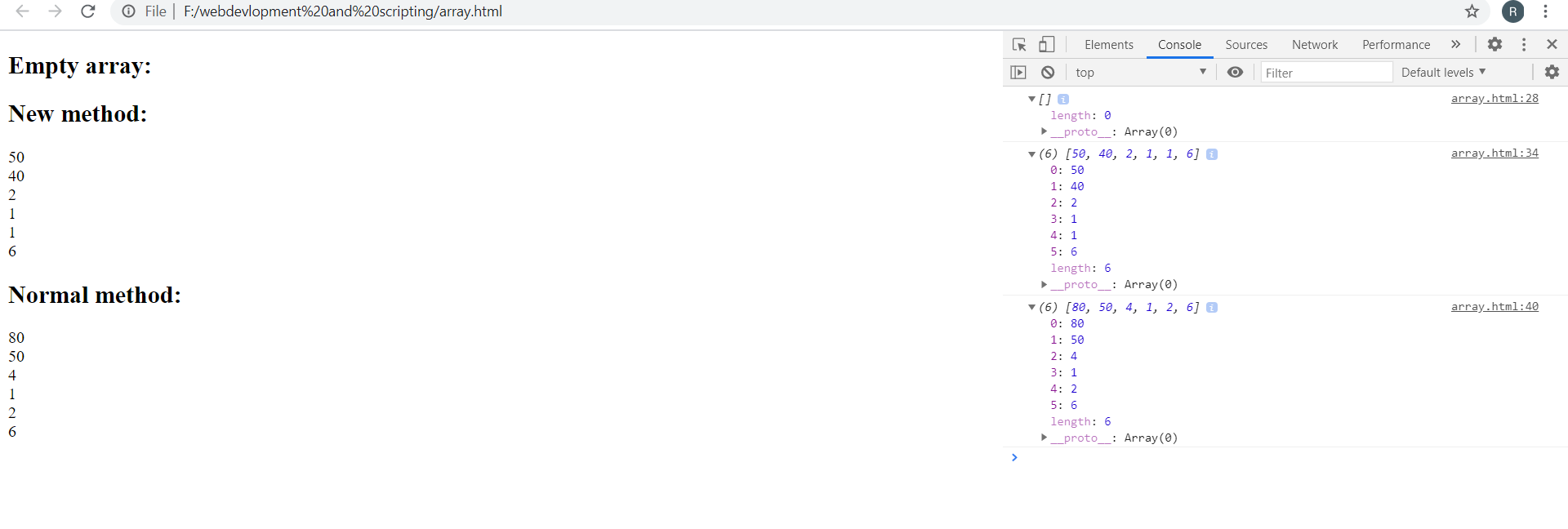

5.object creation:

<!DOCTYPE html>

<html>

<head>

 <script>

     var person={

         firstName:"John",

         lastName:"Doe",

         age:50,

         eyeColor:"blue"

     };

     console.log(person.firstName+person.lastName+""+" is"+person.age+""+"years old.");

     console.log(person);

     var person=new Object();

        person.firstName="John",

         person.lastName="Doe",

         person.age=50,

         person.eyeColor="blue"

     console.log(person.firstName+person.lastName+" "+" is"+person.age+""+" year old"+" "+" and has"+person.eyeColor+" "+"eyecolor.")

     console.log(person);

 </script>

</head>

<body>

</body>

</html>

Output:

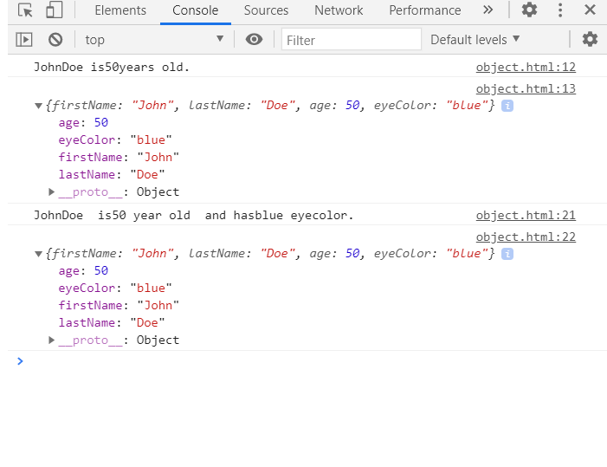

5.objectprinting challenge

<!DOCTYPE html>

<html>

<head>

 <script>

     var myobj={

         prop1:10,

         prop2:20,

        prop3:30

     };

     console.log(myobj);

     console.log("prop1:",+myobj.prop1,"prop2:",+myobj.prop2,"prop1:",+myobj.prop3);

 </script>

</head>

<body>

</body>

</html>

Output:

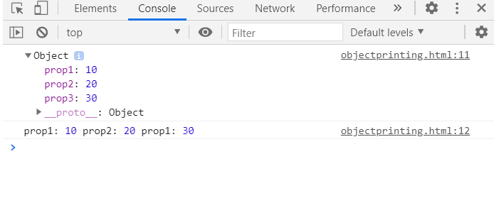

6.Modified challenge:

<!DOCTYPE html>

<html>

<head>

 <script>

     var car={

         name:"fiat",

         model:500,

        color:"white"

     };

     console.log(car);

     car.model=800;

     console.log("modified moidel:",+car.model);

 </script>

</head>

<body>

</body>

</html>

Output:

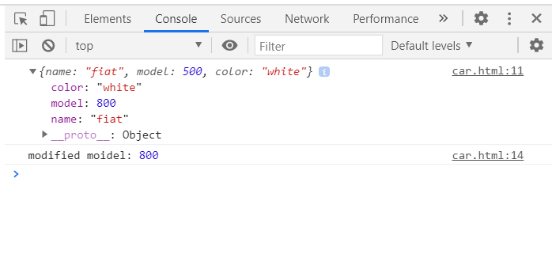

7.challenge 8:

<!DOCTYPE html>

<html>

<head>

 <script>

    var myArray=[10,20,30];

    var myobj={

        prop1:60,

        prop2:true

    }

    console.log(myArray);

    myArray[3]=myobj;

    console.log(myArray);

    myArray.push(myobj.prop1,myobj.prop2);

    console.log(myArray);

 </script>

</head>

<body>

</body>

</html

Output:

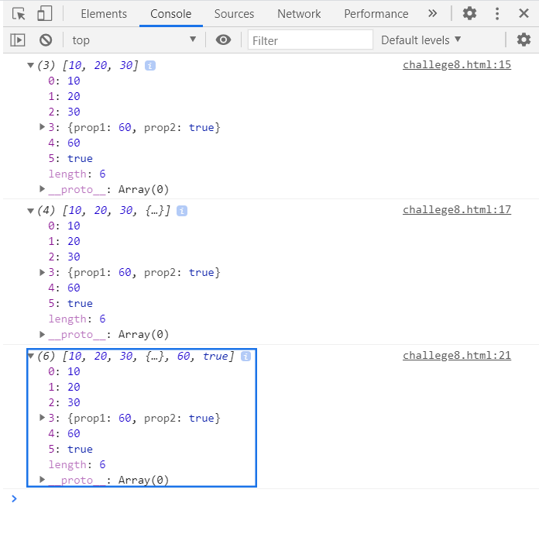

8. BMI

<!DOCTYPE html>

<html>

<head>

 <script>

     var mark = {

    mass : 78,

    height : 1.8

}

var John = {

    mass : 87,

    height : 1.8

}

mark.BMI = mark.mass/(mark.height\*mark.height);

John.BMI = John.mass/(John.height\*John.height);

boo = mark.BMI > John.BMI;

console.log(`Mark's BMI ${mark.BMI} higher than John's BMI ${John.BMI} ? ${boo}`);

 </script>

</head>

<body>

</body>

</html

OUTPUT:

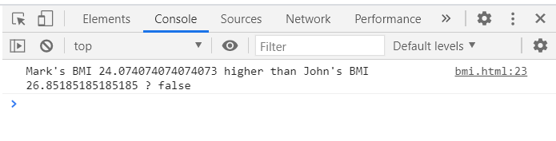

9.Userinput:

<!DOCTYPE html>

<html>

<head>

 <script>

var bmi ={mass:null,height:null,BMI:null}

var Mark = new Object();

var John = new Object();

var bool = false;

Mark.height=prompt("Enter marks heigth");

Mark.weight=prompt("Enter marks weight");

John.height=prompt("Enter johns heigth");

John.weight=prompt("Enter johns weight");

function callbmi(temp){

    temp.bmi = temp.mass / temp.height\*\*2 ;

}

callbmi(Mark);

callbmi(John);

if (Mark.bmi > John.bmi){

    bool = true

}

console.log("Is Mark's BMI higher than John's?"+ String(bool));

 </script>

</head>

<body>

</body>

</html

Output:

