1)<!DOCTYPE html>

<html>

    <head>

        <title>

            Template literals

        </title>

        <script>

            const mynum=36;

            var rf=0;

            var i=0;

            const templit=function(num){

                while(num){

                        if(num<i){

                            rf=i;

                            break;

                        }

                        i=i+10;

                        }

                return `Number is ${num}.\nThis Number is lesser than ${rf}.\nSquare root of this number is ${Math.sqrt(num)}.`

  }

            ;

            console.log(templit(mynum));

        </script>

    </head>

</html>

Output:

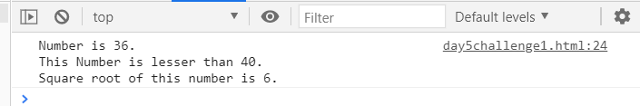

2) <!DOCTYPE html>

<html>

    <head>

        <title>

           Tagged Template

        </title>

        <script>

                const a = 10

                const b = 5

                function taggedTemplate(strArray,...a){

                    let c =" "

                    str.map((b,i) =>{

                        c += b+(a[i] ? a[i] :"" )

                    })

                    return c;

                }

                const sum = taggedTemplate`

                Sum of the two variables a(${a}) and b(${b}) is ${a+b}

                `

                console.log(sum)

        </script>

    </head>

</html>

Output:

