1.Class Declaration:

<script>

    class sample{

    }

    var sm=new sample;

    console.log(sm);

</script>

Output:

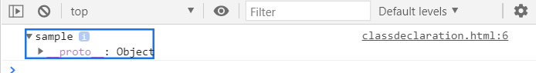

2.Class constructor:

<script>

    class sample2{

        constructor(){

        }

    }

    var sm2=new sample2();

    console.log(sm2);

</script>

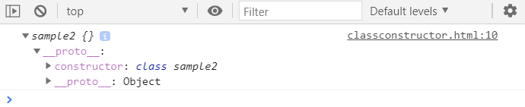

3)Constructor declaration:

<script>

    class student{

        constructor(sname,srollno,sage){

            this.name=sname;

            this.rollno=srollno;

            this.age=sage;

        }

    }

    var std=new student("Raja","E0219054",19);

    var std1=new student("Thawfiq","E0219040",18);

    var std2=new student("Rethick","E0219024",19);

    var std3=new student("Lakshminarayanan","E0219064",19);

    console.log(std,std1,std2,std3);

</script>

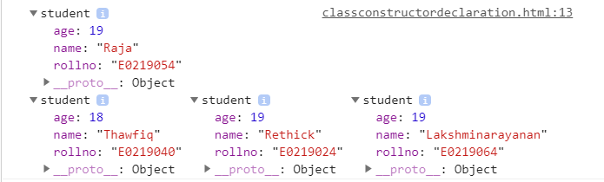

4)Passing object to the constructor:

<script>

    class arr{

        constructor(obj){

            this.name=obj.name;

            this.age=obj.age;

        }

    }

    const arr2={

        name:"raja",

        age:19

    }

    var s=new arr(arr2);

    console.log(s);

</script>

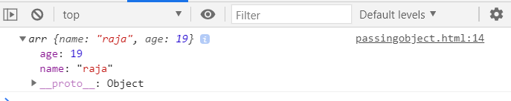

5. Default Argument:

<script>

    class defaultarg{

        constructor(pname="Unknown"){

            this.name=pname;

        }

        }

    var v=new defaultarg();

    console.log(v);

</script>

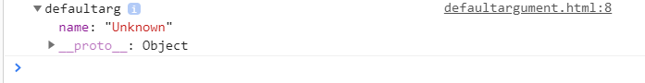

6.

<script>

    //class hoisting cannot be done

    var sd=new gg();

    class gg{

        constructor(){

        }

    }

</script>

