Rajalakshmanan.C

E0219054

SEVER:

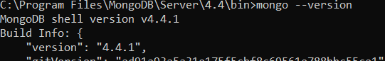

Mongo:

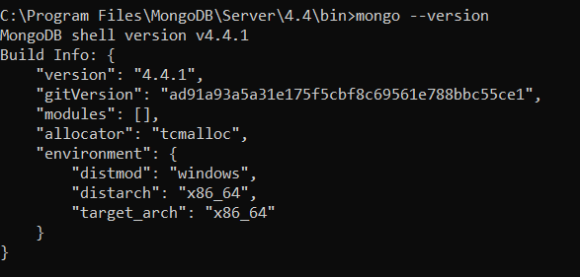

Serverpath:

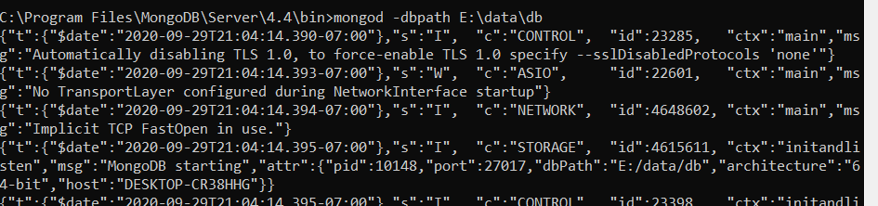

Shell:

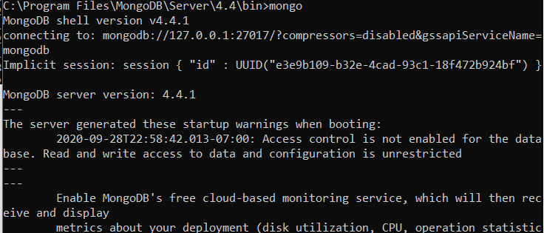

First db:

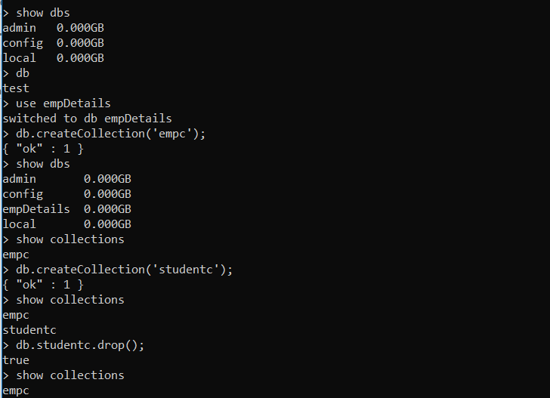



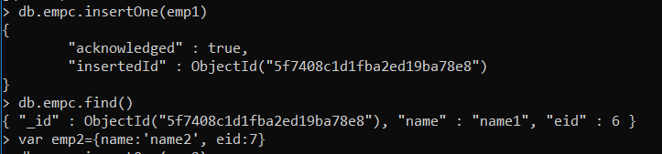

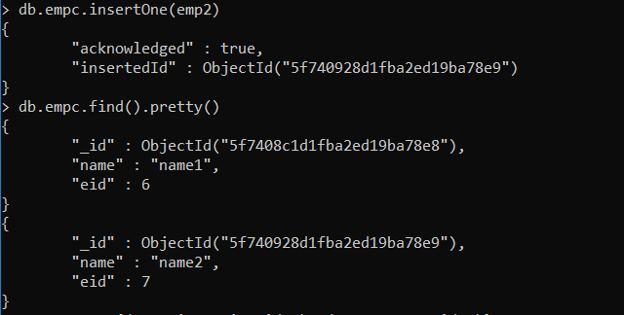

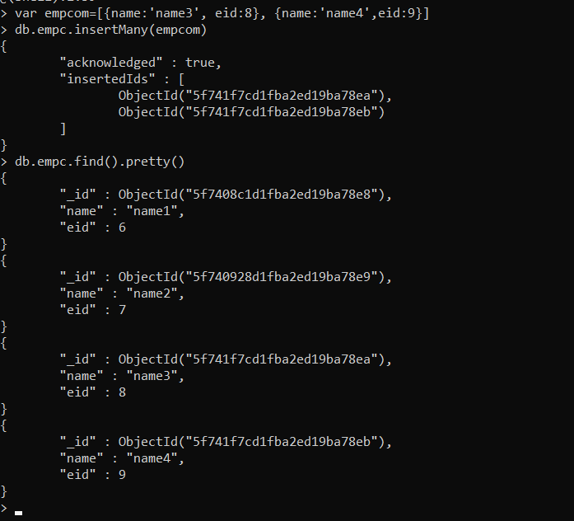

2nd Collection

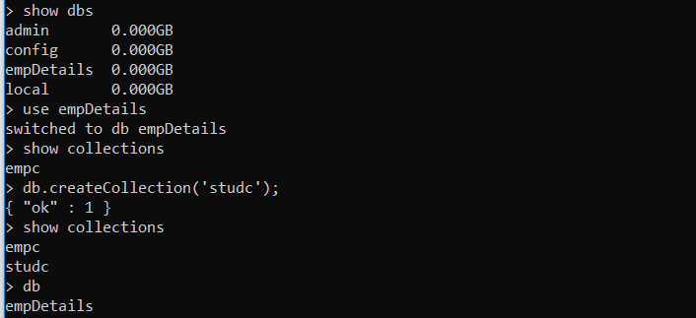

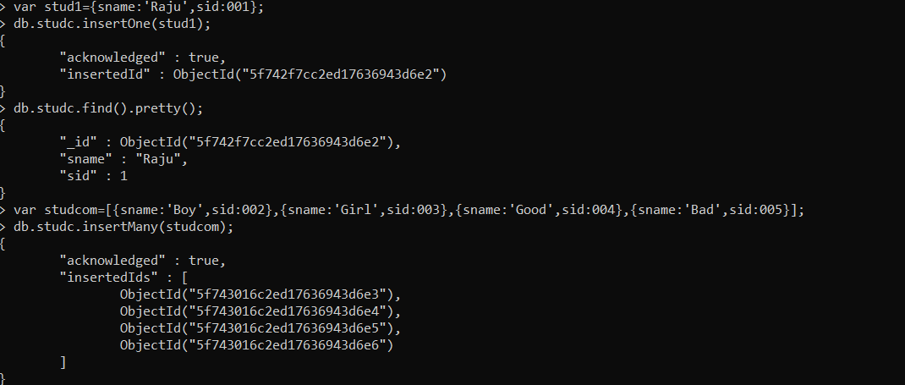

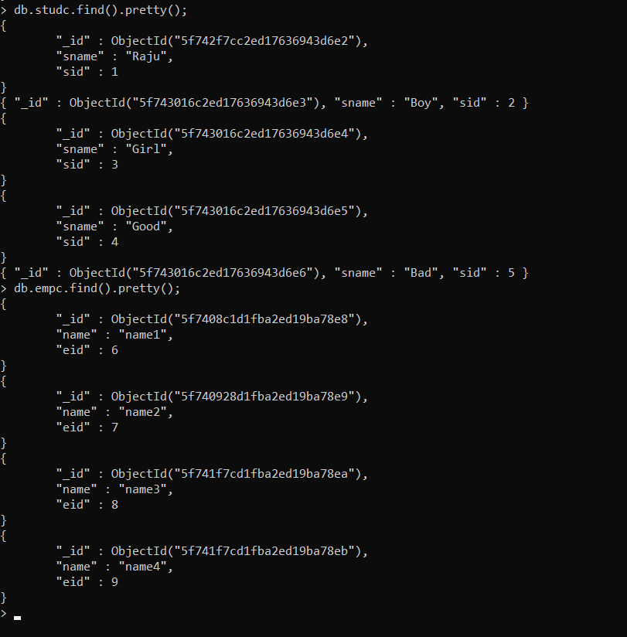

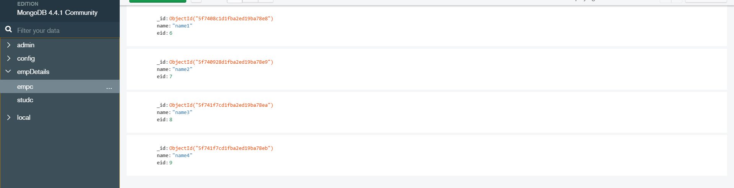

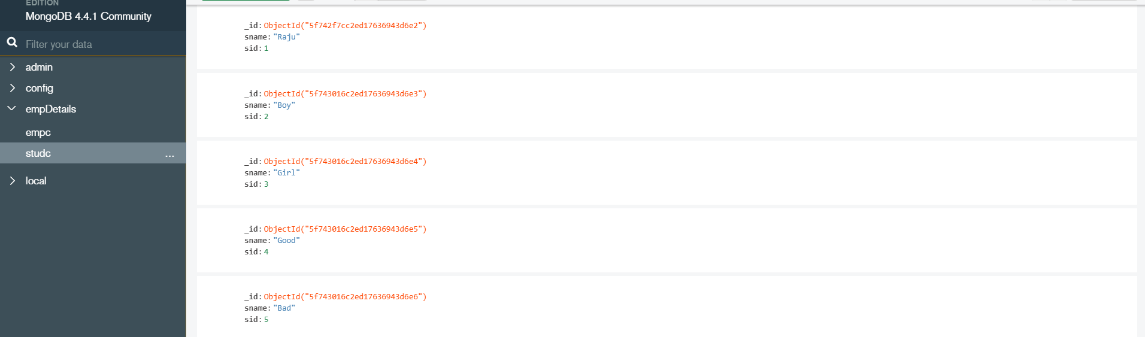

2nd Db:

Firstcollection

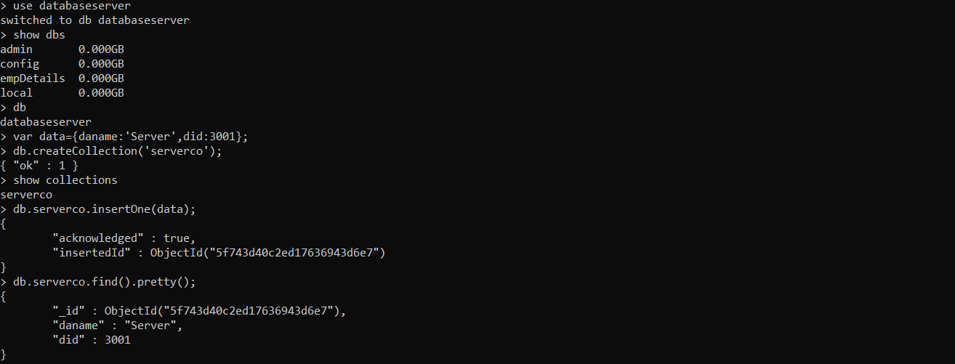



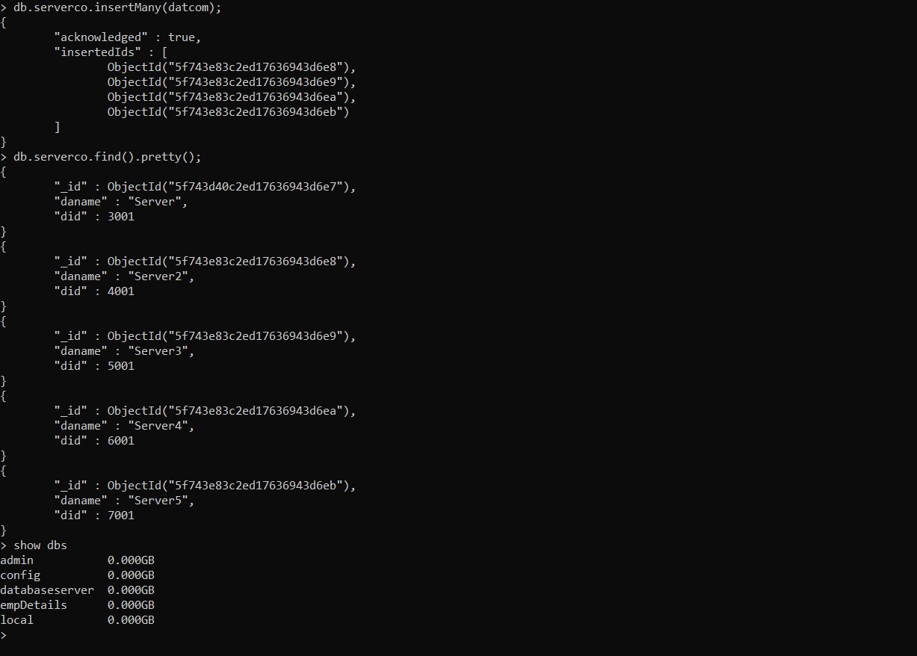

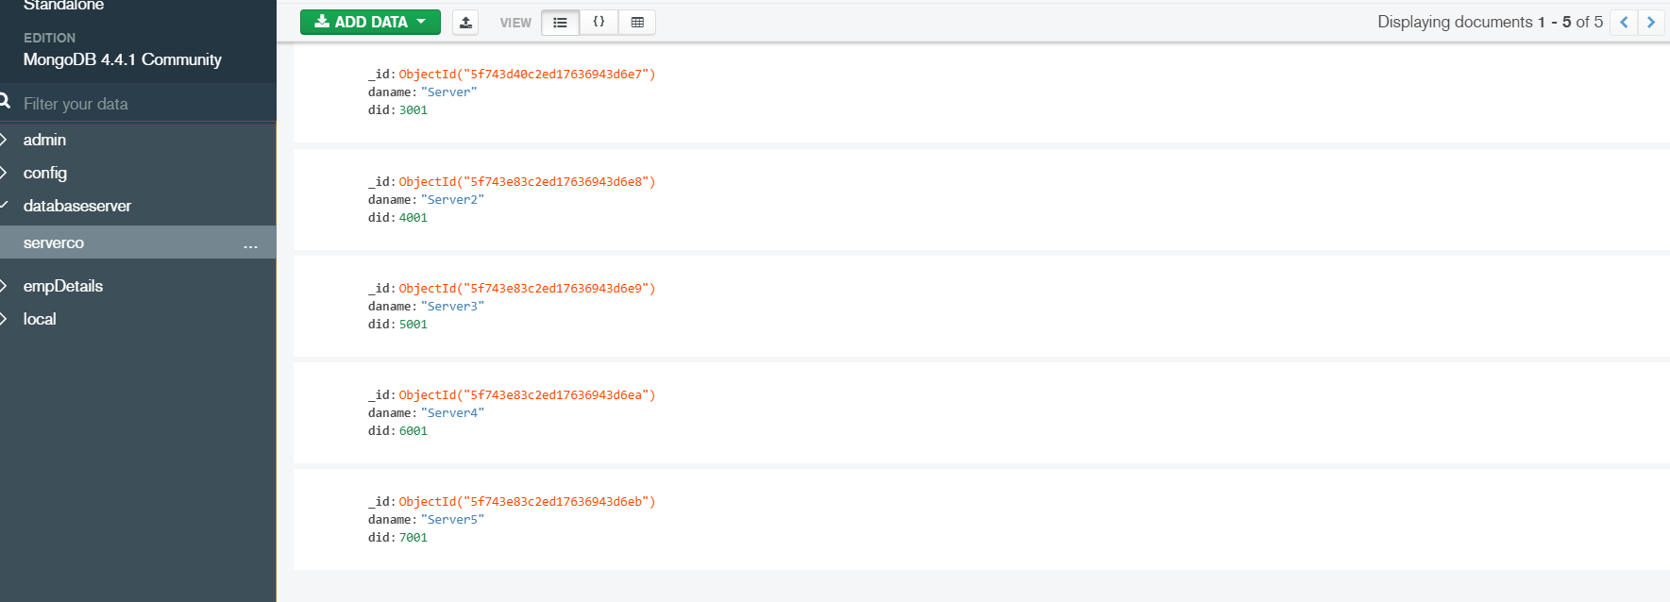

Second collection:

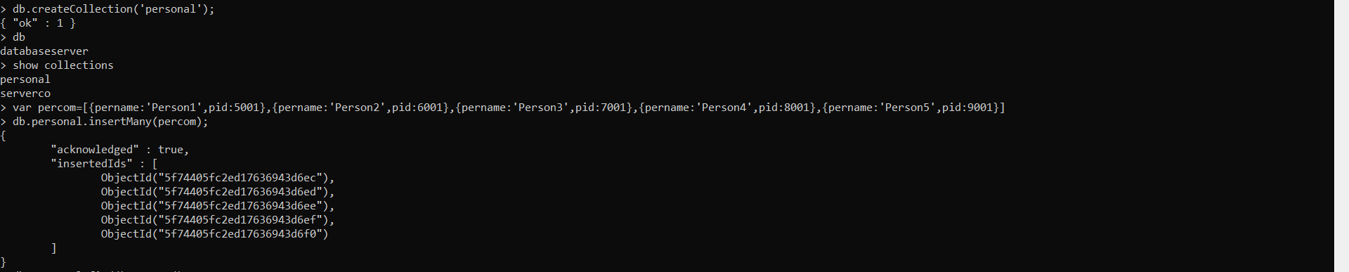

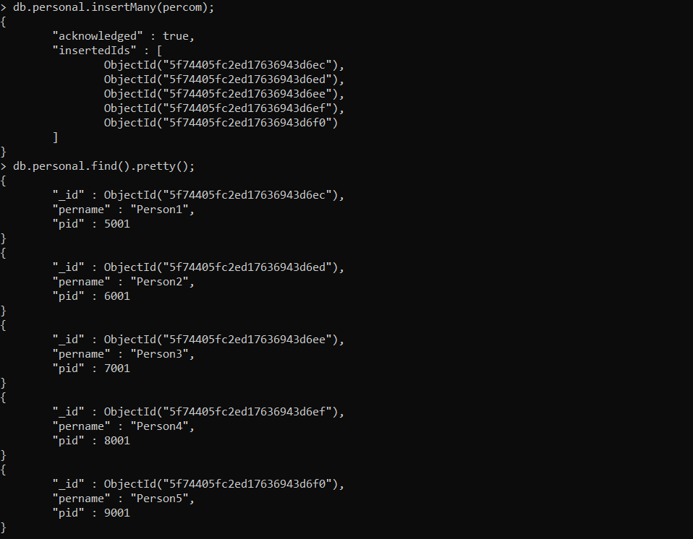

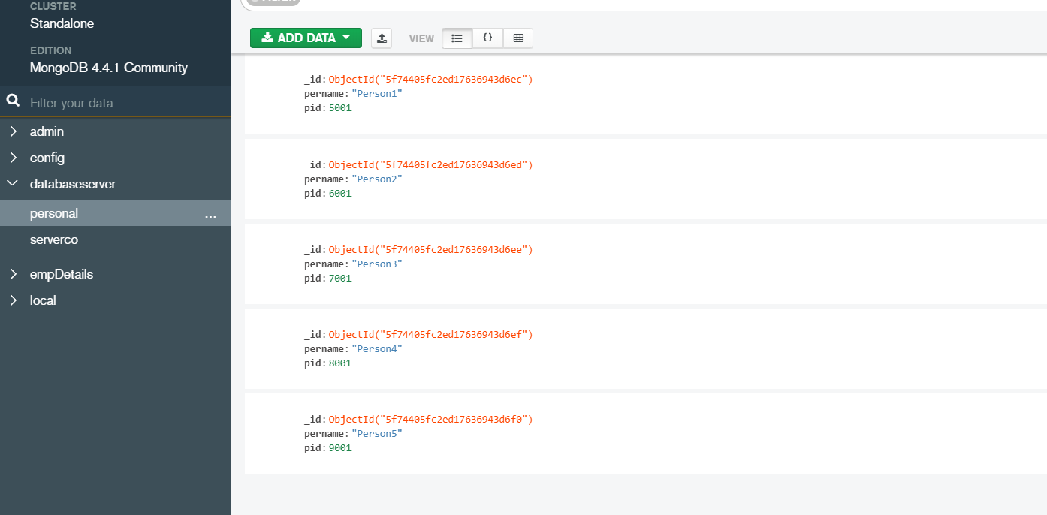

3Rd db:

1st collection:

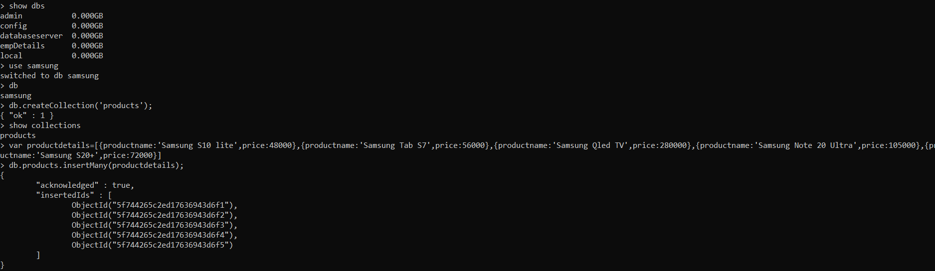

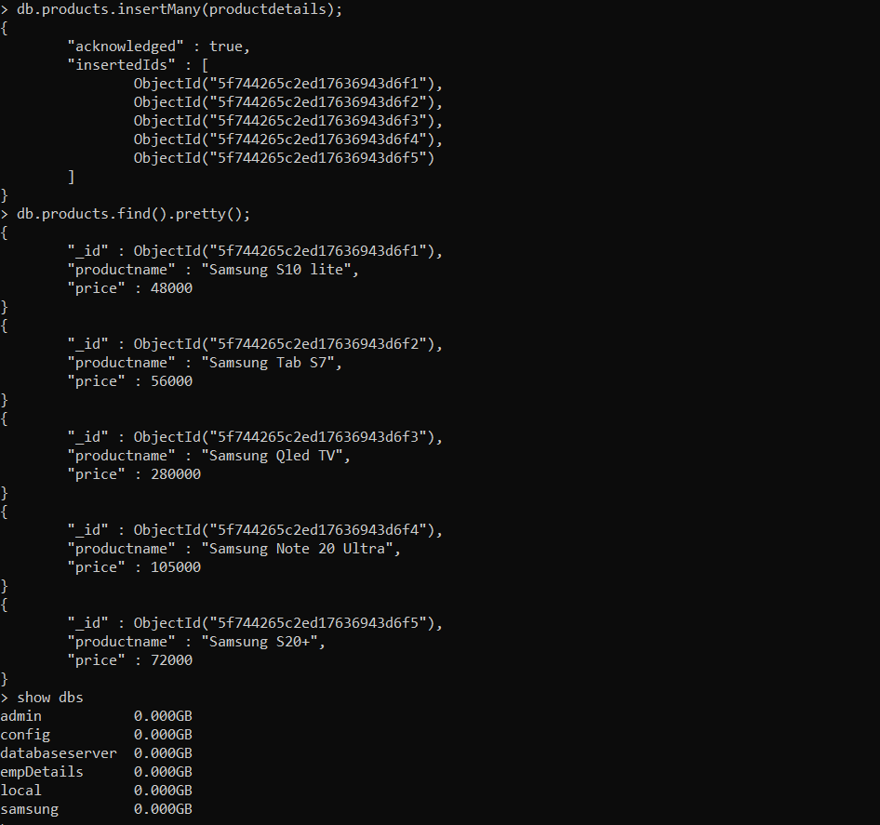

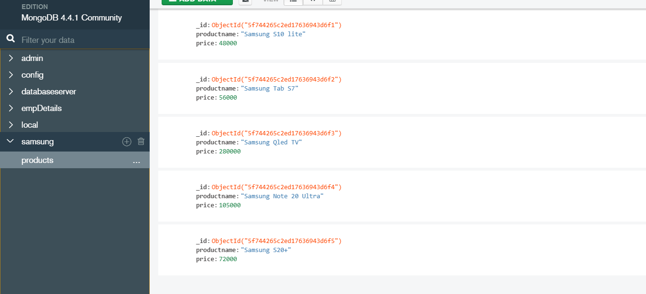

2nd collection:

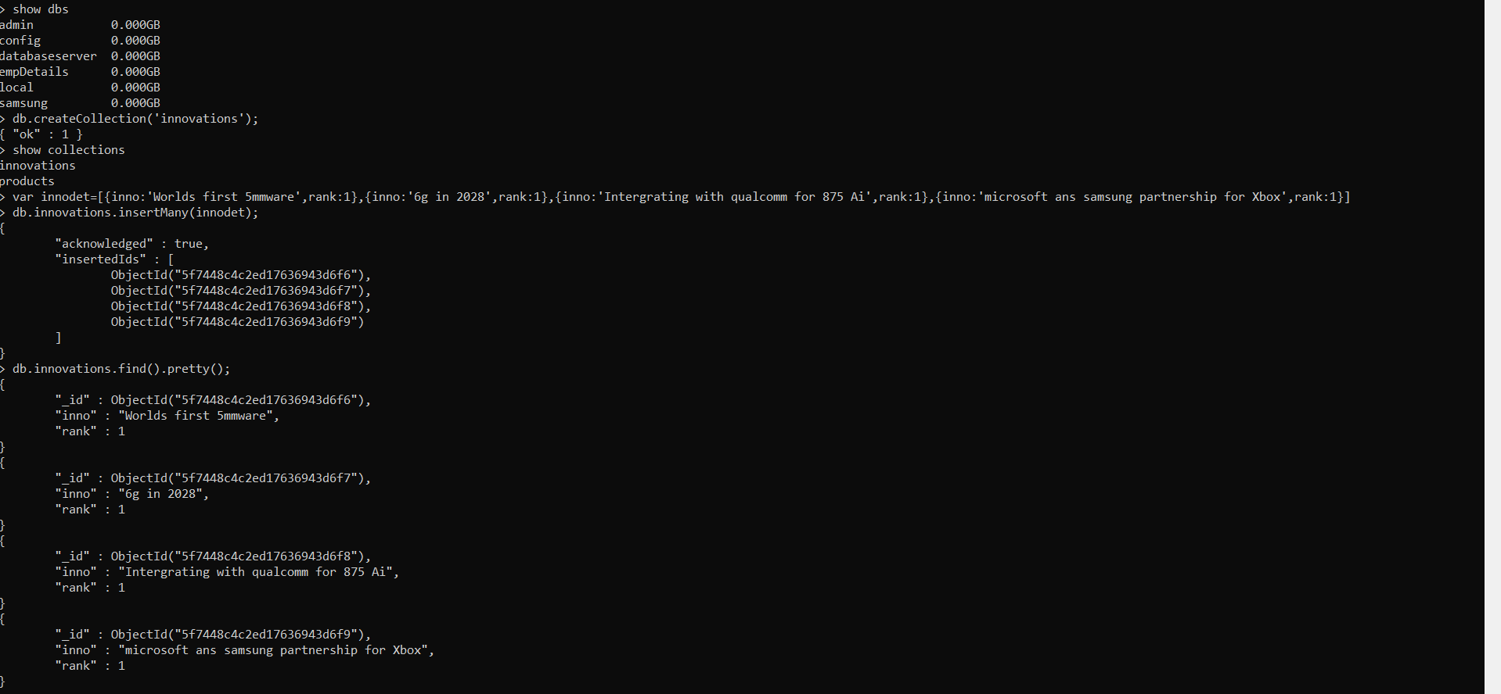

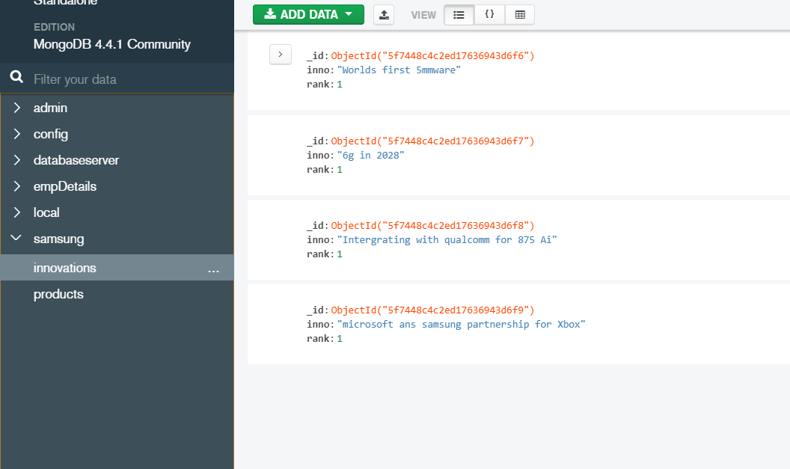

2nd Challenge:

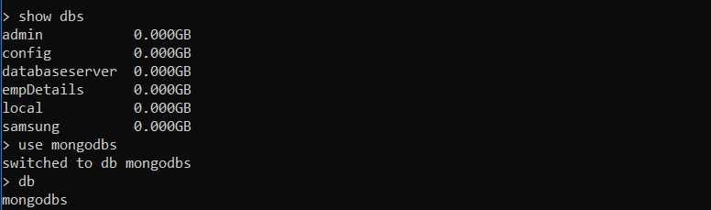





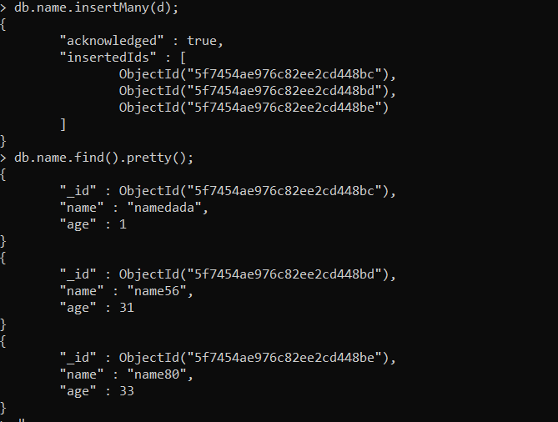

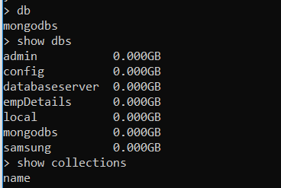

After running this code :

var MongoClient = require('mongodb').MongoClient;

var url = "mongodb://localhost:27017/";

MongoClient.connect(url, function(err, db) {

  if (err) throw err;

  var dbo = db.db("mongodbs");

  dbo.createCollection("customers", function(err, res) {

    if (err) throw err;

    console.log("Collection created!");

    db.close();

  });

});

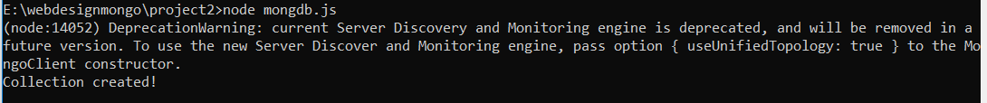

After this a new collection is created and the database have overwritten.



OBSERVATION:

After running the code in mangodb.JS file with the same DB name and creating a new collection in it, the new collection is created and in the same database it has overwritten

This is in mongodb compass:

