**SQL Bolt - Assignments**

**Lesson-1**

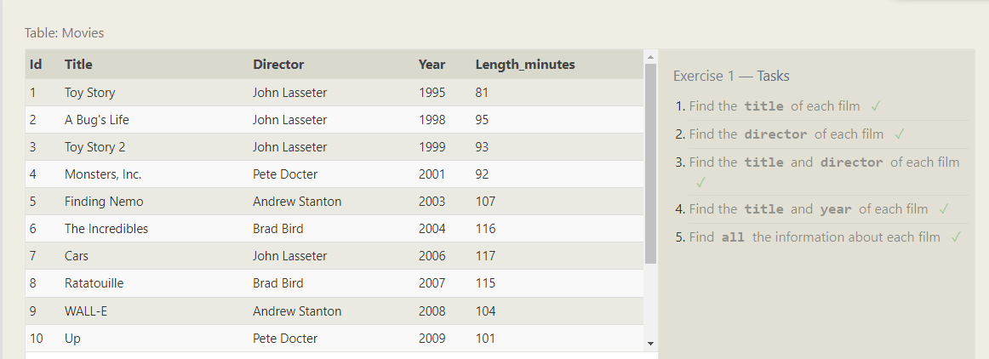

1. SELECT title FROM movies;
2. SELECT director FROM movies;
3. SELECT title, director FROM movies;
4. SELECT title, year FROM movies;
5. SELECT * FROM movies;

**Lesson-2**

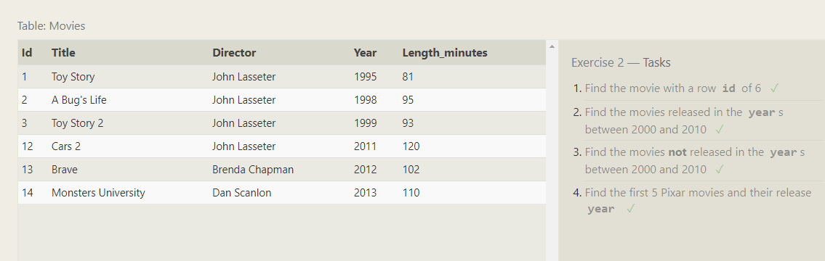

1. SELECT * FROM movies WHERE id = 6;
2. SELECT * FROM movies WHERE year BETWEEN 2000 AND 2010;
3. SELECT * FROM movies WHERE year NOT BETWEEN 2000 AND 2010;
4. SELECT * FROM movies where year LIMIT 5;

**Lesson-3**

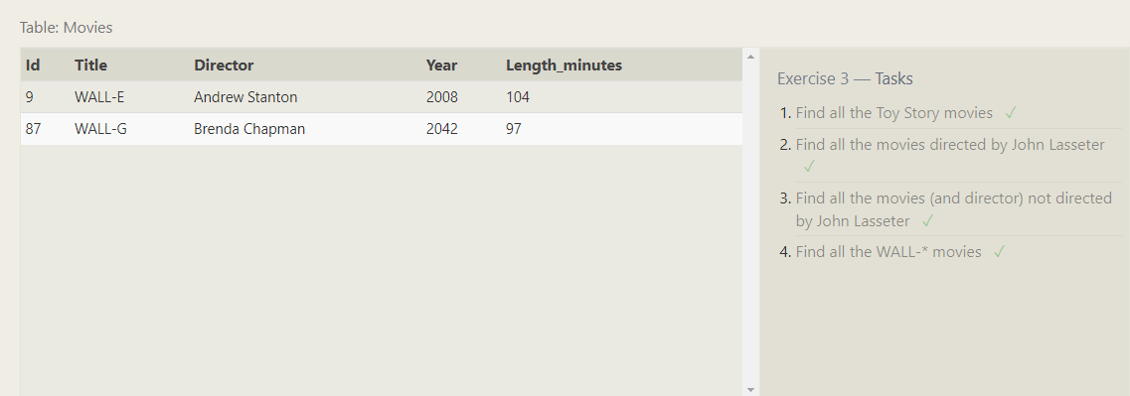

1. SELECT * FROM movies WHERE title like 'toy story%';
2. SELECT * FROM movies where director = 'John Lasseter';
3. SELECT * FROM movies where director <> 'John Lasseter';
4. SELECT * FROM movies where title like 'WALL-%';

**Lesson – 4**

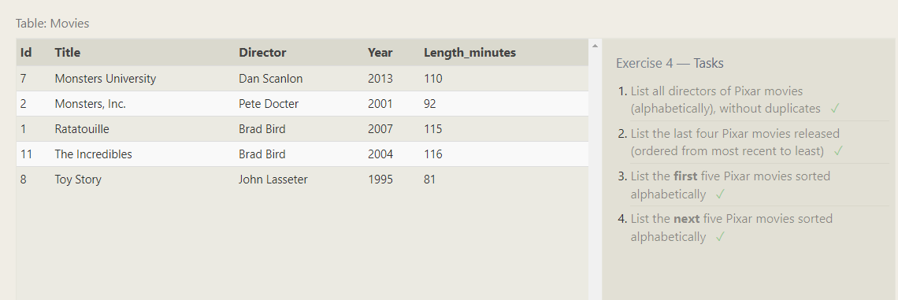

1. SELECT DISTINCT director FROM movies order by director;
2. SELECT DISTINCT title FROM movies ORDER BY year DESC LIMIT 4;
3. SELECT title FROM movies ORDER BY title ASC LIMIT 5;
4. SELECT title FROM movies ORDER BY title ASC LIMIT 5 OFFSET 5;

**Lesson – 5**

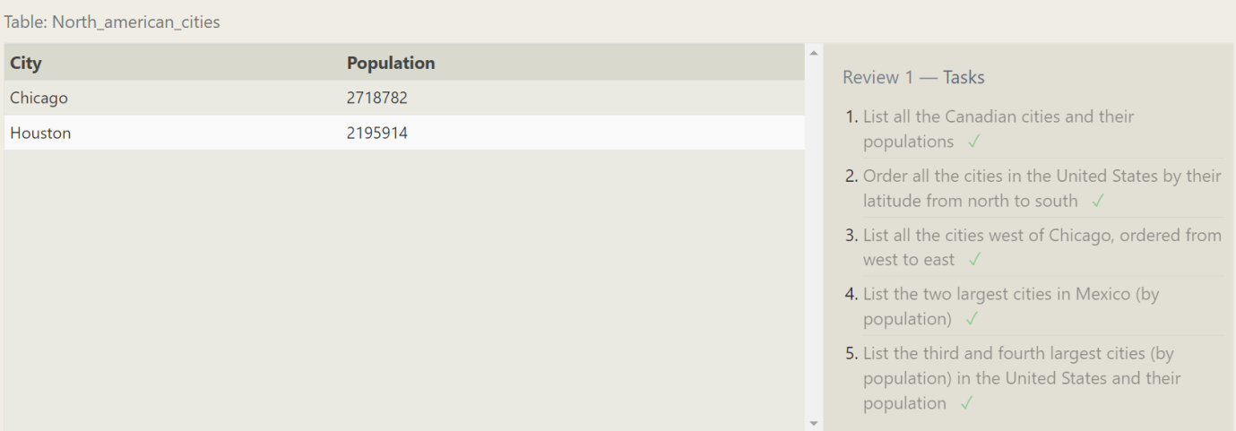

1. SELECT City, Population FROM north_american_cities WHERE COUNTRY = 'Canada';
2. SELECT City FROM north_american_cities WHERE Country = 'United States' ORDER BY Latitude DESC;
3. SELECT city FROM north_american_cities WHERE longitude < -87.629798 ORDER BY longitude;
4. SELECT city from north_american_cities WHERE country = "Mexico" order by population DESC LIMIT 2
5. SELECT city,population from north_american_cities WHERE country = "United States" ORDER by population DESC LIMIT 2 OFFSET 2

**Lesson -6**

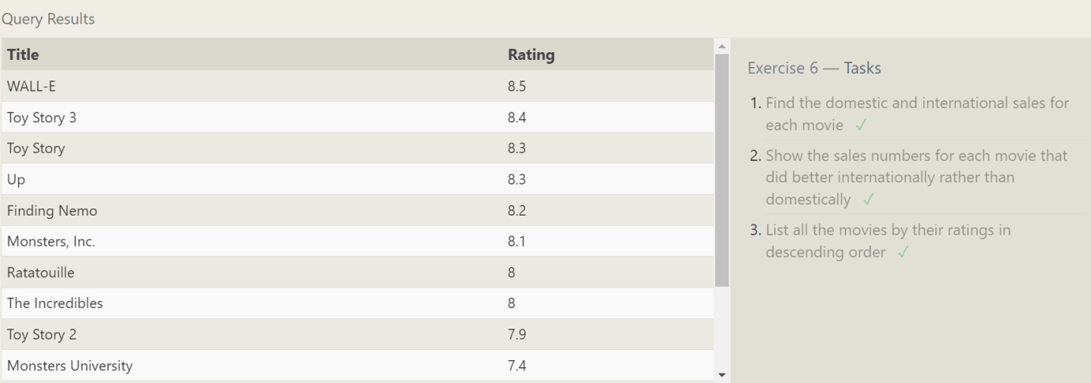

1. SELECT title,domestic_sales,International_sales from Movies join Boxoffice on movies.Id= Boxoffice.Movie_Id
2. SELECT title,domestic_sales,International_sales from Movies join Boxoffice on movies.Id= Boxoffice.Movie_Id where international_sales > domestic_sales
3. SELECT title,rating from Movies join Boxoffice on movies.Id= Boxoffice.Movie_Id order by rating desc

**Lesson -7**

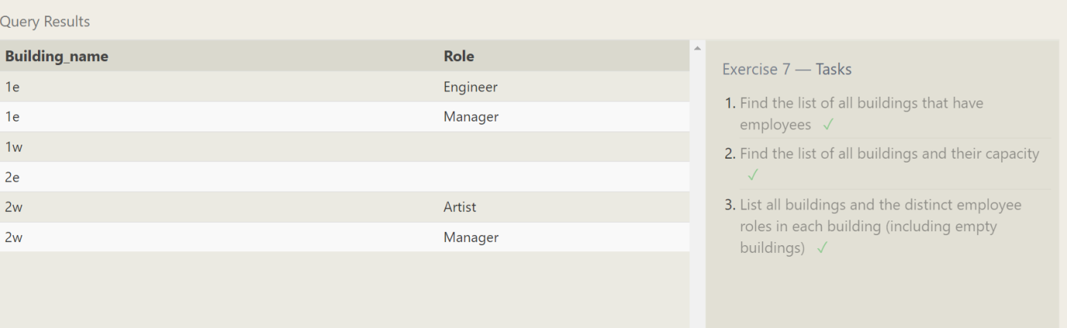

1. SELECT building from employees group by building having count(name) >1
2. SELECT * from buildings
3. SELECT distinct building_name,role from buildings left join employees on buildings.building_name = employees.building

**Lesson – 8**

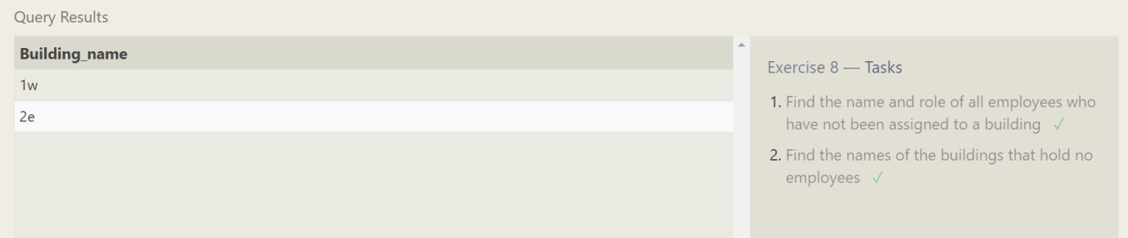

1. SELECT name,role FROM employees where building is null
2. SELECT building_name FROM buildings left join employees on buildings.building_name = employees.building group by building_name having count(name)<1

**Lesson – 9**

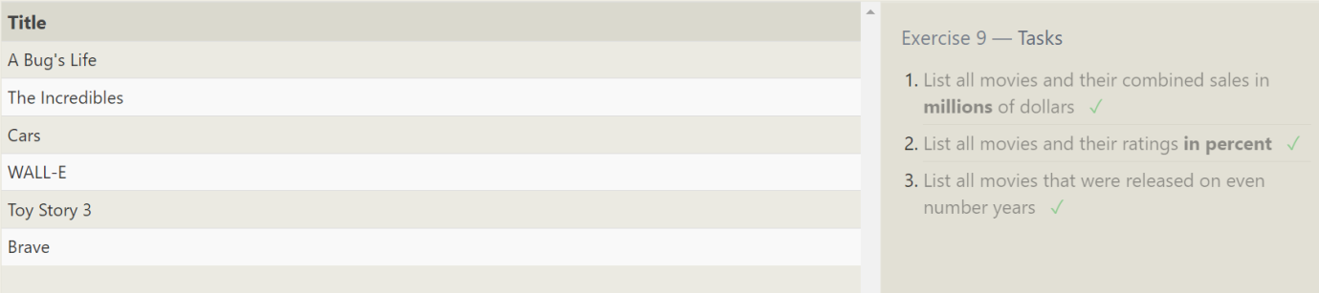

1. SELECT title, (domestic_sales+International_sales)/1000000 from Movies join Boxoffice on movies.Id= Boxoffice.Movie_Id
2. SELECT title, rating*10 from Movies join Boxoffice on movies.Id= Boxoffice.Movie_Id
3. SELECT title from Movies where year%2 = 0

**Lesson—10**

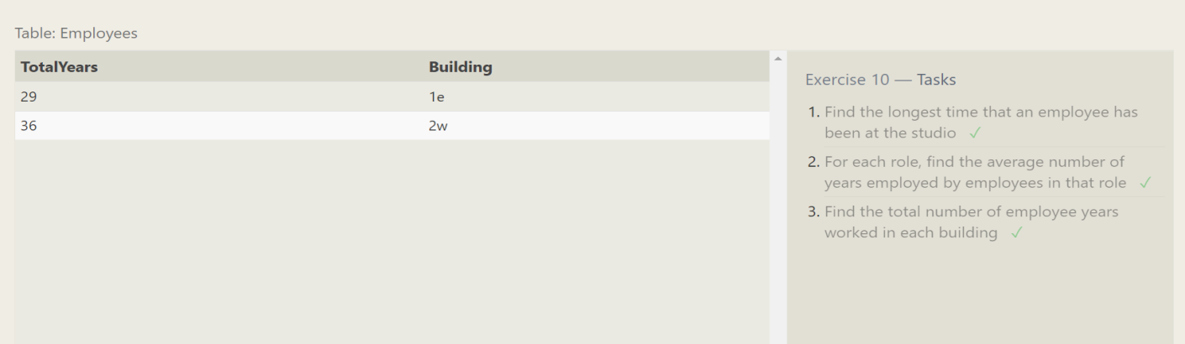

1. SELECT MAX(Years_employed) as longest from Employees;
2. SELECT AVG(Years_employed) AS AverageYears,Role FROM Employees GROUP BY role;
3. SELECT SUM(Years_employed) AS TotalYears,Building FROM Employees GROUP BY building;

**Lesson-11**

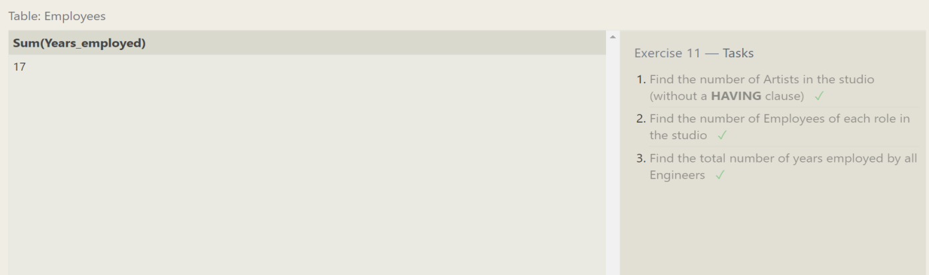

1. SELECT count(role) FROM employees WHERE Role='Artist';
2. SELECT Role,count(Name) FROM employees group by Role;
3. SELECT sum(years_employed) FROM employees where Role='Engineer' group by Role;

**Lesson-12**

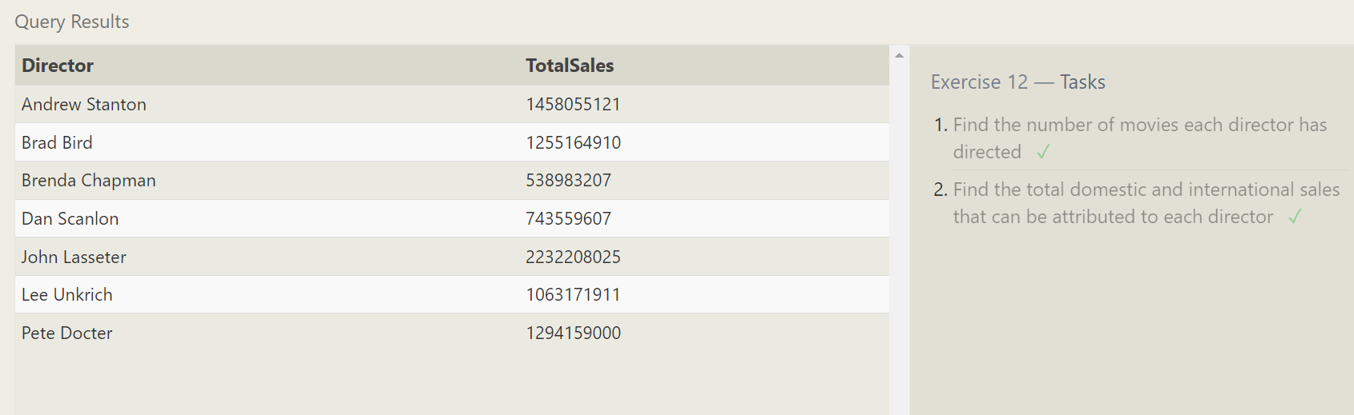

1. SELECT Director,COUNT(title) FROM movies group by Director;
2. SELECT director,SUM(domestic_sales + international_sales) AS TotalSales FROM movies m

INNER JOIN boxoffice b ON m.id = b.movie_id GROUP BY director;

**Lesson-13**

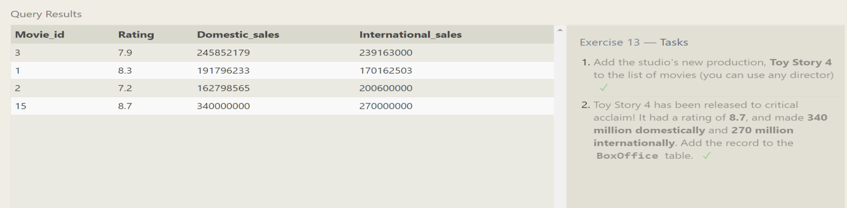

1. INSERT into movies (title, director, year, length_minutes)

VALUES ('Toy Story 4', 'Lance Lafontaine', 2984, 15);

1. INSERT INTO boxoffice (movie_id, rating, domestic_sales, international_sales)

VALUES (15, 8.7, 340000000, 270000000);

**Lesson-14**

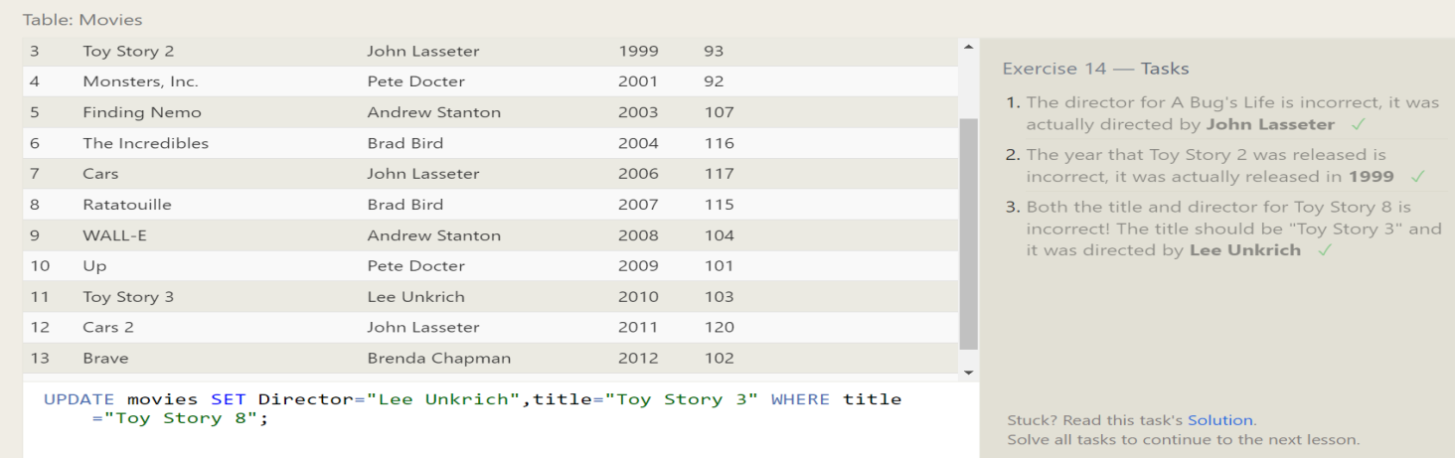

1. UPDATE movies SET Director="John Lasseter" WHERE title="A Bug's Life";
2. UPDATE movies SET Year="1999" WHERE title="Toy Story 2";
3. UPDATE movies SET Director="Lee Unkrich",title="Toy Story 3" WHERE title="Toy Story 8";

**Lesson-15**

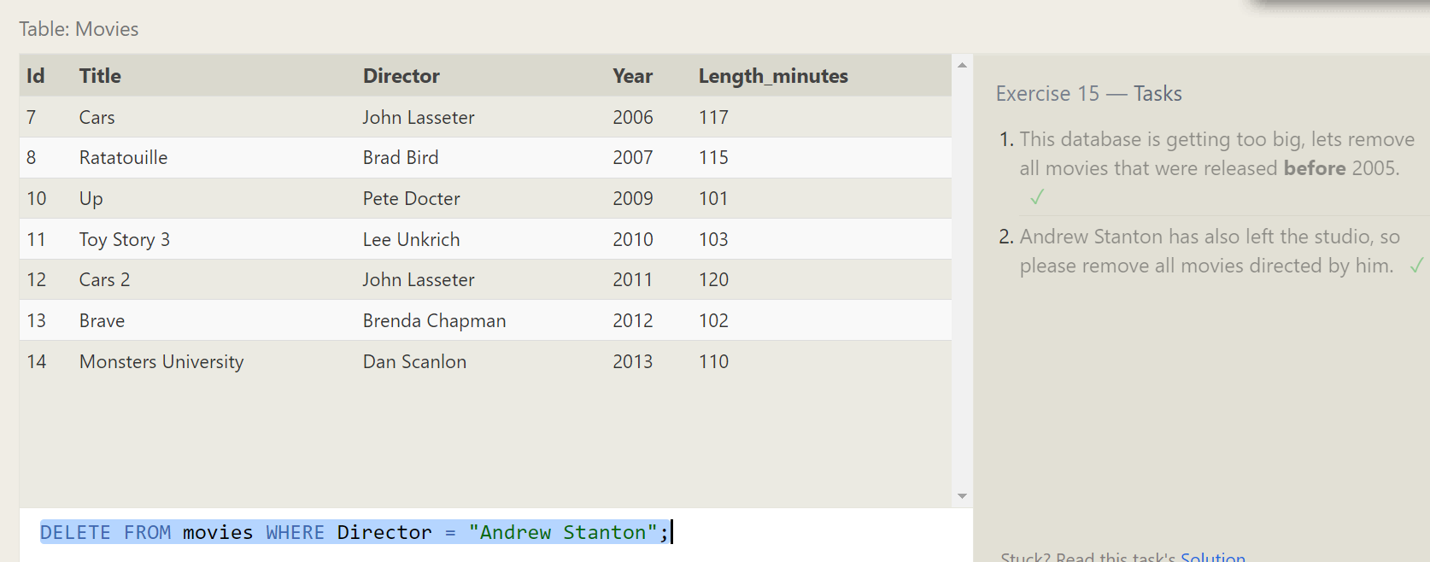

1. DELETE FROM movies WHERE Year < 2005;
2. DELETE FROM movies WHERE Director = "Andrew Stanton";

**Lesson-16**

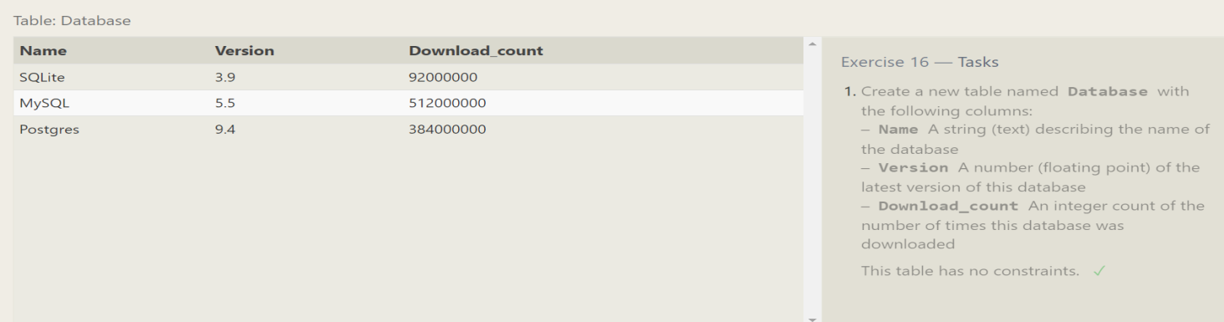

CREATE TABLE Database (

Name TEXT ,

Version INTEGER,

Download_count INTEGER

);

**Lesson-17**

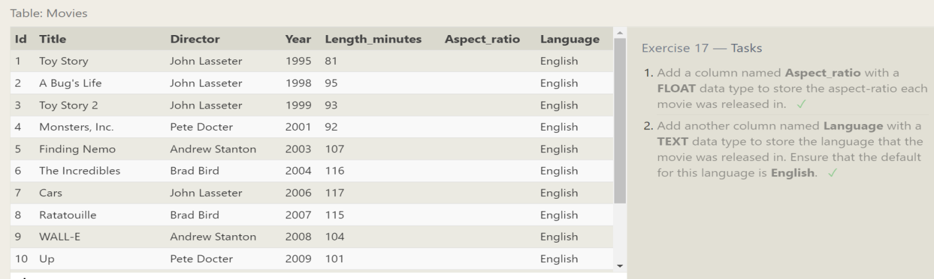

1. ALTER TABLE Movies ADD Aspect_ratio FLOAT;
2. ALTER TABLE Movies ADD Language TEXT DEFAULT "English";

**Lesson-18**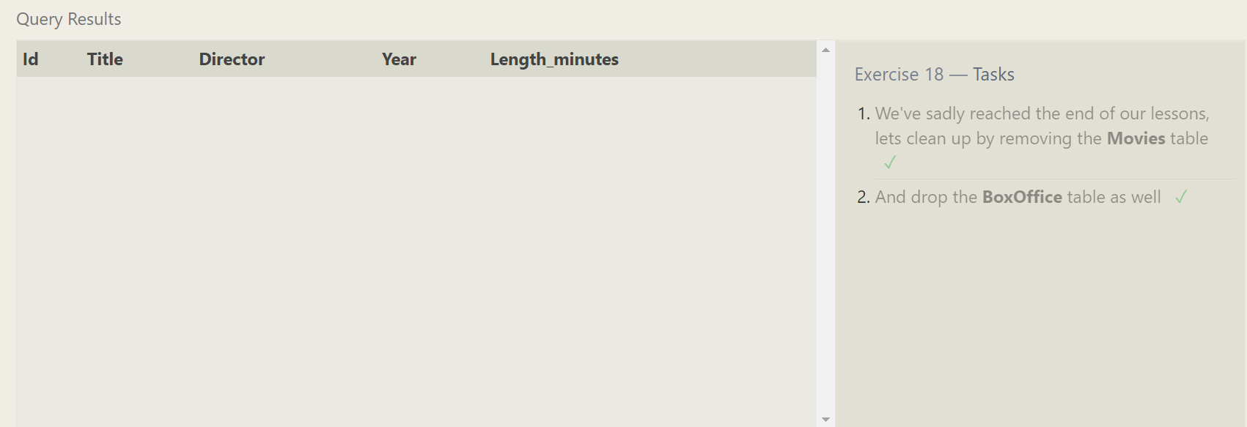

1. DROP TABLE IF EXISTS Movies;
2. DROP TABLE IF EXISTS BoxOffice;