**JAVA FOUNDATION TRAINING**

**BATCH 8**

**Name:** Rajalakshmi Ganesh             **Case Study:** TicketBookingSystem

**Tasks 1: Database Design**

**1. Create the database named "TicketBookingSystem"**

🡪 CREATE DATABASE TicketBookingSystem;

🡪 USE TicketBookingSystem;

**2. Write SQL scripts to create the mentioned tables with appropriate data types, constraints, and relationships (Venu, Event, Customers, Booking)**

* **Venue**

**🡪** CREATE TABLE Venue (

venue_id INT AUTO_INCREMENT PRIMARY KEY,

venue_name VARCHAR (50) NOT NULL,

address TEXT NOT NULL);

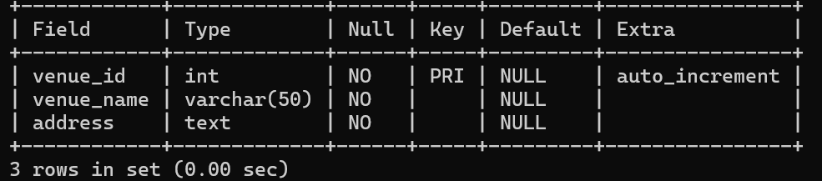

* **Event**

**🡪** CREATE TABLE Event (

event_id INT AUTO_INCREMENT PRIMARY KEY,

event_name VARCHAR (100) NOT NULL,

event_date DATE NOT NULL,

event_time TIME NOT NULL,

venue_id INT,

total_seats INT NOT NULL CHECK (total_seats > 0),

available_seats INT NOT NULL CHECK (available_seats >= 0),

ticket_price DECIMAL (10,2) NOT NULL CHECK (ticket_price >= 0), event_type ENUM ('Movie', 'Sports', 'Concert') NOT NULL,

FOREIGN KEY (venue_id) REFERENCES Venue (venue_id)); 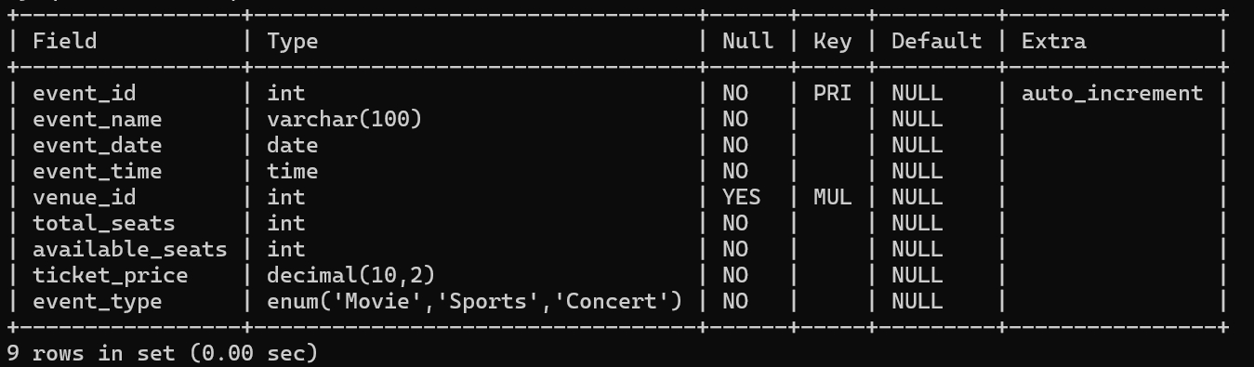

* **Customer**

**🡪** CREATE TABLE Customer (

customer_id INT AUTO_INCREMENT PRIMARY KEY,

customer_name VARCHAR (50) NOT NULL,

email VARCHAR (50) UNIQUE NOT NULL,

phone_number VARCHAR (10) NOT NULL

);

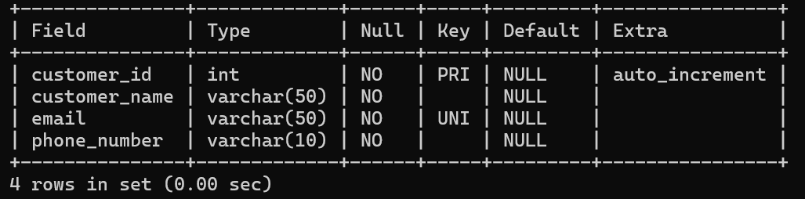

* **Booking**

**🡪** CREATE TABLE Booking (

booking_id INT AUTO_INCREMENT PRIMARY KEY,

customer_id INT NOT NULL,

event_id INT NOT NULL,

num_tickets INT NOT NULL CHECK (num_tickets > 0),

total_cost DECIMAL(10,2) NOT NULL CHECK (total_cost >= 0), booking_date DATE NOT NULL DEFAULT (CURDATE ()),

FOREIGN KEY (customer_id) REFERENCES Customer(customer_id),

FOREIGN KEY (event_id) REFERENCES Event(event_id));

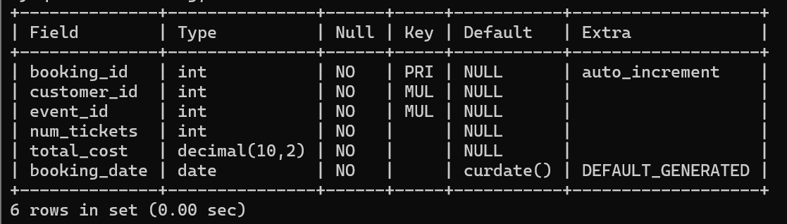

**3. Create an ERD (Entity Relationship Diagram) for the database.**

