Retail Data Engineering
Use Case Assessment Report

Prepared by: Rajalakshmi M
Submitted to: NeoStat
Date: 1 June 2026

Tools Used:
Python (Pandas) | Jupyter Notebook | Microsoft Power BI | GitHub

1. Project Overview
This report documents the end-to-end data engineering pipeline developed for ABC Retail Solutions as part of the NeoStat Data Engineering Use Case Assessment. The objective was to ingest, clean, transform, and visualize retail transaction data sourced from two operational datasets and one product dimension table, totalling approximately 8,500 records.

The pipeline was built entirely in Python using Pandas within a Jupyter Notebook environment. The final curated dataset was exported as a CSV file and loaded into Microsoft Power BI, where an interactive multi-page dashboard was developed to surface key business insights.

2. Data Sources
Three datasets were provided as part of this assessment, all contained within a single Microsoft Excel workbook:

Dataset | Records | Description
retail_data1 | 4,243 | Transactional records from System 1
retail_data2 | 4,251 | Transactional records from System 2
product_details | 10 | Product dimension table with product ID, name, and category

3. System Architecture
The solution follows a layered data pipeline architecture covering ingestion, transformation, and visualization. The diagram below illustrates the end-to-end data flow:

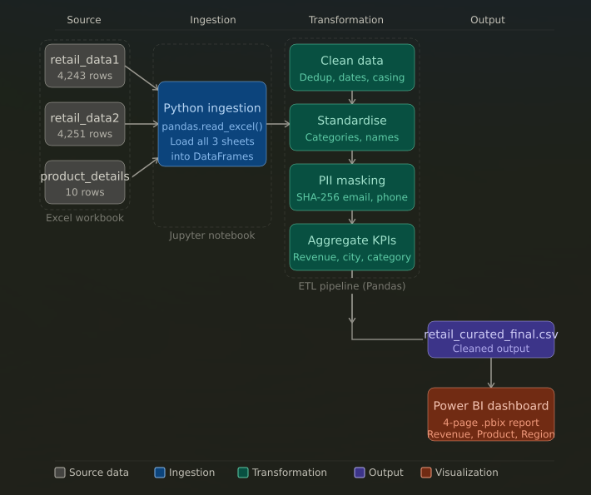

Stage-by-stage description:
- Source Layer: Raw Excel files containing two transactional datasets (retail_data1, retail_data2) and the product_details dimension table, all within a single Excel workbook.

- Ingestion Layer: All three sheets were loaded into the Python environment using pandas.read_excel(), creating separate DataFrames for each dataset.

- Transformation Layer: Four sequential ETL steps were applied — data cleaning (deduplication, date standardization, casing fixes), category and name standardization, PII masking via SHA-256 hashing, and KPI aggregation.

- Output Layer: The fully cleaned and transformed dataset was exported as retail_curated_final.csv.

- Visualization Layer: The curated CSV was imported into Microsoft Power BI where a four-page interactive dashboard was built.

4. Data Model
The final data model consists of a single unified fact table produced by merging and joining the three source datasets:

- retail_data1 and retail_data2 were unioned (stacked) into a single transactions DataFrame after individual cleaning.
- The merged transactions table was then joined to the product_details dimension table on the product_id key field.
- The resulting unified table contains all transactional attributes enriched with product name and category information.

Key fields in the final curated dataset:

Field | Data Type | Description
transaction_id | String | Unique transaction identifier
customer_id | String | Unique customer identifier (PII masked)
product_id | String | Foreign key to product_details
product_name | String | Standardized product name
category | String | Standardized product category
quantity | Integer | Number of units purchased (validated)
price | Float | Unit price of the product
revenue | Float | Derived field: quantity x price
transaction_date | Date | Standardized transaction date
city | String | City of the transaction
payment_method | String | Mode of payment
email_masked | String | SHA-256 hashed email address
phone_masked | String | SHA-256 hashed phone number

5. Data Quality Issues Identified
A thorough exploratory data analysis was conducted on both source datasets. The following data quality issues were identified and addressed:

Issue | Description
Duplicate transactions | Same transaction_id appeared with both 'successful' and 'failed' status values across datasets
Inconsistent category names | Category values used abbreviations (ELEC, FURN, HOME, CLOTH) instead of full names
Inconsistent date formats | Transaction dates appeared in mixed formats including Excel serial numbers and MM-DD-YYYY strings
Inconsistent product name casing | Product names had mixed casing (e.g. 'laptop', 'Laptop', 'LAPTOP')
PII data present | Customer email addresses and phone numbers were present in raw form and required masking
Missing or invalid values | Some records contained null or invalid entries in critical fields

6. Data Cleaning and Transformation Logic

6.1 Duplicate Record Handling
Duplicate transaction IDs were identified where the same transaction appeared with both 'successful' and 'failed' status values. To resolve this, records were sorted by transaction_id and status, and only the record with 'successful' status was retained. This ensured that revenue calculations reflected only completed transactions.

6.2 Category Standardization
Category abbreviations were mapped to their full descriptive names using a Python dictionary mapping. The transformation applied was:
- ELEC → Electronics
- FURN → Furniture
- HOME → Home Appliances
- CLOTH → Clothing

6.3 Date Format Standardization
Transaction dates were present in two formats across the datasets — Excel serial number format (integer) and MM-DD-YYYY string format. A custom parsing function was applied to detect and convert both formats into a consistent Python datetime format (YYYY-MM-DD), enabling time-series analysis in Power BI.

6.4 Product Name Standardization
All product name values were converted to title case using the Pandas str.title() method to ensure consistency across records and accurate grouping in aggregations and visualizations.

6.5 PII Masking
Customer email addresses and phone numbers were identified as personally identifiable information (PII). Both fields were masked using SHA-256 cryptographic hashing via Python's hashlib library. The original fields were replaced with their hashed equivalents (email_masked, phone_masked), ensuring that no raw PII was present in the curated output dataset.

6.6 Final Validation
After all cleaning steps, a final validation pass confirmed that the curated dataset contained no missing values in critical fields and no duplicate transaction records. The cleaned dataset was then exported as retail_curated_final.csv.

7. Assumptions Made
- Where a transaction ID appeared with both 'successful' and 'failed' status, the 'successful' record was retained as the authoritative transaction.
- Category abbreviations (ELEC, FURN, HOME, CLOTH) were assumed to map directly to Electronics, Furniture, Home Appliances, and Clothing respectively.
- Revenue was derived as quantity multiplied by unit price for all valid transactions.
- Excel serial date numbers were converted using the standard Excel epoch (1 January 1900) as the reference date.
- Records with null or invalid values in critical fields (quantity, price, transaction_date) were excluded from the final dataset.
- The pipeline was executed entirely in a local Python environment using Pandas. Cloud ingestion via Azure Blob Storage was considered as a future enhancement but was not implemented within the scope of this assessment.
- All product names were standardized to title case as the canonical format.

8. KPI Definitions
KPI | Definition
Total Revenue | Sum of (quantity x price) for all valid, successful transactions
Total Transactions | Count of unique transaction IDs in the curated dataset
Total Customers | Count of unique customer IDs across all transactions
Total Products | Count of unique product IDs in the product_details dimension table
Revenue by Category | Total revenue aggregated by standardized product category
Revenue by City | Total revenue aggregated by transaction city
Revenue by Month | Total revenue aggregated by calendar month of transaction date
Revenue by Product | Total revenue aggregated by individual product name

9. Visual Insights Summary
The following key insights were derived from the Power BI dashboard built on the curated dataset:

- Electronics is the dominant product category, contributing approximately 58% of total revenue, significantly outperforming all other categories.
- Laptop is the highest revenue-generating product across all categories, followed by Sofa in the Furniture segment.
- Chennai generates the highest city-level revenue among all regions, followed closely by Delhi and Hyderabad.
- Payment methods are evenly distributed, with Card, Cash, UPI, and NetBanking each contributing approximately 24-26% of total transactions. This indicates no strong customer payment preference.
- Revenue peaked in August 2024 and declined sharply towards December, suggesting potential seasonality or campaign effects in mid-year that warrant further investigation.
- Clothing is significantly underperforming compared to other categories, contributing less than 5% of total revenue. This presents a clear business opportunity for targeted promotion or product review.

10. Conclusion
This assessment successfully demonstrates an end-to-end data engineering pipeline for retail transaction data. Starting from raw, inconsistent source files, the pipeline systematically addressed data quality issues, standardized formats, protected customer privacy through PII masking, and produced a clean, analytics-ready dataset.

The resulting Power BI dashboard provides ABC Retail Solutions with actionable visibility into revenue performance across products, categories, cities, and time periods. The insights surfaced — particularly the dominance of Electronics and Laptops, the even payment method distribution, and the underperformance of Clothing — provide a strong foundation for data-driven business decisions.

The pipeline is designed to be reproducible and extensible, with clear separation between ingestion, transformation, and visualization layers, making it straightforward to incorporate additional data sources or KPIs in future iterations.

