All-Pairs Shortest Paths
Data StructureAnalysis of AlgorithmsAlgorithms

The all pair shortest path algorithm is also known as Floyd-Warshall algorithm is used to find all pair shortest path problem from a given weighted graph. As a result of this algorithm, it will generate a matrix, which will represent the minimum distance from any node to all other nodes in the graph.
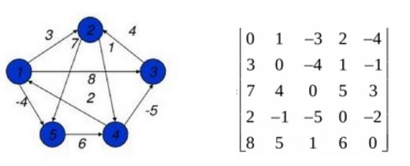
At first the output matrix is same as given cost matrix of the graph. After that the output matrix will be updated with all vertices k as the intermediate vertex.
The time complexity of this algorithm is O(V3), here V is the number of vertices in the graph.
Input − The cost matrix of the graph.
0 3 6 ∞ ∞ ∞ ∞
3 0 2 1 ∞ ∞ ∞
6 2 0 1 4 2 ∞
∞ 1 1 0 2 ∞ 4
∞ ∞ 4 2 0 2 1
∞ ∞ 2 ∞ 2 0 1
∞ ∞ ∞ 4 1 1 0
Output − Matrix of all pair shortest path.
0 3 4 5 6 7 7
3 0 2 1 3 4 4
4 2 0 1 3 2 3
5 1 1 0 2 3 3
6 3 3 2 0 2 1
7 4 2 3 2 0 1
7 4 3 3 1 1 0

Algorithm

floydWarshal(cost)
Input − The cost matrix of given Graph.
Output − Matrix to for shortest path between any vertex to any vertex.
Begin
for k := 0 to n, do
for i := 0 to n, do
for j := 0 to n, do
if cost[i,k] + cost[k,j] < cost[i,j], then
cost[i,j] := cost[i,k] + cost[k,j]
done
done
done
display the current cost matrix
End

Floyd Warshall Algorithm Algorithm:
- Initialize the solution matrix same as the input graph matrix as a first step.
- Then update the solution matrix by considering all vertices as an intermediate vertex.
- The idea is to pick all vertices one by one and updates all shortest paths which include the picked vertex as an intermediate vertex in the shortest path.
- When we pick vertex number k as an intermediate vertex, we already have considered vertices {0, 1, 2, .. k-1} as intermediate vertices.
- For every pair (i, j) of the source and destination vertices respectively, there are two possible cases.
  - k is not an intermediate vertex in shortest path from i to j. We keep the value of dist[i][j] as it is.
  - k is an intermediate vertex in shortest path from i to j. We update the value of dist[i][j] as dist[i][k] + dist[k][j], if dist[i][j] > dist[i][k] + dist[k][j]

Pseudo-Code of Floyd Warshall Algorithm :
For k = 0 to n – 1
For i = 0 to n – 1
For j = 0 to n – 1
Distance[i, j] = min(Distance[i, j], Distance[i, k] + Distance[k, j])
where i = source Node, j = Destination Node, k = Intermediate Node

Illustration of Floyd Warshall Algorithm :
Suppose we have a graph as shown in the image:
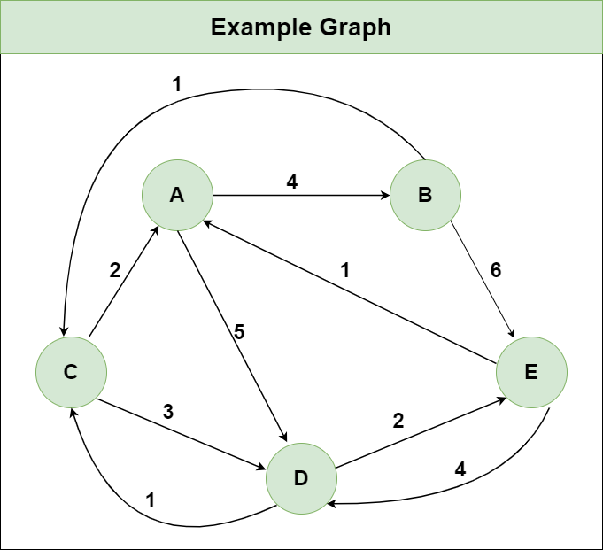
Step 1: Initialize the Distance[][] matrix using the input graph such that Distance[i][j]= weight of edge from i to j, also Distance[i][j] = Infinity if there is no edge from i to j.
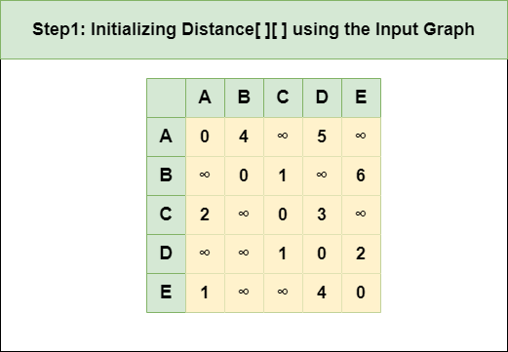
Step 2: Treat node A as an intermediate node and calculate the Distance[][] for every {i,j} node pair using the formula:
= Distance[i][j] = minimum (Distance[i][j], (Distance from i to A) + (Distance from A to j ))
= Distance[i][j] = minimum (Distance[i][j], Distance[i][A] + Distance[A][j])
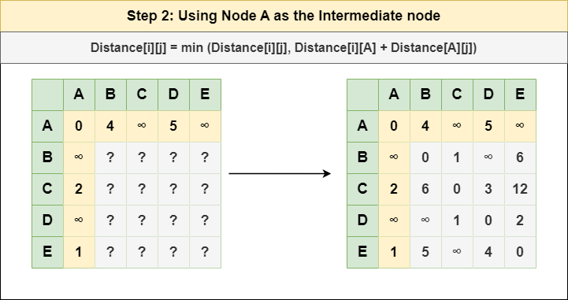
Step 3: Treat node B as an intermediate node and calculate the Distance[][] for every {i,j} node pair using the formula:
= Distance[i][j] = minimum (Distance[i][j], (Distance from i to B) + (Distance from B to j ))
= Distance[i][j] = minimum (Distance[i][j], Distance[i][B] + Distance[B][j])
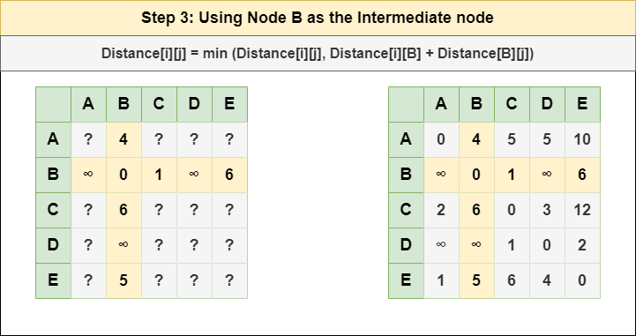
Step 4: Treat node C as an intermediate node and calculate the Distance[][] for every {i,j} node pair using the formula:
= Distance[i][j] = minimum (Distance[i][j], (Distance from i to C) + (Distance from C to j ))
= Distance[i][j] = minimum (Distance[i][j], Distance[i][C] + Distance[C][j])
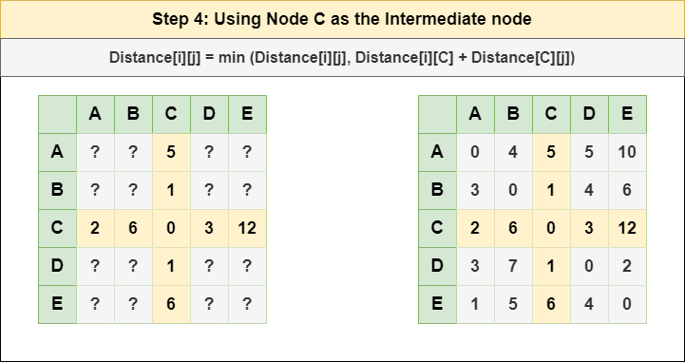
Step 5: Treat node D as an intermediate node and calculate the Distance[][] for every {i,j} node pair using the formula:
= Distance[i][j] = minimum (Distance[i][j], (Distance from i to D) + (Distance from D to j ))
= Distance[i][j] = minimum (Distance[i][j], Distance[i][D] + Distance[D][j])
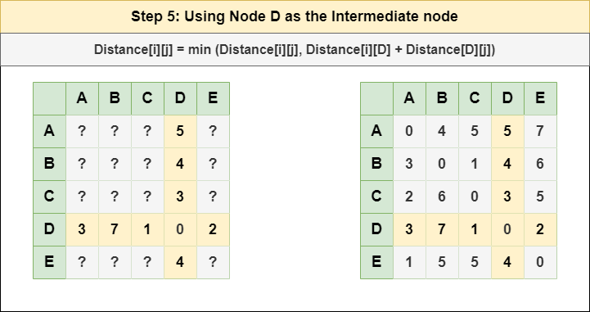
Step 6: Treat node E as an intermediate node and calculate the Distance[][] for every {i,j} node pair using the formula:
= Distance[i][j] = minimum (Distance[i][j], (Distance from i to E) + (Distance from E to j ))
= Distance[i][j] = minimum (Distance[i][j], Distance[i][E] + Distance[E][j])
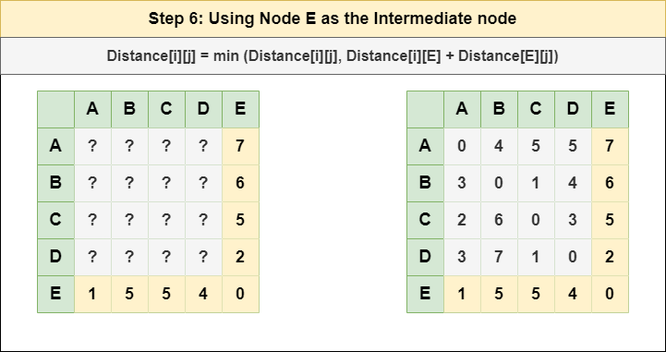
Step 7: Since all the nodes have been treated as an intermediate node, we can now return the updated Distance[][] matrix as our answer matrix.
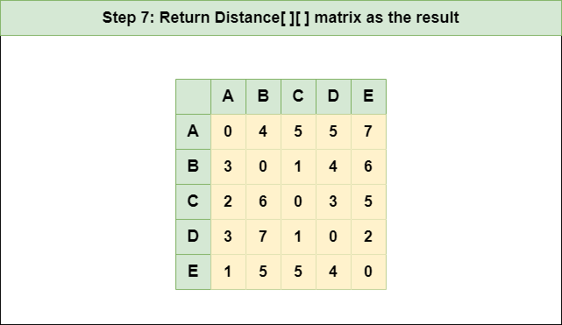
Recommended Problem

Example

