Biconnectd Components

Biconnected Components
- Problems
- Tutorial

Pre-Requisite: Articulation Points
Before Biconnected Components, let's first try to understand what a Biconnected Graph is and how to check if a given graph is Biconnected or not.
A graph is said to be Biconnected if:
- It is connected, i.e. it is possible to reach every vertex from every other vertex, by a simple path.
- Even after removing any vertex the graph remains connected.
For example, consider the graph in the following figure
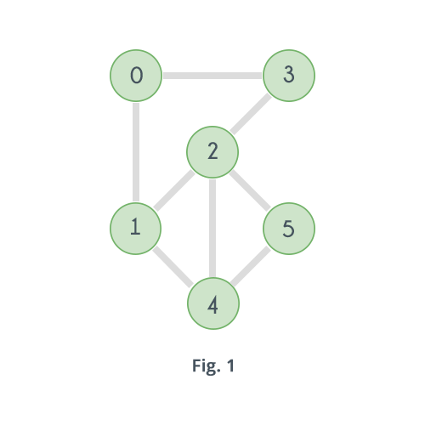
The given graph is clearly connected. Now try removing the vertices one by one and observe. Removing any of the vertices does not increase the number of connected components. So the given graph is Biconnected.
Now consider the following graph which is a slight modification in the previous graph.
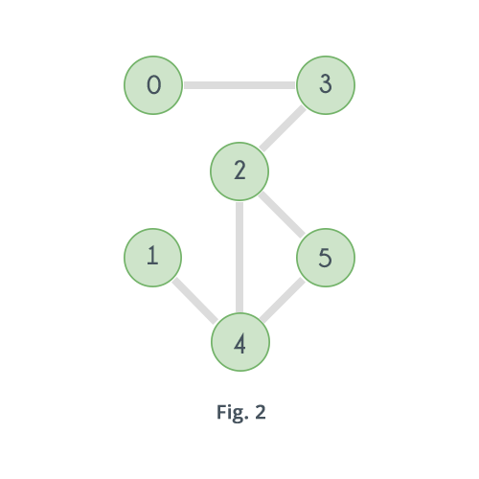
In the above graph if the vertex 2 is removed, then here's how it will look:
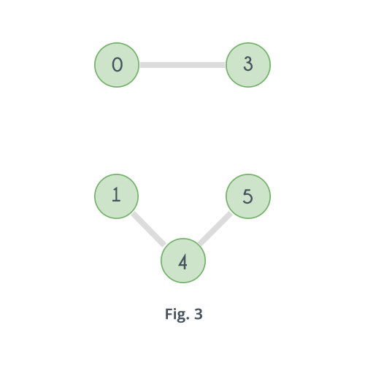
Clearly the number of connected components have increased. Similarly, if vertex 3 is removed there will be no path left to reach vertex 0 from any of the vertices 1, 2, 4 or 5. And same goes for vertex 4 and 1. Removing vertex 4 will disconnect 1 from all other vertices 0, 2, 3 and 4. So the graph is not Biconnected.
Now what to look for in a graph to check if it's Biconnected. By now it is said that a graph is Biconnected if it has no vertex such that its removal increases the number of connected components in the graph. And if there exists such a vertex then it is not Biconnected. A vertex whose removal increases the number of connected components is called an Articulation Point.
So simply check if the given graph has any articulation point or not. If it has no articulation point then it is Biconnected otherwise not. Here's the pseudo code:

time = 0
function isBiconnected(vertex, adj[][], low[], disc[], parent[], visited[], V)
disc[vertex]=low[vertex]=time+1
time = time + 1
visited[vertex]=true
child = 0
for i = 0 to V
if adj[vertex][i] == true
if visited[i] == false
child = child + 1
parent[i] = vertex
result = isBiconnected(i, adj, low, disc, visited, V, time)
if result == false
return false
low[vertex] = minimum(low[vertex], low[i])
if parent[vertex] == nil AND child > 1
return false
if parent[vertex] != nil AND low[i] >= disc[vertex]
return false
else if parent[vertex] != i
low[vertex] = minimum(disc[i], low[vertex])
return true
The code above is exactly same as that for Articulation Point with one difference that it returns false as soon as it finds an Articulation Point.
The image below shows how the DFS tree will look like for the graph in Fig. 2 according to the algorithm, along with the value of the arrays ���[] and ����[].
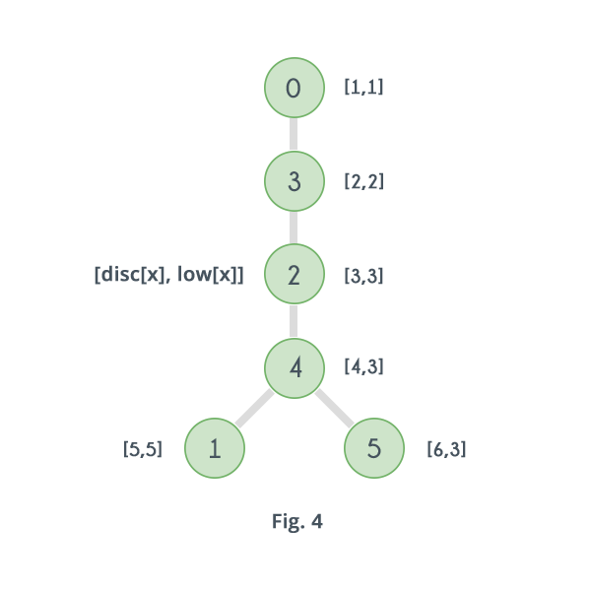
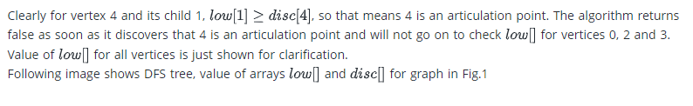 image shows DFS tree, value of arrays ���[] and ����[] for graph in Fig.1
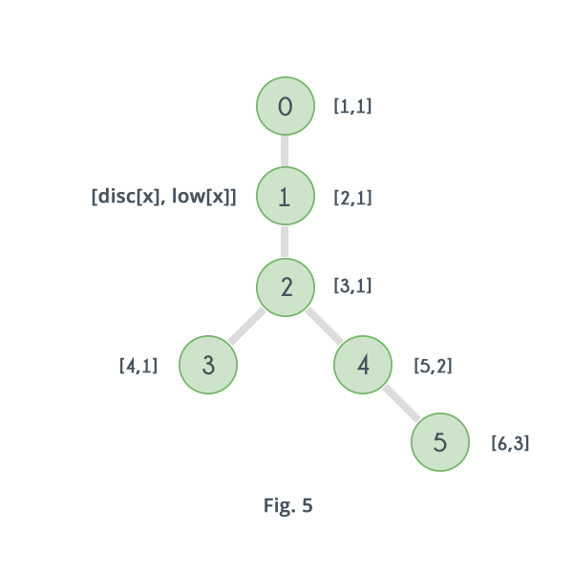
Now let's move on to Biconnected Components. For a given graph, a Biconnected Component, is one of its subgraphs which is Biconnected. For example for the graph given in Fig. 2 following are 4 biconnected components in the graph
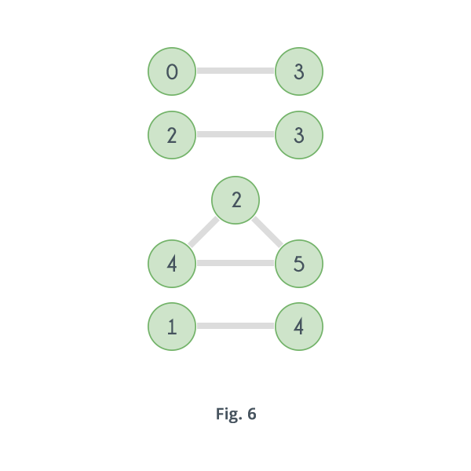
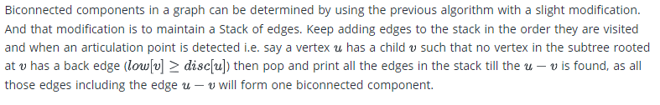
time = 0
function DFS(vertex, adj[][], low[], disc[], parent[], visited[], V, stack)
disc[vertex]=low[vertex]=time+1
time = time + 1
visited[vertex]=true
child = 0
for i = 0 to V
if adj[vertex][i] == true
if visited[i] == false
child = child + 1
push edge(u,v) to stack
parent[i] = vertex
DFS(i, adj, low, disc, visited, V, time, stack)
low[vertex] = minimum(low[vertex], low[i])
if parent[vertex] == nil AND child > 1
while last element of stack != (u,v)
print last element of stack
pop from stack
print last element of stack
pop from stack
if parent[vertex] != nil AND low[i] >= disc[vertex]
while last element of stack != (u,v)
print last element of stack
pop from stack
print last element of stack
pop from stack
else if parent[vertex] != i AND disc[i] < low[vertex]
low[vertex] = disc[i]
push edge(u,v) to stack

fuction biconnected_components(adj[][], V)
for i = 0 to V
if visited[i] == false
DFS(i, adj, low, disc, parent, visited, V, time, stack)
while stack is not empty
print last element of stack
pop from stack

Example: https://www.hackerearth.com/practice/algorithms/graphs/biconnected-components/tutorial/

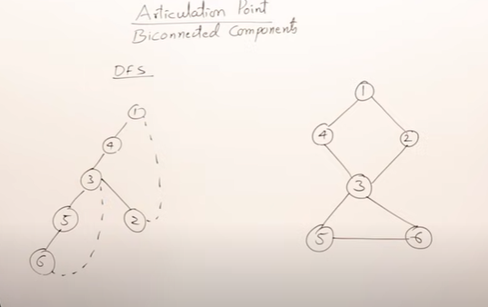
Discovery times
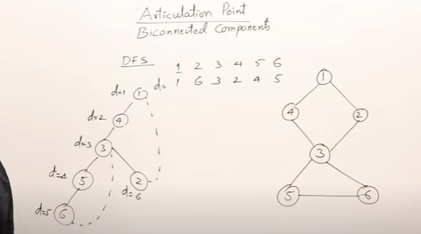

From a node the Lowest DFS number is L

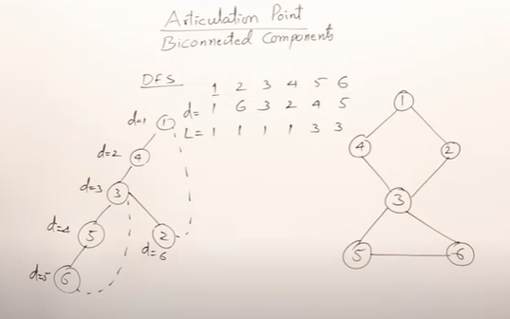
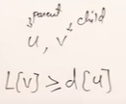
This condition is for except root
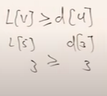
Therefore 3 is an articulation point

