Asssignment5: Flow diagram to represent inheritance in selenium

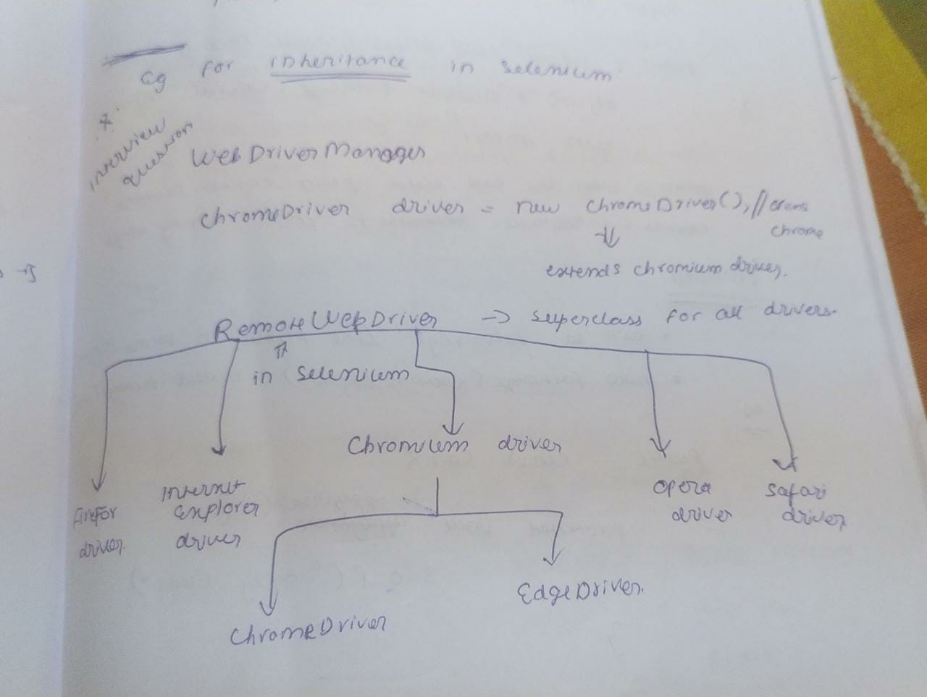

Assignment6 :

String str3 = new String("Kutty");

String str4 = new String("Kutty");

if(str3==str4) {

System.out.println(" Same text");

}

else

System.out.println("Diff text");

Answer:

“Diff text”

Reason: ‘==’ operator checks the memory reference . Here Each string is assigned a new memory location using “new” keyword. Hence it will not reference the same memory location. So different text is printed as output.