INTRODUCTION

The goal of this project is to develop a chatbot program that can assist users with various tasks such as answering questions, providing recommendations, and making reservations. The chatbot will use natural language processing (NLP) techniques to understand and interpret user input, and will use machine learning algorithms to learn from user interactions and improve its responses over time.

The chatbot will be designed to be user-friendly and intuitive, and will have a friendly and conversational tone to engage users in a natural and interactive way. It will be accessible via a web or mobile interface, and will be available 24/7 to provide assistance to users.The chatbot will be trained on a variety of data sources such as customer reviews, frequently asked questions

Overall, the chatbot program aims to provide users with a convenient and efficient way to access information and complete tasks, while also providing an enjoyable and personalized user experience.

OBJECTIVE OF THE PROJECT

The objective of a Python chatbot for a food delivery system could be to provide a convenient and personalized way for customers to place orders, track deliveries, and receive support and assistance with their orders. Some specific objectives of such a chatbot could include:

1.Simplify the order placement process: A chatbot can help customers place orders quickly and easily, without the need for manual input or navigation of a website or mobile app.

2.Personalize the user experience: By using machine learning algorithms, a chatbot can learn about a customer's preferences and order history to provide personalized recommendations and promotions.

3.Offer customer support: A chatbot can provide customer support and assistance with any issues or questions related to their order, such as changes to their order, delivery instructions, or refunds.

4.Improve customer satisfaction: By providing a convenient and personalized experience, a chatbot can improve overall customer satisfaction and loyalty, leading to increased revenue and customer retention.

5.Overall, the objective of a Python chatbot for a food delivery system is to provide a seamless and efficient customer experience, while also reducing the workload of customer

DESIGN OF THE SYSTEM

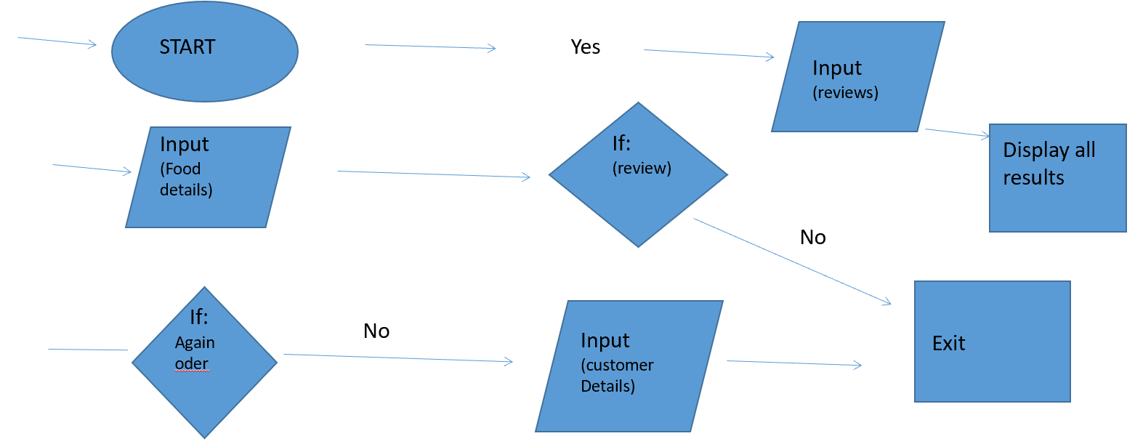

SYSTEM SPECIFICATION/ FUNCTION MODULES

* This program will show the menu card with food items and its rate.
* we can place order of our desired meal with mentioning quantity.
* It will ask for further oders .
* A confirmation on order message will be asked.
* customer details will be collected for delivery.
* Order ID will be created and order details + customer details will be displayed.
* A service review/rating will be asked to customer .

Implementation

import random

# Define the menu as a dictionary with items and prices

print(" ")

print("HI! welcome to DOINK Food services")

print(" ")

menu = {

"Biriyani": 100,

"Full meals": 80,

"Chapathi": 8,

"Parotta": 10

}

# Define a function to display the menu

print("Here's your Menu:")

for item, price in menu.items():

print("- {} (Rs.{:.2f})".format(item, price))

# Define a variable to hold the order

order = {}

# Get the customer's order

while True:

item = input("What would you like to order?: ")

if item not in menu:

print("Sorry, we don't have that.")

continue

quantity = int(input("How many would you like?: "))

order[item] = quantity

total = sum(menu[item] * quantity for item, quantity in order.items())

print(" ")

print("Your order so far: ", order)

print("Your current total: Rs.{:.2f}".format(total))

print(" ")

response = input("Would you like to add more? (yes/no): ")

print(" ")

if response == "no":

break

# Confirm the order

print("Your order:")

for item, quantity in order.items():

price = menu[item]

subtotal = price * quantity

print("- {} x {} (Rs.{:.2f})".format(item, quantity, subtotal))

total = sum(menu[item] * quantity for item, quantity in order.items())

print("Total: Rs.{:.2f}".format(total))

while True:

response = input("Is this correct? (yes/no) ")

print(" ")

if response == "yes":

break

elif response == "no":

order.clear()

print("Your order has been cancelled.")

exit()

else:

print("Please enter yes or no.")

# Get the customer's details

name = input("What's your name? ")

address = input("What's your address? ")

phone = input("What's your phone number? ")

email = input("What's your email address? ")

# Generate a random order ID

order_id = random.randint(10000, 99999)

# Display the order details

print("Thank you for your order! Your order ID is {}.".format(order_id))

print("Order details:")

print("- ID: {}".format(order_id))

for item, quantity in order.items():

price = menu[item]

subtotal = price * quantity

print("- {} x {} (Rs.{:.2f})".format(item, quantity, subtotal))

print("- Total: Rs.{:.2f}".format(total))

print(" ")

print("Customer details:")

print("- Name: {}".format(name))

print("- Address: {}".format(address))

print("- Phone: {}".format(phone))

print("- Email: {}".format(email))

print(" ")

print("Your oder will be delivered to to your address ASAP")

print(" #ENJOY your MEAL#")

print(" ")

# Define an empty list to hold the reviews

reviews = []

# Ask the customer for a review

response = input("Would you like to leave a review for our service? (yes/no) ")

print(" ")

if response.lower() == "yes":

# Ask the customer to rate the service

rating = int(input("Please rate our service from 1 to 5: "))

while rating < 1 or rating > 5:

rating = int(input("Please enter a number between 1 and 5: "))

# Ask the customer for feedback

feedback = input("Please enter your feedback (optional): ")

print(" ")

# Add the review to the list

reviews.append({"rating": rating, "feedback": feedback})

print("Thank you for your review!")

print(" ")

else:

print("Thank you for choosing our food delivery service!")

# Display the reviews

if len(reviews) > 0:

print("Customer Reviews:")

for i, review in enumerate(reviews):

print("{}. Rating: {} Feedback: {}".format(i+1, review["rating"], review["feedback"] if review["feedback"] else "No feedback given."))

else:

print("There are no reviews yet.")

Implementation Screenshots

