Day19-TASK:

Create a S3 bucket, with no public access and upload files to the bucket 2. Launch two ec2-instances and connect it to an application load balancer, where the output traffic from the server must be an load balancer IP address.

1.Created a S3 bucket as rmreddy-bucket with no public access:

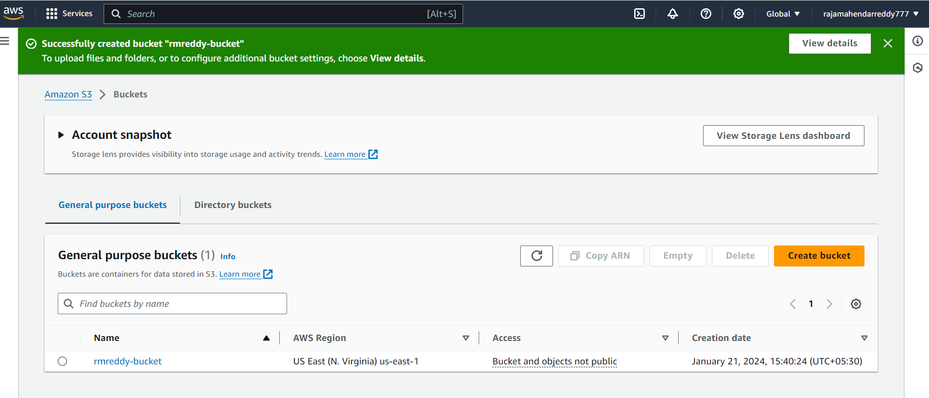

uploaded files to the bucket :

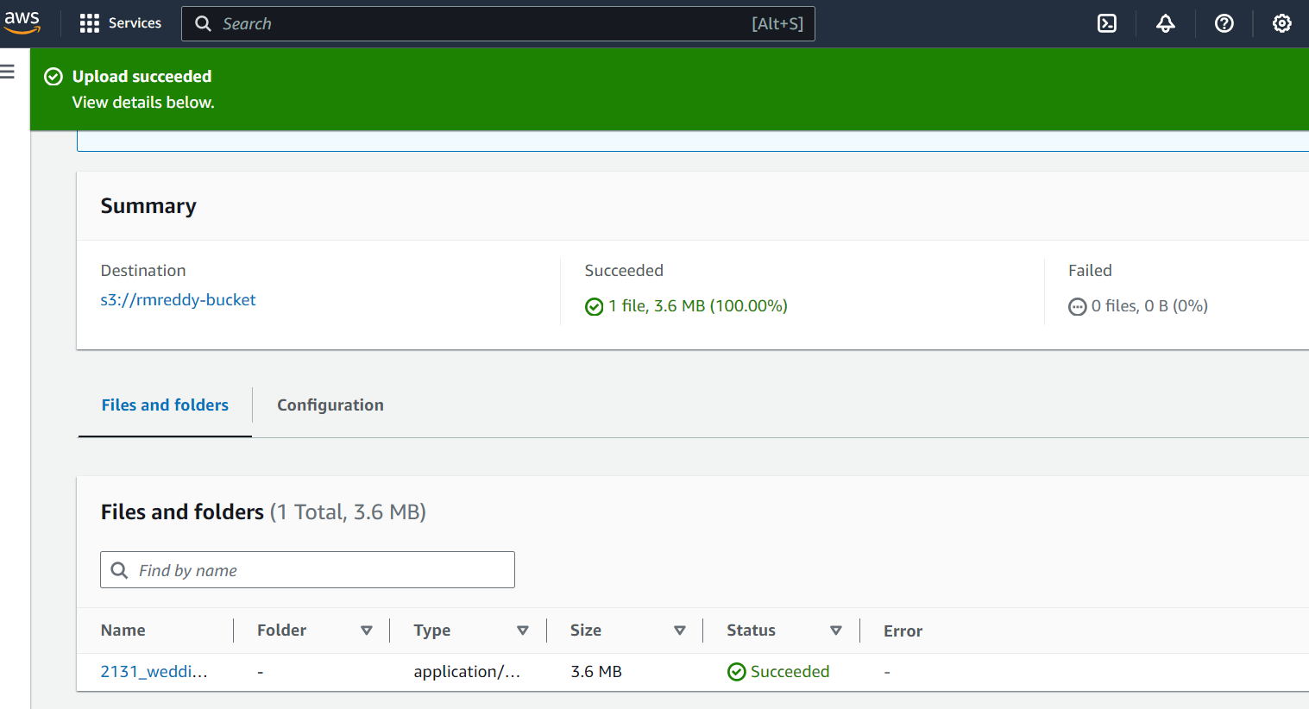

2.Launched two ec2-instances:

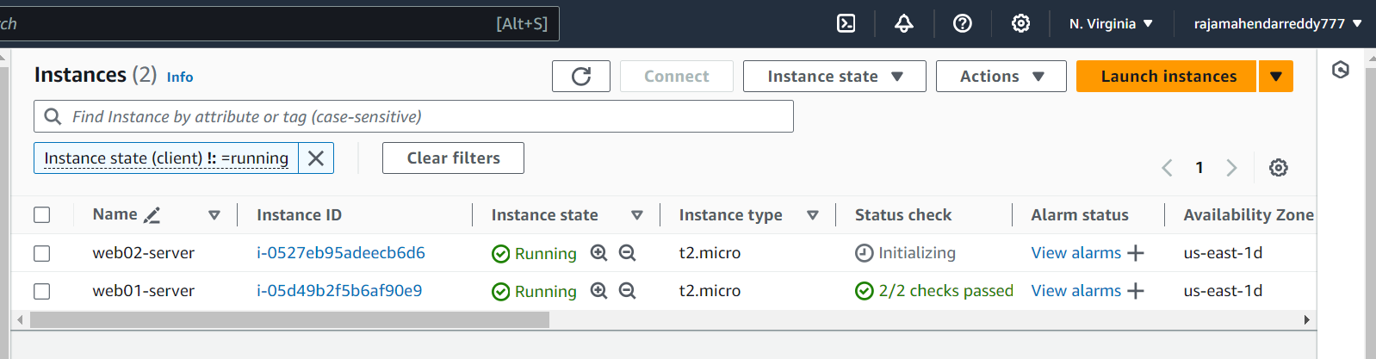

Created Target group and added two instances into that group:

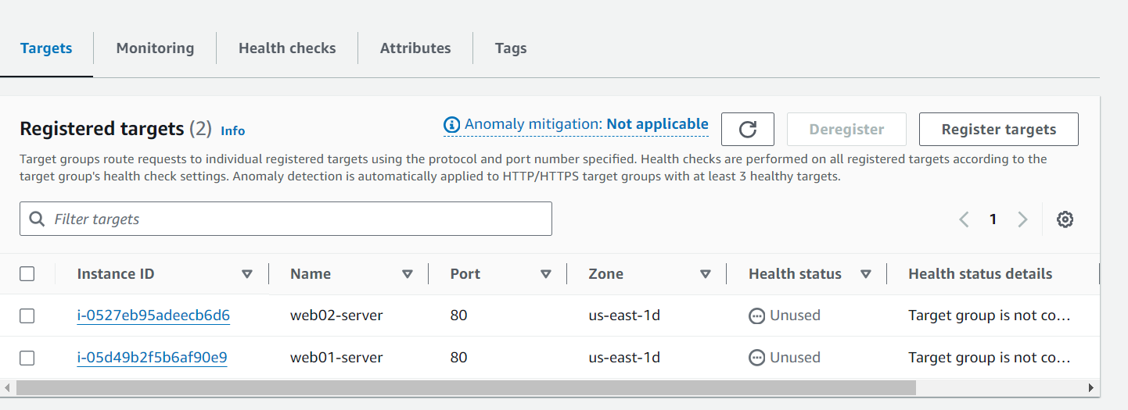

Created Application load balancer:

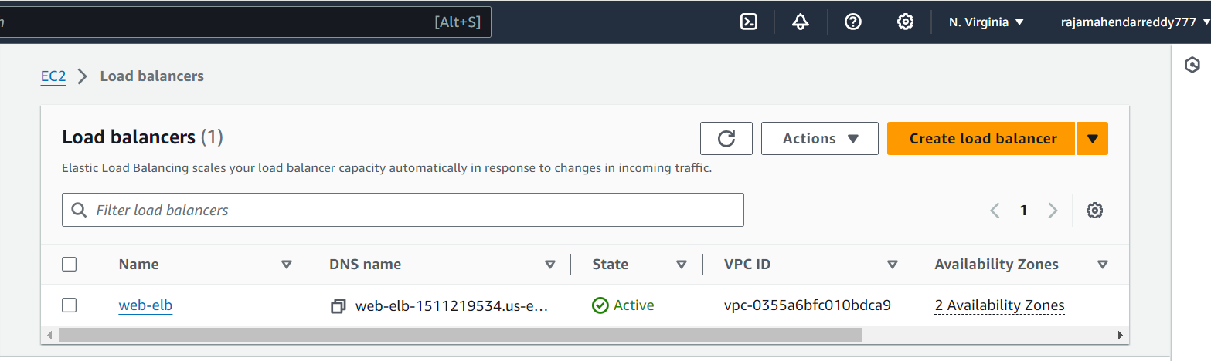

Again went to security group of ec2 instance given output traffic of the server as load balancer IP address.

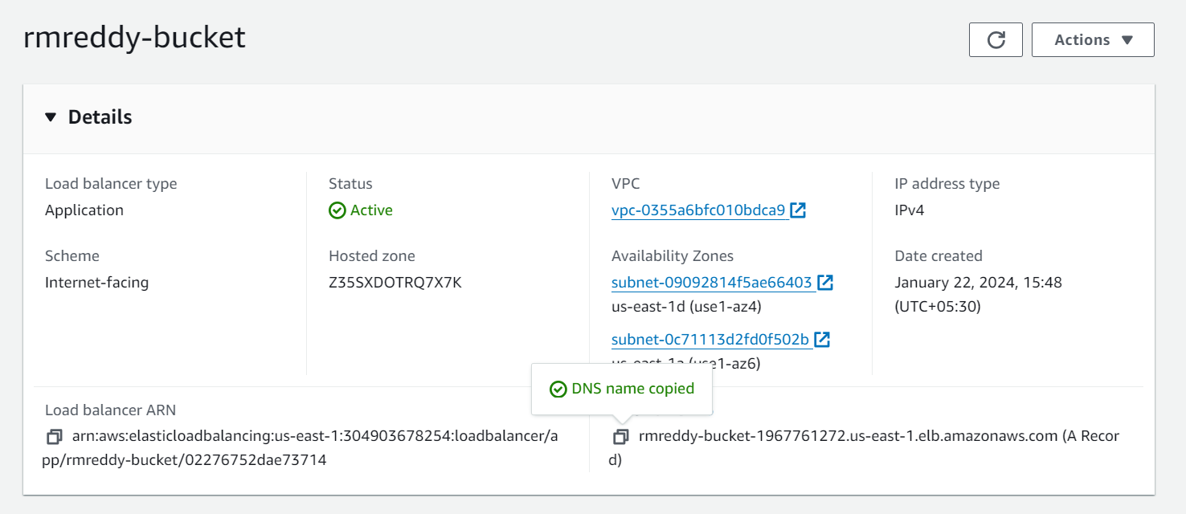

And opened with ELB DNS in website-

