Day23-TASK:

Write Terraform script to create highly available infrastructure in AWS. The infra should have1 vpc, 3 subnets setup in 3 different az and 2 instances setup in 2 different subnets.

SUBMISSION:

1) Created a folder as guvi-task

2)Added files

Provider.tf

Variable.tf

Terraform.tfvars

Main.tf

3)Wrote the script as per requirements

**provider.tf**

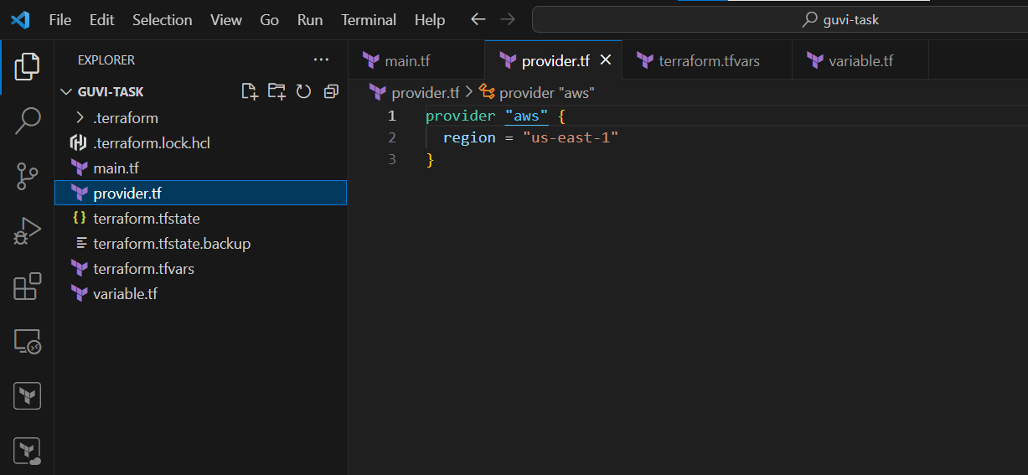

**Variables.tf**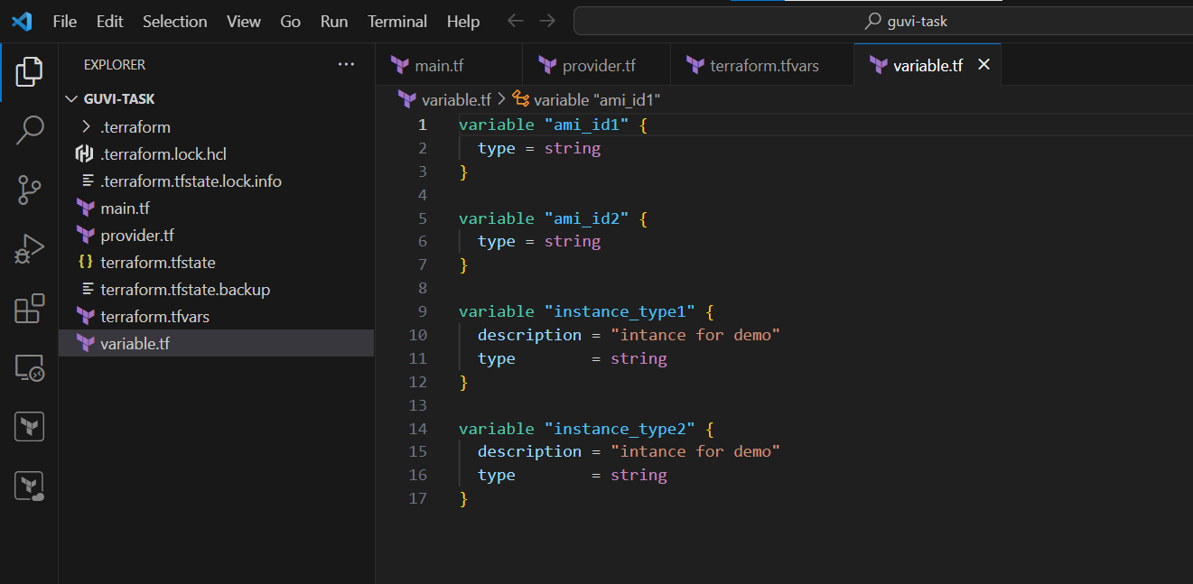

**Terraform.tfvars**

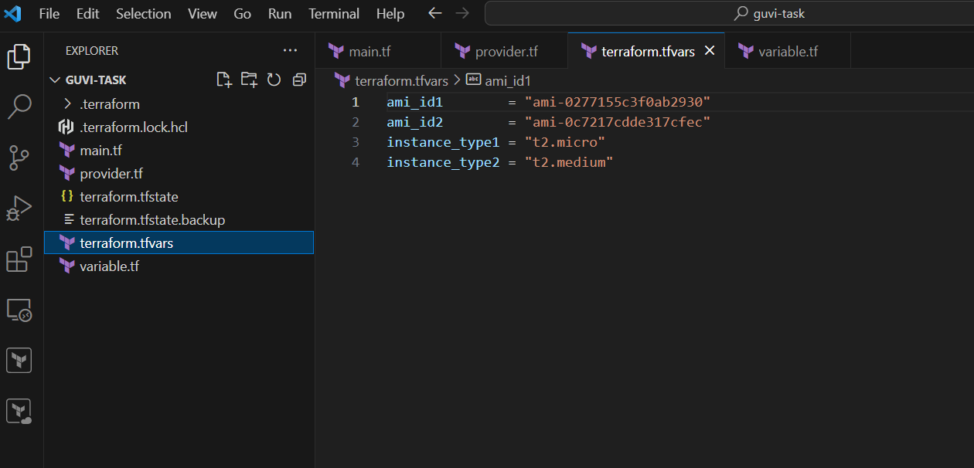

**Main.tf**

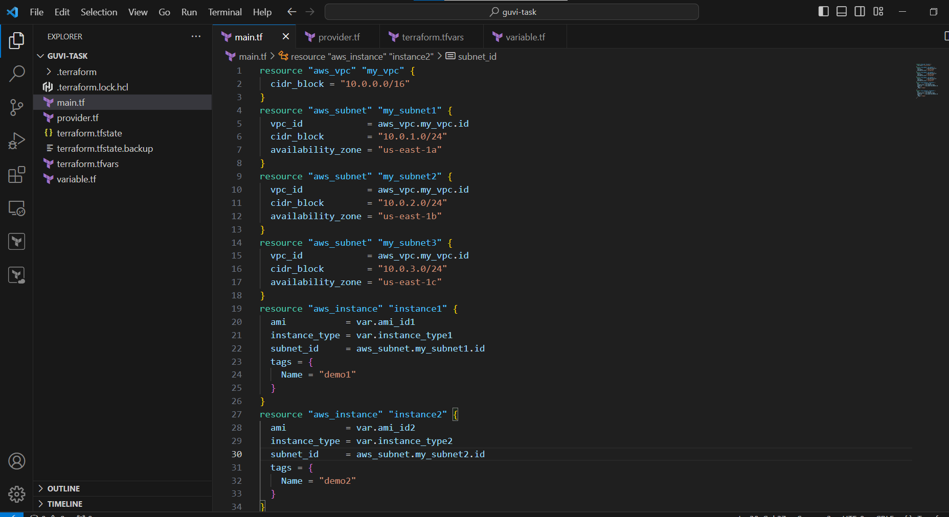

Given 1 vpc and 3 subnets in 3 different az

Created 2 instances (demo1,demo2) in 2 different subnets.

**Run the commands:**

terraform init

terraform validate

terraform fmt

terraform plan

terraform apply



