Day25-TASK:

Setup minikube at your local and explore creating namespaces (Go through official documentation)

1). Installed minkube in my local machine by using chocolatey.

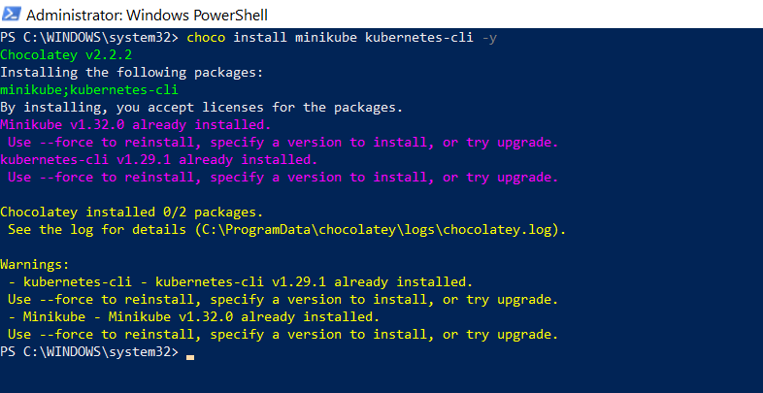

minikube version:

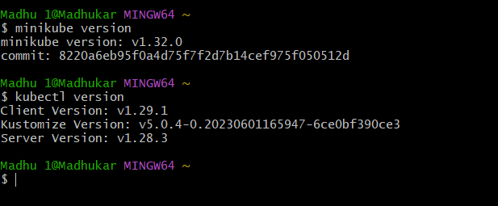

2) started minikube

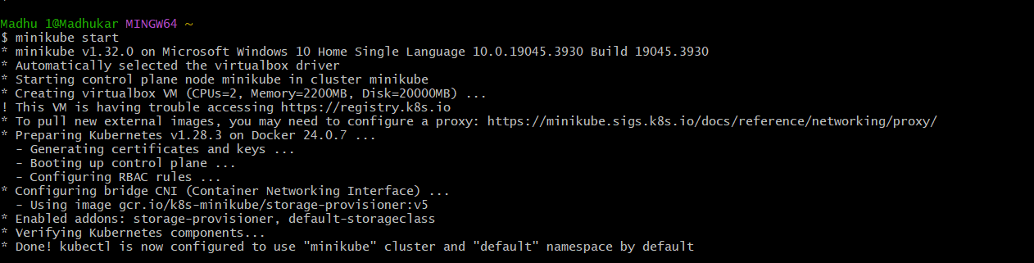

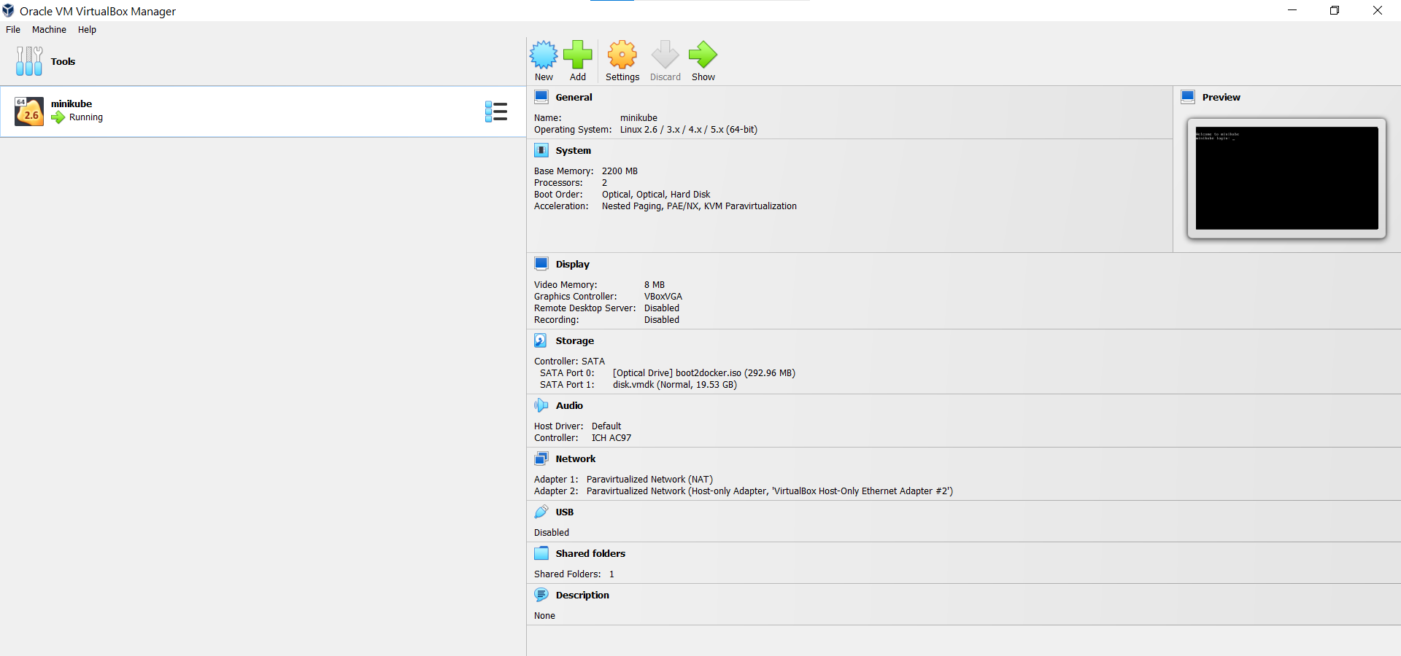

3)Default namespaces :Kubernetes starts with four initial namespaces:

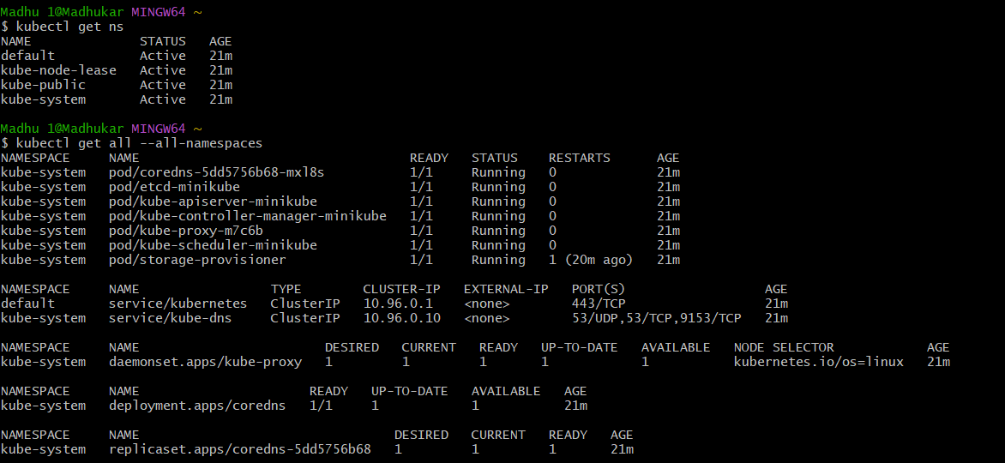

4)Created a namespaces **“mycart-1,2,3”** by using kubectl

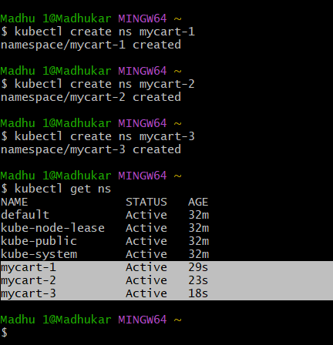

( Or )

we can create namespace by .yaml file also

Like:

**apiVersion: v1**

**kind: Namespace**

**metadata:**

**name: yaml-cart**

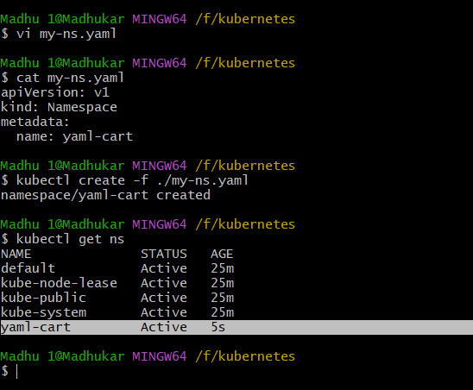

5) Run the nginx to set namespace

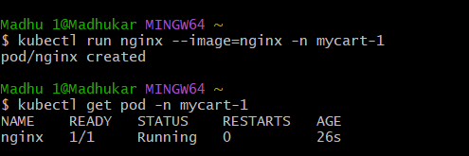

6)permanently saved the namespace for all subsequent kubectl commands in that context.

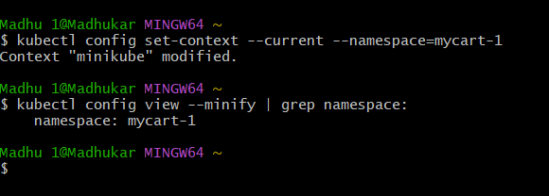

Deleted namespaces:

