Day26-Task

Create the K8s EKS,further you have to do the deployment of Nginx application

1)Install prerequisites

choco install kubernetes-cli

choco install -y eksctl

Choco install awscli

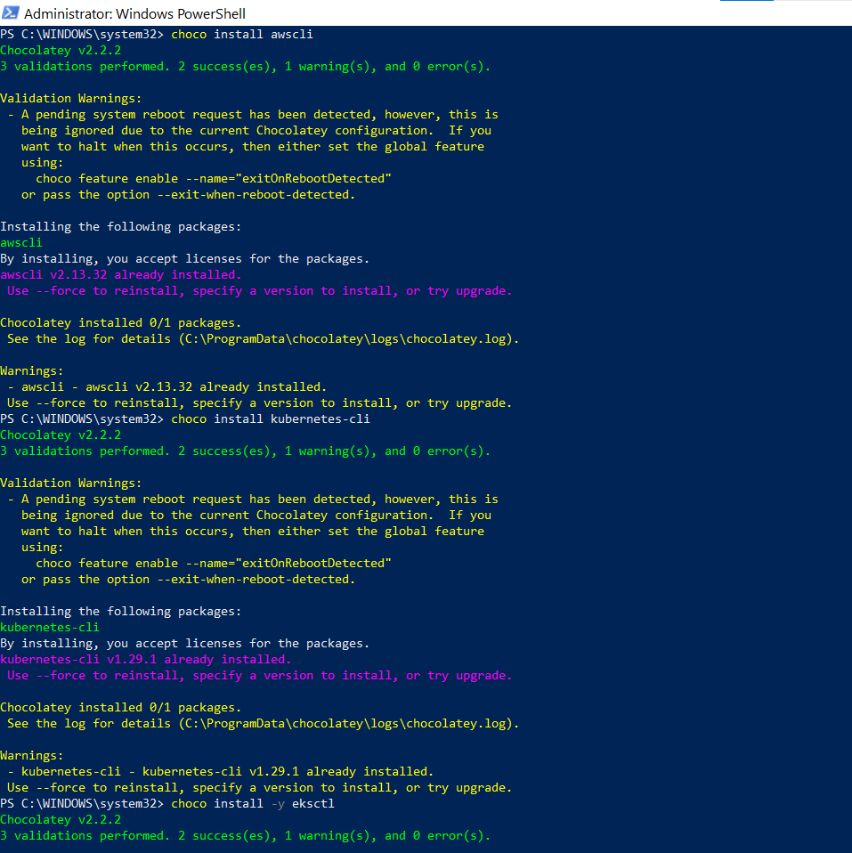

2)configure the aws

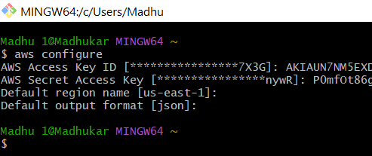

3)Use eksctl to create an EKS cluster. Adjust the configuration parameters as needed

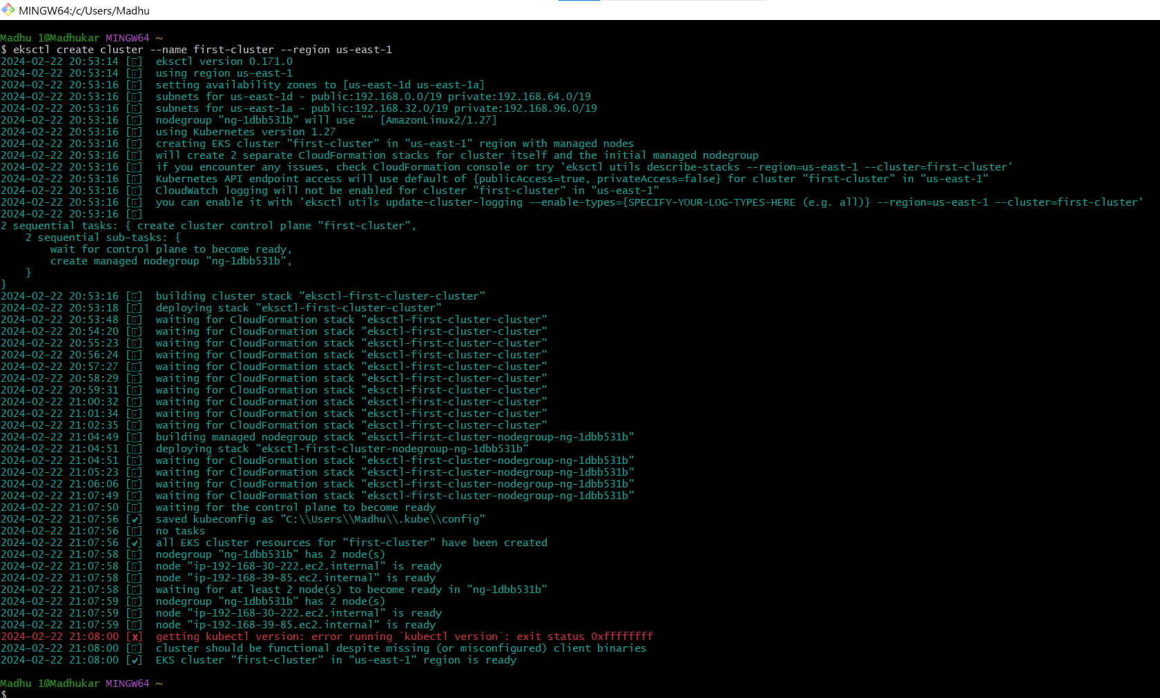

Cluster created

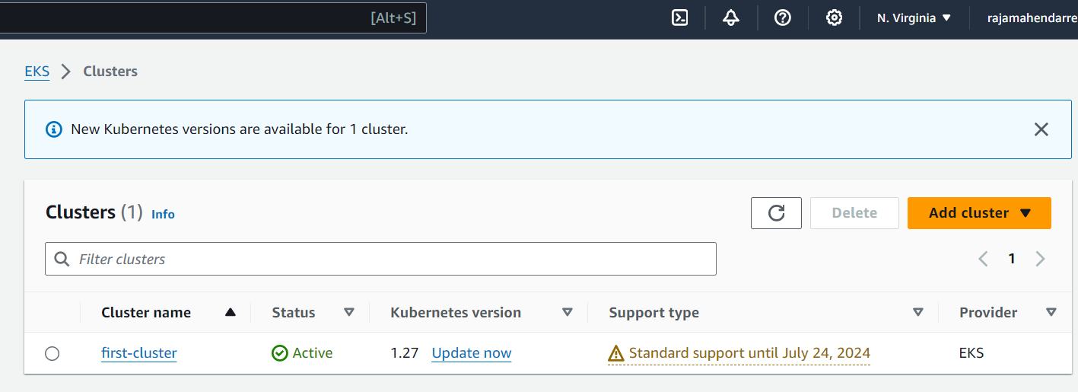

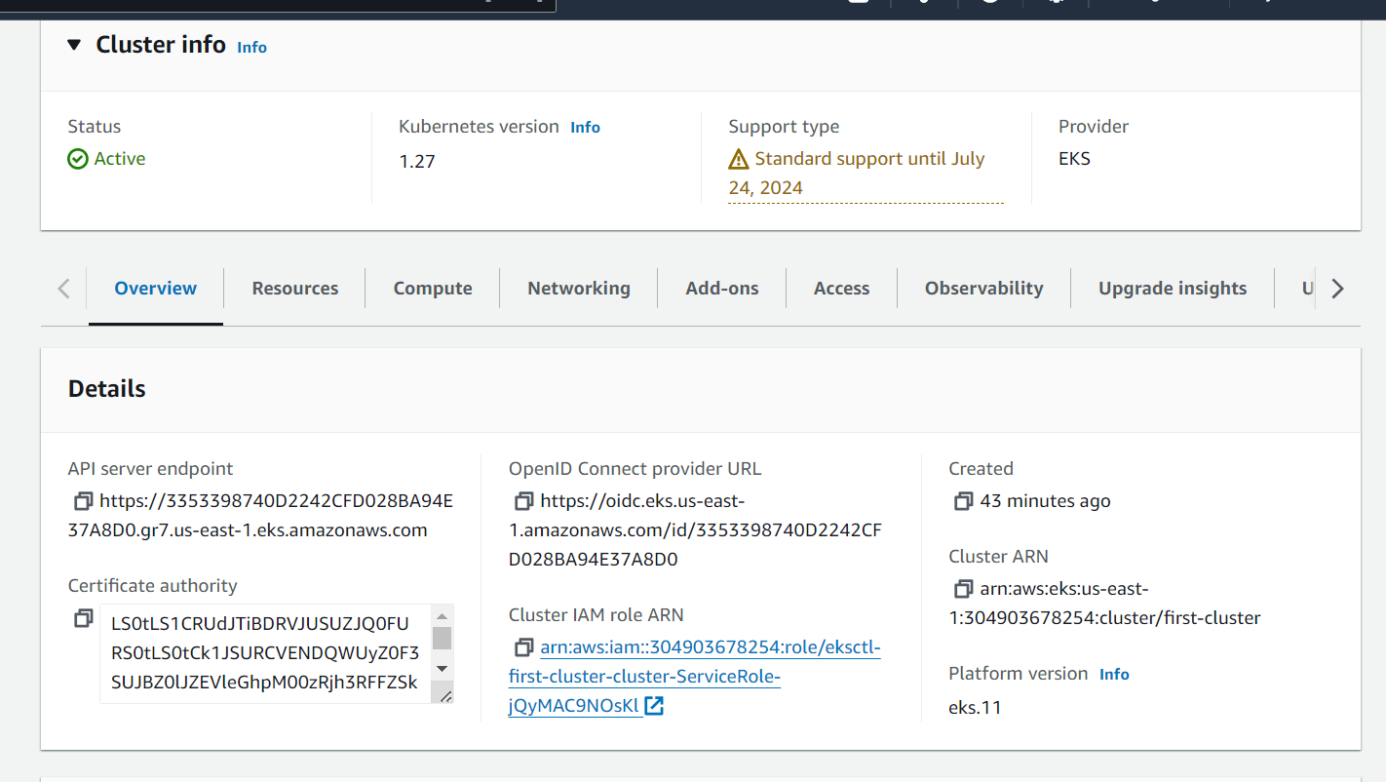

Cloudformation stack details

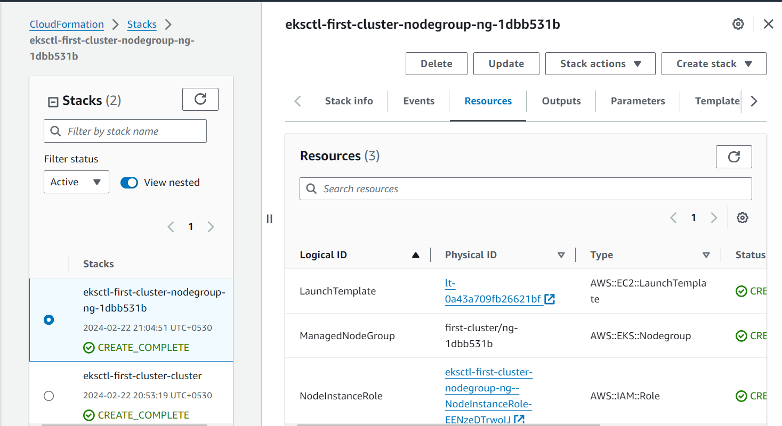

4)Configure kubectl to use the new EKS cluster

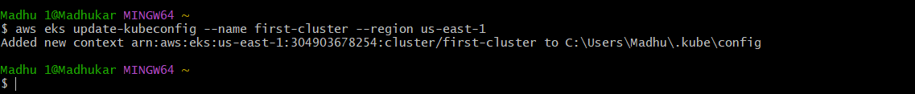

5)Create a Kubernetes manifest file for the Nginx Deployment and Service

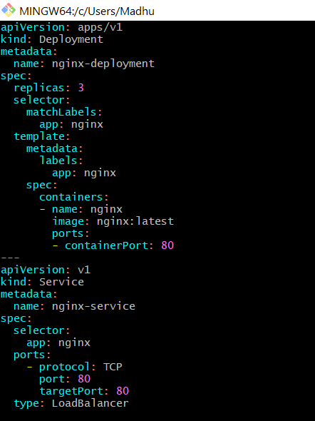

6)Apply the Kubernetes manifest to deploy the Nginx application

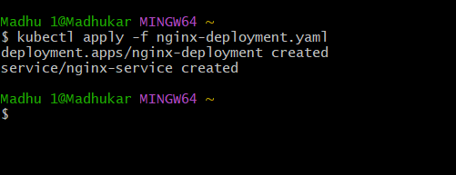

7)Check the status of the Nginx Deployment.

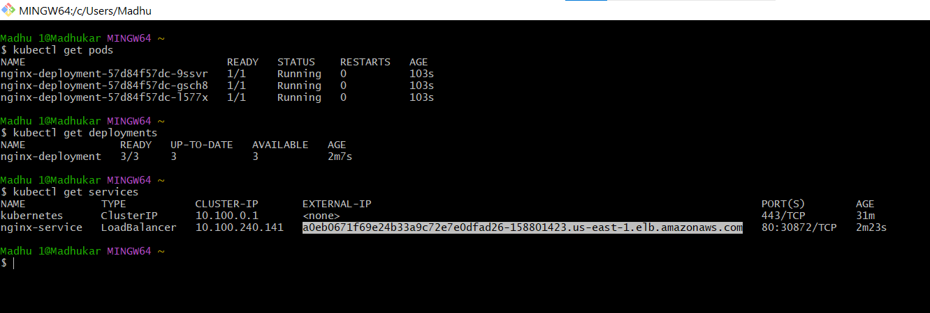

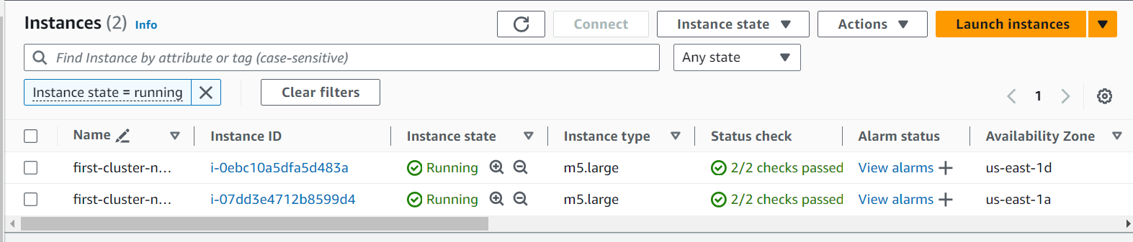

Browse external ip of load balancer and check the nginx page

