Day28-Task

Launch an ec2 instance under a default subnet and VPC using terraform template

write terraform configuration as follows in main.tf file

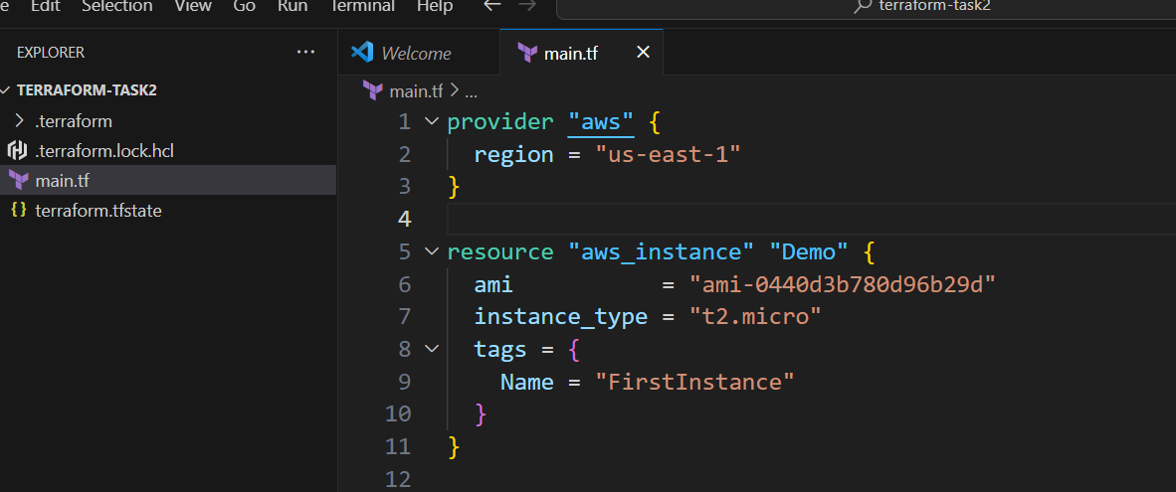

Give commands

-terraform init

-terraform validate

-terraform plan

-terraform apply

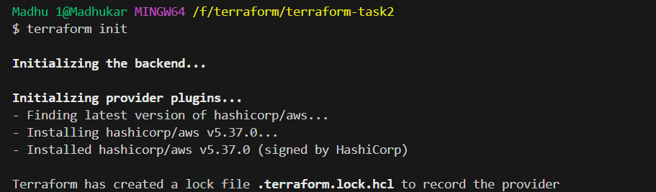

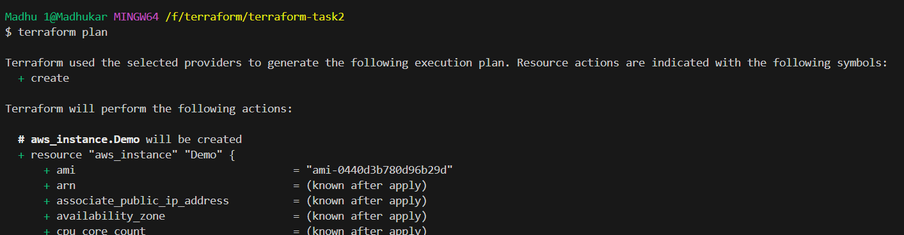

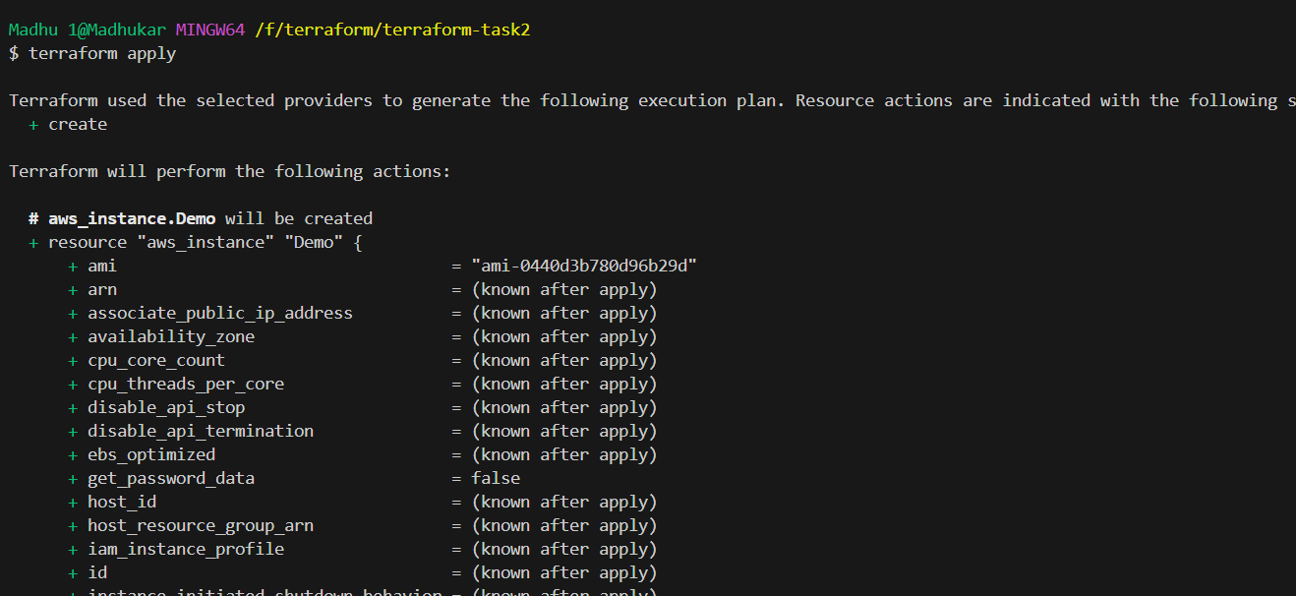

Ec2 created with default vpc and subnet

