DAY 3 TASK:

1)Get me the IP address of a particular domain (guvi.in)

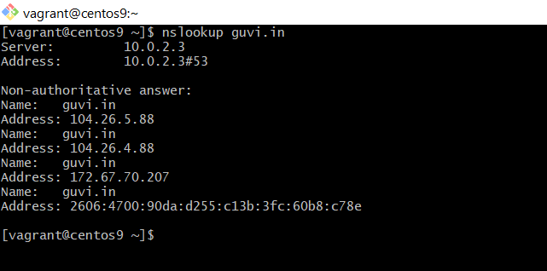

2)How do I find the CPU/memory usage of my server?

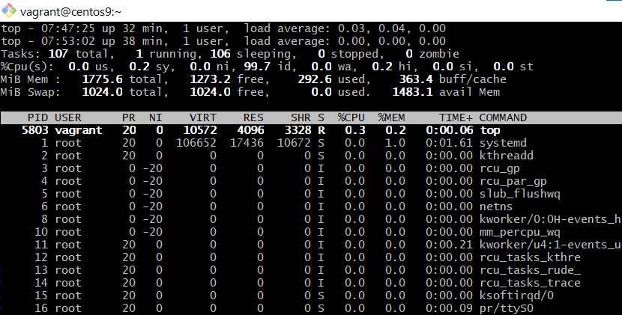



3)Test the connectivity between 2 nodes.

