Day12-TASK:

Create a custom docker image for nginx and deploy it using docker-compose, where the volume mount should be at /var/opt/nginx location. Push the created custom docker image to your docker hub.

SUBMISSION:

Created docker images for nginx

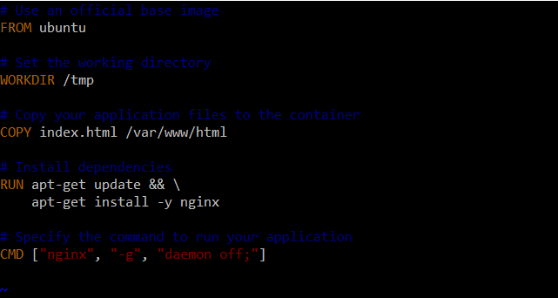

Deployed using docker-compose command

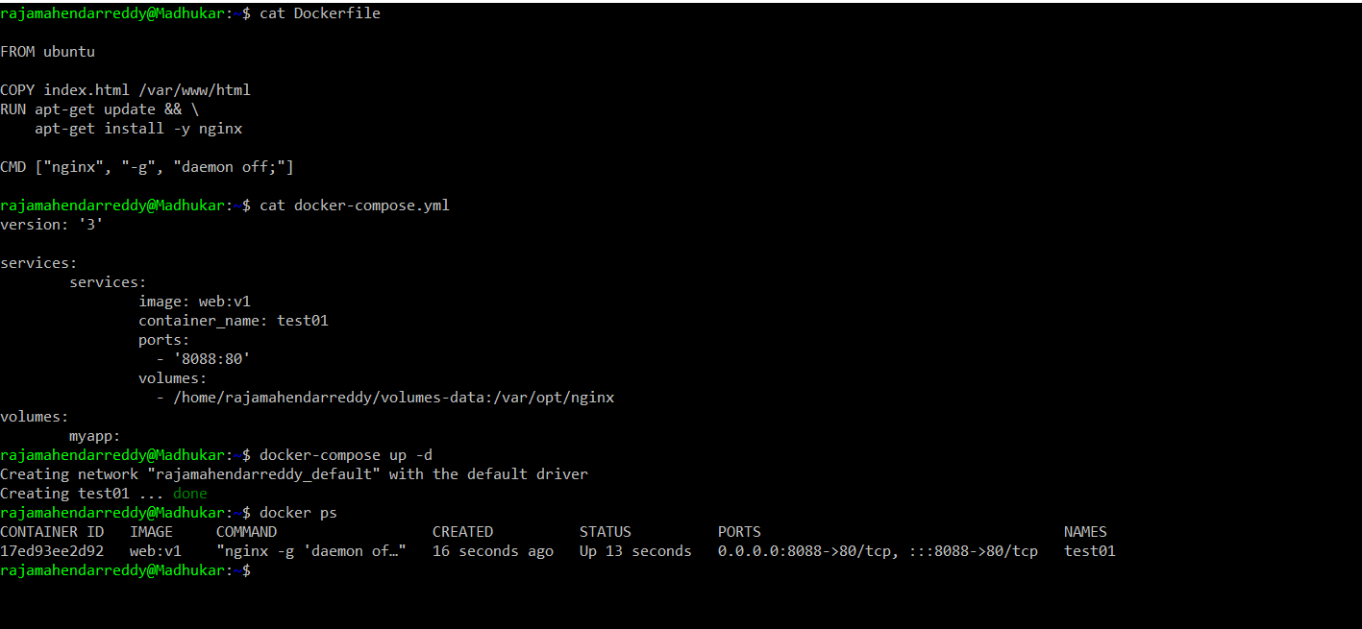

Pushed the created custom docker image into my docker hub.

My Docker hub URL :

<https://hub.docker.com/repository/docker/rajamahendarreddy777/guvi>