Day15-TASK:

Create a simple script file , with some data present it and push it to repo. Now Create a project in Jenkins connected to your GitHub repository. When a commit is made to your repo, automatically build must get triggered from Jenkins and the output must be shared to me via email.

Submission:

Step 1 - Created a simple script as script.sh

#!/bin/bash

# This is a simple script

echo "Hello, World I am groot”"

Step 2 - Pushed to my repo

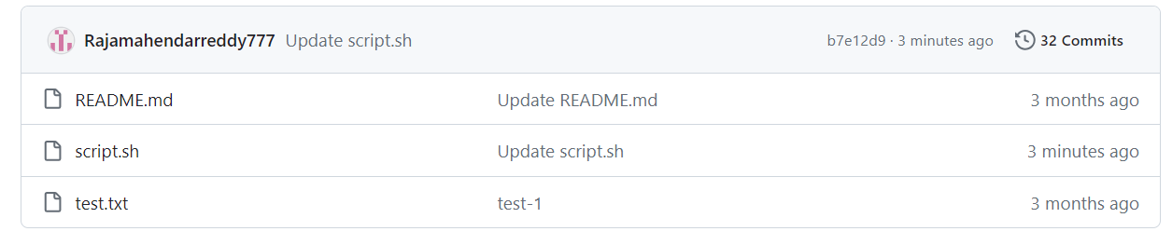

Step 3 - created a project As jenkins-demo

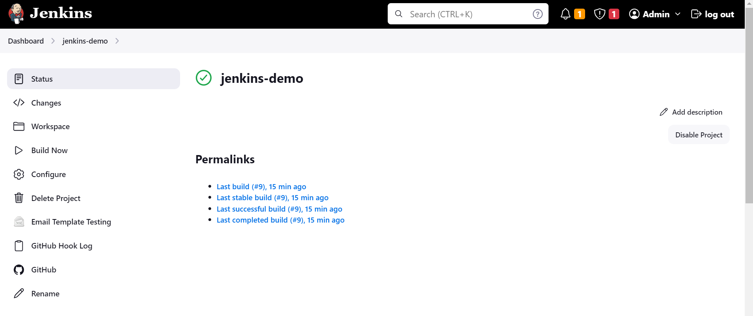

Step 4: configured github-webhook with jenkins

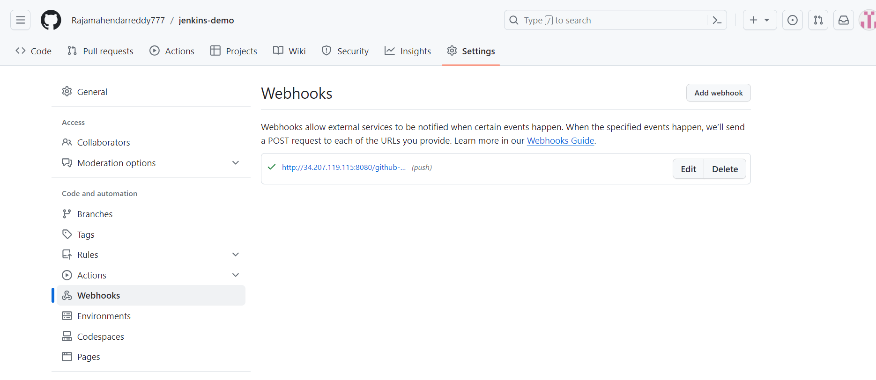

Step 5- configured all plugins to trigger E-MAIL

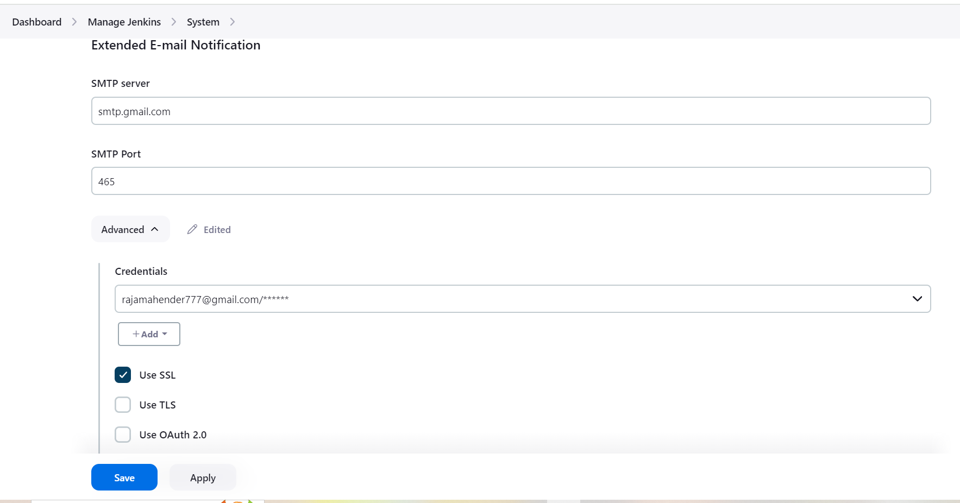

Step 6- committed a change in my repo it automatically triggered in jenkins and builded

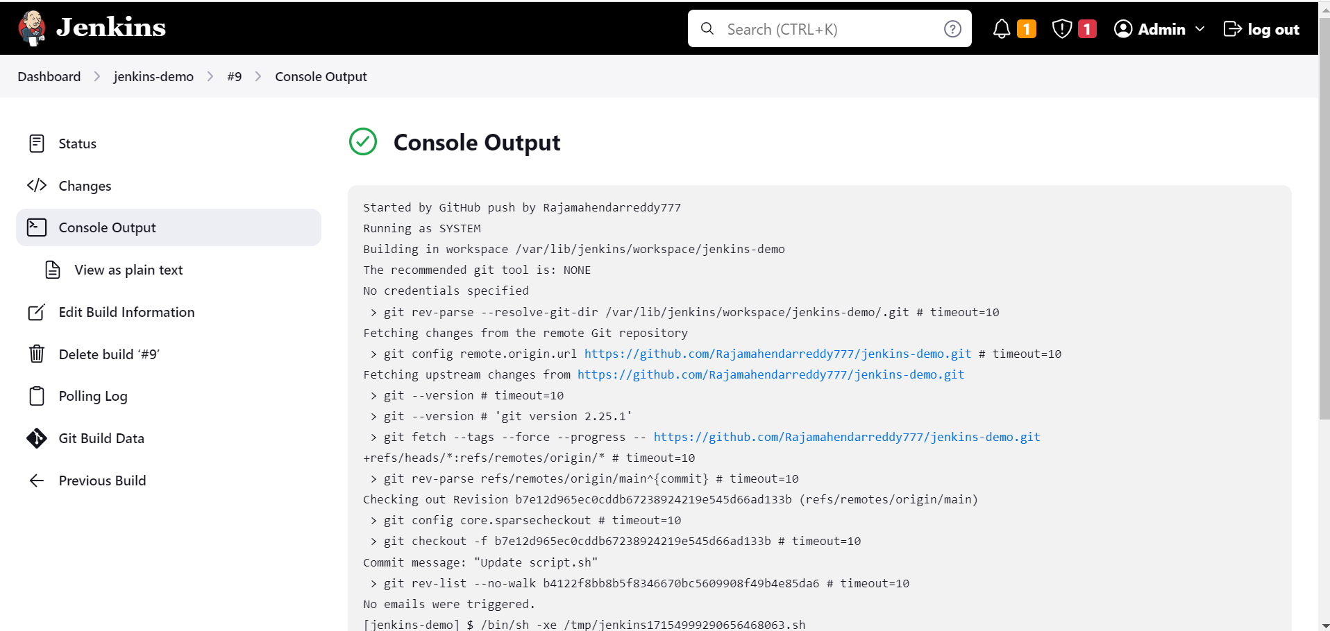

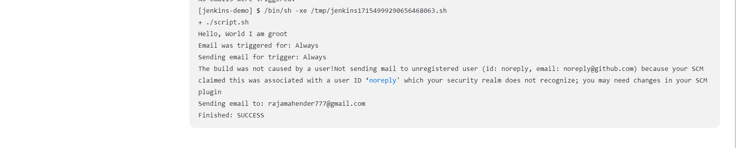

STEP 7 -Build triggered from Jenkins and the output shared to me via Gmail.

