Day17-TASK:

Launch a t2.micro instance in Mumbai region where ssh can be done only from your IP address with docker and docker-compose installed in it.

SUBMISSION:

1)Launched ec2 instance in mumbai region

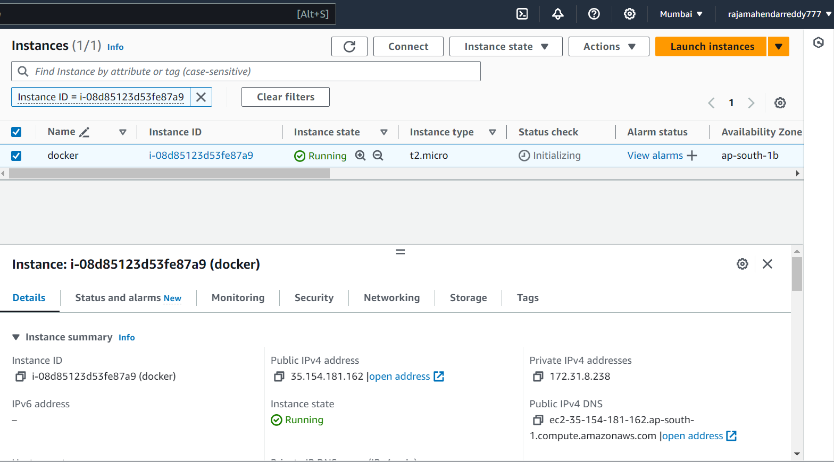

By given

TAG :docker

AMI : ubuntu

INSTANCE TYPE : t2.micro

CREATED KEY : docker-key.pem

CREATED SECURITY GROUP : SSH with my ip only(not given any other traffic)

ADDED SCRIPT IN USER DATA:For Docker installation and Docker compose from ec2 instance itself .

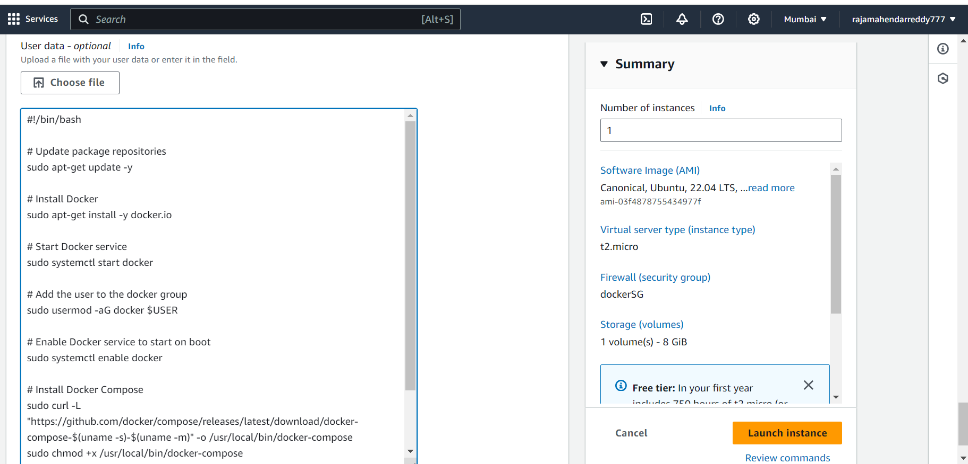

2)Connected ec2 from my Gitbash

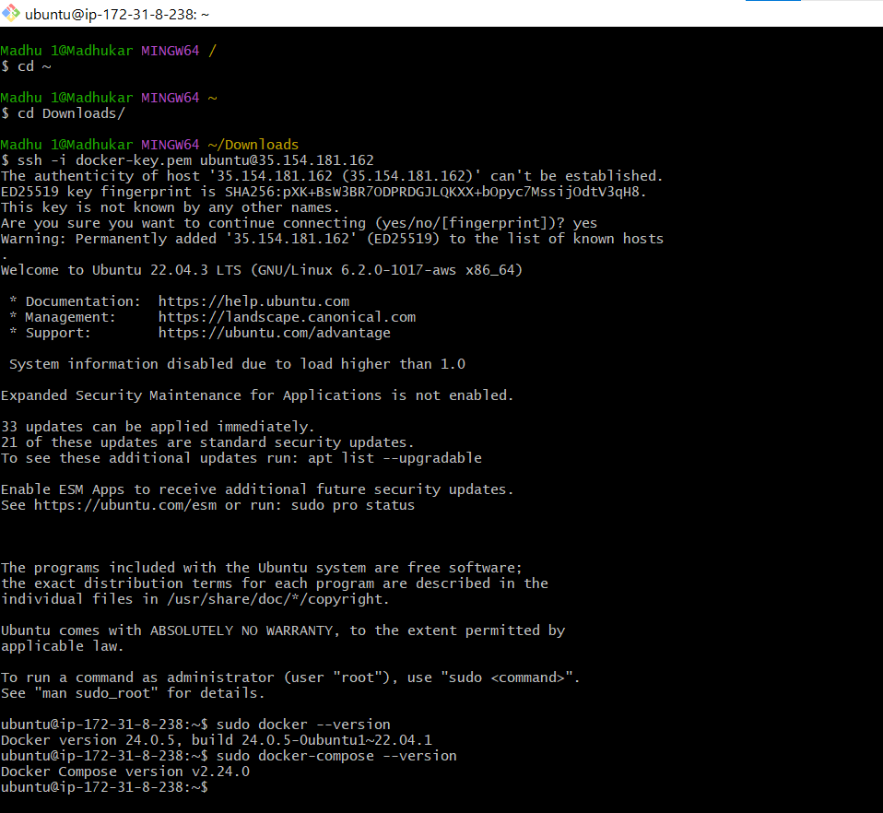

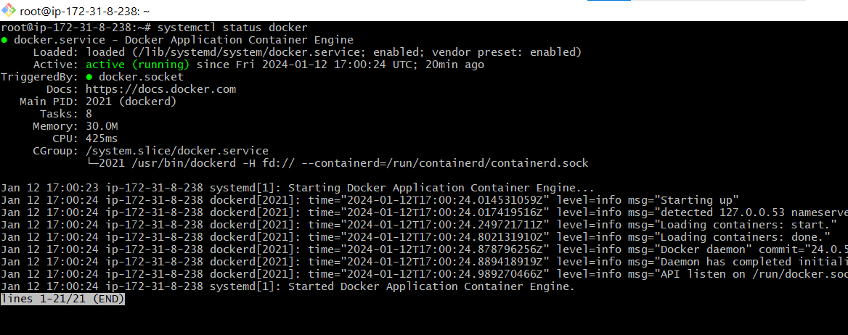

Docker & Docker compose installed from EC2 instance and running successfully.

We can see from above

Docker –version = 24.0.5

Docker-compose -version= 2.24.0