**LAB EXERCISE – 13**

**Decision Tree Classifier – ID3**

1. **Aim of the Experiment:**

Implement and demonstrate the working of the decision tree based ID3 algorithm using a sample data set. Build the decision tree and use this model to classify a test sample.

1. **Reference to Text book for Algorithms:**

Refer to Section 6.2.1 in Chapter 6 Decision Tree Learning to understand the working of the algorithm.

**Listing 1:**

Sample Dataset Used: **Table 6.3**

|  |  |  |  |  |  |
| --- | --- | --- | --- | --- | --- |
| S.No. | CGPA | Interactiveness | Practical Knowledge | Communication Skills | Job Offer |
| 1. | ≥9 | Yes | Very good | Good | Yes |
| 2. | ≥8 | No | Good | Moderate | Yes |
| 3. | ≥9 | No | Average | Poor | No |
| 4. | <8 | No | Average | Good | No |
| 5. | ≥8 | Yes | Good | Moderate | Yes |
| 6. | ≥9 | Yes | Good | Moderate | Yes |
| 7. | <8 | Yes | Good | Poor | No |
| 8. | ≥9 | No | Very good | Good | Yes |
| 9. | ≥8 | Yes | Good | Good | Yes |
| 10. | ≥8 | Yes | Average | Good | Yes |

3**. Python Program with Explanation:**

1. Import the library ‘pandas’ to create a Data frame which is a two-dimensional data

Structure.

import pandas

2. Import DecisionTreeClassifier from sklearn.tree.

from sklearn.tree import DecisionTreeClassifier

3. Import LabelEncoder to normalize labels.

from sklearn.preprocessing import LabelEncoder

4. Import train_test_split function.

from sklearn.model_selection import train_test_split

5. Import metrics module to implement functions to measure classification performance.

from sklearn import metrics

6. Import classification_report and confusion_matrix from sklearn.metrics to measure the quality of predictions.

from sklearn.metrics import classification_report, confusion_matrix

7. Create a list ‘data’ with the sample dataset.

data = {'CGPA':['g9','g8','g9','l8','g8','g9','l8','g9','g8','g8'],

'Inter':['Y','N','N','N','Y','Y','Y','N','Y','Y'],

'PK':['+++','+','==','==','+','+','+','+++','+','=='],

'CS':['G','M','P','G','M','M','P','G','G','G'],

'Job':['Y','Y','N','N','Y','Y','N','Y','Y','Y']}

8. Create pandas dataframe “table” using the structure DataFrame with the given dataset ‘data'.

table=pandas.DataFrame(data, columns=["CGPA","Inter","PK","CS","Job"])

9. Use a value ["CGPA"]=="g9" in the table to select matching row and count the number of columns.

table.where(table["CGPA"]=="g9").count()

10. Use LabelEncoder() to encode target labels with value between 0 and no_of_classes-1.

encoder=LabelEncoder()

11. Then transform non-numerical labels to numerical labels.

for i in table:

table[i]=encoder.fit_transform(table[i])

12. Use iloc property to select by position.

Select the columns until (excluding) the fifth column.

X=table.iloc[:,0:4].values

Select the fifth column

y=table.iloc[:,4].values

13. Split the dataset into training dataset and test dataset by using the function train_test_split(). This function has several parameters, but we pass 3 parameters, data, test_size and random_state.

X, y is the dataset we are selecting to use.

test_size to specify the size of the testing dataset. It will be set to 0.25 if the training size is set to default.

random_state to perform a random split.

X_train is the features of the training subset

y_train is the class labels of the target feature of the training subset

X_test holds the features of the testing subset

y_test holds the class labels of the target feature of the testing subset

X_train, X_test, y_train, y_test = train_test_split(X, y, test_size=0.3, random_state=2)

14. Use DecisionTreeClassifier model. It allows some attributes like criterion*,* splitter,

**max_features,**  max_depth, max_leaf_nodes etc., we will use the attribute criterion which takes a value ‘entropy’ to implement a classifier using ID3. The attribute value for max_depth is given as 3 to pre prune the tree.

model=DecisionTreeClassifier(criterion='entropy', max_depth=3)

13. DecisionTreeClassifier  model takes as input two arrays: an array X_train, holding the training instances, and an array y_train holding the class labels for the training instances.

Then train the classifier using the function fit().

model.fit(X_train,y_train)

14. To make predictions, the predict method of the DecisionTreeClassifier class is used.

y_pred = model.predict(X_test)

15. Use sklearn.metrics.accuracy_score() to compute the accuracy by comparing actual test set values and predicted values.

print("Accuracy:",metrics.accuracy_score(y_test, y_pred))

16. Generate classification report & confusion matrix to measure the quality of predictions.

print(confusion_matrix(y_test, y_pred))

print(classification_report(y_test, y_pred))

17. After training, the fitted model can be used to predict a new instance.

# The non-numerical equivalent of the new instance [1,0,0,1] given is [‘g9’, ‘Y’, ‘***’, ‘M’]

print([1,0,0,1])

if model.predict([[1,0,0,1]])==1:

print("Got JOB")

else:

print("Didnt get JOB")

# The non-numerical equivalent of the new instance [2,0,2,0] given is [‘l8’, ‘Y’, ‘==’, ‘G’]

print([2,0,2,0])

if model.predict([[2,0,2,0]])==1:

print("Got JOB")

else:

print("Didnt get JOB")

**Complete Program:**

import pandas

from sklearn.tree import DecisionTreeClassifier

from sklearn.preprocessing import LabelEncoder

from sklearn.model_selection import train_test_split

from sklearn import metrics

from sklearn.metrics import classification_report, confusion_matrix

data = {'CGPA':['g9','g8','g9','l8','g8','g9','l8','g9','g8','g8'],

'Inter':['Y','N','N','N','Y','Y','Y','N','Y','Y'],

'PK':['+++','+','==','==','+','+','+','+++','+','=='],

'CS':['G','M','P','G','M','M','P','G','G','G'],

'Job':['Y','Y','N','N','Y','Y','N','Y','Y','Y']}

table=pandas.DataFrame(data,columns=["CGPA","Inter","PK","CS","Job"])

table.where(table["CGPA"]=="g9").count()

encoder=LabelEncoder()

for i in table:

table[i]=encoder.fit_transform(table[i])

X=table.iloc[:,0:4].values

y=table.iloc[:,4].values

 X_train,X_test,y_train,y_test=train_test_split(X,y,test_size= 0.20,random_state=2)

model=DecisionTreeClassifier(criterion='entropy', max_depth=3)

model = model.fit(X_train,y_train)

y_pred = model.predict(X_test)

print("Accuracy:",metrics.accuracy_score(y_test, y_pred))

print(confusion_matrix(y_test, y_pred))

print(classification_report(y_test, y_pred))

print([1,0,0,1])

if model.predict([[1,0,0,1]])==1:

print("Got JOB")

else:

print("Didn’t get JOB")

print([2,0,2,0])

if model.predict([[2,0,2,0]])==1:

print("Got JOB")

else:

print("Didn’t get JOB")

**Output:**

Python 3.8.3 (tags/v3.8.3:6f8c832, May 13 2020, 22:37:02) [MSC v.1924 64 bit (AMD64)] on win32

Type "help", "copyright", "credits" or "license()" for more information.

>>>

======== RESTART: C:\Users\ADMIN\pythonpgms\decision tree sklearn id3.py =======

Accuracy: 1.0

[[1]]

precision recall f1-score support

1 1.00 1.00 1.00 1

accuracy 1.00 1

macro avg 1.00 1.00 1.00 1

weighted avg 1.00 1.00 1.00 1

[1, 0, 0, 1]

Got JOB

[2, 0, 2, 0]

Didn’t get JOB

>>>

**Screen Shot of the Output:**

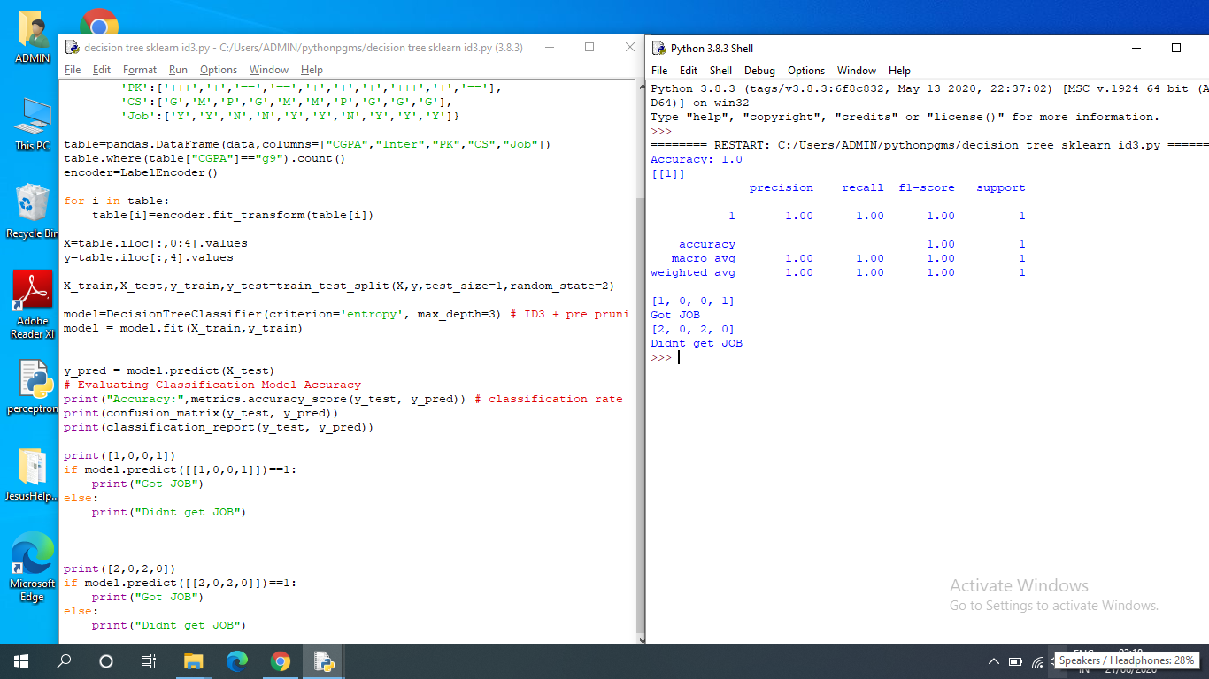

**Listing 2:**

**Program Code:**

from matplotlib import pyplot as plt

from sklearn import datasets

from sklearn.tree import DecisionTreeClassifier

from sklearn import tree

import graphviz

# Load the Iris dataset

iris = datasets.load_iris()

X = iris.data

y = iris.target

# Train the model using DecisionTreeClassifier ID3

clf = DecisionTreeClassifier(criterion='entropy', max_depth=3)

model = clf.fit(X, y)

#Visualize the model using tree graph

fig = plt.figure(figsize=(10,8))

_ = tree.plot_tree(clf,

feature_names=iris.feature_names,

class_names=iris.target_names,

filled=True)

plt.show()

#fig.savefig("decistion_tree.png")

