Deep Cross-modal Face Naming for People News Retrieval

In this paper author is introducing Deep Cross-Modal (a single model which will identify objects in images and then describe its caption) algorithm which will deep extract facial features and its associated caption to train Deep learning algorithm and after training this algorithm can predict caption and faces using Naming query. This scheme integrates deep multimodal analysis, cross-modal correlation learning, and multimodal information mining, in which the efficient naming mechanism aims to cluster the deep features of different modalities into a common space to explore their inter-related correlations, and a special Web mining pattern is designed to optimize the name-face matching for rare non-celebrity. Such a cross-modal face naming model can be treated as a problem of bi-media semantic mapping and modelled as an inter-related correlation distribution over deep representations of multimodal news, in which the most important is to create more effective cross-modal name-face correlation and measure to what degree they are correlated.

As we know all existing news will be searched based on query matching but it will not identify news for specify person by using naming or person face. So in propose paper author training algorithm with name, face and caption so by giving face and name application can obtained related caption or news.

In propose paper author has used YAHOO NEWS CAPTION dataset but this dataset is not available on internet so we use images and its caption dataset. So by uploading any image we can get its caption from trained model as dataset don’t have Naming option so we can retrieve caption on names so by uploading images we can get it caption.

By querying also we can get related image

To implement this project we have designed following modules

1. Generate & Load Deep Cross-Modal Model: using this module we will load deep cross modal model to the application
2. Upload Image: using this module we will upload image
3. Caption/News Retrieval: using this module we will extract related caption associated with the image
4. Search News/Caption: using this module we will input news/query and then application will retrieve related image with caption

SCREEN SHOTS

To run project double click on ‘run.bat’ file to get below output

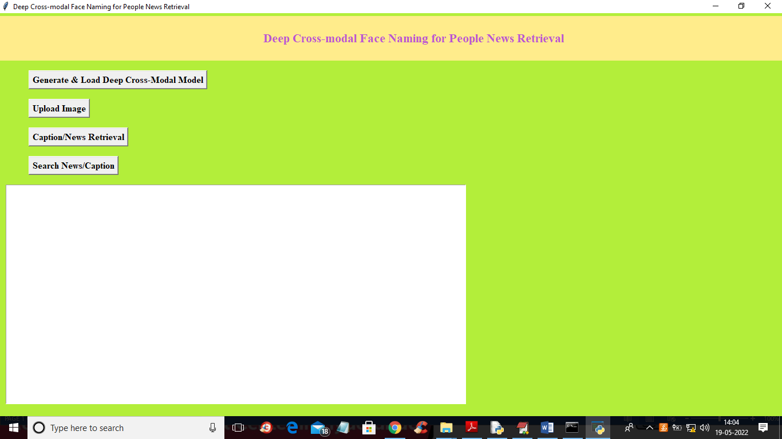

In above screen click on ‘Generate & Load Deep Cross-Modal Model’ button to load cross deep face extraction model and get below output

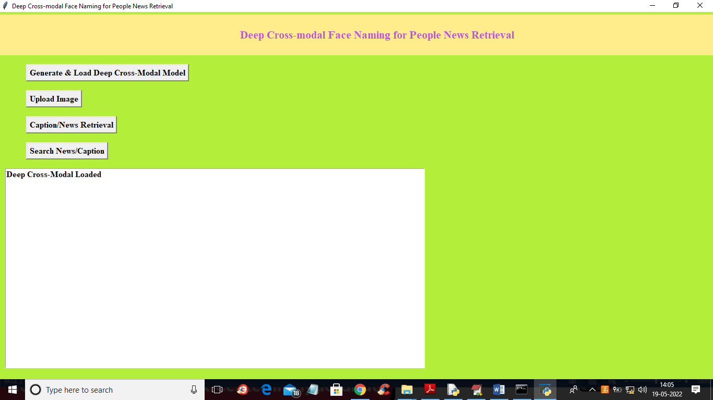

In above screen in text area we can see model is loaded and now click on ‘Upload Image’ button to upload image and get below output

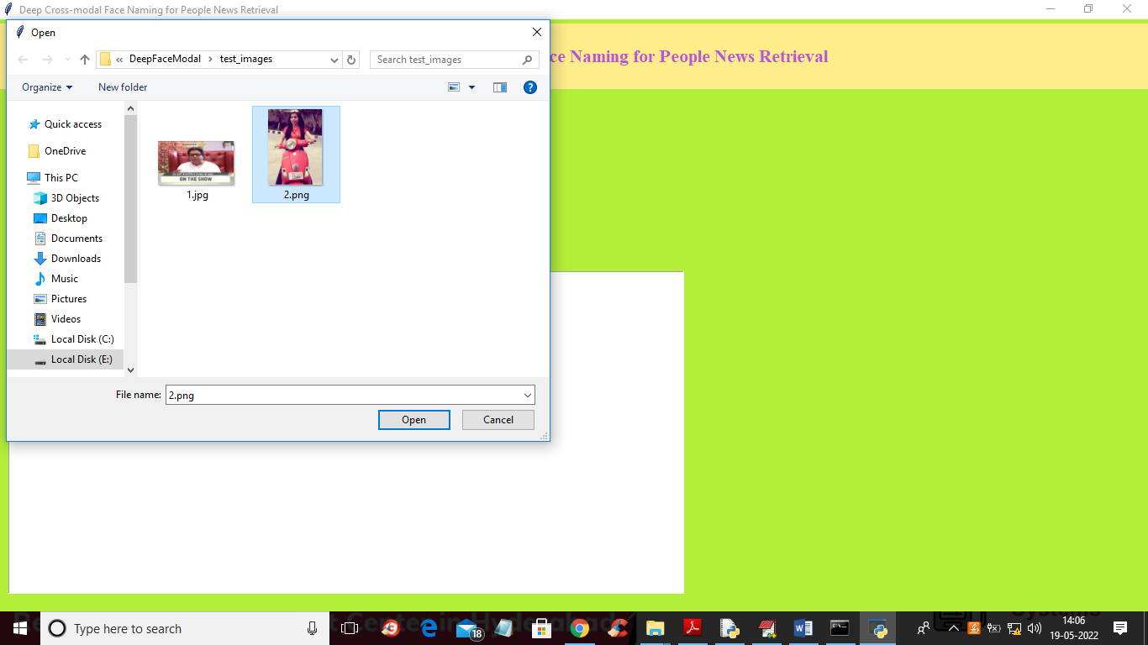

In above screen selecting and uploading ‘2.png’ and then click on ‘Open’ button to load image and then click on ‘Caption/News Retrieval’ button to extract caption from image and get below output

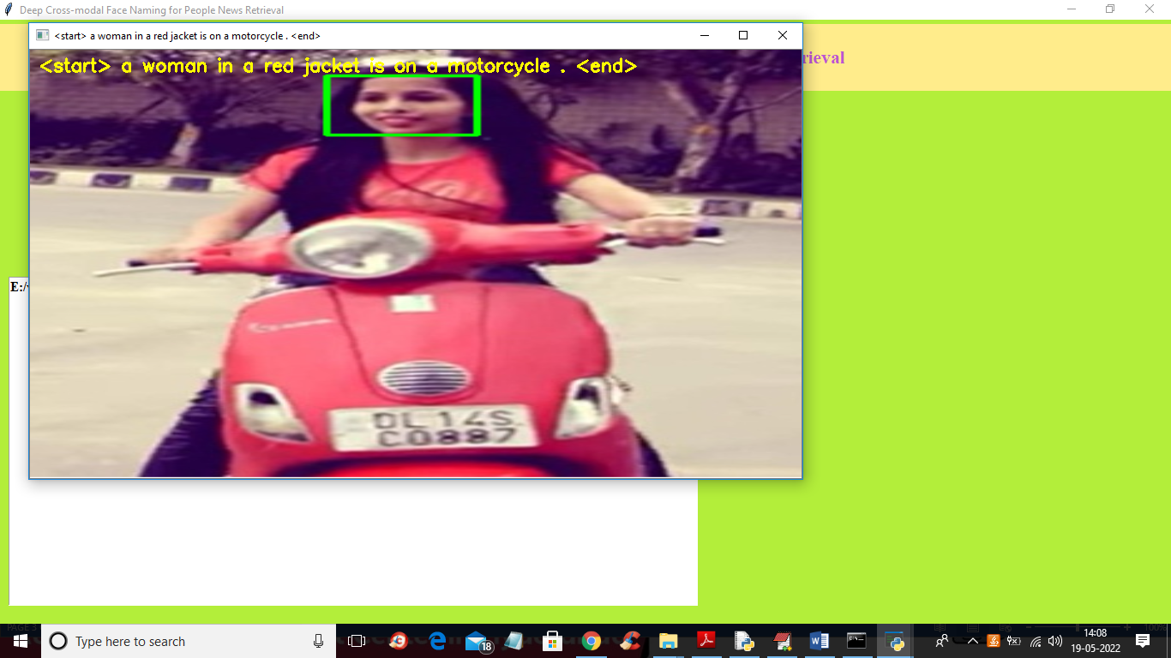

In above screen we got caption associated with image and now to search news with images then we need to give query like below screen

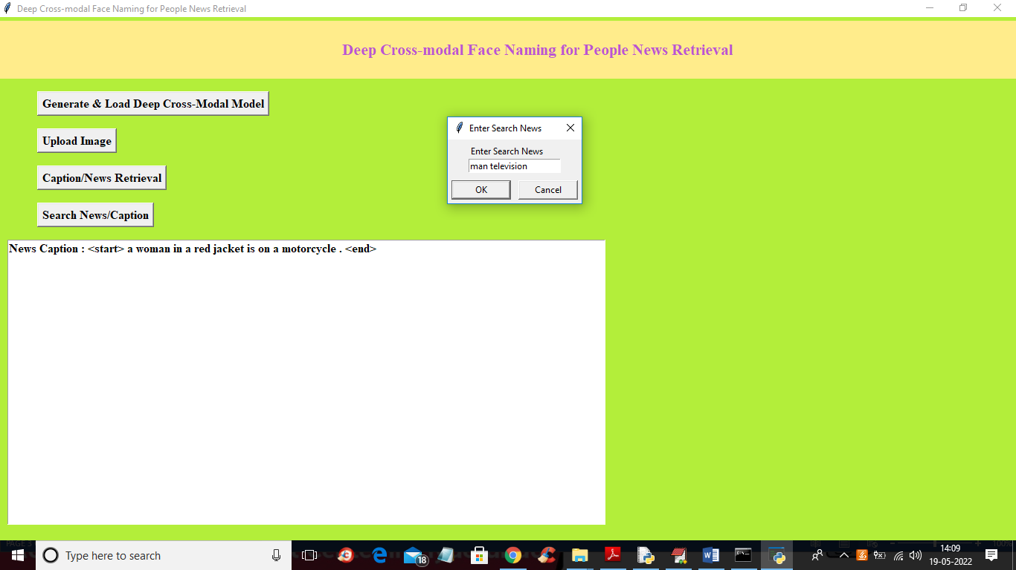

In above screen I gave query as ‘man television’ to get below output

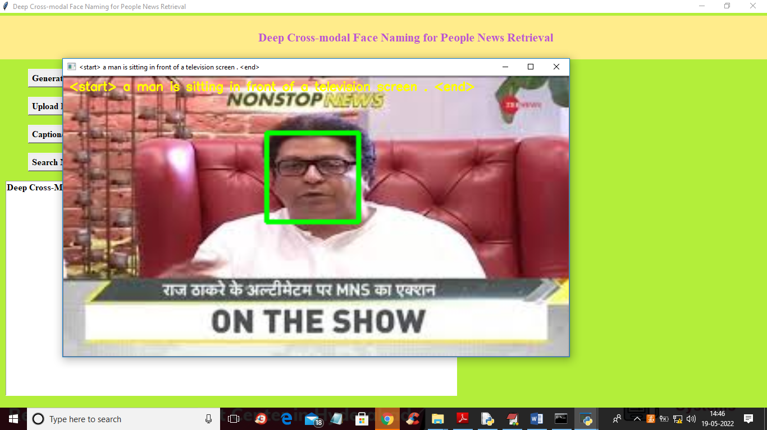

In above screen in image we got man and television so by giving query we retrieve related image and similarly you can upload any image to get caption or give query to get related caption image