ITS - INTERVIEW TRACKING SYSTEM.
Microservices
ITS-UserManagement --8003
ITS-Admin - port :8004
ITS-TechPanel - port :8005
ITS-HR - port :8006

Extra Mircoservices:
1.Eureka - port : 8001
2.Api-Gateway - port : 8002

Priority List
Priority -1
Endpoints -
1.ITS-Admin ----- 1,2,3,4,6,7,8,9,10
2.ITS-Tech ----- 1,2,3
3.ITS-HR ----- 1,2,3

Priority - 2
Endpoints -
1.ITS-Admin ----- 5 - [Update Interview]
2.ITS-Tech ----- 4 - [Surrender as Tech
Panel Member]
3.ITS-HR ----- 4 - [Surrender as HR
Panel Member]

Team member specific endpoints:

1.Nagaraju

ITS-Admin
8 - Search Employee (by
ID or Name)
9 - Delete Panel Member
10 - List All Panel Members

2.Madhumita -

ITS-Tech
1. View Interview
Members
2. Give Rating to a
candidate
3. View a candidate

3.Ruchi -

ITS-HR
1. View Interview
Members
2. Give Rating to a
candidate
3. View a candidate

4.Raja -

ITS-Admin
3. Share Candidate withTech/HR panel
4. Schedule Interview
5. Update Interview
6. Cancel Interview

5.Satyam

ITS-Admin
1. Add Candidate
2. View Candidate Candidate
7. Add Panel Member

Database - Mysql

ITS-Admin

1.pom dependencies

2. Java - Version - 8

3.Change pom version to 2.5.6 - which is a stable version to avoid errors

4.Entites
1.Candidates
id
candidateName
role
primarySkills,
secondarySkills,
experience,
qualification,
designation,
noticePeriod,
location

2.Interview
interviewID,
candidateID,
title,
techRating,
hrRating,
finalStatus
remarks --->[optional]

3.Panel Members
employeeID,
empName
role - [Type(Tech/HR),]
location

5.DTO
Same as entities
1.Candidates
id
candidateName
role
primarySkills,
secondarySkills,
experience,
qualification,
designation,
noticePeriod,
location

2.Interview
interviewID,
candidateID,
title,
techRating,
hrRating,
finalStatus
remarks --->[optional]

3.Panel Members
employeeID,
empName
role - [Type(Tech/HR),]
location

UI Design

Overview UI design of Interview Tracking System.

This is the overview diagram . There will be a signup page page where user(admin, tech, and hr) will register themselves. Similarly following up the login page, user will login into their respcetive departments.

Admin will have “candidate, Panel member, and Interview schedule button and a search bar. Candidate page includes add, viewand share operations. Similarly, Panel member and interview schedules include their basic operations.

Tech panel will have Same options as admin i.e. candidate, panel member, Interview schedule. And will carry on the same.

Similarly we have HR panel with the same functionalitis as tech panel.

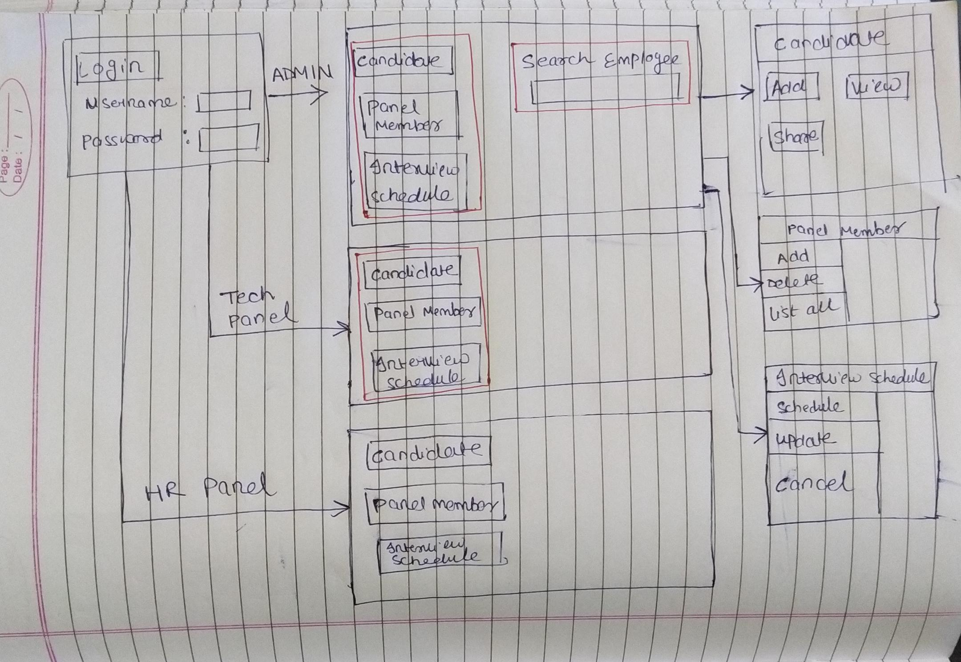

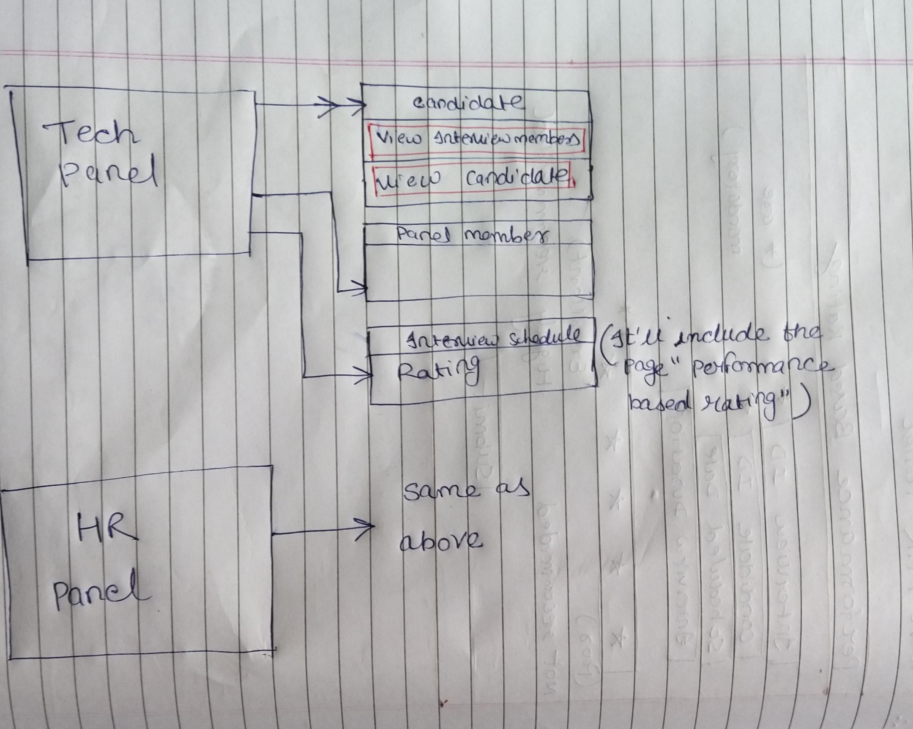

When admin will click on “candidate”, It will appear with the options “Add”, “View candidate” and “Share candidate with Hr/tech”. On clicking add, this page will appear. It'll be similar for view candidate too.

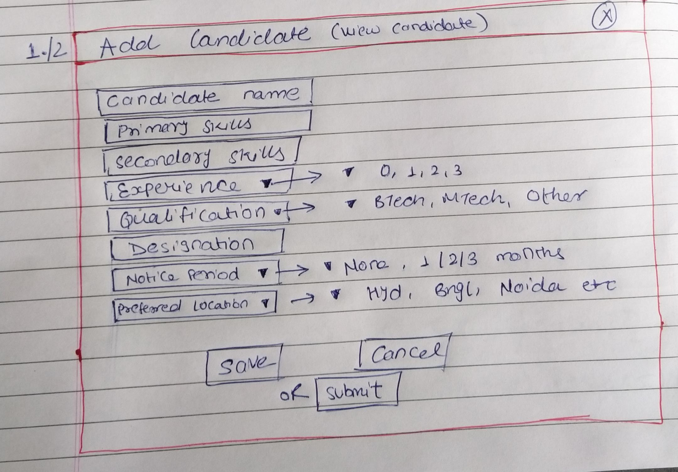

This is the fourth service to schedule the interview.

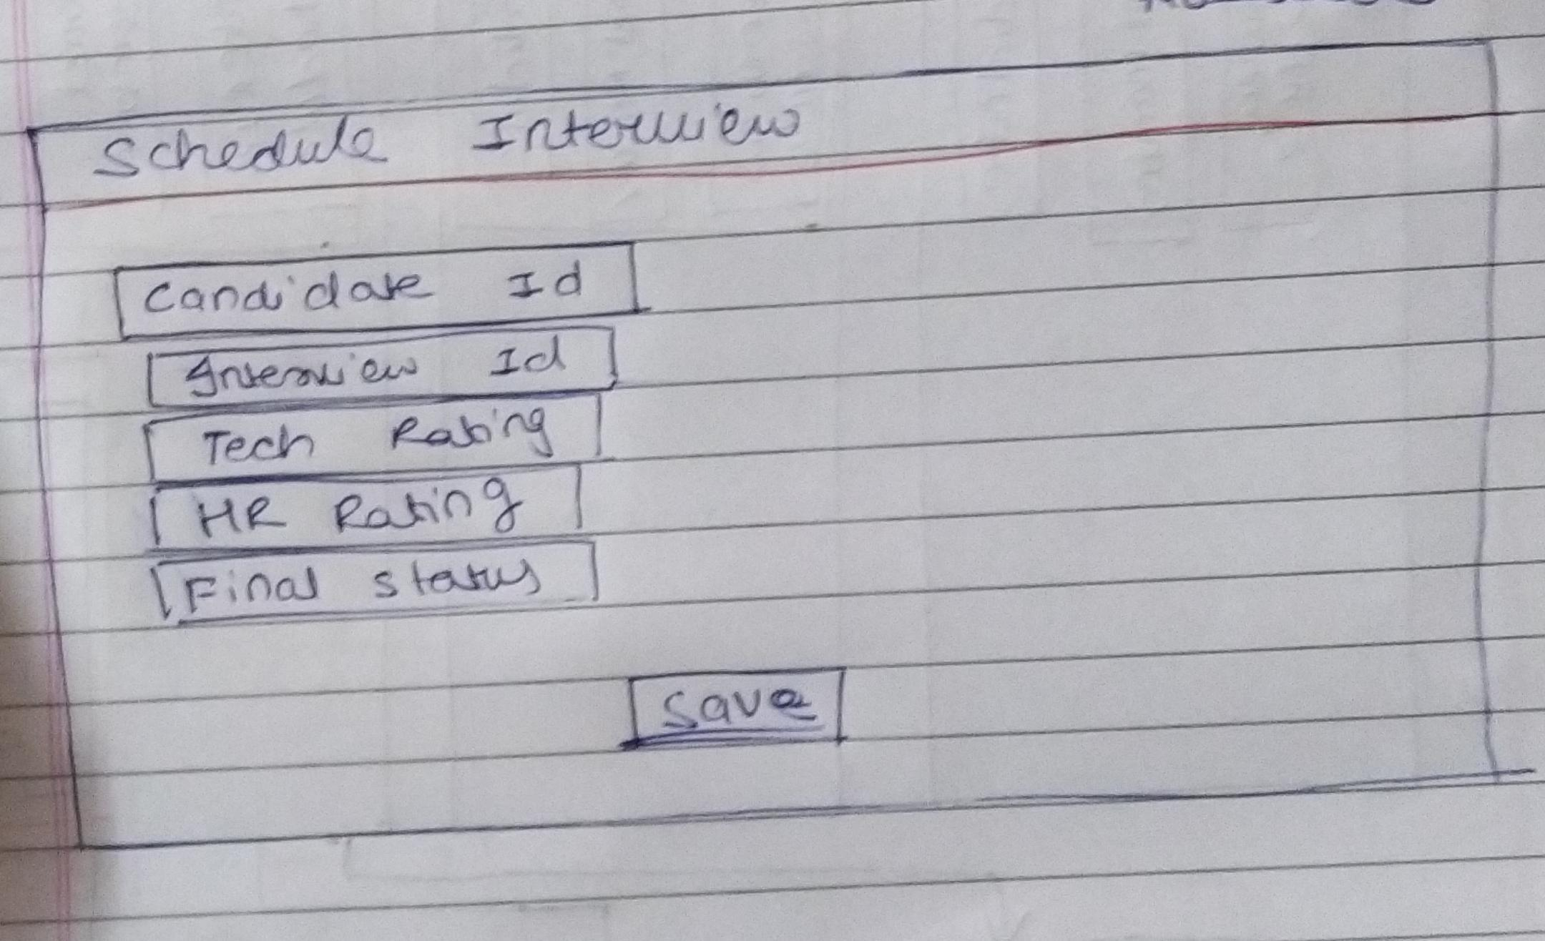

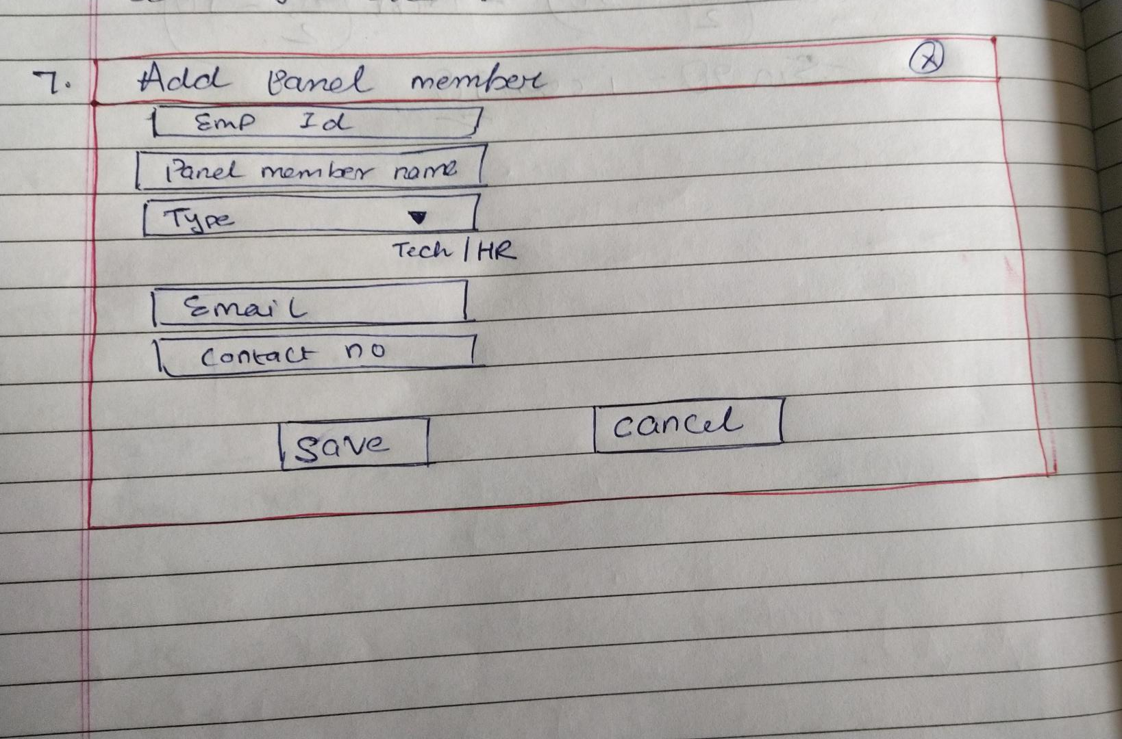

This page is for Hr/tech for rating the candidates based on their performance. This is service no 2 in both the panels.

