# ITS - INTERVIEW TRACKING SYSTEM.

# Microservices

1.Eureka - port : 8001

2.Api-Gateway - port : 8002

3.Config Server - port :8003

4.ITS-Admin - port :8004

5.ITS-TechPanel - port :8005

6.ITS-HR - port :8006

Database - Mysql

## ITS-Admin

### 1.pom dependencies

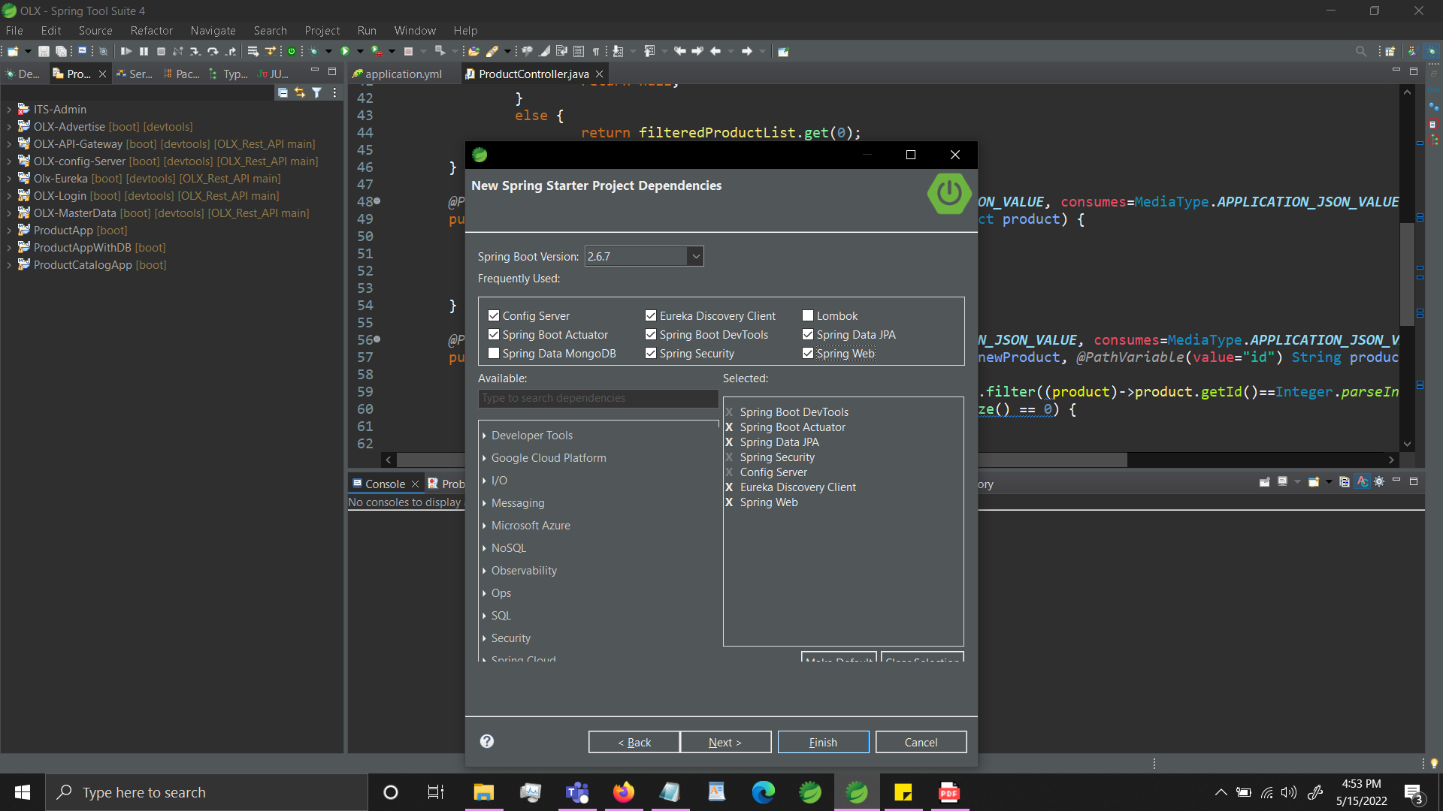

## 2. Java - Version - 8

## 3.Change pom version to 2.5.6 - which is a stable version to avoid errors

## 4.Entites

### 1.Candidates

id

Candidate Name,

Role,

PrimarySkills,

SecondarySkills,

Experience,

Qualification,

Designation,

NoticePeriod,

Location

### 2.Interview

InterviewID,

CandidateID,

Title,

TechRating,

HRRating,

FinalStatus

Remarks[optional]

### 3.Panel Members

EmployeeID,

EmpName

Role - [Type(Tech/HR),]

Location

## 5.DTO

Same as entities

### 1.Candidates

id

Candidate Name,

Role,

PrimarySkills,

SecondarySkills,

Experience,

Qualification,

Designation,

NoticePeriod,

Location

### 2.Interview

InterviewID,

CandidateID,

Title,

TechRating,

HRRating,

FinalStatus

Remarks[optional]

### 3.Panel Members

EmployeeID,

EmpName

Role - [Type(Tech/HR),]

Location