**Interactive quiz**

**Step 1:**

**Login form**

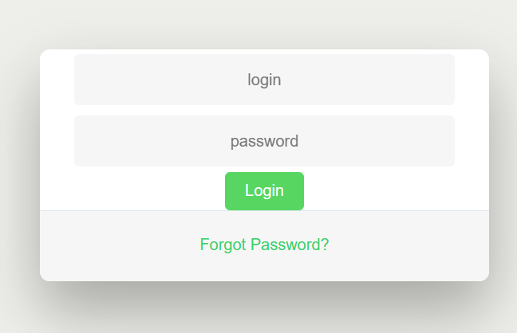

Start with login.html file Login with credentials and press on login

**Step 2:**

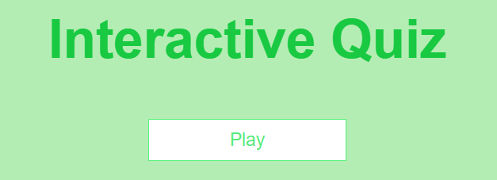

Press play button to start quiz

**Step 3:**

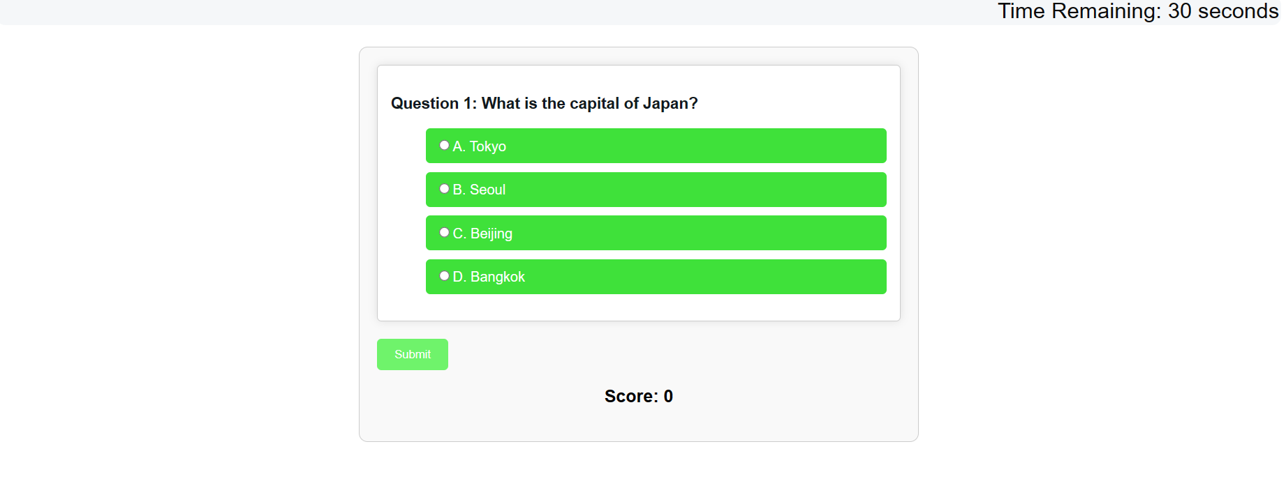

Question with options and score will be awarded for correct answers



Timmer is set for quiz, when time completed quiz will end

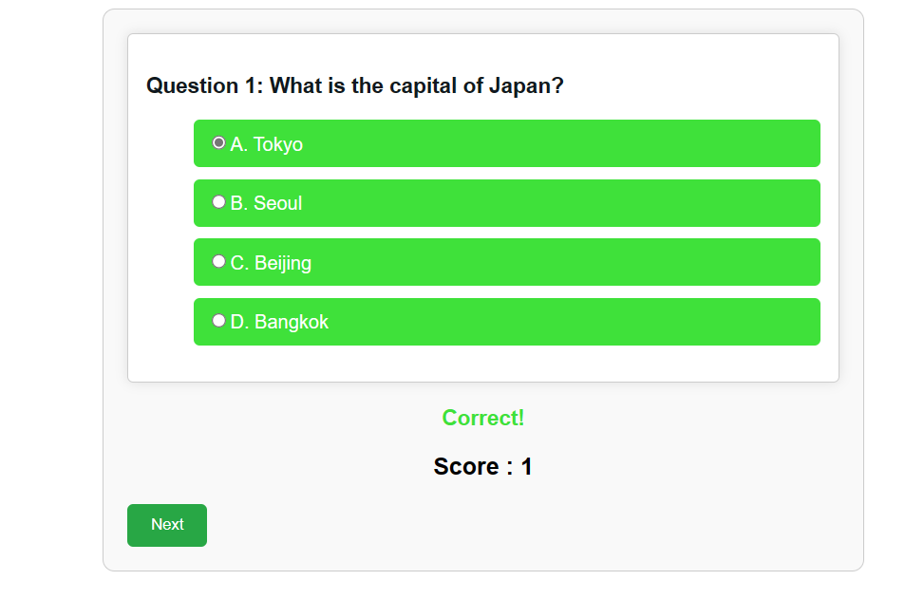

Correctly answered questions will awarded 1 point and a feedback

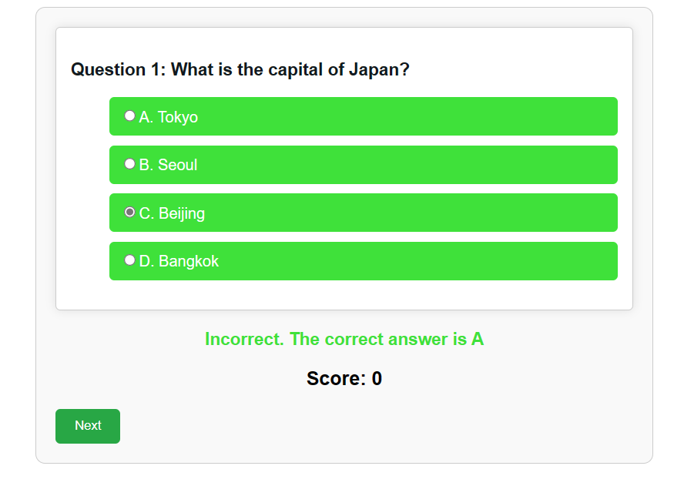

For wrong answers feedback

**Step 4:**

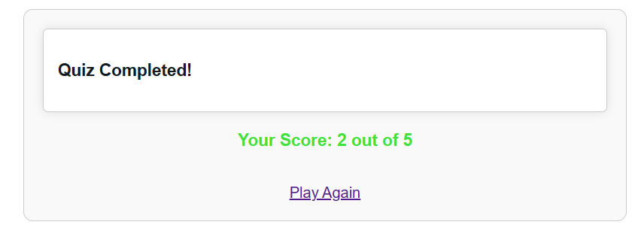

After end of quiz display of score and play again link