PROJECT-H1B
Done by RAJARATHINAM.M

What is Big Data?
Big data means really a big data, it is a collection of large datasets that cannot be processed using traditional computing techniques. Big data is not merely a data, rather it has become a complete subject, which involves various tools, technqiues and frameworks.

What Comes Under Big Data?
Big data involves the data produced by different devices and applications. Given below are some of the fields that come under the umbrella of Big Data.
- Black Box Data : It is a component of helicopter, airplanes, and jets, etc. It captures voices of the flight crew, recordings of microphones and earphones, and the performance information of the aircraft.
- Social Media Data : Social media such as Facebook and Twitter hold information and the views posted by millions of people across the globe.
- Stock Exchange Data : The stock exchange data holds information about the ‘buy’ and ‘sell’ decisions made on a share of different companies made by the customers.
- Power Grid Data : The power grid data holds information consumed by a particular node with respect to a base station.
- Transport Data : Transport data includes model, capacity, distance and availability of a vehicle.
- Search Engine Data : Search engines retrieve lots of data from different databases.

Types of Data

- Structured data : Relational data.
- Semi Structured data : XML data.
- Unstructured data : Word, PDF, Text, Media Logs.

Hadoop Architecture
Hadoop framework includes following four modules:
- Hadoop Common: These are Java libraries and utilities required by other Hadoop modules. These libraries provides filesystem and OS level abstractions and contains the necessary Java files and scripts required to start Hadoop.
- Hadoop YARN: This is a framework for job scheduling and cluster resource management.
- Hadoop Distributed File System (HDFS™): A distributed file system that provides high-throughput access to application data.
- Hadoop MapReduce: This is YARN-based system for parallel processing of large data sets.

MapReduce
Hadoop MapReduce is a software framework for easily writing applications which process big amounts of data in-parallel on large clusters (thousands of nodes) of commodity hardware in a reliable, fault-tolerant manner.
The term MapReduce actually refers to the following two different tasks that Hadoop programs perform:
- The Map Task: This is the first task, which takes input data and converts it into a set of data, where individual elements are broken down into tuples (key/value pairs).
- The Reduce Task: This task takes the output from a map task as input and combines those data tuples into a smaller set of tuples. The reduce task is always performed after the map task.
Typically both the input and the output are stored in a file-system. The framework takes care of scheduling tasks, monitoring them and re-executes the failed tasks.
The MapReduce framework consists of a single master JobTracker and one slave TaskTracker per cluster-node. The master is responsible for resource management, tracking resource consumption/availability and scheduling the jobs component tasks on the slaves, monitoring them and re-executing the failed tasks. The slaves TaskTracker execute the tasks as directed by the master and provide task-status information to the master periodically.
The JobTracker is a single point of failure for the Hadoop MapReduce service which means if JobTracker goes down, all running jobs are halted.

Hadoop Yarn:
Apache Yarn – “Yet Another Resource Negotiator” is the resource management layer of Hadoop. The Yarn was introduced in Hadoop 2.x. Yarn allows different data processing engines like graph processing, interactive processing, stream processing as well as batch processing to run and process data stored in HDFS (Hadoop Distributed File System). Apart from resource management, Yarn also does job Scheduling. Yarn extends the power of Hadoop to other evolving technologies, so they can take the advantages of HDFS (most reliable and popular storage system on the planet) and economic cluster. To learn installation of Apache Hadoop 2 with Yarn follows this quick installation guide.

Hadoop Yarn Architecture

Resource Manager (RM)
It is the master daemon of Yarn. RM manages the global assignments of resources (CPU and memory) among all the applications. It arbitrates system resources between competing applications. follow Resource Manager guide to learn Yarn Resource manager in great detail.
Resource Manager has two Main components
- Scheduler
- Application manager

a) Scheduler
The scheduler is responsible for allocating the resources to the running application. The scheduler is pure scheduler it means that it performs no monitoring no tracking for the application and even doesn’t guarantees about restarting failed tasks either due to application failure or hardware failures.

b) Application Manager
It manages running Application Masters in the cluster, i.e., it is responsible for starting application masters and for monitoring and restarting them on different nodes in case of failures.

Node Manager (NM)
It is the slave daemon of Yarn. NM is responsible for containers monitoring their resource usage and reporting the same to the ResourceManager. Manage the user process on that machine. Yarn NodeManager also tracks the health of the node on which it is running. The design also allows plugging long-running auxiliary services to the NM; these are application-specific services, specified as part of the configurations and loaded by the NM during startup. A shuffle is a typical auxiliary service by the NMs for MapReduce applications on YARN

Application Master (AM)
One application master runs per application. It negotiates resources from the resource manager and works with the node manager. It Manages the application life cycle.
The AM acquires containers from the RM’s Scheduler before contacting the corresponding NMs to start the application’s individual tasks.

What is Apache Pig?
Apache Pig is an abstraction over MapReduce. It is a tool/platform which is used to analyze larger sets of data representing them as data flows. Pig is generally used with Hadoop; we can perform all the data manipulation operations in Hadoop using Apache Pig.
To write data analysis programs, Pig provides a high-level language known as Pig Latin. This language provides various operators using which programmers can develop their own functions for reading, writing, and processing data.
To analyze data using Apache Pig, programmers need to write scripts using Pig Latin language. All these scripts are internally converted to Map and Reduce tasks. Apache Pig has a component known as Pig Engine that accepts the Pig Latin scripts as input and converts those scripts into MapReduce jobs.

Features of Pig
Apache Pig comes with the following features −
- Rich set of operators − It provides many operators to perform operations like join, sort, filer, etc.
- Ease of programming − Pig Latin is similar to SQL and it is easy to write a Pig script if you are good at SQL.
- Optimization opportunities − The tasks in Apache Pig optimize their execution automatically, so the programmers need to focus only on semantics of the language.
- Extensibility − Using the existing operators, users can develop their own functions to read, process, and write data.
- UDF’s − Pig provides the facility to create User-defined Functions in other programming languages such as Java and invoke or embed them in Pig Scripts.
- Handles all kinds of data − Apache Pig analyzes all kinds of data, both structured as well as unstructured. It stores the results in HDFS.

What is Hive
Hive is a data warehouse infrastructure tool to process structured data in Hadoop. It resides on top of Hadoop to summarize Big Data, and makes querying and analyzing easy.
Initially Hive was developed by Facebook, later the Apache Software Foundation took it up and developed it further as an open source under the name Apache Hive. It is used by different companies. For example, Amazon uses it in Amazon Elastic MapReduce.

Hive is not
- A relational database
- A design for OnLine Transaction Processing (OLTP)
- A language for real-time queries and row-level updates

Features of Hive
- It stores schema in a database and processed data into HDFS.
- It is designed for OLAP.
- It provides SQL type language for querying called HiveQL or HQL.
- It is familiar, fast, scalable, and extensible.

Sqoop:
Sqoop is a tool designed to transfer data between Hadoop and relational database servers. It is used to import data from relational databases such as MySQL, Oracle to Hadoop HDFS, and export from Hadoop file system to relational databases. It is provided by the Apache Software Foundation.

Sqoop Import
The import tool imports individual tables from RDBMS to HDFS. Each row in a table is treated as a record in HDFS. All records are stored as text data in text files or as binary data in Avro and Sequence files.

Sqoop Export
The export tool exports a set of files from HDFS back to an RDBMS. The files given as input to Sqoop contain records, which are called as rows in table. Those are read and parsed into a set of records and delimited with user-specified delimiter.

H1-B Case Study

The H1B is an employment-based, non-immigrant visa category for temporary foreign workers in the United States. For a foreign national to apply for H1B visa, an US employer must offer a job and petition for H1B visa with the US immigration department. This is the most common visa status applied for and held by international students once they complete college/ higher education (Masters, Ph.D.) and work in a full-time position.

We will be performing analysis on the H1B visa applicants between the years 2011-2015. After analyzing the data, we can derive the following facts.

1 a) Is the number of petitions with Data Engineer job title increasing over time?
b) top 5 job titles who are having highest growth in applications.

2 a) The part of the US has the most Data Engineer jobs for each year
b)Top 5 locations in the US who have got certified visa for each year.

3)Industry with the most number of Data Scientist positions?

4)Top 5 employers file the most petitions each year?

5)Popular top 10 job positions for H1B visa applications for each year?

6) Percentage and the count of each case status on total applications for each year and a graph depicting the pattern of All the cases over the period of time.

7) A bar graph to depict the number of applications for each year

8) Average Prevailing Wage for each Job for each Year (take part time and full time separate)

9)Top ten employers who have the highest success rate in petitions?

10) Top 10 job positions which have the highest success rate in petitions?

11) Exporting result for question no 10 to MySql database.

SUCCESS RATE % = (Certified + Certified Withdrawn)/Total x 100

TOOLS USED:

1)JAVA
2)MYSQL
3)HIVE
4)SQOOP
5)PIG
SOLUTIONS

1 a) Is the number of petitions with Data Engineer job title increasing over time?

PIGSCRIPT:

A = load '/home/rajamv9497/project/inputfile/Q1a' using PigStorage(',') as (s_no:int,case_status:chararray,employer_name:chararray,soc_name:chararray,job_title:chararray,full_time_position:chararray,prevailing_wage:int,year:chararray, worksite:chararray,longitute:double,latitute:double);

A1 = filter A by job_title == 'DATA ENGINEER';
A2 = group A1 by year;
A3 = foreach A2 generate group as A2,COUNT(A1.job_title);
dump A3;

OUPUT
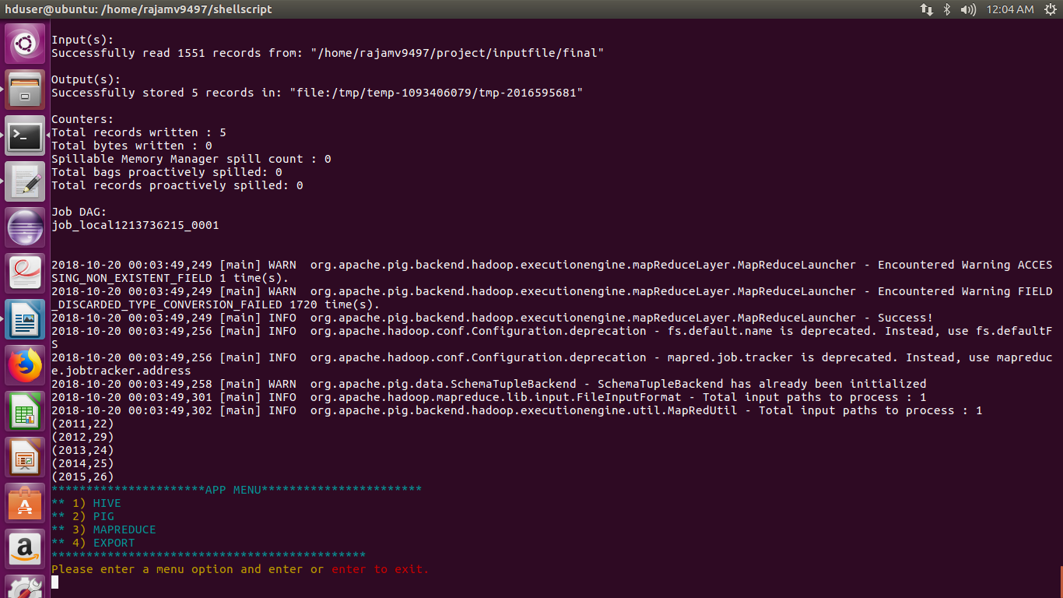

b) Find top 5 job titles who are having highest growth in applications.

PIGSCRIPT:
A = load '/home/rajamv9497/project/inputfile/Q1b' using PigStorage(',') as (s_no:int,case_status:chararray,employer_name:chararray,soc_name:chararray,job_title:chararray,full_time_position:chararray,prevailing_wage:int,year:chararray, worksite:chararray,workstate:chararray,longitute:double,latitute:double);

A1 = group A by (year,job_title);
A2 = foreach A1 generate group.year,group,COUNT(A.case_status) as counts;
A3 = group A2 by year;
A4 = foreach A3 {
A5 = order A2 by counts desc;
A6 = limit A5 5;
generate flatten(A6);
};
A7 = foreach A4 generate flatten(group),counts;
dump A7;

OUPUT

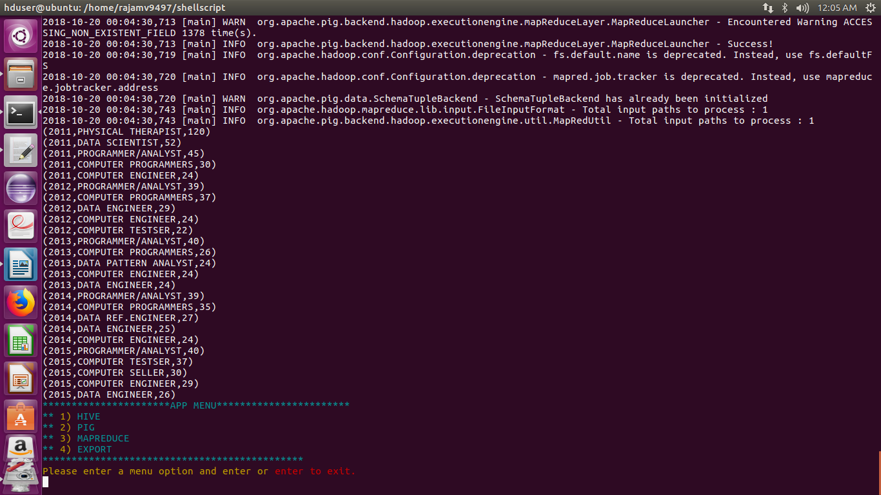

2 a) Which part of the US has the most Data Engineer jobs for each year?

PIGSCRIPT:
A = load '/home/rajamv9497/project/inputfile/Q2a' using PigStorage(',') as (s_no:int,case_status:chararray,employer_name:chararray,soc_name:chararray,job_title:chararray,full_time_position:chararray,prevailing_wage:int,year:chararray, worksite:chararray,workstate:chararray,longitute:double,latitute:double);

A1 = filter A by case_status == 'CERTIFIED';
A2 = group A1 by (workstate,year);
A3 = foreach A2 generate group.year,group,COUNT(A1.case_status) as counts;
A4 = group A3 by year;
A5 = foreach A4 {
A6 = order A3 by counts desc;
A7 = limit A6 5;
generate flatten(A7);
};
A8 = foreach A5 generate flatten(group),counts;
dump A8;

OUPUT
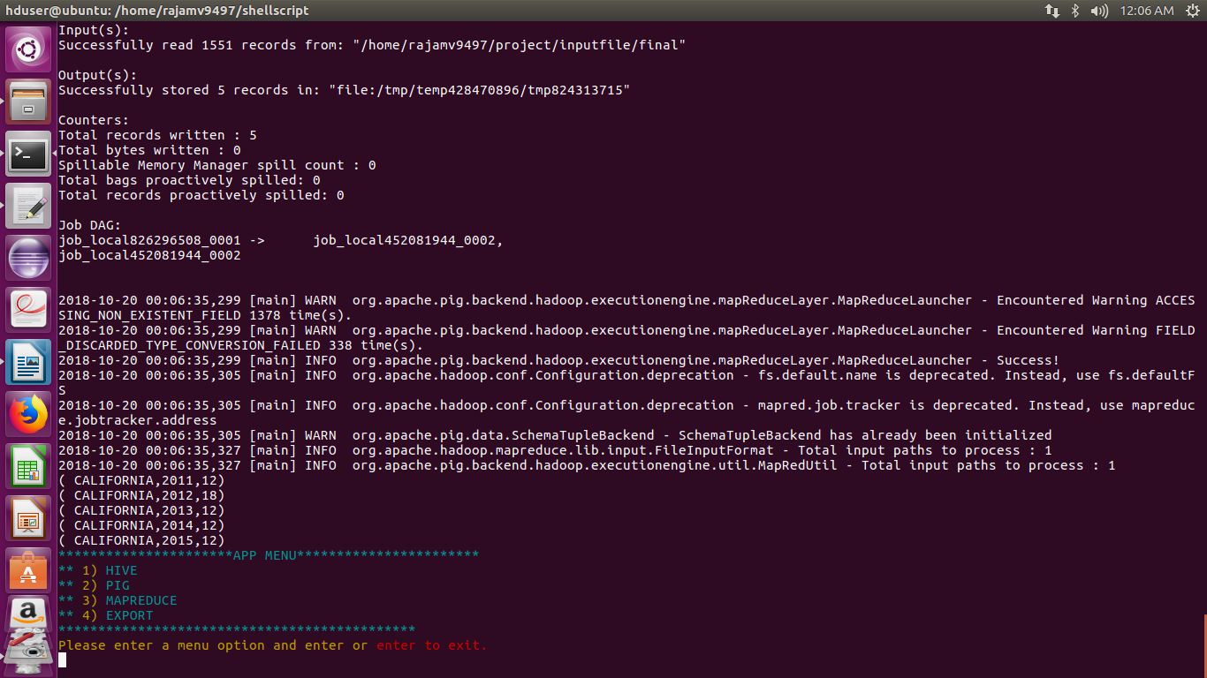

b) find top 5 locations in the US who have got certified visa for each year.

PIGSCRIPT:

A = load '/home/rajamv9497/project/inputfile/Q2b' using PigStorage(',') as (s_no:int,case_status:chararray,employer_name:chararray,soc_name:chararray,job_title:chararray,full_time_position:chararray,prevailing_wage:int,year:chararray, worksite:chararray,workstate:chararray,longitute:double,latitute:double);

A1 = filter A by job_title == 'DATA ENGINEER';
A2 = group A1 by (workstate,year);
A3 = foreach A2 generate group.year,group,COUNT(A1.job_title) as counts;
A4 = group A3 by year;
A5 = foreach A4 {
A6 = order A3 by counts desc;
A7 = limit A6 1;
generate flatten(A7);
};
A8 = foreach A5 generate flatten(group),counts;
dump A8;

OUPUT
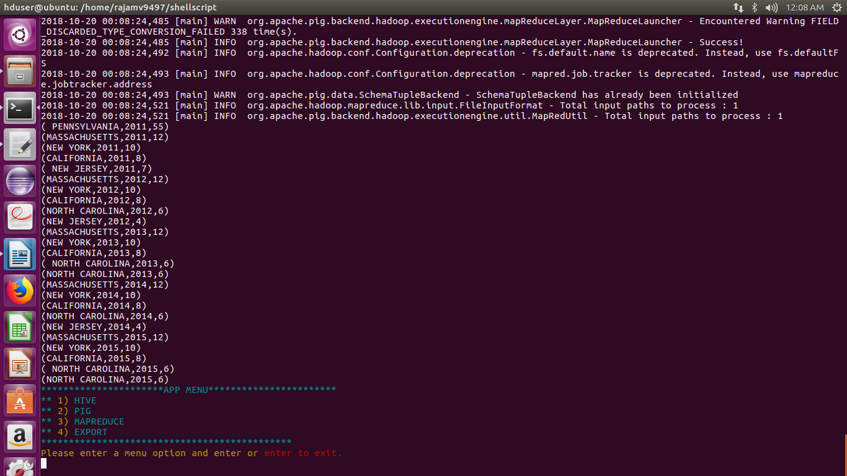

3)Which industry has the most number of Data Scientist positions?

PROGRAM:

import java.io.IOException;
import java.util.TreeMap;
import org.apache.hadoop.conf.Configuration;
import org.apache.hadoop.fs.Path;
import org.apache.hadoop.io.LongWritable;
import org.apache.hadoop.io.NullWritable;
import org.apache.hadoop.io.Text;
import org.apache.hadoop.mapreduce.Job;
import org.apache.hadoop.mapreduce.Mapper;
import org.apache.hadoop.mapreduce.Reducer;
import org.apache.hadoop.mapreduce.lib.input.FileInputFormat;
import org.apache.hadoop.mapreduce.lib.output.FileOutputFormat;

public class question3 {
public static class question3Mapper extends
Mapper<LongWritable, Text, Text, Text> {
public void map(LongWritable key, Text value, Context context
) throws IOException, InterruptedException {
try {
String[] str = value.toString().split(",");
String cname= str[2];
String position= str[4];
if(str[4].equals("DATA SCIENTIST"))
context.write(new Text(cname),new Text(position));

}
catch(Exception e)
{
System.out.println(e.getMessage());
}
}
}

public static class question3Reducer extends
Reducer<Text, Text, NullWritable, Text> {
private TreeMap<Long, Text> repToRecordMap = new TreeMap<Long, Text>();

public void reduce(Text key, Iterable<Text> values,
Context context) throws IOException, InterruptedException {
long count=0;
String myvalue= "";
String mysum= "";
for (Text val : values) {
count++;
}
myvalue= key.toString();
mysum= String.format("%d", count);
myvalue= myvalue + ',' + mysum;
repToRecordMap.put(new Long(count), new Text(myvalue));
if (repToRecordMap.size() > 1) {
repToRecordMap.remove(repToRecordMap.firstKey());
}
}

protected void cleanup(Context context) throws IOException,
InterruptedException {
for (Text t : repToRecordMap.values()) {
// Output our five records to the file system with a null key
context.write(NullWritable.get(), t);
}
}

}

public static void main(String[] args) throws Exception {

Configuration conf = new Configuration();
Job job = Job.getInstance(conf, "Top record for largest amount spent");
job.setJarByClass(question3.class);
job.setMapperClass(question3Mapper.class);
job.setReducerClass(question3Reducer.class);
job.setMapOutputKeyClass(Text.class);
job.setMapOutputValueClass(Text.class);
job.setOutputKeyClass(NullWritable.class);
job.setOutputValueClass(Text.class);
FileInputFormat.addInputPath(job, new Path(args[0]));
FileOutputFormat.setOutputPath(job, new Path(args[1]));
System.exit(job.waitForCompletion(true) ? 0 : 1);
}
}

OUTPUT
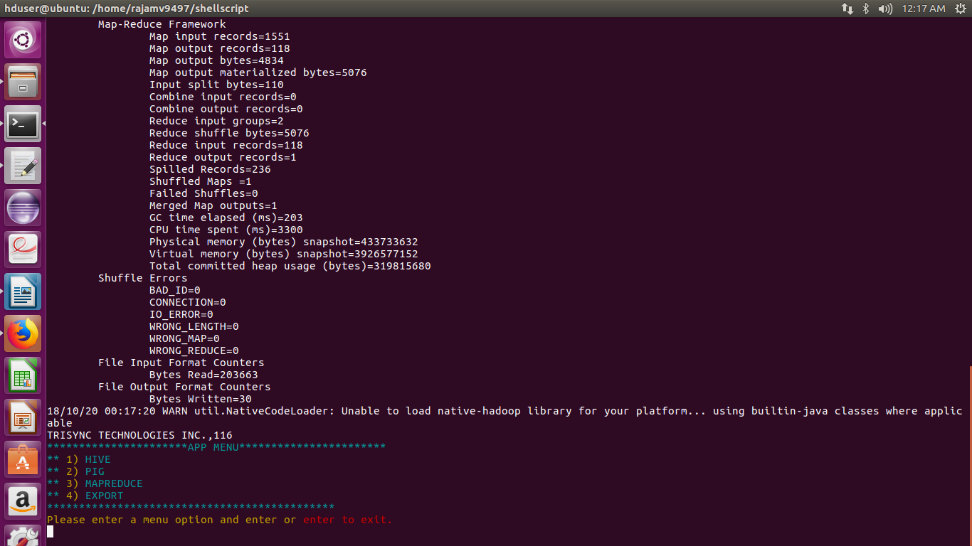

4)Which top 5 employers file the most petitions each year?

PROGRAM:
import java.io.*;
import java.util.TreeMap;

import org.apache.hadoop.io.*;
import org.apache.hadoop.mapreduce.*;
import org.apache.hadoop.conf.*;

import org.apache.hadoop.fs.*;

import org.apache.hadoop.mapreduce.Reducer.Context;
import org.apache.hadoop.mapreduce.lib.input.*;
import org.apache.hadoop.mapreduce.lib.output.*;

import org.apache.hadoop.util.*;

public class question4 extends Configured implements Tool
{
//Map class

public static class MapClass extends Mapper<LongWritable,Text,Text,Text>
{
public void map(LongWritable key, Text value, Context context)
{
try{
String[] str = value.toString().split(",");

String status=str[1];
String cname=str[2];
String year=str[7];
String myrow = cname+","+status+","+year;
context.write(new Text(cname), new Text(myrow));
}
catch(Exception e)
{
System.out.println(e.getMessage());
}
}
}

//Reducer class

public static class ReduceClass extends Reducer<Text,Text,NullWritable,Text>
{
private TreeMap<Long, Text> repToRecordMap = new TreeMap<Long, Text>();

public void reduce(Text key, Iterable <Text> values, Context context) throws IOException, InterruptedException
{
long count=0;
String myvalue= "";
String mycount= "";
String my="";
for(Text i:values)
{
count++;
my=i.toString();
}
mycount=String.format("%d",count);
myvalue=my+","+mycount;
repToRecordMap.put(new Long(count), new Text(myvalue));
if (repToRecordMap.size() > 5) {
repToRecordMap.remove(repToRecordMap.firstKey());
}
//context.write(key, new IntWritable(count));

}
protected void cleanup(Context context) throws IOException,
InterruptedException {
for (Text t : repToRecordMap.values()) {
// Output our five records to the file system with a null key
context.write(NullWritable.get(), t);
}
}

}

//Partitioner class

public static class CaderPartitioner extends
Partitioner < Text, Text >
{
@Override
public int getPartition(Text key, Text value, int numReduceTasks)
{
String[] str = value.toString().split(",");
if((Integer.parseInt(str[2]))==2011)
{
return 0;
}
else if((Integer.parseInt(str[2]))==2012)
{
return 1;
}
else if((Integer.parseInt(str[2]))==2013)
{
return 2;
}
else if((Integer.parseInt(str[2]))==2014)
{
return 3;
}
else
{
return 4;
}

}

}

public int run(String[] arg) throws Exception
{

Configuration conf = new Configuration();
Job job = Job.getInstance(conf);
job.setJarByClass(question4.class);
job.setJobName("Year Wise top 5 employer details");
FileInputFormat.setInputPaths(job, new Path(arg[0]));
FileOutputFormat.setOutputPath(job,new Path(arg[1]));

job.setMapperClass(MapClass.class);

job.setMapOutputKeyClass(Text.class);
job.setMapOutputValueClass(Text.class);

//set partitioner statement

job.setPartitionerClass(CaderPartitioner.class);
job.setReducerClass(ReduceClass.class);
job.setNumReduceTasks(5);
job.setInputFormatClass(TextInputFormat.class);

job.setOutputFormatClass(TextOutputFormat.class);
job.setOutputKeyClass(NullWritable.class);
job.setOutputValueClass(Text.class);

System.exit(job.waitForCompletion(true)? 0 : 1);
return 0;
}

public static void main(String ar[]) throws Exception
{
ToolRunner.run(new Configuration(), new question4(),ar);
System.exit(0);
}
}

OUTPUT
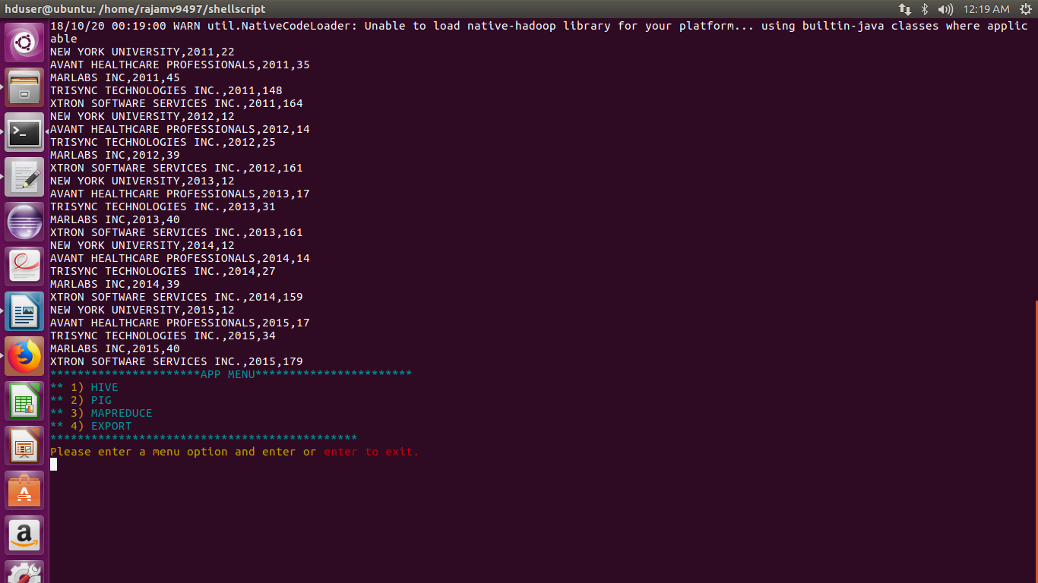

5)Find the most popular top 10 job positions for H1B visa applications for each year?

PROGRAM:
import java.io.IOException;
import java.util.TreeMap;
import org.apache.hadoop.conf.Configuration;
import org.apache.hadoop.fs.Path;
import org.apache.hadoop.io.LongWritable;
import org.apache.hadoop.io.NullWritable;
import org.apache.hadoop.io.Text;
import org.apache.hadoop.mapreduce.Job;
import org.apache.hadoop.mapreduce.Mapper;
import org.apache.hadoop.mapreduce.Partitioner;
import org.apache.hadoop.mapreduce.Reducer;
import org.apache.hadoop.mapreduce.lib.input.FileInputFormat;
import org.apache.hadoop.mapreduce.lib.output.FileOutputFormat;

public class question5 {
public static class question3Mapper extends
Mapper<LongWritable, Text, Text, Text > {
public void map(LongWritable key, Text value, Context context
) throws IOException, InterruptedException {
try {
String[] str = value.toString().split(",");
String position= str[4];
String year = str[7];
context.write(new Text(position),new Text(year));

}
catch(Exception e)
{
System.out.println(e.getMessage());
}
}
}

public static class question3Reducer extends
Reducer<Text, Text, NullWritable, Text> {
private TreeMap<Long, Text> repToRecordMap = new TreeMap<Long, Text>();

public void reduce(Text key, Iterable<Text> values,
Context context) throws IOException, InterruptedException {
long count=0;
String myvalue= "";
String mysum= "";
String value="";
for (Text val : values) {
count++;
value=val.toString();
}
myvalue= key.toString();
mysum= String.format("%d", count);
myvalue= myvalue + ',' + mysum + ',' +value;
repToRecordMap.put(new Long(count), new Text(myvalue));
if (repToRecordMap.size() > 10) {
repToRecordMap.remove(repToRecordMap.firstKey());
}
}

protected void cleanup(Context context) throws IOException,
InterruptedException {
for (Text t : repToRecordMap.values()) {
// Output our five records to the file system with a null key
context.write(NullWritable.get(), t);
}
}

}

public static class CaderPartitioner extends
Partitioner < Text, Text >
{
@Override
public int getPartition(Text key, Text value, int numReduceTasks)
{
String a=value.toString();
if(a.equals("2011"))
{
return 0;
}
else if(a.equals("2012"))
{
return 1;
}
else if(a.equals("2013"))
{
return 2;
}
else if(a.equals("2014"))
{
return 3;
}
else
{
return 4;
}

}

}

public static void main(String[] args) throws Exception {

Configuration conf = new Configuration();
Job job = Job.getInstance(conf, "Top record for largest amount spent");
job.setJarByClass(question5.class);
job.setMapperClass(question3Mapper.class);
job.setReducerClass(question3Reducer.class);
job.setMapOutputKeyClass(Text.class);
job.setMapOutputValueClass(Text.class);
job.setPartitionerClass(CaderPartitioner.class);
job.setNumReduceTasks(5);
job.setOutputKeyClass(NullWritable.class);
job.setOutputValueClass(Text.class);
FileInputFormat.addInputPath(job, new Path(args[0]));
FileOutputFormat.setOutputPath(job, new Path(args[1]));
System.exit(job.waitForCompletion(true) ? 0 : 1);
}
}

OUTPUT
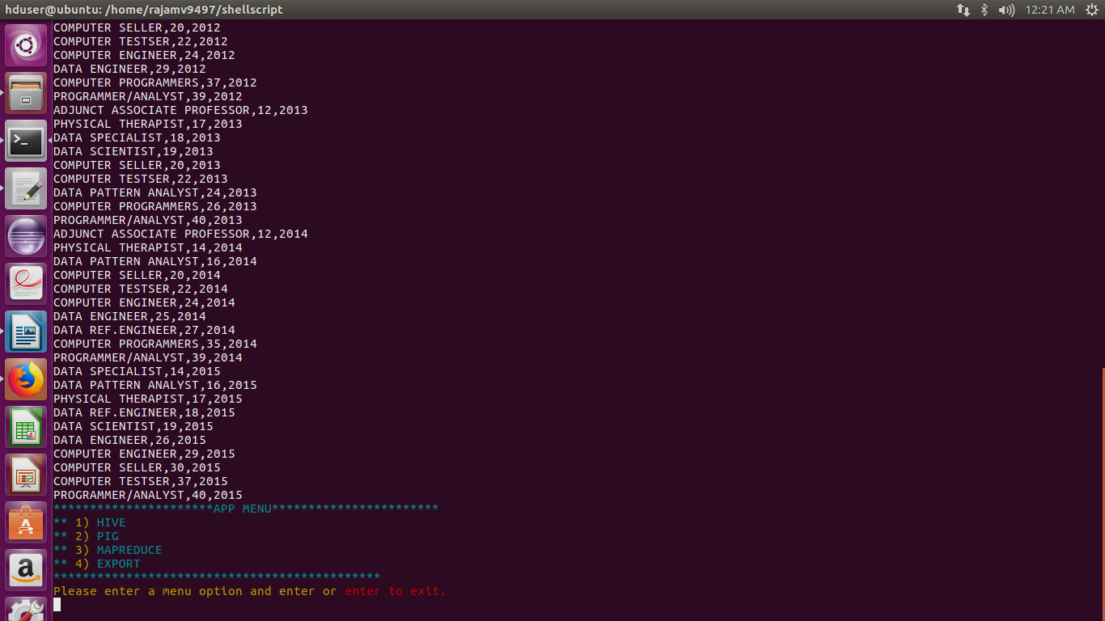

6) Find the percentage and the count of each case status on total applications for each year. Create a graph depicting the pattern of All the cases over the period of time.

PROGRAM:
import java.io.*;
import java.util.TreeMap;

import org.apache.hadoop.io.*;
import org.apache.hadoop.mapreduce.*;
import org.apache.hadoop.conf.*;

import org.apache.hadoop.fs.*;

import org.apache.hadoop.mapreduce.Reducer.Context;
import org.apache.hadoop.mapreduce.lib.input.*;
import org.apache.hadoop.mapreduce.lib.output.*;

import org.apache.hadoop.util.*;

public class question6 extends Configured implements Tool
{
//Map class

public static class MapClass extends Mapper<LongWritable,Text,Text,Text>
{
public void map(LongWritable key, Text value, Context context)
{
try{
String[] str = value.toString().split(",");

String status=str[1];
String year=str[7];
context.write(new Text(status), new Text(year));
}
catch(Exception e)
{
System.out.println(e.getMessage());
}
}
}

//Reducer class

public static class ReduceClass extends Reducer<Text,Text,Text,Text>
{

public void reduce(Text key, Iterable<Text> values, Context context) throws IOException, InterruptedException
{
int count1=50;
int count=0;
String years ="";
for(Text i:values)
{
count++;
years = i.toString();
}

float res = (float)count/(float)count1;
String op = String.format("%d,%f",count,res);
context.write(key,new Text(years+","+op));

}

}

//Partitioner class

public static class CaderPartitioner extends
Partitioner < Text, Text >
{
@Override
public int getPartition(Text key, Text value, int numReduceTasks)
{
String a=value.toString();
if(a.equals("2011"))
{
return 0;
}
else if(a.equals("2012"))
{
return 1;
}
else if(a.equals("2013"))
{
return 2;
}
else if(a.equals("2014"))
{
return 3;
}
else
{
return 4;
}

}

}

public int run(String[] arg) throws Exception
{

Configuration conf = new Configuration();
Job job = Job.getInstance(conf);
job.setJarByClass(question6.class);
job.setJobName("Case status percentage yearwise");
FileInputFormat.setInputPaths(job, new Path(arg[0]));
FileOutputFormat.setOutputPath(job,new Path(arg[1]));

job.setMapperClass(MapClass.class);

job.setMapOutputKeyClass(Text.class);
job.setMapOutputValueClass(Text.class);

//set partitioner statement

job.setPartitionerClass(CaderPartitioner.class);
job.setReducerClass(ReduceClass.class);
job.setNumReduceTasks(5);
job.setInputFormatClass(TextInputFormat.class);

job.setOutputFormatClass(TextOutputFormat.class);
job.setOutputKeyClass(Text.class);
job.setOutputValueClass(Text.class);

System.exit(job.waitForCompletion(true)? 0 : 1);
return 0;
}

public static void main(String ar[]) throws Exception
{
ToolRunner.run(new Configuration(), new question6(),ar);
System.exit(0);
}
}

OUTPUT

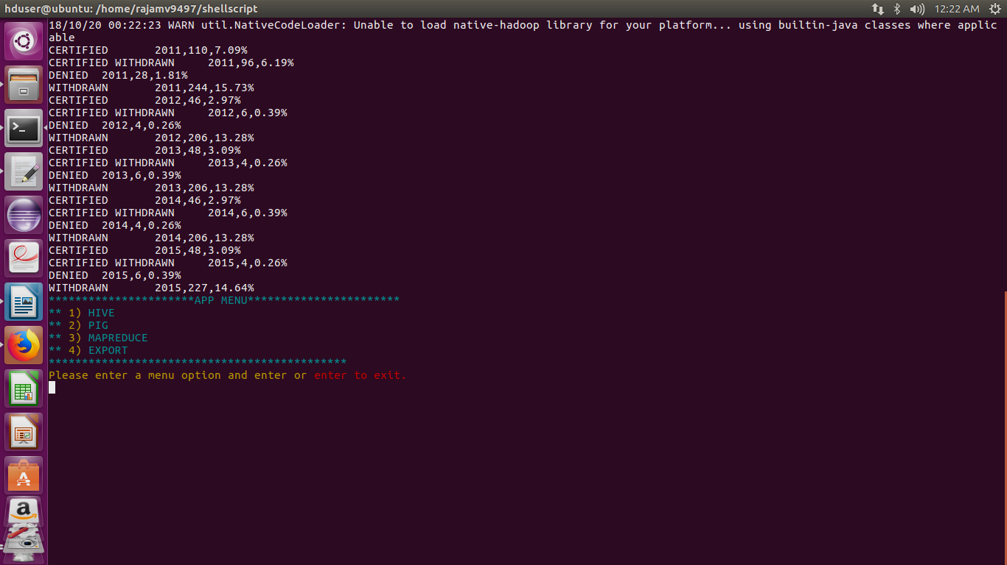

7) Create a bar graph to depict the number of applications for each year

HIVE QUERY:

select count(case_status),year from Q7 group by year;

OUTPUT
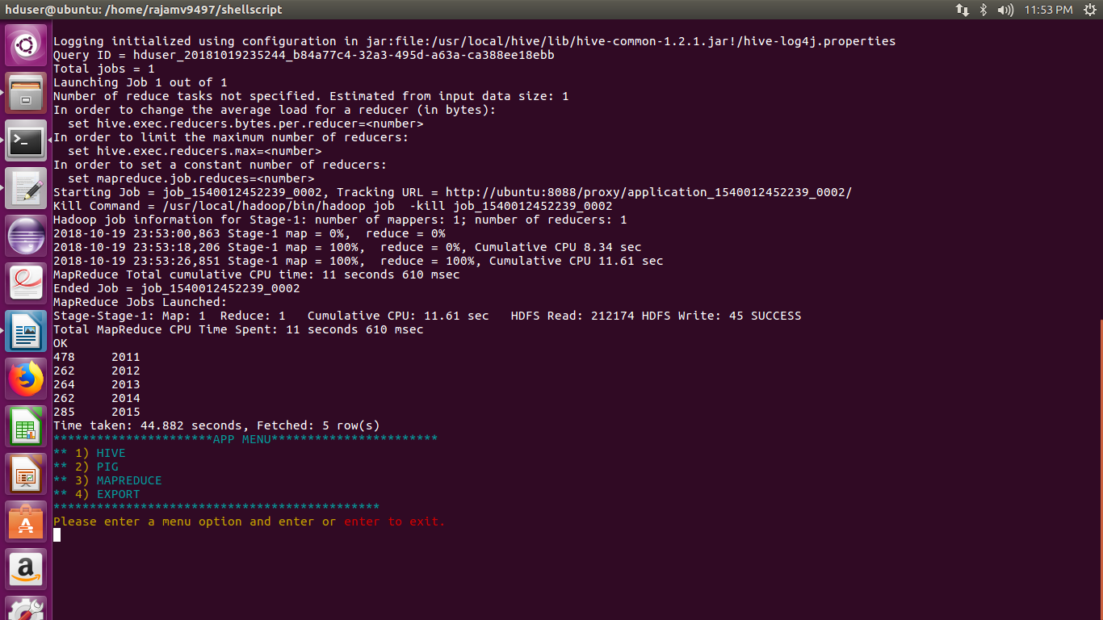

8) Find the average Prevailing Wage for each Job for each Year (take part time and full time separate)

HIVE QUERY:

select job_title,avg(prevailing_wage),year,full_time_position from Q8 group by job_title,year,full_time_position sort by year;

OUTPUT
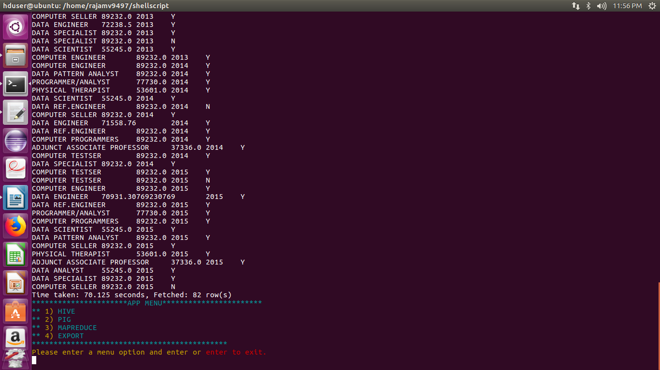

9) Which are top ten employers who have the highest success rate in petitions?

HIVE QUERY:

select employer_name,round((count(case_status)/99),2) as counts from Q9 where case_status="CERTIFIED" or case_status="CERTIFIED WITHDRAWN" group by employer_name order by counts desc limit 10;

OUTPUT

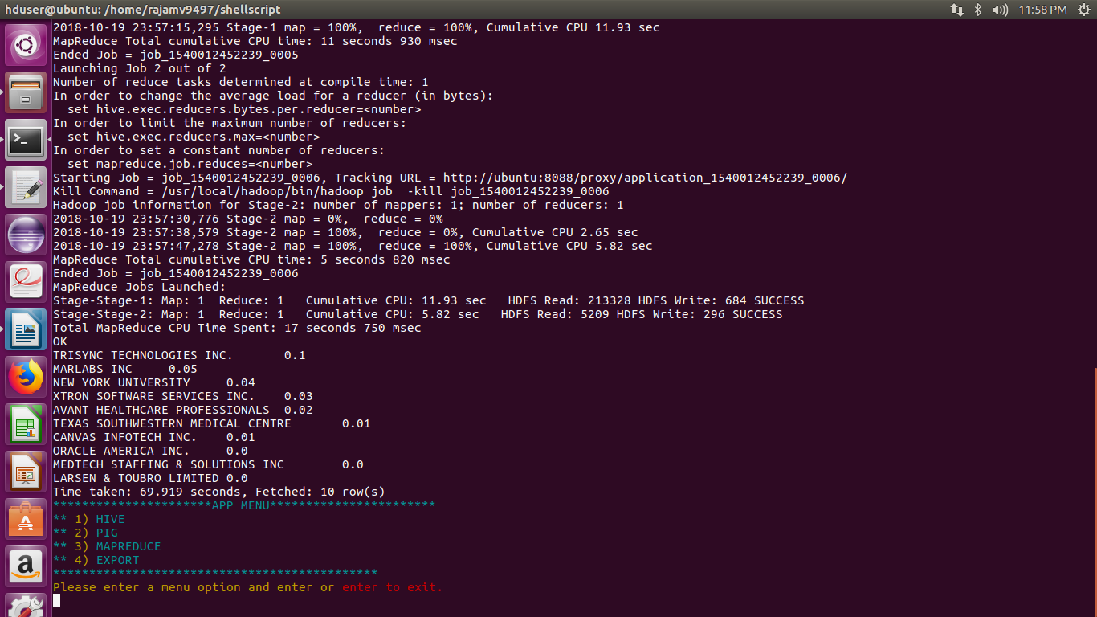

10) Which are the top 10 job positions which have the highest success rate in petitions?

HIVE QUERY:

select job_title,round((count(case_status)/99),2) as counts from Q10 where case_status="CERTIFIED" or case_status="CERTIFIED WITHDRAWN" group by job_title order by counts desc limit 10;

OUTPUT

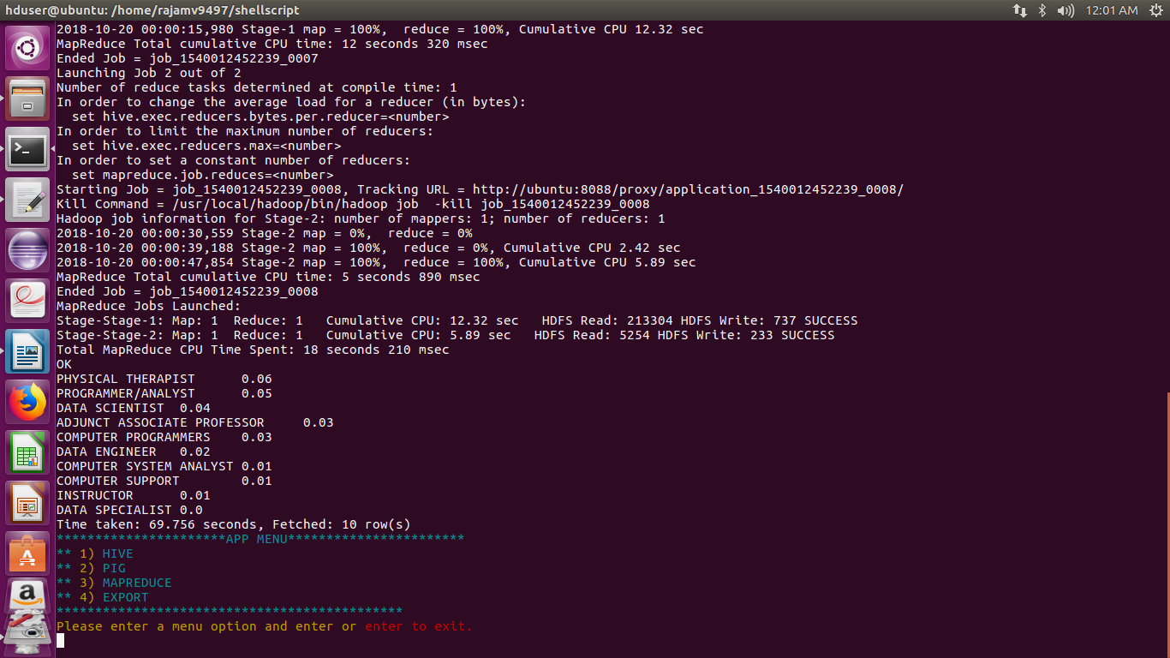

11) Export result for question no 10 to MySql database.

SQOOP:

hive -e "insert overwrite directory '/hanoid1'row format delimited fields terminated by ',' select job_title,round((count(case_status)/99),2) as counts from niit.Q10 where case_status='CERTIFIED' or case_status='CERTIFIED WITHDRAWN' group by job_title order by counts desc limit 10;"

sqoop export --connect jdbc:mysql://localhost/college --username root --password 'root' --table h1b1 --export-dir /hanoid1/000000_0 --input-fields-terminated-by ',' ;

mysql -u root -p -D college -e "select * from h1b1 order by perc desc"

OUTPUT

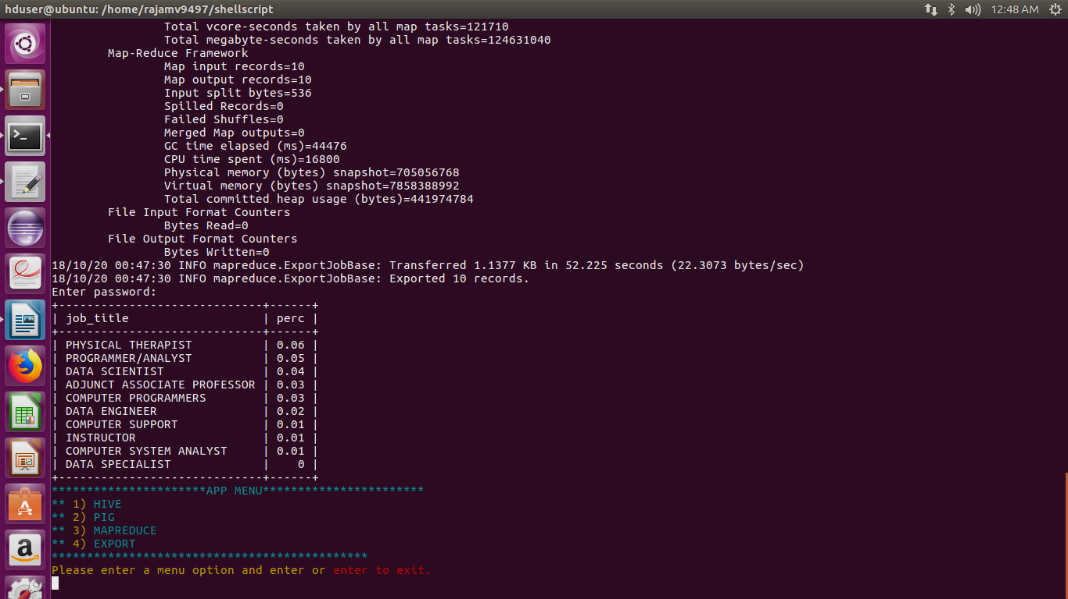

CONCLUSION

H1B application file has been studied clearly and analyzed using apache pig,mapreduce,hive,sqoop
and flume.The code along with the result is attached with this document for future references.

