FWD HK (Agency Enquiry System (AES)) - WEB Penetration Testing Report
Report Release Date: 11/4/2024
CONFIDENTIAL


Document Control

Document Distribution

Table of Contents

Introduction

Terms of Use
This report is being provided to seclance as a deliverable of the Vulnerability Assessment and Penetration Testing engagement. The purpose of this report is to provide our findings and recommendations derived from the assessment on the in-scope application (point in time) during the engagement.

Objective
company12 performed a security assessment to identify security issues and vulnerabilities in FWD HK (Agency Enquiry System (AES)) WEB application. The results are then compared to industry leading standards and highlighted, and the gap between the current state and the desired secure Web application standards are highlighted.
The objectives of this assessment were:
- To identify technical as well as logical vulnerabilities/weakness in the application and provide recommendation for risk mitigation
- To discover whether an adversary can leverage flaws in the application to compromise the confidentiality, integrity and availability of the information
- To help the development team to understand the status of their application security standards to develop an action plan to minimize the threat of an attack

Scope of Work
Testing was conducted 24th april. The assessment activity was conducted on FWD provided scope on the following web application:
Target URL:
- https://uathome.fwd.com.hk/AESNETU105/SuperUser.aspx

Limitations
- Egs Team has excluded Denial of Service attacks/Distributed Denial of Services attacks test cases that may potentially disrupt the business
- Egs Team has excluded methods that could potentially modify integrity of FWD data on the systems such as DELETE/MODIFY etc.
- Phishing attempts to exploit vulnerabilities are out of scope
- During the pen test, unauthenticated and authenticated scanning activities were performed on in-scope URL only
- Egs team has performed scan and manual tests to application which was accessible on Egs whitelisted IP(s) during test schedule. Refer to the scope of work section
- Penetration testing was performed during the scheduled testing window
- Penetration testing was restricted to provided URL or end point in scope, but sub-domain & its sub directories were not included in the test

Company Information
Seclance International Ltd is the world's largest cyber security certification body to offer quality comprehensive professional & managed cyber security services to enterprises in Malaysia and international markets through its owned subsidiaries via Seclance Global Services Sdn Bhd (ECCGS/EGS). This enabled that the EGS team to have access to globally acclaimed License Penetration Tester / Certified Ethical Hacker methodology which are currently endorsed by the Department of Defense of the United States of America under the DOD8570 Directive and mapped to the National Institute of Standards and Technology (NIST) cybersecurity framework.

Testing Framework
The OWASP Testing Framework is used during the penetration testing of this web application.

Type of Assessment
The type of the assessment activity for this web application is:
- any Web Application Security Assessment

Executive Summary

Key Observations
company12 carried out WEB penetration testing exercise to assess the security posture of the externally facing web application. The scope of the testing included the testing of 1 URL using a combination of manual and automated testing techniques. The testing was performed over a period of 1 week.
During the testing, several vulnerabilities were identified, including 1 High and 1 Medium. The high-severity vulnerabilities included and Error-based SQL injection. The medium-severity vulnerabilities included and Basic HTTP authentication enabled .
The report provides detailed information on each vulnerability, including the potential impact and recommended remediation steps. The report also includes an overall assessment of the security posture of the FWD externally facing web application, along with recommendations for ongoing security improvements.
Based on the findings of the penetration testing, it is recommended that the organization implement ongoing vulnerability scanning and penetration testing to ensure that the security posture of the externally facing web application is regularly assessed and improved.
No. of vulnerabilities identified:
Critical | High | Medium | Low | Informational
0 | 1 | 1 | 0 | 0
List of vulnerabilities identified:
Severity | Title | Vulnerability class | Status
High | Error-based SQL injection | A03 – Injection | close
Medium | Basic HTTP authentication enabled | A02 – Identification and Authentication failures | open

Analysis of Overall Findings
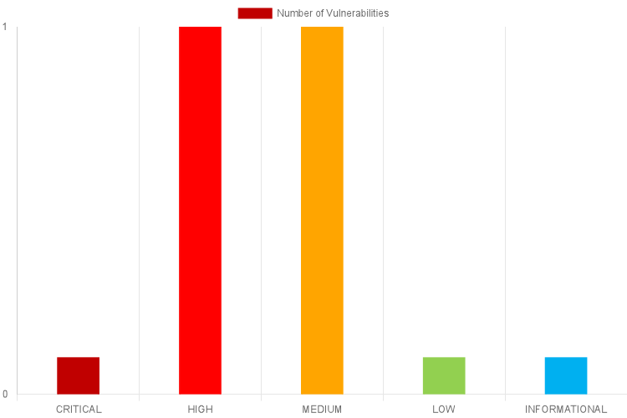

Finding Details

Error-based SQL injection
Risk Level | High
Vulnerability class | A03 – Injection
Status | Open
Vulnerability ID | XXXXX-X-XX-XX
CVSS v3.1 rating | 7.1
CVSS v3.1 Vectors | AV:N/AC:L/PR:L/UI:N/S:U/C:H/I:L/A:N

Description
Error-based SQLi is an in-band SQL injection technique that relies on error messages thrown by the database server to obtain information about the structure of the database. In some cases, error-based SQL injection alone is enough for an attacker to enumerate an entire database. While errors
are very useful during the development phase of a web application, they should be disabled on a live site, or logged to a file with restricted access instead.
It was observed that the API endpoint is vulnerable to error based SQLi where API responded with detailed error messages that included the SQL statements.

Impact
An error-based SQL injection vulnerability poses a significant security risk to the application. An adversary can use this information to gather knowledge about the underlying database schema, table names, column names, and potentially sensitive data.

Affected URL
https://uat-memberchoice.eb.fwd.com.hk/pccw/login/hr

Remediation
It is recommended to
It is recommended to
- Use parameterized queries or prepared statements with proper validation to prevent SQL injection. Avoid directly inserting user inputs into queries without sanitization
- Ensure that error messages shown to users or logged internally don&#39;t reveal database details or specific SQL queries
References:
https://owasp.org/Top10/A03_2021-Injection/
https://owasp.org/www-community/attacks/SQL_Injection

Proof of Concept
Steps to reproduce the finding:
Step 1: Access the affected application "https://uatmemberchoice.eb.fwd.com.hk/pccw/login/hr"
and log in with a valid credentials. Navigate to the "HR APPROVAL" section by clicking "View HR Approval" button.
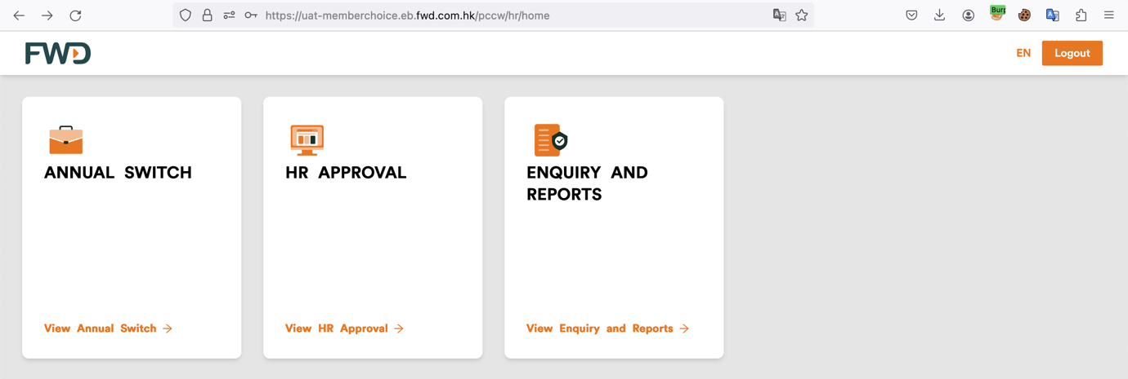
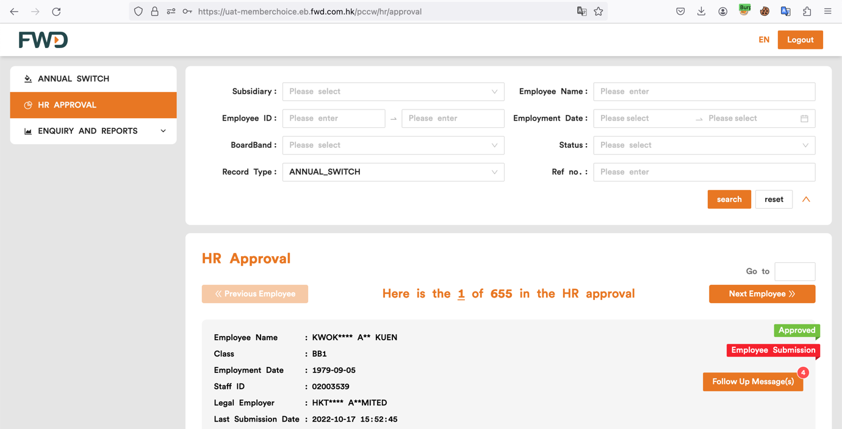
Step 2: Click on Next Employee. Intercept the request using proxy tools such as burp suite and send it to the repeater.
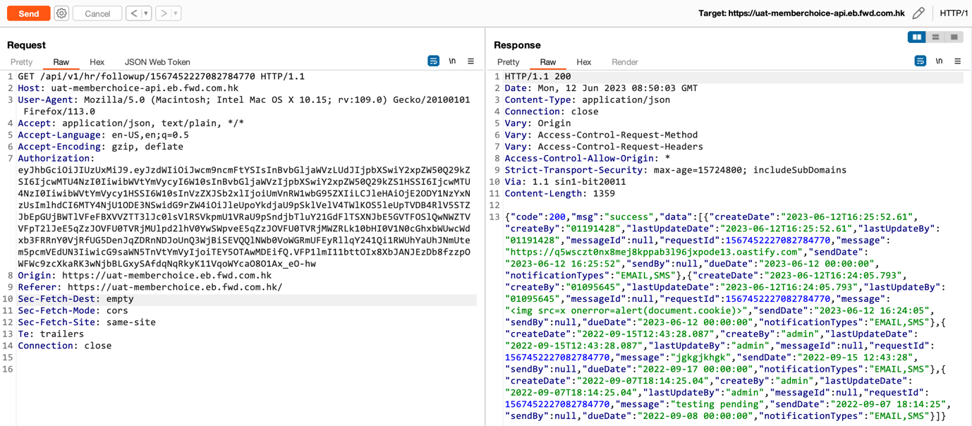
Step 3: Add "’" (quotation) in the path and observe that the application responds with SQL error response revealing affected java file, classes and specific SQL statements.
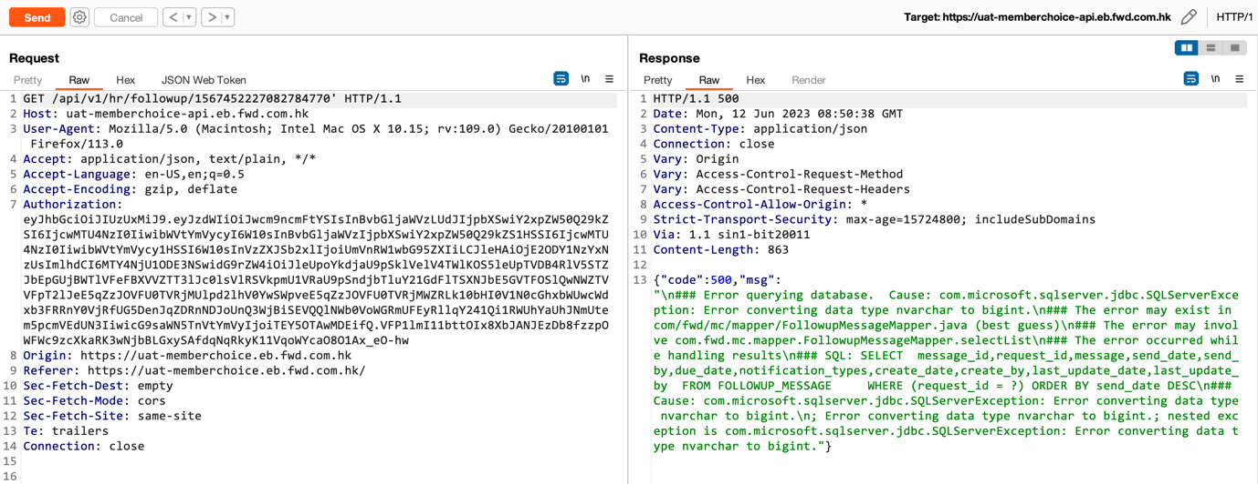

Basic HTTP authentication enabled
Risk Level | Medium
Vulnerability class | A02 – Identification and Authentication failures
Status | Open
Vulnerability ID | XXXXX-X-XX-XX
CVSS v3.1 rating | 4
CVSS v3.1 Vectors | AV:A/AC:H/PR:H/UI:R/S:U/C:H/I:N/A:N

Description
Basic HTTP authentication is a method used by web servers to restrict access to specific resources. It prompts the user for a username and password, which are then sent as a base64-encoded string in the HTTP Authorization header. The server then decodes and verifies the credentials before allowing access to the protected resource.
It was observed that the server is using basic HTTP authentication, which involves sending the user's credentials (i.e., username and password) in plain text, encoded with base64.

Impact
The use of basic HTTP authentication with base64 encoding can have a significant impact on the security of a web application or server. Since basic authentication does not provide any encryption or hashing of the user's credentials, an adversary who intercepts the HTTP request can easily obtain the username and password and use them to gain unauthorized access to the web application or other resources on the server. This can lead to a wide range of security breaches, including theft of sensitive information, modification or deletion of data, and unauthorized access to privileged resources or functions.

Affected URL
https://uathome.fwd.com.hk/AESNETU105/SuperUser.aspx

Remediation
It is recommended to
It is recommended to use stronger authentication mechanisms, such as Digest authentication, OAuth, or JSON Web Tokens (JWT). These methods provide better security by using encryption, stronger credential storage techniques, and additional security features.
References:
https://owasp.org/Top10/A07_2021-Identification_and_Authentication_Failures/
https://technet.microsoft.com/en-us/library/cc780170(v=ws.10).aspx

Proof of Concept
Steps to reproduce the finding:
Step 1: Browse the affected URL. Login with the valid credentials.
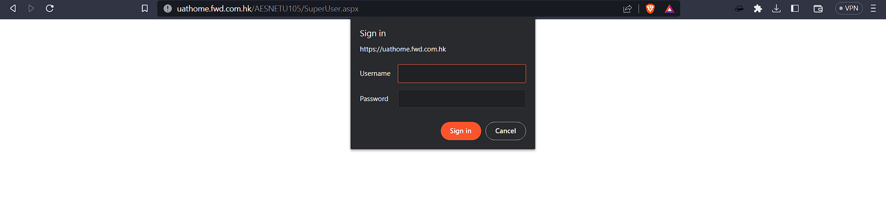

Point of Contacts
EGS stakeholders - Initial Test/ subsequent Retests:
Role | Full Name | Email Address
admin | rajan | rajnagpya;710@gmail.com
FWD stakeholders:
Role | Full Name | Email Address
admin2 | rajanh | rahan@gmail.com

Appendix – A Severity Rating Classification
The severity rating system provides a rating for each vulnerability, per component or platform. This rating represents the worst theoretical outcome were a vulnerability to be exploited on a given component or platform. The severity rating does not indicate the likelihood of that outcome. The definitions of the Severity ratings are:

Ratings | Definition
Critical | A vulnerability whose exploitation could allow code execution without user interaction. These scenarios include self-propagating malware (e.g. network worms), or unavoidable common use scenarios where code execution occurs without warnings or prompts. This could mean browsing to a web page or opening email.
High | A vulnerability whose exploitation could result in compromise of the confidentiality, integrity, or availability of user data, or of the integrity or availability of processing resources. These scenarios include common use scenarios where client is compromised with warnings or prompts regardless of the prompt's provenance, quality, or usability. Sequences of user actions that do not generate prompts or warnings are also covered.
Medium | Impact of the vulnerability is mitigated to a significant degree by factors such as authentication requirements or applicability only to non-default configurations.
Low | Impact of the vulnerability is comprehensively mitigated by the characteristics of the affected component. IT teams evaluate whether to apply the security update to the affected systems.
Informational | Information Gathered includes visible information about the network related to the host, such as traceroute information, Internet Service Provider (ISP), or a list of reachable hosts. Information Gathered severity levels also include Network Mapping data, such as detected firewalls, SMTP banners, or a list of open TCP services

Appendix – B Web Application Security Assessment Methodology
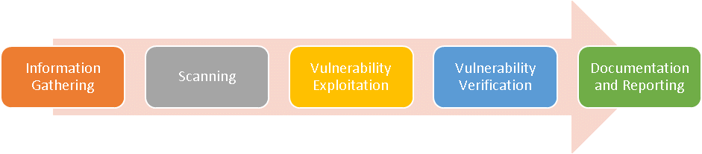

Phase 1: Information Gathering
The target application will be crawled using a web crawler as part of the information gathering phase. This allows the tester to understand the functionalities of the web application before conducting the assessment.

Phase 2: Scanning
Automated scan will be performed on the web application to identify vulnerabilities that are present. Manual scans will also be conducted to identify certain business logic flaws that are not detected by automated scans.
Below are some examples of test case that are conducted during manual assessment:
- Cookie Hijacking/Stealing
- Account Enumeration
- Forced Browsing
- Privilege Escalation
- Local File Inclusion

Phase 3: Vulnerability Exploitation
In this phase, exploitation is conducted to exploit the vulnerabilities that has been identified from the scanning phase. Exploitation tools is executed in this phase to exploit the vulnerabilities in the web application.

Phase 4: Vulnerability Verification
Manual verification and analysis had been carried out in this phase to validate all the findings that was identified earlier. Findings that are evaluated as false positive will be remove from the results. This phase also enables further research to be done to determine the severity and technical impact of each finding.

Phase 5: Documentation and Reporting
All identified and verified findings from the previous phase will be documented in the report and have a severity rating assigned to each vulnerability. Recommendation for each vulnerability will also be documented.

Appendix – C Testing Scenarios
company12 adopts the OWASP Testing Guide checklist to perform web application security assessment. The checklist contents are as below:
# | Test case
 | Information Gathering
1 | Conduct Search Engine Discovery and Reconnaissance for Information Leakage
2 | Fingerprint Web Server
3 | Review Webserver Metafiles for Information Leakage
4 | Enumerate Applications on Webserver
5 | Review Webpage Comments and Metadata for Information Leakage
6 | Identify application entry points
7 | Map execution paths through application
8 | Fingerprint Web Application Framework
9 | Fingerprint Web Application
10 | Map Application Architecture
 | Configuration and Deploy Management Testing
11 | Test Network/Infrastructure Configuration
12 | Test Application Platform Configuration
13 | Test File Extensions Handling for Sensitive Information
14 | Backup and Unreferenced Files for Sensitive Information
15 | Enumerate Infrastructure and Application Admin Interfaces
16 | Test HTTP Methods
17 | Test HTTP Strict Transport Security
18 | Test RIA cross domain policy
19 | Test File Permission
20 | Test for Subdomain Takeover
21 | Test Cloud Storage
 | Identity Management Testing
22 | Test Role Definitions
23 | Test User Registration Process
24 | Test Account Provisioning Process
25 | Testing for Account Enumeration and Guessable User Account
26 | Testing for Weak or unenforced username and policy
 | Authentication Testing
27 | Testing for Credentials Transported Over an Encrypted Channel
28 | Testing for default credentials
29 | Testing for weak lock out mechanism
30 | Testing for bypassing authentication schema
31 | Test remember password functionality
32 | Testing for Browser cache weakness
33 | Testing for weak password policy
34 | Testing for weak security question/answer
35 | Testing for weak password change or reset functionalities
36 | Testing for weaker authentication in alternative channel
 | Authorization Testing
37 | Testing Directory traversal/file include
38 | Testing for bypassing authorization schema
39 | Testing for privilege escalation
40 | Testing for Insecure Direct Object Reference
 | Session Management Testing
41 | Session Management Testing
42 | Testing for Cookies attributes
43 | Testing for Session Fixation
44 | Testing for Exposed Session Variables
45 | Testing for Cross Site Request Forgery
46 | Testing for logout functionality
47 | Test Session Timeout
48 | Testing for Session puzzling
49 | Testing for Session Hijacking
 | Input Validation Testing
50 | Testing for reflected cross site scripting
51 | Testing for stored cross site scripting
52 | Testing for HTTP Verb tampering
53 | Testing for HTTP parameter pollution
54 | Testing for SQL injection
55 | Testing for Oracle
56 | Testing for MySQL
57 | Testing for SQL Server
58 | Testing PostgreSQL
59 | Testing for MS Access
60 | Testing for NoSQL injection
61 | Testing for ORM Injection
62 | Testing for Client-side
63 | Testing for LDAP injection
64 | Testing for XML injection
65 | Testing for SSI injection
66 | Testing for XPath injection
67 | IMAP/SMTP Injection
68 | Testing for Code Injection
69 | Testing for Local File Inclusion
70 | Testing for Remote File Inclusion
71 | Testing for Command Injection
72 | Testing for Format String
73 | Testing for incubated vulnerabilities
74 | Testing for HTTP Splitting/Smuggling
75 | Testing for HTTP Incoming Requests
76 | Testing for Host Header Injection
77 | Testing for Server-side Template Injection
78 | Testing for Server-side Request Forgery
 | Testing for Error Handling
79 | Testing for Improper Error Handling
80 | Testing for Stack Traces
 | Testing for Weak Cryptography
81 | Testing for Weak Transport Layer Security
82 | Testing for Padding Oracle
83 | Testing for Sensitive information sent via unencrypted channels
84 | Testing for Weak Encryption
 | Business Logic Testing
85 | Test Business Logic Data Validation
86 | Test Ability to Forge Requests
87 | Test Integrity Checks
88 | Test for Process Timing
89 | Test Number of Times a Function Can be Used Limits
90 | Testing for the Circumvention of Work Flows
91 | Test Defense Against Application Misuse
92 | Test Upload of Unexpected File Types
93 | Test Upload of Malicious Files
 | Client-Side Testing
94 | Testing for DOM based Cross Site Scripting
95 | Testing for JavaScript Execution
96 | Testing for HTML Injection
97 | Testing for Client-Side URL Redirect
98 | Testing for CSS Injection
99 | Testing for Client-Side Resource Manipulation
100 | Test Cross Origin Resource Sharing
101 | Testing for Cross Site Flashing
102 | Testing for Clickjacking
103 | Testing WebSocket’s
104 | Test Web Messaging
105 | Test Browser Storage
106 | Testing for Cross Site Scripting
 | API Testing
107 | Testing GraphQL

